Example Number Plugging

Grant Nguyen

10/20/2017

## R Markdown

This is an R Markdown document. Markdown is a simple formatting syntax for authoring HTML, PDF, and MS Word documents. For more details on using R Markdown see <http://rmarkdown.rstudio.com>.

When you click the **Knit** button a document will be generated that includes both content as well as the output of any embedded R code chunks within the document. You can embed an R code chunk like this:

summary(data$val)

## Min. 1st Qu. Median Mean 3rd Qu. Max.   
## 0.000 0.000 0.011 72.100 15.190 21110.000

You can display a formatted table like so. We use echo = FALSE to hide the code underlying the data.

|  |  |
| --- | --- |
| sex | ui_val |
| Male | 10,072 (7,646, 14,532) |
| Female | 4,971 (3,714, 7,702) |

You can embed numbers like so: There were 195 locations studied.

For more complicated operations, you can first invisibly create a data.table, then perform operations off of it.

The 10 countries with the most male cyclist road deaths in 2010 were China, Indonesia, India, Brazil, Japan, United States, Russia, Mexico, Iran, Vietnam. The 10 countries with the most female cyclist road deaths in 2010 were China, India, Indonesia, Japan, Brazil, Vietnam, Uganda, Nigeria, North Korea, Russia. Vietnam was surprisingly high on this list, with 623 (321, 1,021) male deaths and 205 (102, 332) female deaths.

## Including Plots

You can also embed plots, for example:

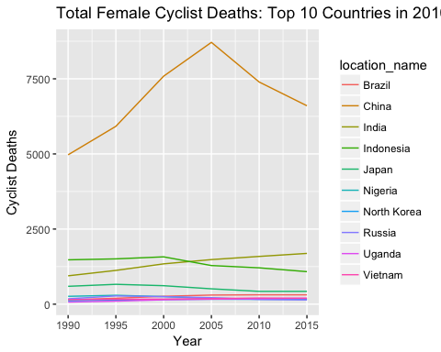

A more advanced plot might also have a caption and customizable width and height:

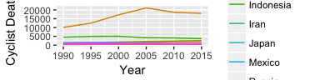

Total Male Cyclist Deaths: Top 10 Countries in 2010

If a plot takes a long time to render, you can embed a PNG of the plot (for example, a GBD Map). Here is the code used to generate the PNG in the first place:

top10_rates_male <- data[year_id == 2010 & sex == "Male" & metric_name == "Rate"]  
setorder(top10_rates_male, -val)  
top10_rates_male <- top10_rates_male[1:10]  
  
top10_rates_male <- data[location_name %in% unique(top10_rates_male$location_name) & sex == "Male" & metric_name == "Rate"]  
png("input_data/male_death_rate.png")  
ggplot(top10_rates_male) +  
 geom_line(aes(x = year_id, y = val, color = location_name)) +  
 xlab("Year") +  
 ylab("Cyclist Deaths Per 100,000")  
dev.off()

And here is the PNG (sourced directly from the PNG file)

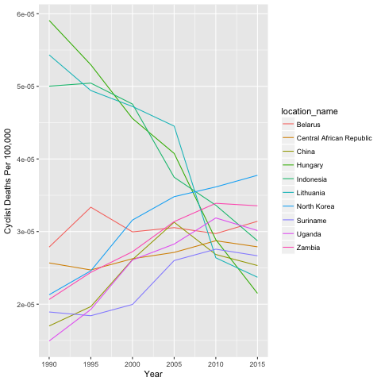

Male Death Rate: 2010 Cycling Road Injuries

## LaTeX

LaTeX is fairly straightforward

$$distance=\frac{n_{match}}{n_{admit}+n_{discharge}−n_{match}}$$

## Bibliographies and Citations

To add a bibliography, see <http://rmarkdown.rstudio.com/authoring_bibliographies_and_citations.html>. You simply need to add a .bib file which can be exported from Zotero or other citation managers. From there, you can use brackets to cite the source and add it to your printed citation list.

XYZ study analyzed the relative proportion of cyclist deaths [@sourceXYZ].

To standardize your citation display, you can add a csl file. In total, the following code pieces need to be added to the header part of your .Rmd:

bibliography: mybib.bib  
csl: lancet-style.csl