**BIM-Asite Mapping Tool Manual**

**Introduction:**

The Bim-Asite Mapping Tool is a custom made tool to help maintain and synchronize the Asite and BIM 360 data base for the prequalification process.

Note: *Once companies are inputted on BIM. Lis will have to input the same companies on Asite. To make sure this program can compare the databases at all, Copy and paste the Asite ID # for a given company to its description on BIM prior to running this program.*

There are four things that we want to make sure are true in order to keep these data bases sufficiently maintained and synchronized. While these five things are not the only important information to maintain they are paramount to ensuring that the prequalification process is not undermined. Since these five things are so important, from here on out we will call them “the Big Five” and they are as follows:

1. No company on Asite that is missing on BIM 360 should ever have an “approved” status.
2. Each company’s status on BIM 360 matches that company’s status on Asite.
3. All companies on BIM 360 are on Asite and each company that is on BIM 360 has an ID number in its description that matches that company’s ID number on Asite.
4. Each company on both data bases should be unique (i.e. have no doppelgangers)
5. Each company’s name on BIM 360 matches that company’s name on Asite.

The Big Five are ordered from most important to least important but all four are crucial to making sure the prequalification process is doing its job. Any deviations from the Big Five must be corrected on Asite or BIM 360 as soon and as accurately as possible. There are three steps to utilizing this tool to help find any deviations from the Big Five and they are as follows:

1. Download the prequalification directories for BIM 360 and Asite.
2. Place the two prequalification directories in the input folder for the BIM-Asite Mapping Tool and run it.
3. Manipulate the output to better notice deviations from the Big Five and act on them accordingly.
4. DOUBLE CHECK, TRIPLE CHECK, AND QUADRUPLE CHECK!!! This tool might be accurate but it is not capable of thinking critically about its data. Do not assume all data is correct just because the computer said it is. THIS IS BY FAR THE MOST IMPORTANT STEP. This tool might be helpful in expediting this process but it is by no means a replacement for human critical thinking. More on this later.

**Step 1:**

1. To download the prequalification directory for BIM 360 you must go to bim360field.autodesk.com and sign in. After signing in go to the equipment section by clicking on the fan icon as seen in the image below:

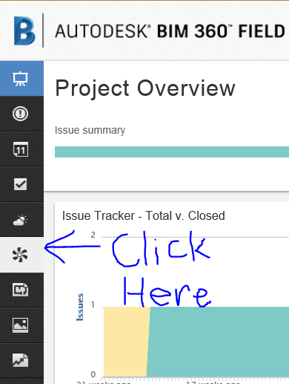

From the equipment section click on the “More Actions” drop down menu and click on the “Export All” option as seen in the image below:

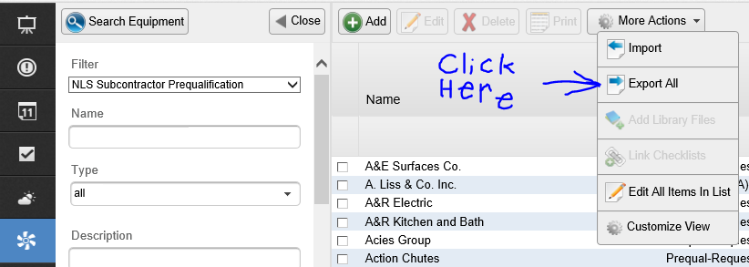

After BIM 360 finishes loading (this may take a minute or two) your browser may ask if you want to save a file from bim360field.autodesk.com. If so click save. It should then be downloaded to your computers download folder

1. To download the prequalification directory for Asite you must go to asite.com and sign in. After signing in go to the “Project Forms” tab as seen in the image below:

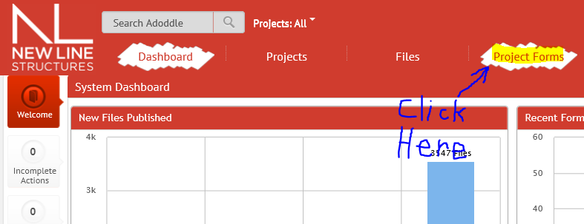

From the “Project Forms” tab go to the “Company Directory” in “New Line Master Workspace\A. DIRECTORY\” as shown below:

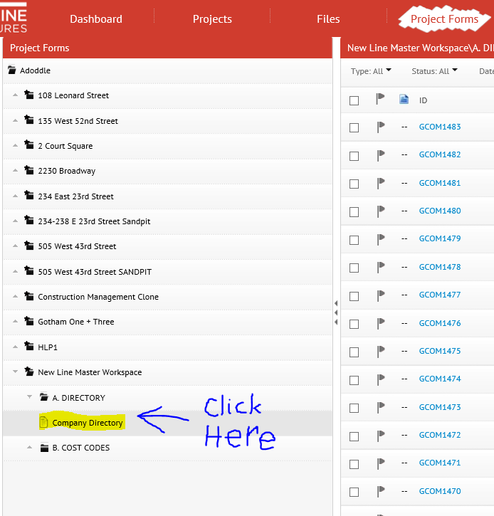

Once you are in the “Company Directory” go to the “Export” drop down menu on the upper right side of the page and select “Export All fields” as seen below:

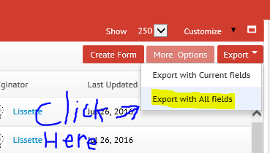

After Asite finishes loading (this may take a minute or two) your browser may ask if you want to save a file from adoddleb.asite.com. If so click save. It should then be downloaded to your computers download folder.

**Step 2:**

1. Assuming there was nothing else in the folder prior to starting this process, by now your Downloads folder should look something like the image below: 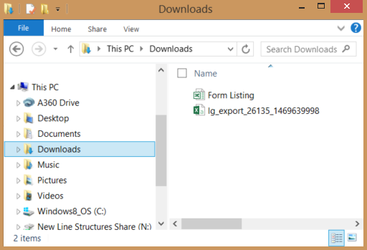

Open a new window in File Explorer and move the two files you just downloaded to “N:\PROGRAMS\BimAsiteMappingTool\” (or you can drag them directly into the BimAsiteMappingTool.exe and it will run the tool on these files) as depicted in the image below: 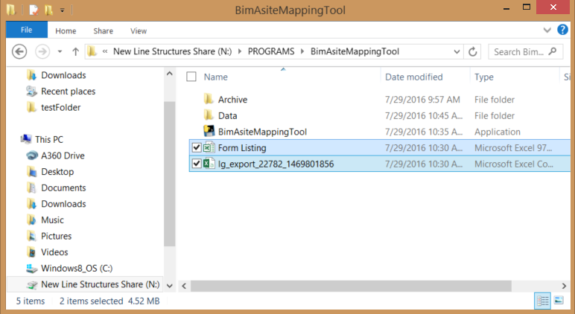

1. After placing the files in the “BimAsiteMappingTool” folder, run the program titled “BimAsiteMappingTool.exe” as seen in the image below: 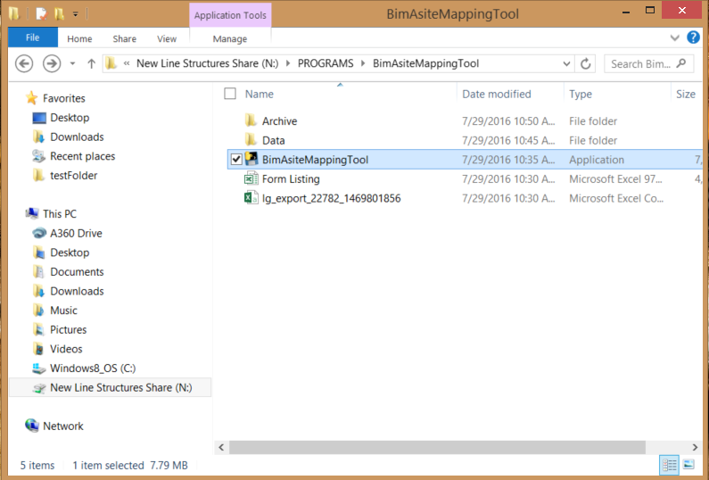The “BimAsiteMappingTool.exe” will take a minute or two to run. At first it may seem as though it’s not running. Be patient. Then a Windows cmd window will pop up. If the program runs correctly “Operation Complete!!!” should eventually appear in the Windows cmd window just as depicted in the image below: 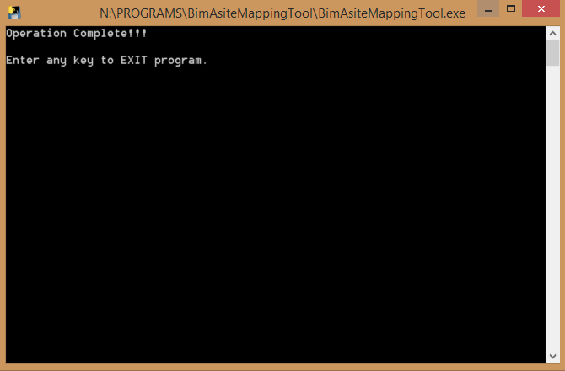If the above happens as described then there should now be a .xlsx file with a time stamp on it in the “BimAsiteMappingTool” folder as seen below: 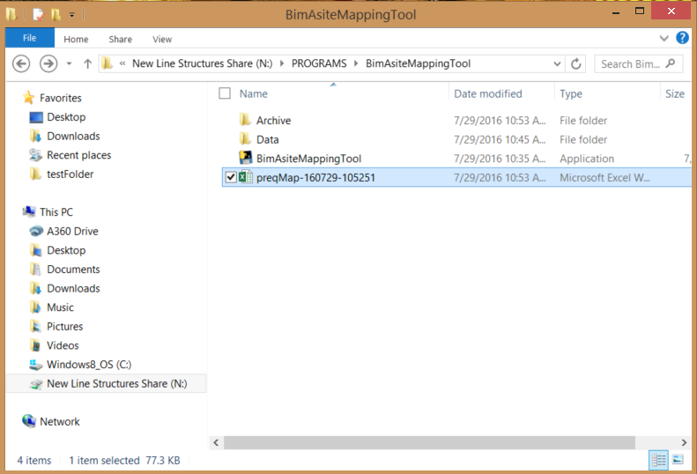
2. The program automatically keeps “BimAsiteMappingTool” folder organized and will not overwrite or delete anything. It automatically moves all old or already processed files to the “Archive” folder. Notice that after the program runs correctly the Asite and Bim directory files that were in the “BimAsiteMappingTool” folder (or where ever you dragged them from) are no longer there. That is because the tool renamed those files with a time stamp and moved them to the Archive folder as seen below:

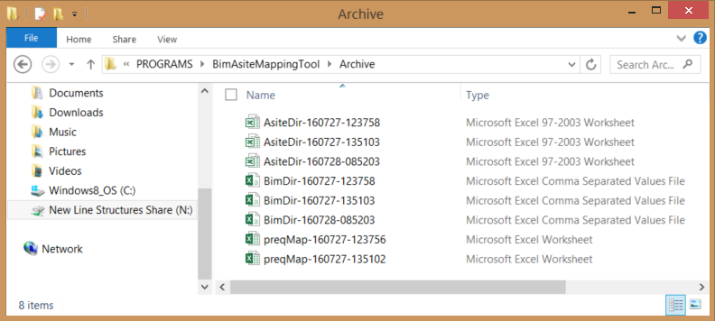

Notice that there are also older output files from this tool in the Archive folder. That is because the tool checks the “BimAsiteMappingTool” folder for an .xlsx file before generating its output. If it finds an .xlsx file it will move that file to the Archive folder before generating its output. As such do not add extra files to the “BimAsiteMappingTool” folder or any of its sub-folders that are not supposed to be there unless explicitly advised to.

1. The ReadMe.txt(found in the “Data” folder) is meant to explain how to make the tool use a new folder setup, how to change how the tool compares statuses, and how to properly trouble shoot the tool if it is crashing or giving you error messages. That may involve editing the settings.txt file or/and the BimAsiteStatusTrans.txt file. Never edit these files unless explicitly instructed to. These files being edited correctly is vital to this tool being able to run properly. It is highly recommended that you make copies of these files before editing them. If the program brakes and a solution cannot be found there is a support section at the end of the ReadMe.txt.

**Step 3:**

1. After opening the output file the data should look like the following: 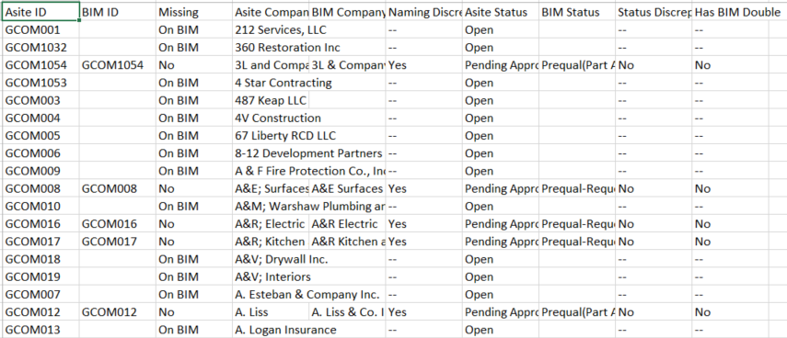

To read this data better start by selecting the header row and applying a filter so that you can sort the data by selecting “Filter” in the “Sort & Filter” drop down menu as shown below: 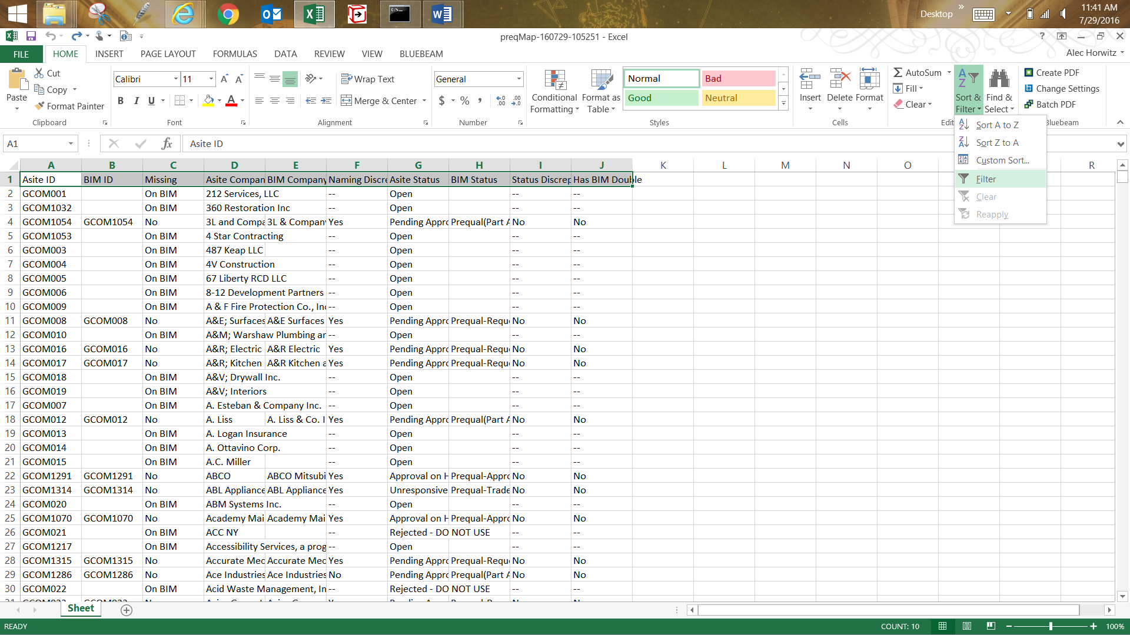After you do that you can select all the columns and then double click on the column divider to automatically resize the columns to show all text in all cells as shown below: 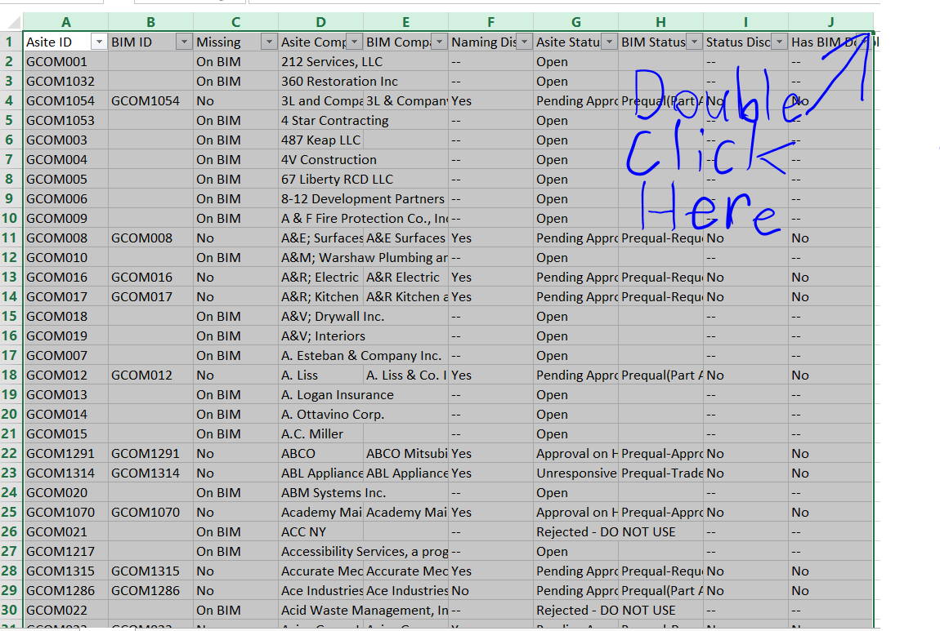After you’ve done that you can begin read the data.

1. To check number one of the Big Five simply sort the “Missing” column to only show the rows with a missing status of “On BIM” and then click ok as shown below:

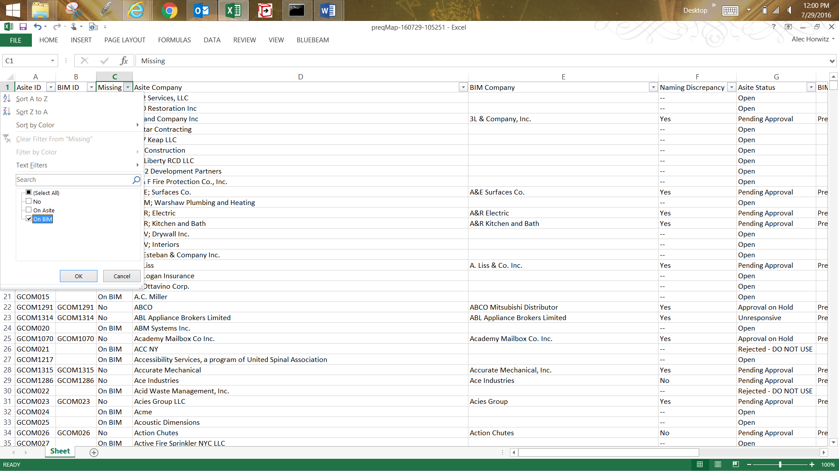You are now seeing a list of only the companies that are on Asite and not BIM. Now to check if any of them have an “Approved” status. To do this sort the “Asite Status” column to only show the rows with an “Approved” status and then click ok as shown below: 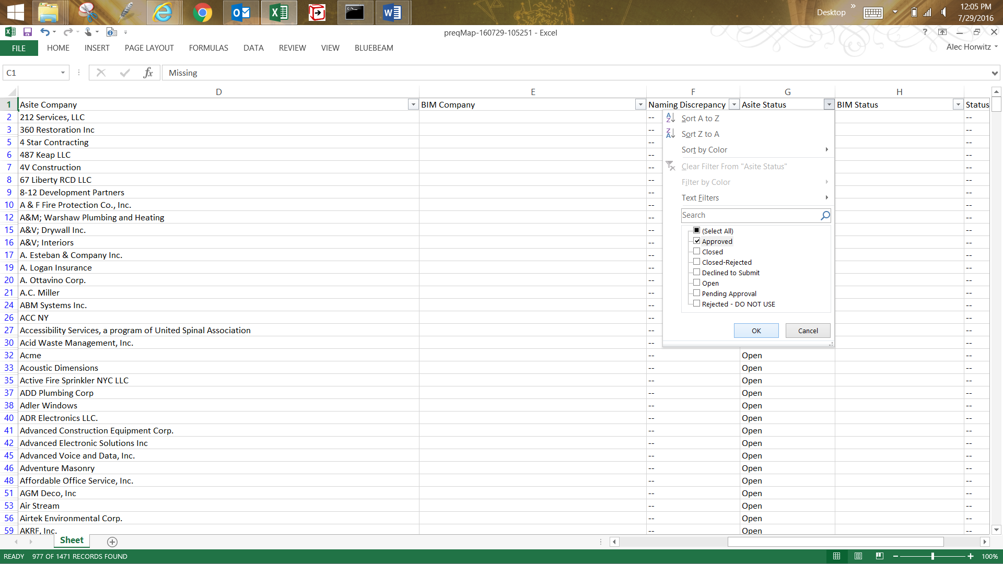

You now have a list of companies that appear to incorrectly have an “Approved” status. Check that each company is indeed not on BIM before changing their status. If the “Approved” check box is not available in the sorting menu then that means that the Asite database appears to be in accordance with rule number one of the Big Five.

1. To check rule number two of the Big Five undo all filters and then sort the “Status Discrepancy” column to only show the rows with a discrepancy status of “Yes” and then click ok as shown below: 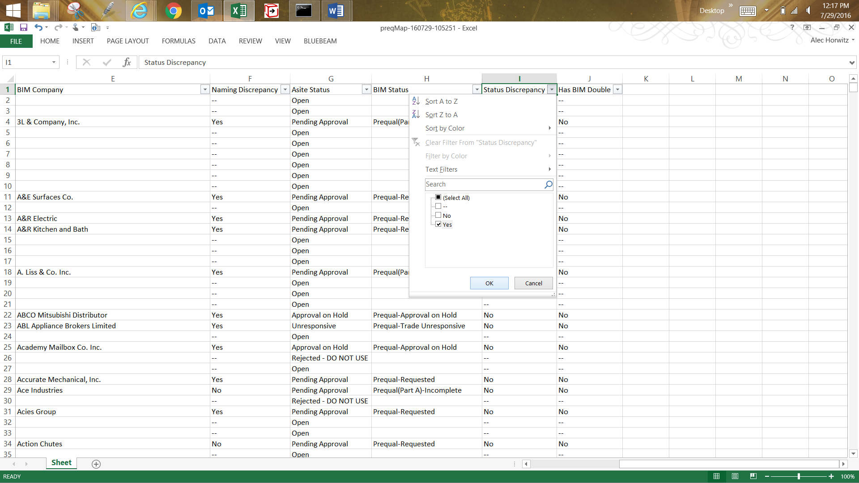

You should now have a list of all companies that have conflicting statuses between the two databases. Ideally if all Asite statuses are correct one of the “Asite Status” or “BIM Status” would have to be corrected. In the following image, the Asite status needs to be changed to “Pending Approval”. Once approved/evaluated on BIM360, Asite can be updated.



Always check that these companies’ statuses are in fact different on both database by going to both websites and checking their statuses. If “Yes” is not an option in the filter menu then the both databases appear to be in accordance with rule number two of the Big Five.

1. To check rule number three of the Big Five undo all filters and then sort the “Missing” column to only show the rows with a missing status of “On Asite” and then click ok as shown below: 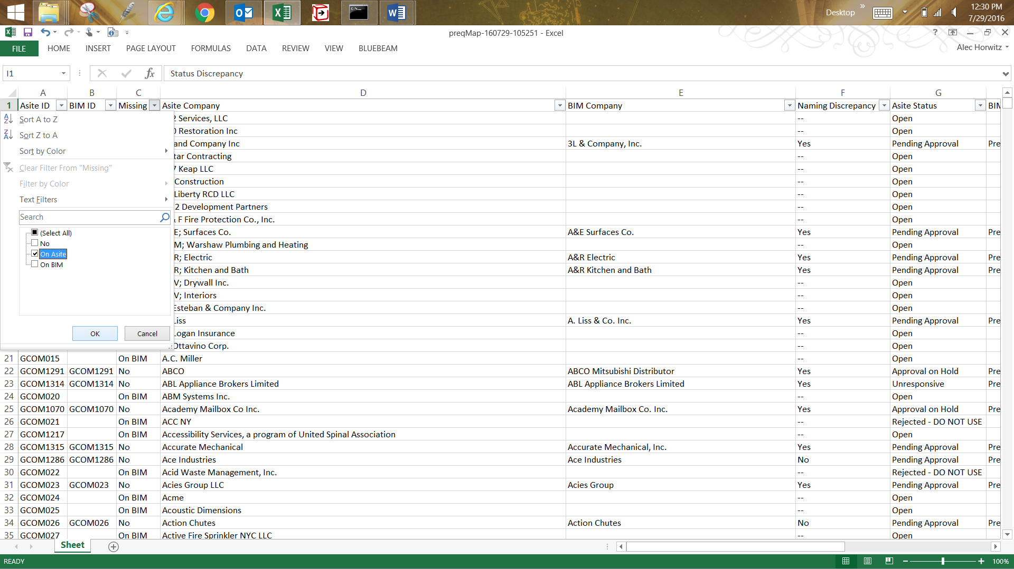You should now have a list of all companies on BIM that do not have an ID number that matches a company on Asite. This means one of two things, either the company is on Asite but its Asite ID hasn’t been added to the company’s description on BIM or the company is missing on Asite and must be added to Asite to generate an Asite ID for that company’s description on BIM. Either way you should check if the company is on Asite before proceeding. Figure out what needs to be done to make all the companies on this list are no longer flagged as missing on Asite by the Bim-Asite mapping tool. Again if a company row appears to be blank in cells Asite ID and BIM ID then PLEASE check both BIM and Asite. BIM should have the proper Asite ID or the company could be completely missing from Asite. If “On Asite” is not an option in the filter menu then the both databases appear to be in accordance with rule number three of the Big Five.
2. Number four of the Big Five is the tricky part. The Bim-Asite mapping tool is not smart enough to identify doubles but it can check for user error with rule number three of the Big Five that results in a violation of rule four.

For example let’s say you see a company listed as missing on Asite and missing its Asite ID from its description. After checking Asite you find that while the company does exist on Asite but its ID wasn’t copied over to the description field on BIM. So you add the ID to the description. What you did not account for is if this company is a double on BIM. Now you have two companies on BIM with the same ID. That’s where this tool can help.

The “Has BIM Double” column will be tracking user error in case a user inputs two of the same Asite ID #s for two BIM Prequals.

Simply sort the “Has BIM Double” column of the spreadsheet to only show the rows with a BIM double status of “Yes” and then click ok as shown below: 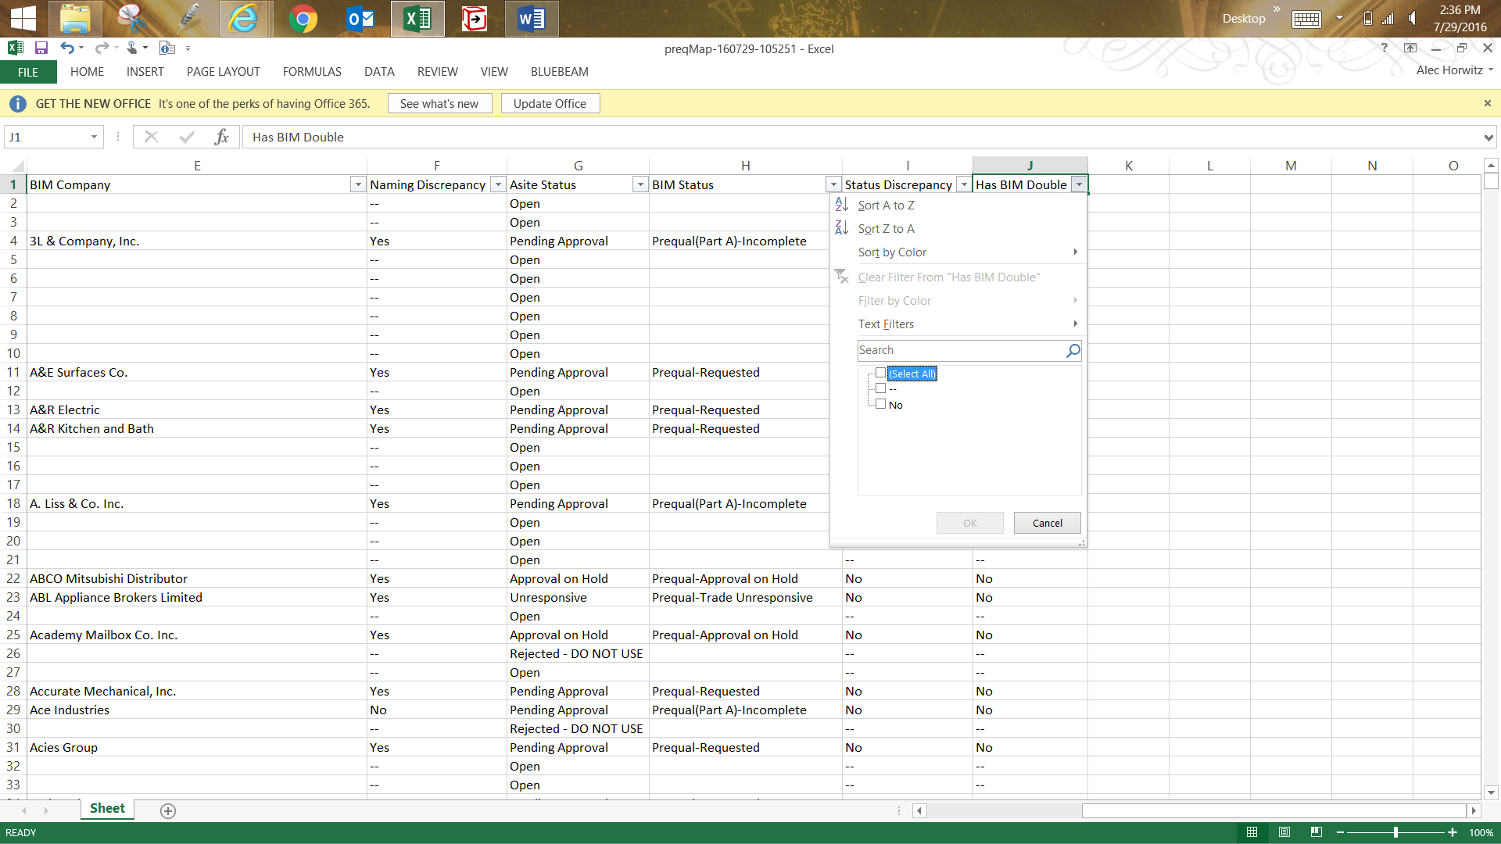

In the image above there is no “Yes” option in the filter right now. That is good. That means everyone is following these guidelines and as such not making doubles. This is not always the case though. Furthermore, this does not keep track of all doubles just some of the ones that come from user error. Finding all doubles requires critical thinking that this program lacks. So to truly take care of rule number four of the Big Five you must check both Asite and BIM the old fashioned way (by using key words in the search bars on the BIM and Asite web pages).

1. To check rule number five of the Big Five undo all filters and then sort the “Naming Discrepancy” column to only show the rows with a discrepancy status of “Yes” and then click ok as shown below: 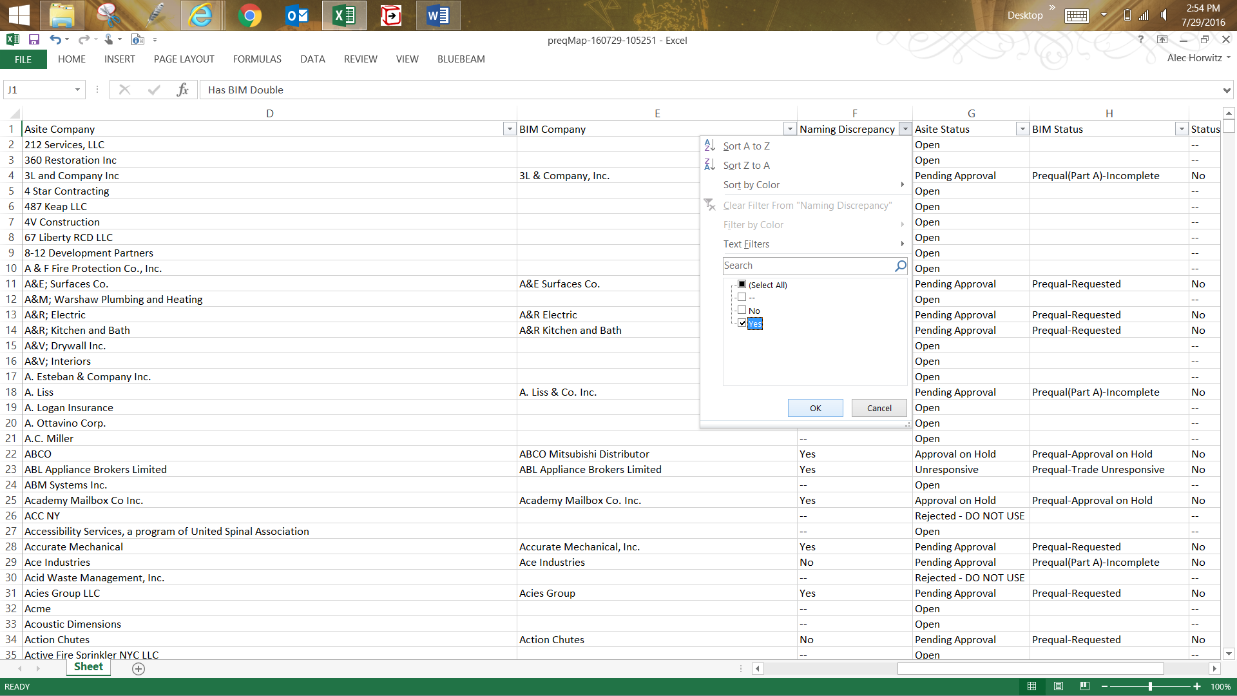You should now have a list of all companies known to have different names between the two databases. If “Yes” is not an option in the filter menu then the both databases appear to be in accordance with rule number five of the Big Five.

**Step 4:**

Just as stated before: DOUBLE CHECK, TRIPLE CHECK, AND QUADRUPLE CHECK!!! If the output of this tool claims there is a deviation from one of the Big Five always assume that it could be wrong. This tool might be accurate but it is not capable of thinking critically about its data. Do not assume all data is correct just because the computer said it is. THIS IS BY FAR THE MOST IMPORTANT STEP. This tool might be helpful in expediting this process but it is by no means a replacement for human critical thinking.