**Museum Controversies**

Detailed Functional Specification

v 1.0

Kamran Noorian, Muneeba Syed, and Alec Horwitz

March 2, 2017

**Table of Contents**

Introduction Page 2

General Description Page 2

Elevator Pitch Page 2

Goals Page 2

Needs Page 3

Client Bio Page 4

Timeline Page 5

Literature Review Page 6

User Interface Page 8

Use Cases Page 14

System Architecture Page 16

Limitations Page 16

Testing Page 17

References Page 18

**Introduction**

Museum Controversies is a website designed to educate users on various controversies that museums face with regards to different artifacts and pieces of their collection.

**General Description**

Museum Controversies is a website that allows a user to learn about various controversies regarding museums. The website will include information about 10 different controversies with three museum pieces per controversy.

Users of the website will be able to learn about any controversy that interests them or all 10. The website will include an about section which will allow the user to learn more about the researchers and how to contact them with questions.

**Elevator Pitch**

We are creating an intuitive website to educate future art historians on museum controversies through a captivating interface.

**Goals**

The goals of our project are to achieve high client satisfaction while also creating an educational, aesthetically pleasing product. We will create an artful website without sacrificing usability, and make the works of the students of the Art History Senior Seminar interactive. This could be accomplished through a game, survey, statistics of page views, etc.

**Needs**

* Timely communication with client and students
* Information on museum controversies
* Pictures of museum pieces that have been deemed controversial for various reasons
* Interactive component idea that is finalized
* Overall webpage layout design that is uniform for each page so that it looks more professional

**Client Bio**



Leah Niederstadt is in her tenth year as a Professor of Museum Studies and Art History, and Curator of the Permanent Collection at Wheaton College (Norton, Massachusetts). A social anthropologist by training, Niederstadt holds postgraduate degrees from the University of Michigan and University of Oxford. Her research focuses on contemporary expressive culture in Ethiopia and on the management and use of academic collections. She is also a well-known expert on Ethiopian wedding paintings and on the Legend of Queen Sheba as it relates to Ethiopia.

When it comes to her life outside of work, Niederstadt enjoys reading and spending time with her daughter and her sister's family in Maine. Her favorite food is *firfir*, an Ethiopian dish made from dried *injera* (a staple Ethiopian starch that most closely resembles a crepe) mixed with onions, garlic, tomato, and *berbere* (red pepper spice blend). Her current guilty pleasure is watching the TV show *Community* on Hulu when she wakes up in the middle of the night and can’t sleep.

Niederstadt’s favorite artistic techniques are collage and mixed media, but her favorite objects in the 6,000 piece Wheaton Collection are from a variety of mediums. One of those objects is a hand-carved wooden Ethiopian hand cross donated by Ambassador Samuel R. Gammon III, whose late wife, sister-in-law, and mother-in-law all attended Wheaton. The name and title of the religious leader who owned it – Qes (Priest) Teklu – is carved into the handle.

**Timeline**

February:

21 - Work on website development and structure, get responses on the survey from the class regarding the interactive component

23 - Get student bios and work on links/ About Me pages

28 - Finalize model and begin prototyping

March:

1 - Have completed wireframes for all webpages

2 - Detailed Functional Specification due

9 - Have completed wireframes for all webpages

23 - Interactive component prototyped

April:

4 - Begin final bug testing

13 - Website is ready to deploy

18 - Begin swapping placeholder text for actual student work

20 - System Design Specification is due

25 - Present Final Product

**Literature Review**

Through searching for other similar projects and how different organizations have represented art information online, we have found a few websites from which we will look to model various aspects of their design and layout.

One such website that we found was [www.artsy.net](http://www.artsy.net)

Artsy.net has a very clean and professional layout that can be adapted well to fit our project goals. One of the first aspects that we saw was the slideshow which also incorporates long scroll. We see this aspect as something that can be used on the Museum Controversy website to better show all of the projects and the Wheaton College Permanent Collection items behind each museum controversy. The slideshow would have a picture from each museum controversy and would help to show all 10 controversies.

Another aspect that we plan to incorporate into the Museum Controversy website is the “Browse Works for Sale” section from Artsy.net. We envision this section as listing out each museum controversy so that a user can select a particular controversy at a glance and begin learning about it.

However, that will not be the only way a user can select different museum controversies. Artsy.net also has a “Works by Popular Artists” section incorporates a mini slideshow that is user controlled. Each element in the slideshow has a picture of the artwork and some information. We envision using some of that design and instead of a slideshow to put a selected image from each project into a grid similar to the museum controversy titles so that users can click on an image or the name of the controversy.

Another website that we found was <http://82nd-and-fifth.metmuseum.org/>

This site is managed by The Met and has a very nice user interface. By clicking on one of the “Episodes”, the user is then given two options. We see a lot of potential in giving the students in the Art History Senior Seminar choice in how they plan to showcase their work. On The Met website each object has two different components to it. These components range from a video with voice over to being able to rotate the object within a 3D space. For the Art History Senior Seminar, each student will be able to represent their research in two ways, such as a video or possibly more detailed photographs of a particular object that relates to their controversy.

**User Interface**

The user will be interacting with a series of HTML pages. The main interface will be each of the individual project pages. Each project page will have an interactive component relevant to that specific museum controversy, and will link to other pages as necessary.

The homepage will showcase the ten projects, and all pages will have a menu bar at the top for navigation. The menu bar will also contain a link to an “About Us” page, which will have a tiling of the professor and students’ pictures, which will then link to their respective bios. The footer will also have a “Developed by” link to more information about us. In addition, we will create a glossary page for the technical art history terms the students will be using.

The following images are sample web pages of the interfaces, which are subject to change as we develop.

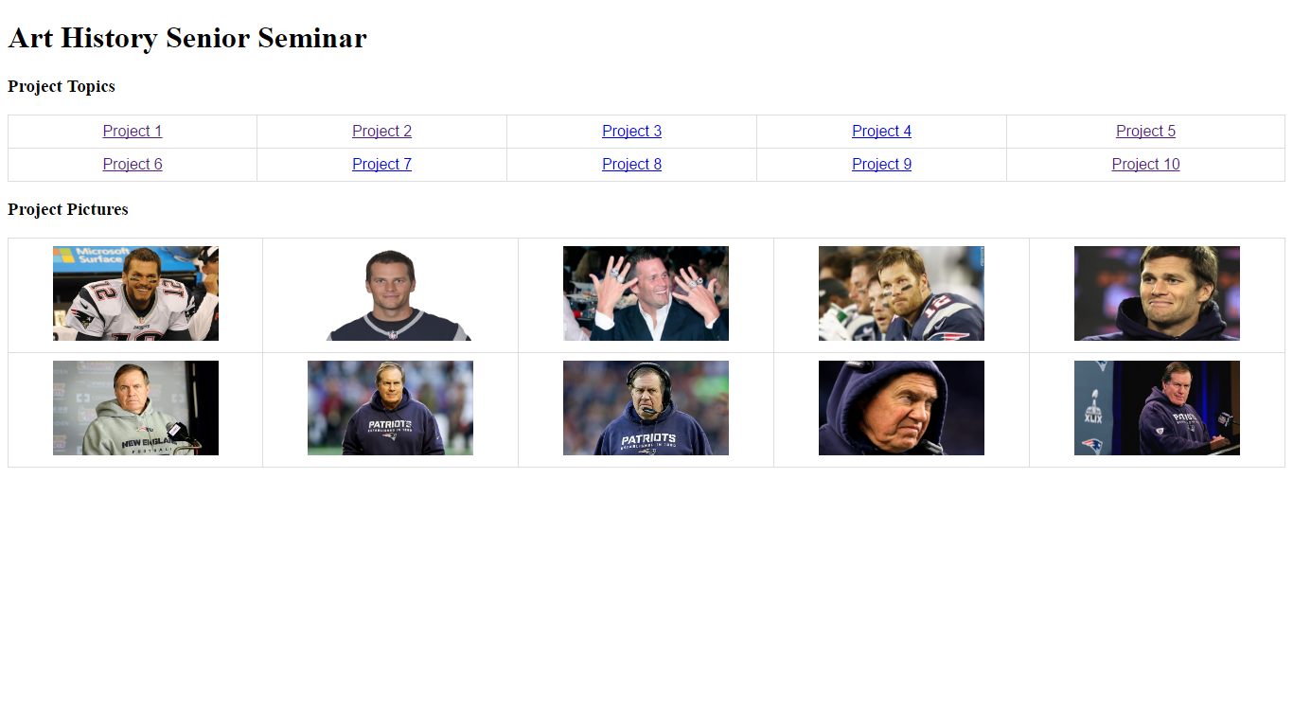

**Fig 1:** This is our landing page in its current state. We will likely have a slideshow of relevant images at the top of the page, followed by a navigation bar, followed by a list of the projects and then pictorial representations. The list of projects and images will be organized in a way similar to that of Artsy.net’s.

The bottom of the landing page will have small tiles of the students, which will lead to the “About Us” page.

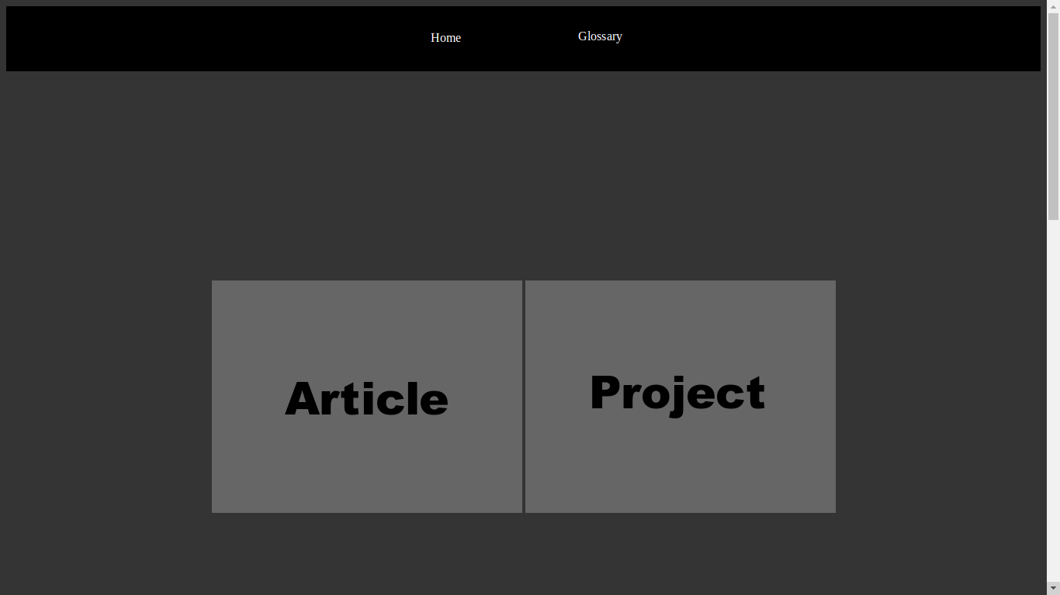

**Fig 2:** This is a mock-up of the first screen that the user will see when they click on an individual project page. There will be a different image in the background to represent each controversy, and the two buttons show how the user can explore the issue in different ways, similar to that of 82nd and 5th’s page. There is also a navigation bar at the top to go between pages.

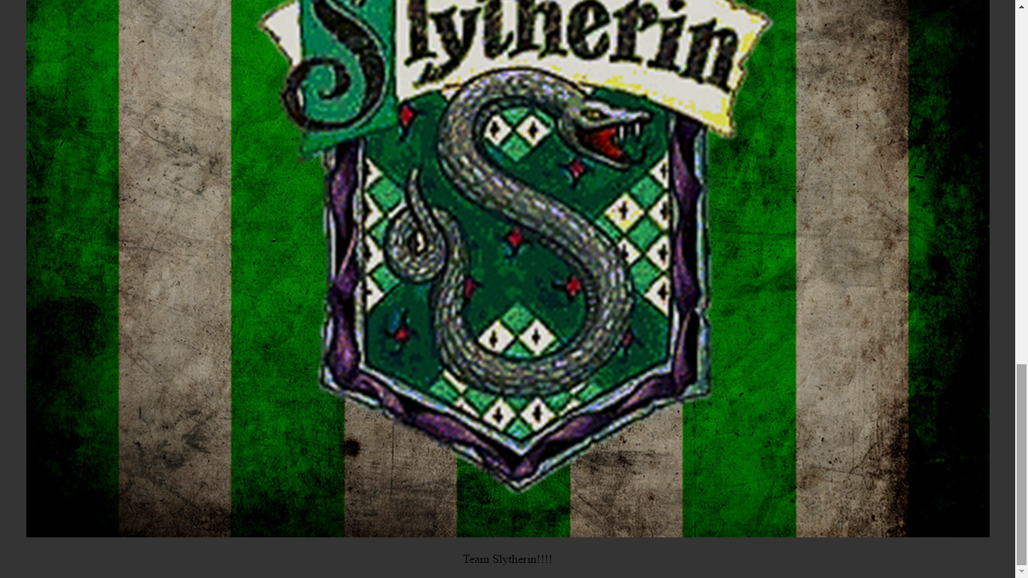

**Fig 3:** When scrolling down to the bottom of an individual project page, there will be a small picture of the student researcher, along with their “elevator pitch” for the project as a whole. There will be a link included to their detailed bio.

The bottom of the page also shows our footer, which will have a link to “About the Developers.”

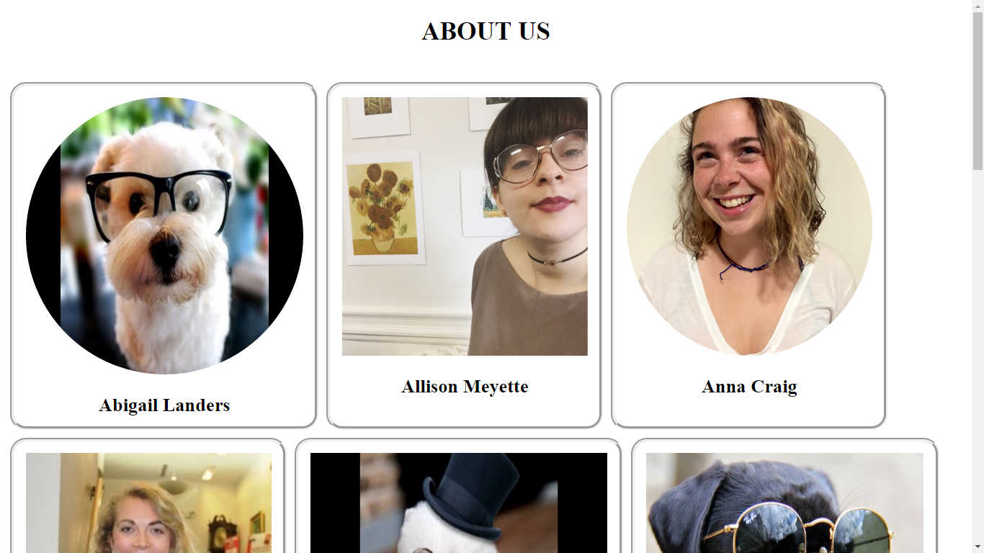

**Fig 4:** This is the mockup for the “About the Researchers” page, which will be linked to from the more general “About” page which will describe the class as a whole. Each student will have their own professional picture hyperlinked to their bio page.

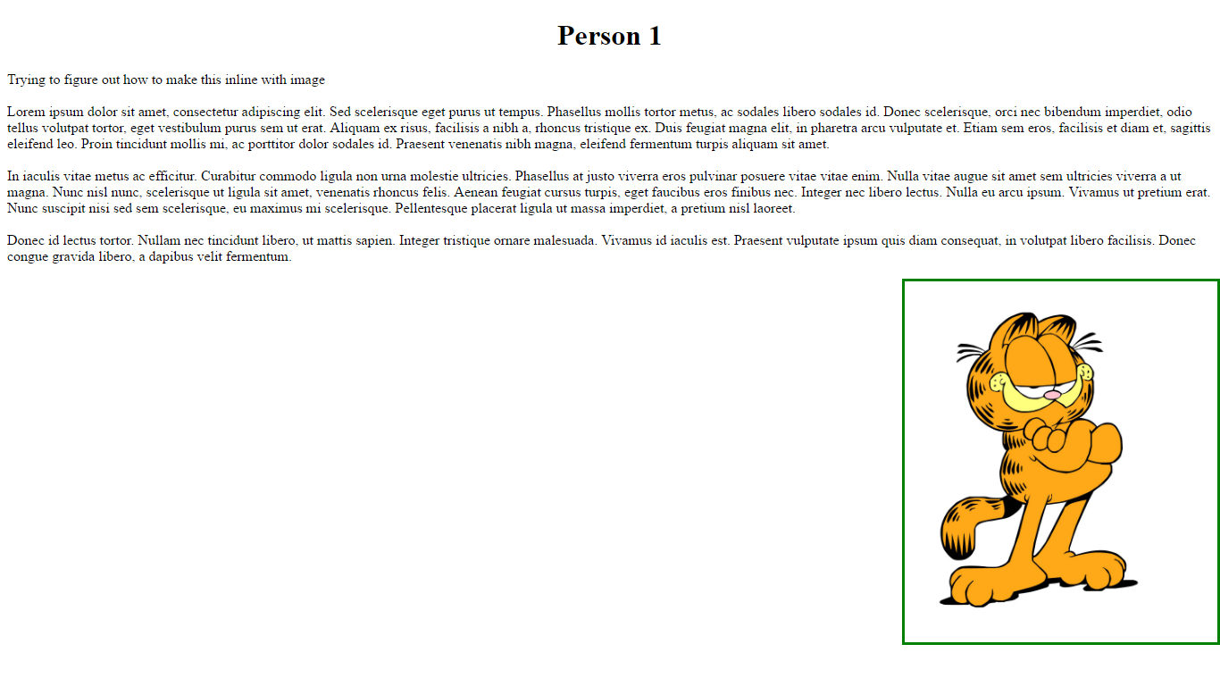

**Fig 5:** This is an individual bio page for each student, which will have text inline with their picture explaining a little about the student’s background. It will also have appropriate external hyperlinks to their LinkedIn, etc.

**Use Cases**

1) Mark

Mark has a particular set of skills that he is interested in utilizing for profit. He has the ability to create field stone walls and wants to sell one as a 1600’s forgery to a museum for $500,000 in order to fund his future con of creating replicas of first-edition presidential biographies. He wants to know how museums in the past have dealt with fakes and forgeries, and Googles “museum controversies.”

He finds our website and browses through the main page of museum controversy listings. He finds the “fakes and forgeries” entry, and goes through the interactive component and reads the academic entry for it. He learns about different perspectives on the issue, and how museums have dealt with it in the past.

Realizing that fakes and forgeries can be discovered through certain methods, he understands that he must refine his forgery technique in order to avoid detection and decides to continue his hoodlum ways.

2) Jackson

Jackson has recently visited an art museum, and is interested in learning more about museum practices. Jackson then finds our website, and lands on our homepage, where all of the controversies are listed. He is then able to explore each of these issues in a concrete manner, through the objects that each researcher has based their controversy on.

Jackson’s interest in museums and their collections has been piqued, and he now intends to pursue further education at Wheaton College with his grandfather in museum studies.

3) Julia

Julia is a high school student who is required to write a research paper on museum controversies and their socioeconomic impacts. She finds simply reading articles on JSTOR to be tedious and difficult to understand, and wants to find a more interesting way of analyzing these issues. She finds our website, and discovers a collection of museum controversies with examples and an associated glossary.

She goes through each of the museum controversies and is able to learn about both sides of each affair in an interactive manner. She explores the individual interactive components, and realizes by the end of her review of the website, she has learned a significant amount about each of the controversies.

Julia now has a better understanding of art history concepts and of museum controversies, and also knows where to go for more information on each of the issues due to the published bibliographies for each of the academic pieces.

“Any resemblance to persons living or dead should be plainly apparent to them and those who know them, especially if the author has been kind enough to provide their real names and, in some cases, their [personal website]. All events described herein actually happened, though on occasion the [authors have] taken certain, very small, liberties with chronology [and facts], because that is [their] right as [Americans]” (Eggers iv).

**System Architecture**

The website will be stored on a server, likely the Wheaton CS server which will be accessible to the public. We will have to discuss more with Professor Niederstadt what she is looking to do to this end. A website for an Art History Senior Seminar for Spring 2015 was created through WordPress. That website incorporates wheatoncollege.edu within its website url. We will have to host the website ourselves instead of turning to a third party. Our website will likely be written using a combination of HTML, CSS, and potentially some JavaScript.

The webpages will be grouped into category directories for code, like /images, /bio, etc. We are also hoping to have XML tagging in order to cross reference terms across projects, which will help users construct a more holistic comprehension of museum controversies and how they are connected.

**Limitations**

High quality images will take more time to load, and in an image-heavy website, we must make sure that it does not reach a point where it negatively impacts user experience. If a student decides to utilize a third-party application such as storyMap, we will have to open it in a new tab as we will not be able to provide navigation back to our page.

We will not receive project data from the students until mid-April when they have finished their research, so our finishing touches will need to be completed within a shorter time frame.

**Testing**

In order to test our code, we will do three things to make sure everything works on our site. First we will try to run the site. If it does not run, we will check that that the server is running correctly. If it is not running, we will work to remedy that. Second, we will connect to the site via different web browsers and check that all interactive components (things that change conditionally and not from clicking links) are working properly. Next we will systematically click every link on every page twice to make sure all links are functional. If there are any broken or incorrect links we will work to debug the issue and fix the root cause. Our hope is that after all this, we will achieve a 0% site failure rate.

***References***

Artsy (2017). <https://www.artsy.net/>

Eggers, D. (2000). *A Heartbreaking Work of Staggering Genius*. London:

Picador.

LeBlanc, M. (2016). <http://cs.wheatoncollege.edu/mleblanc/personal.html>

Metropolitan Museum of Art (2017). <http://82nd-and-fifth.metmuseum.org/>