Internet Marketing Proposal

Our Expertise

Our expertise involves the three interrelated disciplines including Search Engine Optimization, Conversion Optimization and Paid Search management. The diversity of our experience spans ecommerce, lead generation, and media sites with services ranging in scope from Search Engine Optimization, Conversion Optimization, Pay Per Click, Social Media, and every other micro-niche within the search marketing discipline. Our business model is laser focused on first page Google results, ROI, and value for dollar for all clients. Big or small, all of our clients receive high touch service and support!

Internet Marketing involves

Website Optimization: This involves making your site have perfect clarity to the search engine through content, powerful titles, tags, linking structure and site design best practices.

SEO Process, Link Building and Ongoing Management: This involves months of building powerful and diverse links that make your site appear more relevant to the search engine. These links are produced the hard way from “white-hat” sources including social media, directories, blogs, press releases, and other sources. The combinations of these operations bring our client sites to the top of the search results, producing dramatic improvements in site visitors.

Conversion Optimization (CO) is a process focused on converting these increased site visitors into solid sales leads, or transacting customers in the case of ecommerce sites. CO involves multiple phases of site modifications involving modifications to landing pages, well placed testimonials, effective calls to action, and testing for results.

Paid Search Marketing (PPC) management involves a highly analytical process of in depth keyword research, fine tuning campaigns, employing advanced strategies and continually measuring results to lower your cost per sale and increase your ROI.

Our Results

Case Study #1 - Moore Heating & Air
From 2,800 unique visitors per month to over 37k within 6 months of beginning their SEO plan.

With a combination of SEO, PPC and Content Marketing - we were able to help Moore grow from a simple startup with limited funds into a household brand name with over $1.3 million in revenue within 12 months. [www.moorehvac.com]

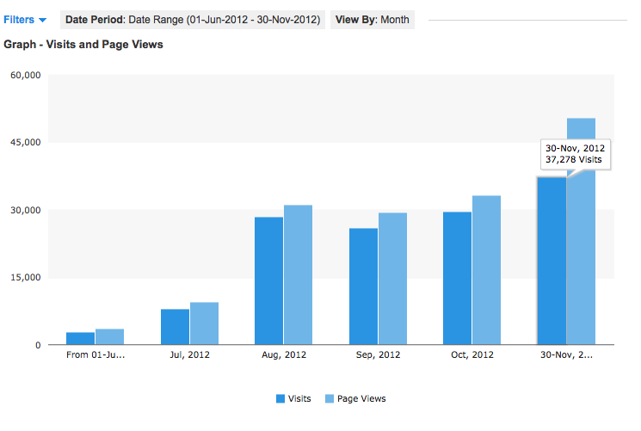
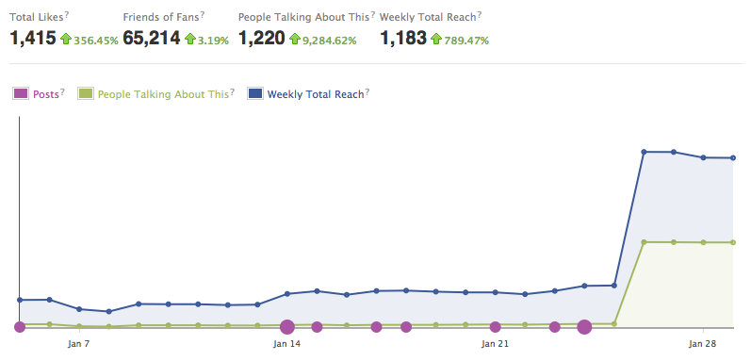
Case Study #2 - Windfall Equestrian
From 61 Facebook company page likes to over 1,400 within 60 days.

After carefully optimizing their website and content marketing plan, Windfall became the hottest growing Facebook company page for equestrian services within the Northern Colorado area. In addition, they started generating leads within 9 days after their new website was launched. [www.windfallequestrian.com]

Case Study #3 - Name.com Landing Page
From 1,000 unique visitors per month to over 8,000 within 5 months of starting their SEO plan.

After carefully crafting their landing page and improving their conversions, Name.com not only saw an increase in visitors - but their page views got to close 16k as the landing page started to generate repeat traffic and conversions for their chosen keywords.
[www.name.com]

Case Study #4 - SIP Inc.
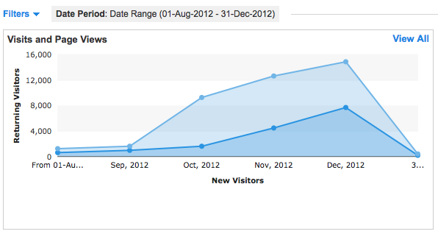
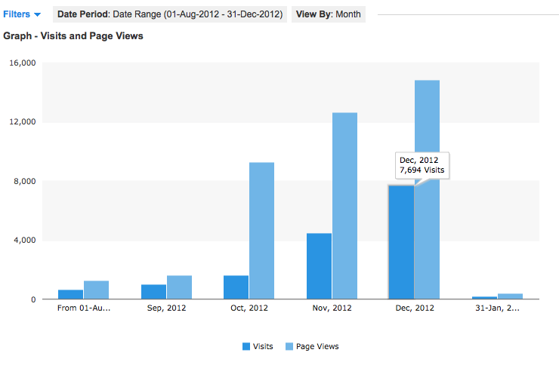
From less than 1000 unique visitors to over 7k within 3 months of starting their on-page seo plan.

Before we even had a chance to start start building quality links for SIP, the on-page website optimization alone gave them a boost in traffic for their chosen keywords. In addition to the new traffic, we saw a 400% increase in their visitors who were actually converting and viewing more pages on the website through carefully crafted calls to action.
[www.siptraining.com]

Which makes the biggest impact on your lead generation goals?
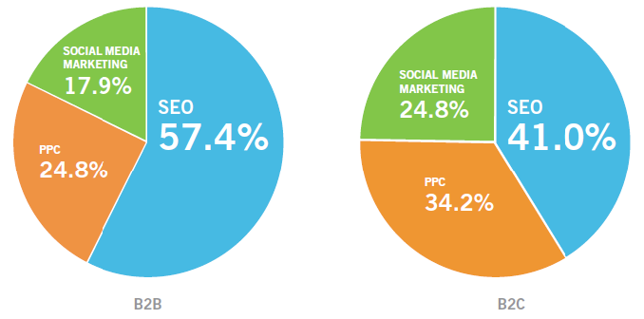

Over 75% of digital marketing impact is derived from SEO and PPC efforts.

The first annual Webmarketing123 State of Digital Marketing Survey was conducted online between August and September 2011. Over 500
U.S. participants completed the survey – all individuals who responded to an email invitation sent to a registered list of marketing professionals.

Current Domain Authority
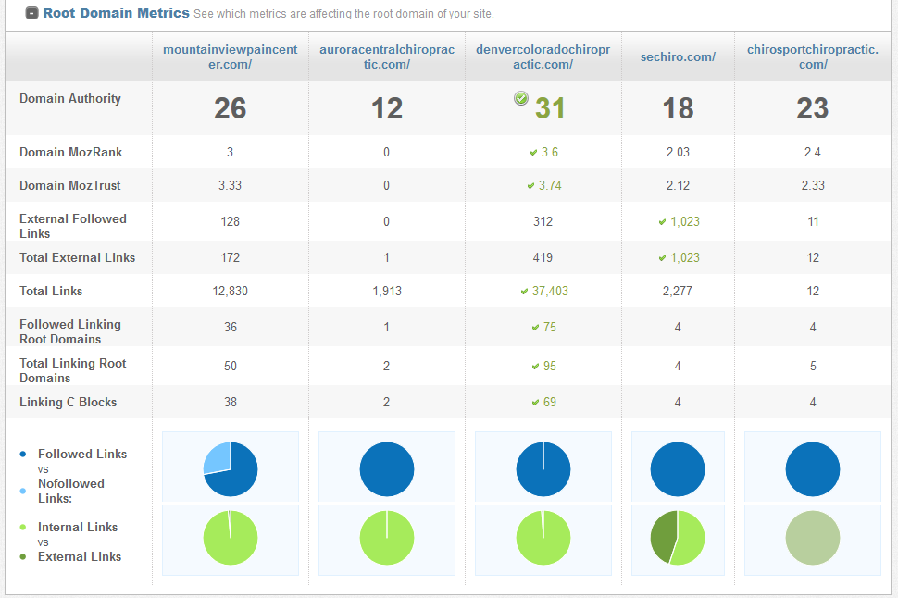

Current Keyword Rankings

Achieving the highest page, and domain authority has a direct relationship with your keywords getting top ranking positions. Your domain authority will rise as a natural result of our comprehensive SEO program. While rankings can vary, this report simply serves as a guide to could be improved upon. Actual rank tracking starts upon campaign signup.

(Keywords pulled from AdWords / Current SEO Value is low)

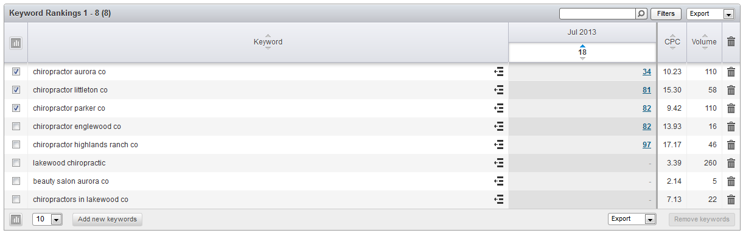

Understanding Ranking Positions:

Google has 10 positions on each page for websites to appear in the organic results section. The “not top 100” position means your site does not appear in the first 10 pages of Google for this keyword.  Since 90% of people do not click on results past the first page on the SERPs, achieving 1st page rankings are imperative for your campaign to be successful.  The most important thing about these potential searchers is that they are people that are uniquely qualified because they are at the last stage of the buying cycle. This gives you the opportunity to be in front of them the exact moment that they are ready to purchase your products. This is our primary goal for your campaign’s target keyword phrases - to obtain 1st page results. Achieving this goal drives significant traffic, conversions and revenue for your company.  We do extensive keyword research with many proprietary keyword research tools to determine the highest converting potential keywords for your campaign. | - Top ranked sites generate thousands and in some cases even millions of dollars in additional revenue.  - Companies with top ranked websites feature significantly higher valuations.  - A completely optimized site maximizes your opportunity with your available customers and is devastating to your competition.  - Doubling the conversion rate of your site is the equivalent of increasing the number of site visitors by 100%  - One top ranked high tech firm claimed a 40:1 return for every dollar spent on SEO.  - In a 2010 study, an average client tracked a 20:1 return on investment. That’s $20.00 back for every dollar spent!

Our Process

Step 1 - Pre Website Optimization

  - Keyword Research
    - Determine optimal keywords and optimal number of keywords to promote for your campaign.
    - Develop optimal keyword strategy necessary to achieve same goal within same time period.
    - Optimal keywords developed from proprietary internal tools and several commercially available tools.

  - Competitor Analysis
    - Determine strength of links and link sources that can be replicated and improved upon as the competitive strategy of the site is developed.
    - Approach competitor links sources for link acquisition opportunities.
    - Determine competitor vulnerabilities, and capitalize upon those weaknesses.

  - Site Structure
    - Evaluate site structure to determine impediments to optimal search engine visibility.
    - Evaluate internal site linking structure and basic site design, identify and provide recommendations for necessary changes to perfect said structure.
    - Analyze website “calls to action”, “flow” and “purchasing paths”.

  - Website optimization plan reviewed and approved by client
    - Develop Baseline ranking report and analytics, explain and email them to customer.
    - Install Google analytics, if not currently employed.
    - Develop client metrics dashboard, explain functions and instruct client in reading and usage.
    - Provide client with document outlining the changes needed to be implemented to complete website updates.
    - Modify content to include keywords developed from keyword research.
    - Ensure the keyword density is optimal for search bots.

Step 2 - Link Building + Social Signals

    - Develop link building & social sharing plan
    - Research and determine link opportunities in social media, blogs, directories, suppliers, business partners, link bait, and other potential link opportunities
    - Link building plan reviewed with client for approval
    - Ongoing monthly Link plan implemented

Step 3 - Ongoing Execution and Management

- Review analytics to insure website keyword traffic is increasing on Google, Yahoo, and Bing.
- Execute actionable site changes based on the hard data from analytics.
- Review keywords to ensure most relevant words are being optimized, and make changes as necessary.
- Review keyword performance and strategy with customer.
- Upon reaching desired goals for keywords apply similar SEO techniques to new keywords and begin SEO process again for new keywords.
- Hold pre-scheduled bi-monthly performance reviews with client.
- Monitor analytics and accounts to maximize results.
- Build powerful links from unique social media sites.
- Acquire links from article submissions if relevant.
- Gather directory links and link to internal pages if relevant.
- Share monthly KPI report with client in regularly scheduled meetings.

- Algorithm changes: When Arctic Gurus Solutions, Inc. realizes changes in the Google algorithm we are authorized to make necessary adjustments and then notify client of such.

Frequently Asked Questions

When can I expect to see results, and what will those results be?

- Keyword traction usually begins in month 2, and as the campaign’s momentum builds, first page rankings are typically seen within 6 months, depending on the competitiveness of the keywords. Above the fold (position 1-5) first page results are usually seen at the 1-year mark.

What kind of benchmarks do we set for the program so we can measure the progress of the program on links, Google placement on top keywords etc.

- Keyword rankings and traffic will be tracked and reported on once a month.
- All the activity for the link building program will also be tracked and reported on each month.
- You will also get automated weekly reporting from our SEO tool set so you can view the progress on your campaign.
- Your account manager will have a meeting with you once a month to go over your campaign.

What is the value I can expect from your service?

- You can expect significant increases in converting traffic, at the best ROI possible. Average SEO clients see a 60% increase within first year of being a client.
- Our average client receives a 2,479% return on investment within one year of signing with SEO.com. That’s means about $25.00 is generated in sales for every dollar spent on SEO.
- We do have a 96.5% client retention rate which speaks to the satisfaction and ROI that our clients experience.

Please keep in mind... we have no control of your sales process so numbers and ROI can vary depending on your sales process and how quickly your prospects go from their research/selection phase to their purchasing phase.
SEO Campaign Pricing Options & Pricing

We offer 2 pricing plans. The first is our most aggressive plan focusing on high-value keywords and maximum ROI. The second is a more standard approach focusing on medium level keywords - or what is also known as “Low hanging fruit”. The only difference within our plans is the difficulty of the keywords.

Please initial the plan that best fits your budget and goals below:

____ Option #1 - Most Aggressive SEO Campaign: Designed to dominate your market & build brand awareness while maximizing increases in traffic, conversions and sales. Includes a combination of medium and maximum level competitive keywords to drive relevant, converting traffic to maximize ROI.

- *Monthly Rate: $2,900/mo
- **First Month Additional Fee: $1,500, one-time fee

____ Option #2 - Medium Aggressive Campaign: Designed to be a competitive seo campaign, driving increases in market share & brand awareness, including medium only competitive keywords to drive relevant, converting traffic for maximum conversions and ROI.

- *Monthly Rate: $1,500/mo
- **First Month Additional Fee: $1,500, one-time fee

*Monthly Fee: We provide web design and development services at $135/hr (or $95/hr with pre-pay hourly packs). If your internal team is un-able to make the changes we recommend for your SEO project(s), we are happy to provide this as an additional service.

**First Month Additional Fee: For extensive, additional work spent on keyword research, link building research, complete site audit(s), and strategy blueprint. Pricing based on 6-month campaign and does not include Paid Search budget or ad spend. Delivered within 30 days from start.

Cancelations: We hate contracts! You may cancel at any time with a 30day written notice delivered via email to alec@arcticgurus.com. Please keep in mind that any return on investment from SEO is not instant and can take up to 90-180 days to see any type of results.

Project Agreement
VENDOR (us, we, our)  Arctic Gurus Solutions, Inc.  5400 Remington Rd.  San Diego, CA 92115  Phone: 206.329.2926  Email: alec@arcticgurus.com |  | CUSTOMER (you, your)  [Business Name]  ATTN:  Phone:  Email:

INVOICES & PAYMENTS
Payment is due upon receipt of invoice. You may not withhold any amounts due and we reserve the right to cease work without prejudice if amounts are not paid when due. Payments are due upon completion of deliverables and/or automated. If you delayed the execution or performance of a deliverable, we reserve the right to make payments due upon the estimated due date.
ENTIRE AGREEMENT
This document together with any attachments, as well as any new, different or additional terms, conditions or policies which we may establish from time to time, and any agreement that we are currently bound by or will be bound by in the future, constitutes the complete and exclusive agreement between you and us concerning your engagement of us on this project, and supersede and govern all prior written and verbal communications.
SIGNATURE
NAME: ____________________________ TITLE: ______________ SIGNATURE: ______________________ DATE: ______
*By signing this document you represent to us that you are a duly authorized representative of your organization and upon its behalf agree to be legally bound by its terms and conditions. You hereby accept and authorize the commencement and payment for the project described above.

