CIS350

Fall 2023

**Homework 4**

**Due by: November 3rd at 11:59pm**

**110 points (40 individual, 70 group)**

This is a split assignment. The first part is individual and the second part is group-based. I'll put up a separate grade entry for the groupwork.

**Each person should submit this document with the answers for INDIVIDUALWORK and your GROUPWORK should be committed to GitHub.**

**INDIVIDUALWORK (40 pts)**

This is just to ensure you're keeping up with the material.

1) What is a key difference between the burn-down and burn-up charts for Agile?

2) At which point in the software engineering process would you perform a COCOMO I estimate for **basic**, **intermediate**, and **advanced**?

3) Assume you need to perform an effort estimation **in the middle** in a project lifecycle (think post-scoping, post-requirements, analysis/design models). What sort of estimation technique would you use **and why**?

4) What is the purpose of a design pattern with respect to software? **Describe** two examples – i.e., what the pattern is and what its purpose is. (hint: this page has a lovely list - https://refactoring.guru/design-patterns/catalog).

**GROUPWORK (70 pts)**

**Select and describe two tasks for your projects.**

**Task 1:** Create the main GUI layout

**Task 2:** Create a method in the database class to receive data form the GUI

Now, make progress on their implementation. Provide at least **three** screenshots for each task to demonstrate that progress has been made.

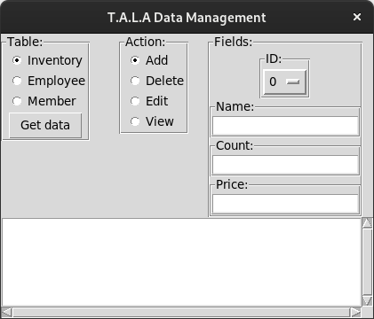**

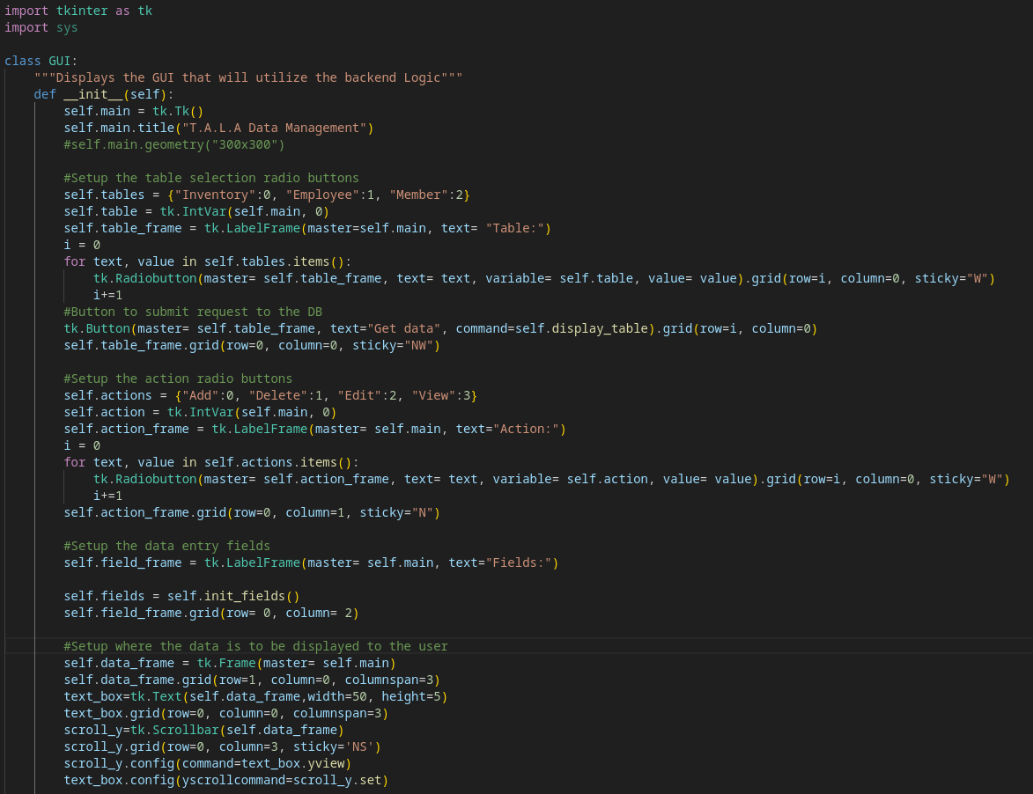

**Task 2 screenshots:**