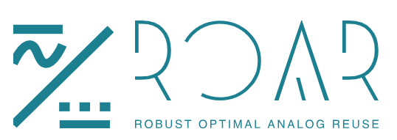

ROAR Quick Start Guide
Common Source Amplifier Design Example with xschem schematic capture, ngspice simulator, and Skywater130 PDK
This guide aims to show the ROAR feature set as well as present a guide to a new user on how to design a common source amplifier using the free and open source EDA tools and Skywater130.
ROAR Technology and Device Exploration
- Launch roar, a blank roar screen with four black boxes for graphing as well as some other widgets should pop up. Each of the four copies are called Lookup Windows. This is where lookups can be done graphically. Click the “Expand” button in any of the lookup windows.

- On the left of the lookup window is what is called the Technology Browser. The technology Browser is where devices can be selected for graphing. Currently the lookup window is in “Device Params” mode. This can be seen from the radio button. The two modes for a lookup window are Device Params, and Design Equations.
- In Device Params mode, device parameters can be explored and compared across technologies, devices, geometries, and corners. In Design Equations mode the same can be done but with the addition of comparisons with a user.
- The Technology Browser shows a hierarchy with the top of the hierarchy structure being
PDK → Device Selection → Device Length → Corners
Device Selection lists the device available and characterized within a PDK
Device Lengths are the lengths of each device characterized
Corners are the corners under which each device in each length in each PDK has been characterized. E.g. Skywater130 → LVT NFET → 500nm → -25 C TT
The color next to the corner represents the color the corner is graphed with. This can be changed by right clicking the corner. Multiple corners can be selected at once with colors changed by holding shift and left click for groups of corners or holding control and left clicking to select multiple individual corners. Right clicking can then be done to change the color of the traces for the groups. Selecting corners will also highlight their traces within a graph.
Any level of the hierarchy can be graphed simultaneously by selecting the checkbox at any hierarchy level. Selecting a hole PDK may cause a bit of slowness.

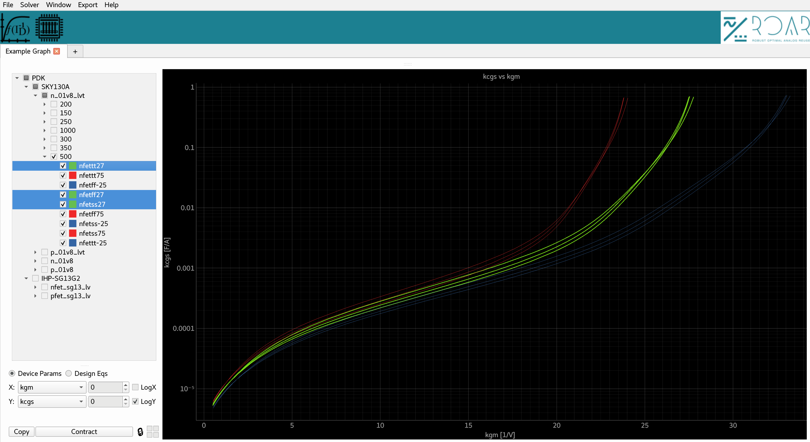

Creating Markers for Lookups
- Three types of markers can be created on a 2-D plot. The three types are Individual point markers, Vertical line markers, and horizontal line markers. To create an individual marker simply click on a trace. To delete the marker click on it again. The marker will highlight to show that clicking on it will delete it.
- To create a Vertical Marker point your mouse where you would like it to be and type “v”. The “v” keystroke will create a vertical marker that can be dragged around by clicking and dragging it. The vertical marker will show the coordinates of all intersection points as well as the percentage difference between the max and min values in the y direction. Sometimes the point text labels can be hard to read when overlapping. To help this problem hover your mouse over the point of interest and click the text. The text will then highlight. The text labels can also be clicked and dragged around and will follow the marker as it moves.
- To create a horizontal marker type “h”. They work the same as vertical markers but in the horizontal direction instead. Vertical and Horizontal Markers can be deleted by selecting them and clicking delete. They can be moved by clicking and dragging them around.
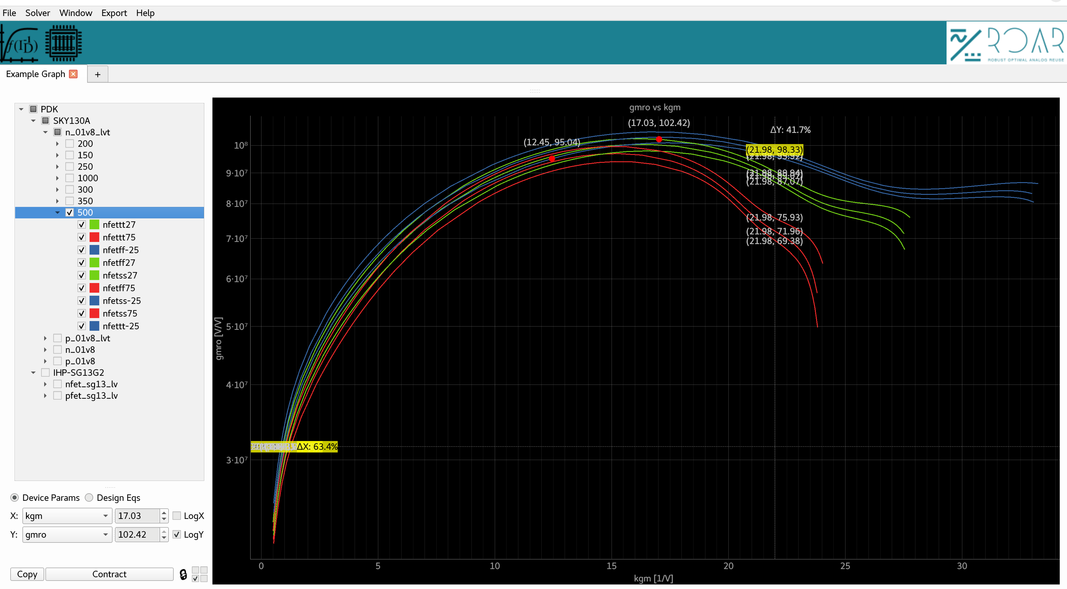
Press the “Contract” button to go back to the original view. Your current graph and settings will remain persistent and intact.

Copying and Pasting Lookup Windows and Graphs
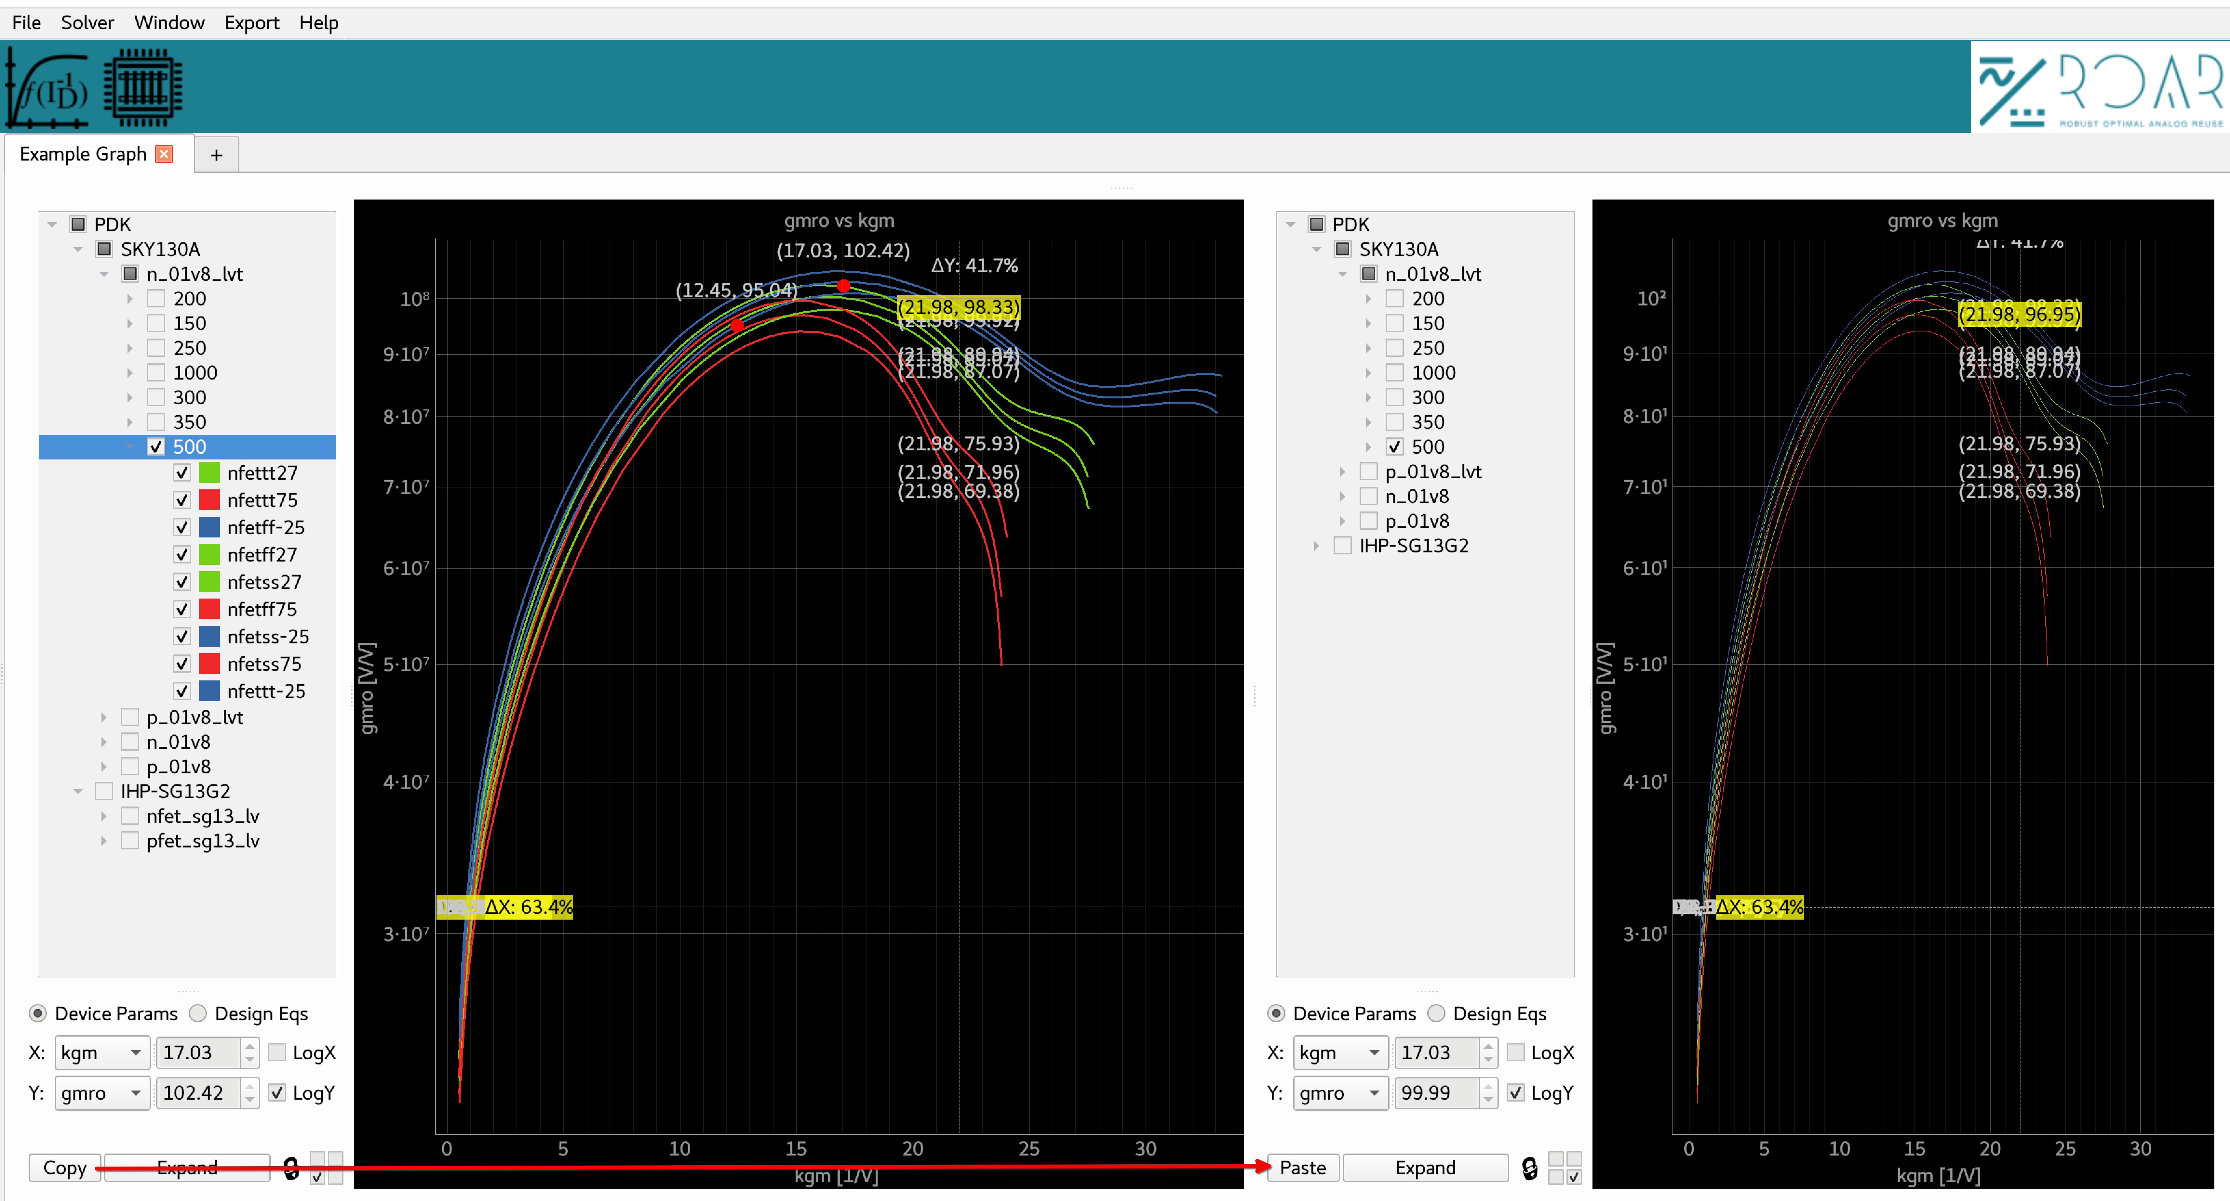
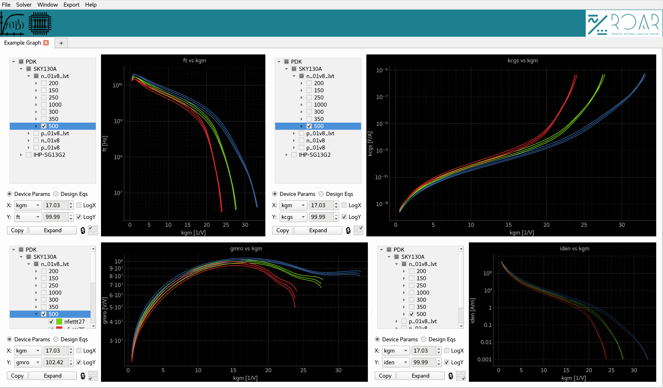
- Graphs can be copied and pasted to other graphs. To do this click the “Copy” button in the lookup window. All of the other lookup window’s Copy buttons will turn to Paste. To escape the operation type the “esc” (escape) key. To paste a graph, simply click “Paste” on one of the other lookup windows paste buttons. All settings, trace colors, corner selections will be pasted. This is a quick and easy way to start process parameter comparisons. After a copy and paste of a lookup window to compare things very easily all that needs to be done is changing the parameters of interest in the pull downs under X: and Y: in the look up window.

Locking and Attaching Graphs
- Graphs can be “attached” or “locked” to each other if they share the same x axis. This attaches markers from one graph to another. To attach one graph to another use the checkboxes next to the Lock icon. Each check mark position represents where it is at in the 2x2 lookup window. When two windows are attached, markers created in one graph will appear in any graphs attached to it. Markers will also click and drag in sync with each other when their lookup windows are attached.
- Graph attachment is implemented as a non cyclical graph meaning cycles can not be created and attachments can propagate.
Parameter Exploration and Feature Overview

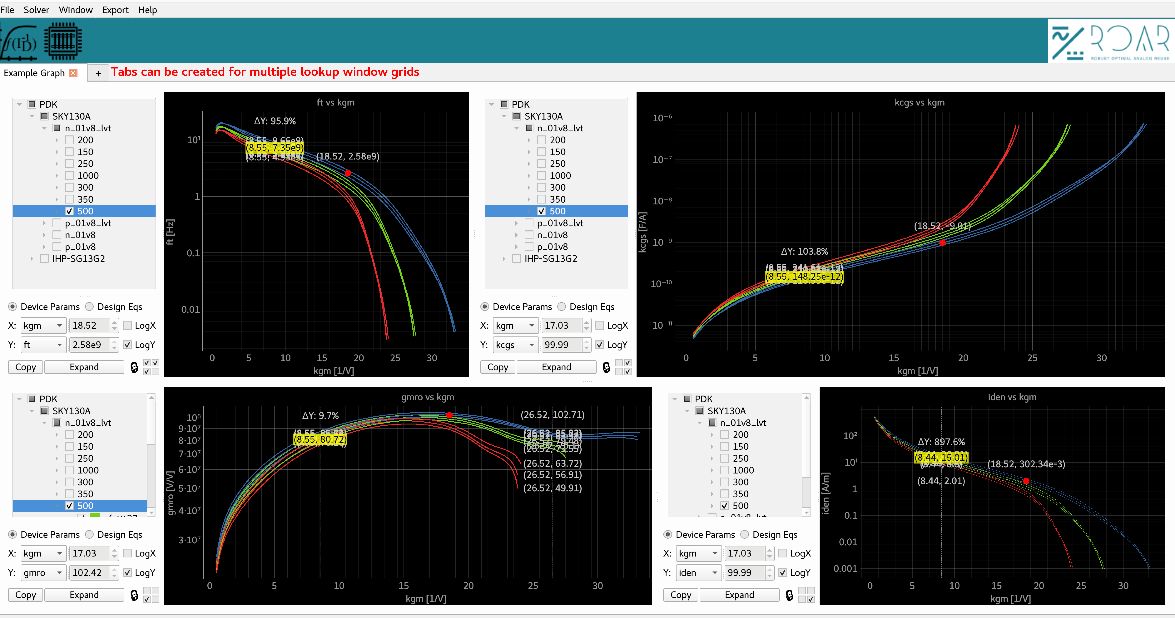

Design Editor and Equations with Common Source Example with Skywater130
On the panel in the right of the main ROAR window is the Design Editor. Here design equations and systems of equations can be built based on lookups. The Design Editor contains 3 components; The Expression Editor, Constraint Editor, and Instance Table.
Instance Table
The Instance Table is used to input device instance names into and attach corners for lookups. The default value for the corners field of a device is [*Global*]. If an instance is set to global, lookups for the device come from a given lookup window’s tech browser. When the Corners field is clicked for a device, a tech browser comes up to select what corners to attach the instance to for lookups to be done with.
