# Designing a game engine in Verilog featuring VGA, mouse and keyboard driver and a PowerPoint UI designer

By Alejandro Cabrerizo and Will Zeurcher

Our goal is to provide an easy to use package that provides all the required functionality to develop a 2D videogame in Verilog.

Apart from that, we noticed that designing a UI to be shown in an FPGA takes a long time since a change in the layout would require a full recompilation.

That is why we are developing our own PowerPoint to Verilog compiler, which allows you to create a slide and design how the screen will look and describe event and then compile it to Verilog code runnable in a FPGA.

All the properties of the objects can easily be changed in PowerPoint by adding TAGS to each element.

To be able to use Verilog to interact with a UI element, the tag [EXTERNAL] must be used, which makes wires controlling the x, y position and other properties editable in Verilog.

We have already developed the VGA display driver and the basic functionalities to be able to display basic shapes (Allowing transparencies) and pictures.

We have also been working in the keyboard and mouse driver, having already completed the keyboard one.

After having spent a couple of hours working on the OTG driver we figured out that it would be faster to buy a 2-1 PS2 connector and stop working on the USB driver.

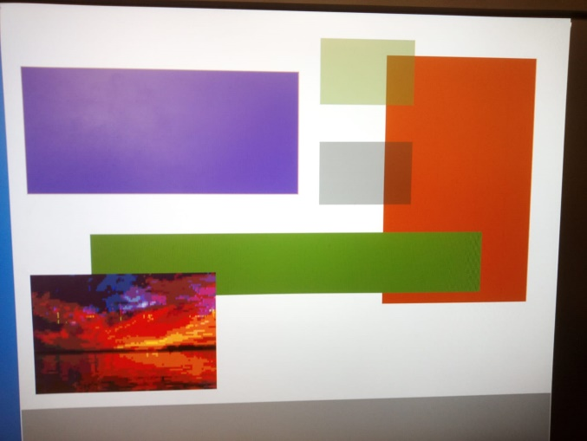

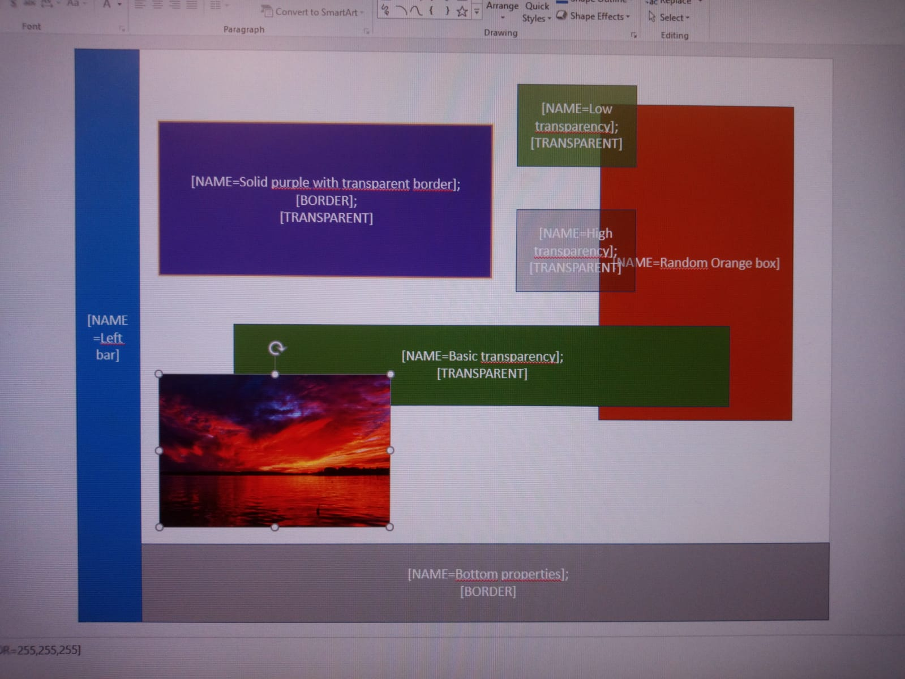

FPGA output PowerPoint slide

But even more important are the features that are still missing, like a collision system, SRAM data loading and sprite handling.

Currently we are going to try to implement:

|  |  |  |
| --- | --- | --- |
| Feature | Time expected | To be completed by: |
| VGA SRAM buffer | 6h | Thanksgiving break |
| Keyboard driver | 3h | 75% there (By next lab) |
| Mouse driver + VGA output | 4h | (By next lab) |
| UART / SD card loader | 15h | TBD (By end of October) |
| Sprite handler (Animations and loading) | 8h | Middle November |
| Collisions | 12h | Middle November |
| Physics (Gravity, bouncing) | 6h | Late November |
| Add those new features to the PowerPoint complier | 15h | By the end of December |
| Write a manual and an example game | 25h | By Dec 16th |

**Github repo:**  https://github.com/alecamaracm/ECE287Project