POLITECNICO DI TORINO
Generative Artificial Intelligence for Graphics and Multimedia
01VRWOV / 01VRWYG — A.A. 2025/26
HOMEWORK 1
Generative Adversarial Networks (GANs)
Training and Comparing Different GAN Architectures
for Unconditional and Conditional Image Generation

Dataset: Oxford Flowers 102
Resolution: 64×64 px (DCGAN: 128×128 px)

Prof: Lia Morra | TA: Pietro Basci
Deadline: 16/03/2026

Table of Contents
1. Introduction to GAN Architectures
2. Exercise 1: DCGAN (Unconditional Generation)
3. Exercise 2: CGAN (Conditional Generation)
4. Exercise 3: WGAN-GP (Unconditional Generation)
5. Exercise 4: WCGAN-GP (Conditional Generation)
6. Comparative Discussion

1. Introduction to GAN Architectures

1.1 Generative Adversarial Networks (GANs)
Generative Adversarial Networks (GANs), introduced by Goodfellow et al. in 2014, consist of two competing neural networks trained simultaneously: a Generator (G) and a Discriminator (D). The Generator learns to synthesize realistic samples from a latent noise vector z ~ p(z), while the Discriminator learns to distinguish real data samples from fake ones produced by G.

The training objective is a minimax game:

min_G max_D E[log D(x)] + E[log(1 - D(G(z)))]

In theory, training converges when G produces samples indistinguishable from real data and D outputs 0.5 for every input. In practice, vanilla GANs suffer from instability issues such as mode collapse and vanishing gradients.

1.2 DCGAN (Deep Convolutional GAN)
DCGAN (Radford et al., 2015) stabilises training through architectural guidelines: the Generator uses transposed convolutions with batch normalisation and ReLU activations; the Discriminator uses strided convolutions with LeakyReLU and batch normalisation. These constraints encourage smoother gradient flow and more stable adversarial dynamics.

1.3 CGAN (Conditional GAN)
CGANs (Mirza & Osindero, 2014) extend vanilla GANs by conditioning both networks on auxiliary information, such as class labels y. The Generator receives the concatenation of noise z and the label embedding, while the Discriminator receives both the image and the label. This allows targeted generation of samples belonging to a specific class.

The objective becomes:

min_G max_D E[log D(x|y)] + E[log(1 - D(G(z|y)))]

1.4 WGAN-GP (Wasserstein GAN with Gradient Penalty)
WGAN (Arjovsky et al., 2017) replaces the Jensen-Shannon divergence with the Wasserstein-1 (Earth Mover) distance, providing more meaningful gradients even when the real and fake distributions have limited overlap. The Discriminator (now called the Critic) is no longer trained to output probabilities; instead, it outputs unbounded real-valued scores.

WGAN-GP (Gulrajani et al., 2017) enforces the Lipschitz constraint via a gradient penalty term on interpolated samples, instead of weight clipping:

L = E[C(x~fake)] - E[C(x~real)] + lambda * E[(||grad C(x~hat)||_2 - 1)^2]

where x̂ is a random interpolation between real and fake samples, and lambda is the gradient penalty coefficient. The critic is updated n_critic times per generator update to ensure a well-trained estimate of the Wasserstein distance.

1.5 WCGAN-GP (Conditional WGAN-GP)
WCGAN-GP combines the conditioning mechanism of CGAN with the Wasserstein objective and gradient penalty of WGAN-GP. Both the conditional generator and conditional critic receive class label embeddings, enabling class-specific generation with the stability benefits of the Wasserstein training.

2. Exercise 1: DCGAN — Unconditional Generation

2.1 Conceptual Overview
This experiment implements a DCGAN-inspired architecture to perform unconditional image generation on the Oxford Flowers 102 dataset. The model is trained on the full dataset (training + validation + test splits) to maximise the available data. Images are resized to 128×128 pixels. One-sided label smoothing (real labels set to 0.9) is employed to improve training stability.

2.2 Architecture

Generator
The Generator maps a 100-dimensional latent vector to a 128×128 RGB image through a fully connected projection followed by five transposed convolutional blocks. Batch normalisation and ReLU activations are used throughout, with a Tanh output activation.

z (100) → FC → (1024, 4×4) → ConvT×5 → (3, 128×128)

Layer details: FC → 1024×4×4, then ConvTranspose2d blocks: 1024→512→256→128→64→3, each with kernel_size=4, stride=2, padding=1.

Discriminator
The Discriminator maps a 128×128 RGB image to a scalar probability through five strided convolutional layers with LeakyReLU(0.2) and batch normalisation, followed by a fully connected layer with Sigmoid output.

Layer details: Conv2d blocks: 3→64→128→256→512→512, each with kernel_size=4, stride=2, padding=1, then FC→1.

2.3 Hyperparameters

Parameter | Value
Latent Dimension | 100
Image Resolution | 128 × 128 px
Batch Size | 64
Learning Rate (G) | 0.0002
Learning Rate (D) | 0.0001
Optimiser | Adam (β1=0.5, β2=0.999)
Epochs | 150
Label Smoothing | Real labels = 0.9, Fake labels = 0.0
Loss Function | Binary Cross-Entropy (BCE)
Normalisation | Batch Normalisation (G & D)
Generator Activation | ReLU (hidden), Tanh (output)
Discriminator Activation | LeakyReLU(0.2)
Weight Init | Normal(0, 0.02)
Sample Interval | Every 100 steps
Checkpoint Interval | Every 5 epochs

2.4 Training Curves

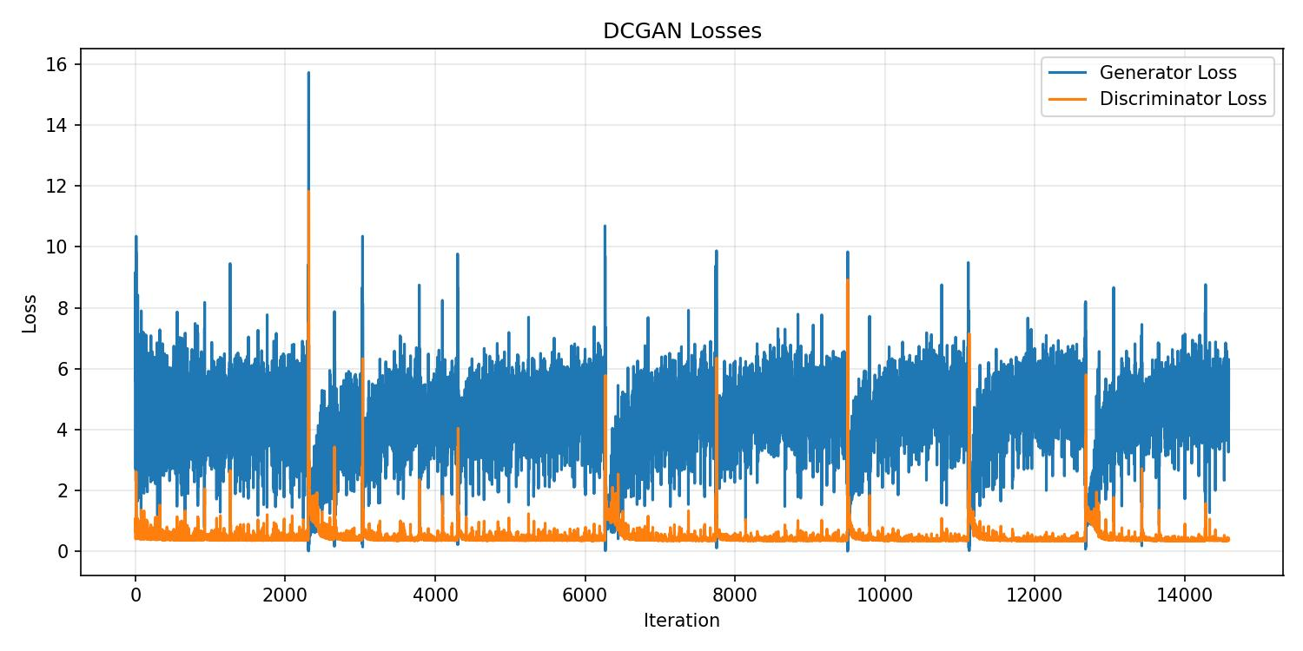
Figure 1: DCGAN — Generator and Discriminator loss curves over 150 epochs.

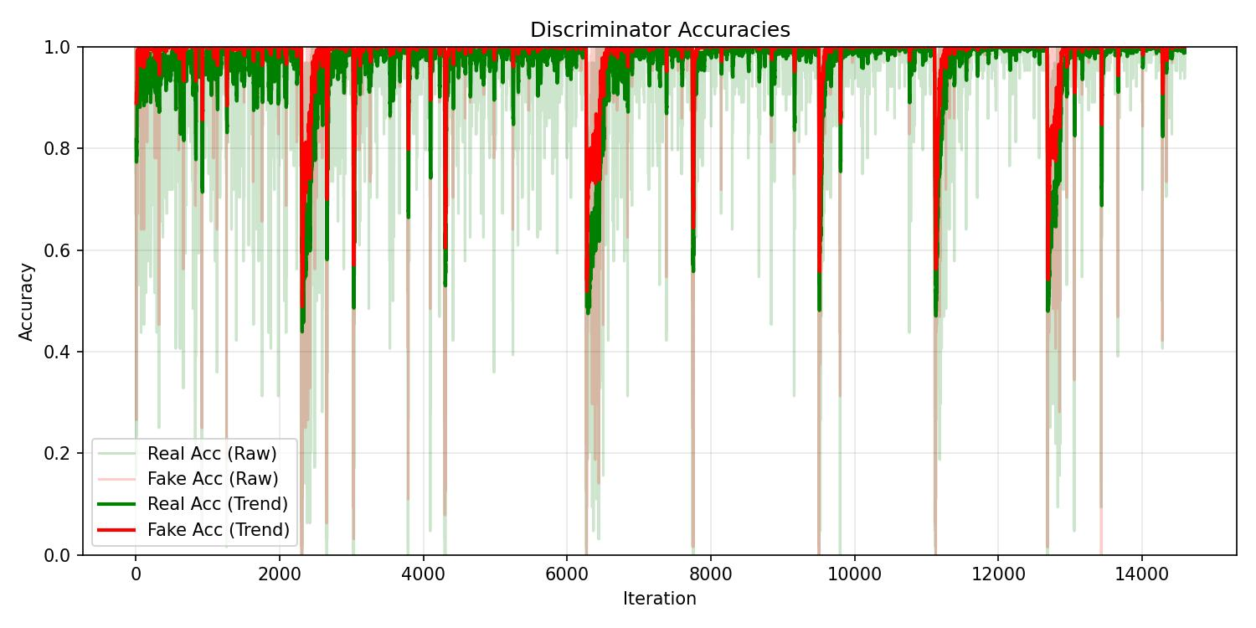
Figure 2: DCGAN — Discriminator accuracy on real and fake samples over training.

The loss curves show the typical adversarial oscillation pattern. The discriminator accuracy on real samples starts high and gradually converges toward ~0.5-0.6, while fake accuracy follows the inverse trajectory, indicating that the generator progressively produces more convincing images. The convergence of both towards ~0.5 is a healthy sign of balanced adversarial training.

2.5 Visual Progression

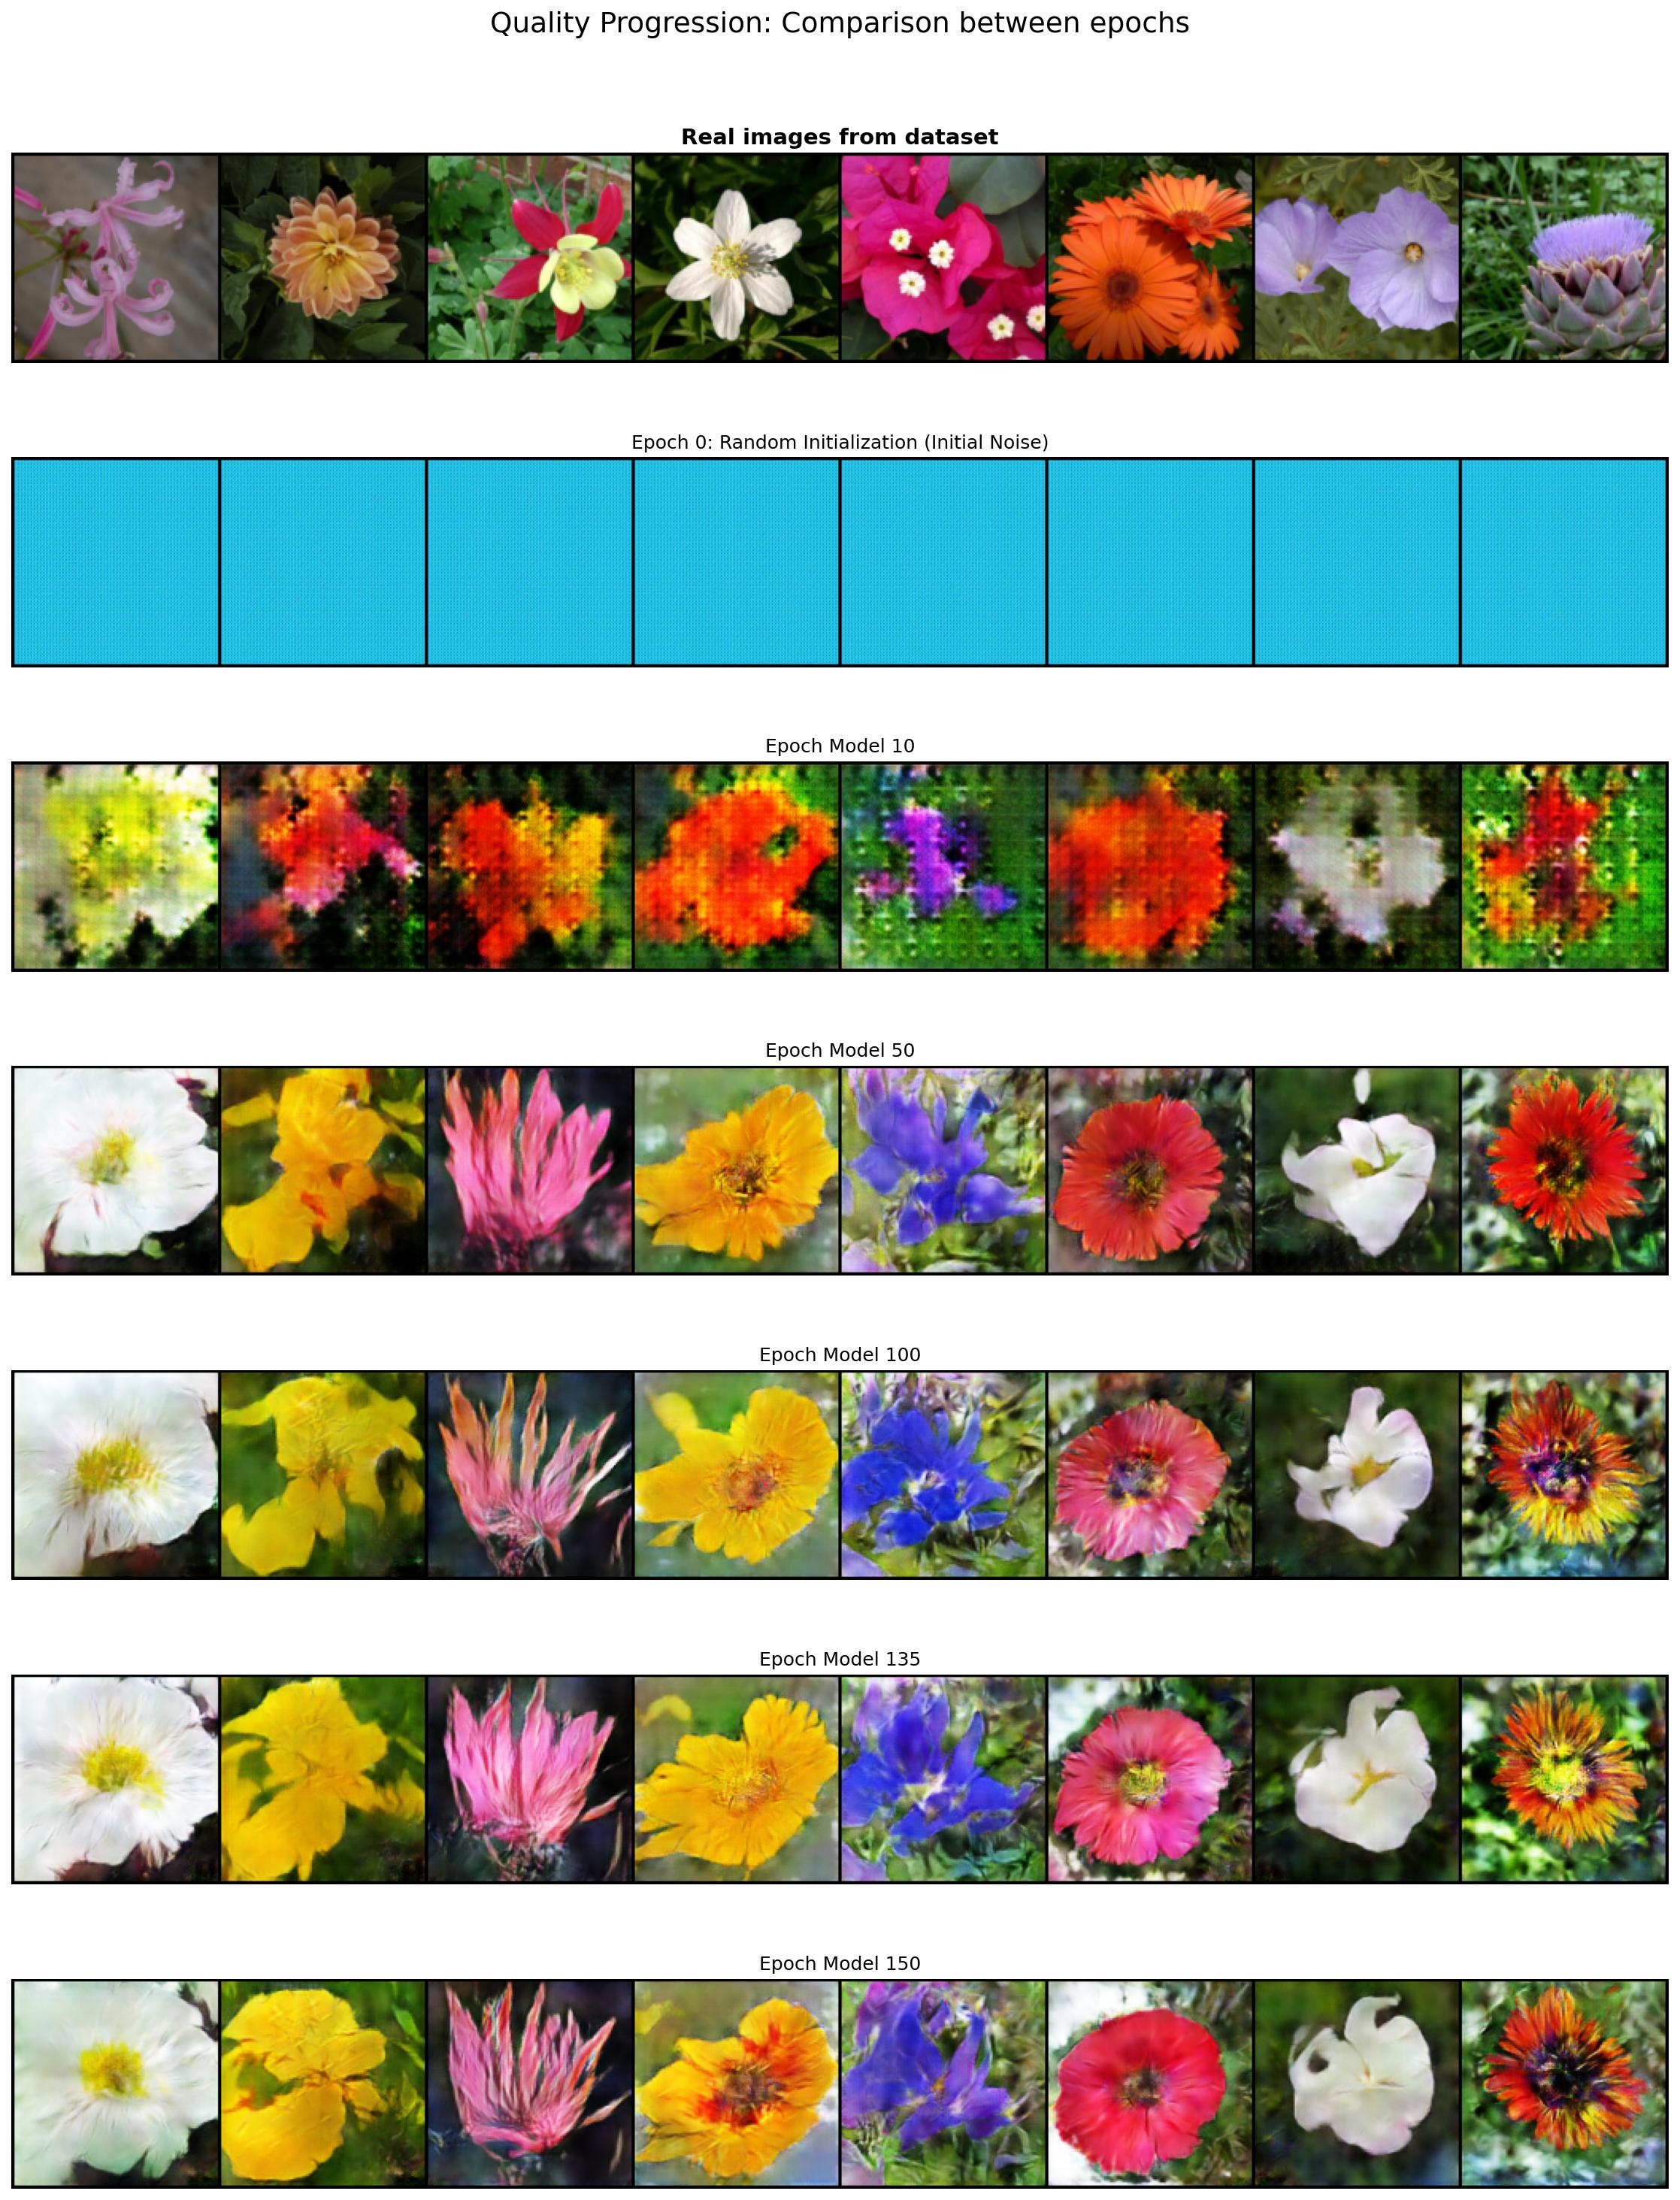
Figure 3: DCGAN — Visual progression of generated images from epoch 0 (noise) to epoch 150. Fixed latent vector used for consistency.

At epoch 0, the generator outputs pure noise. By epoch 10, faint colour blobs begin to emerge. From epoch 50 onward, recognisable flower-like structures with petals and distinct colour regions become visible. By epoch 100-150, images exhibit convincing textures, colour gradients, and spatial structure characteristic of the Flowers102 dataset.

3. Exercise 2: CGAN — Conditional Generation

3.1 Conceptual Overview
The CGAN extends the DCGAN by conditioning both the generator and discriminator on class labels from the Flowers102 dataset (102 classes). Labels are embedded into a learned 50-dimensional embedding space and concatenated with the latent vector (Generator) or projected into the feature space (Discriminator). This enables targeted generation of specific flower species. The discriminator uses spectral normalisation for additional stability.

3.2 Architecture

Conditional Generator
The label is embedded via nn.Embedding(102, 50). The embedding is concatenated with the noise vector z (100-dim), yielding a 150-dim input to a 3-layer MLP (512 → 1024 → 8192), which is reshaped to (512, 4, 4). Four transposed convolutional blocks upsample to 64×64 RGB output.

Layer details: Linear 150→512→BN→ReLU → 512→512×4×4, then ConvT: 512→256→128→64→3 (4×4 kernels, stride=2, padding=1), Tanh output.

Conditional Discriminator
The Discriminator uses four spectral-normalised Conv2d layers (LeakyReLU + BatchNorm) to extract a 512×4×4 feature map. This is flattened and concatenated with the label embedding (50-dim), then passed through two spectral-normalised FC layers with Dropout(0.3) to a scalar logit with Sigmoid.

3.3 Hyperparameters

Parameter | Value
Latent Dimension | 100
Image Resolution | 64 × 64 px
Batch Size | 128
Learning Rate (G) | 0.0002
Learning Rate (D) | 0.0001
Optimiser | Adam (β1=0.5, β2=0.999)
Epochs | 150
Number of Classes | 102
Embedding Dimension | 50
Loss Function | Binary Cross-Entropy (BCE)
Discriminator Regularisation | Spectral Normalisation + Dropout(0.3)
Generator Activation | ReLU (hidden), Tanh (output)
Discriminator Activation | LeakyReLU(0.2)
Sample Interval | Every 200 steps
Checkpoint Interval | Every 5 epochs

3.4 Training Curves

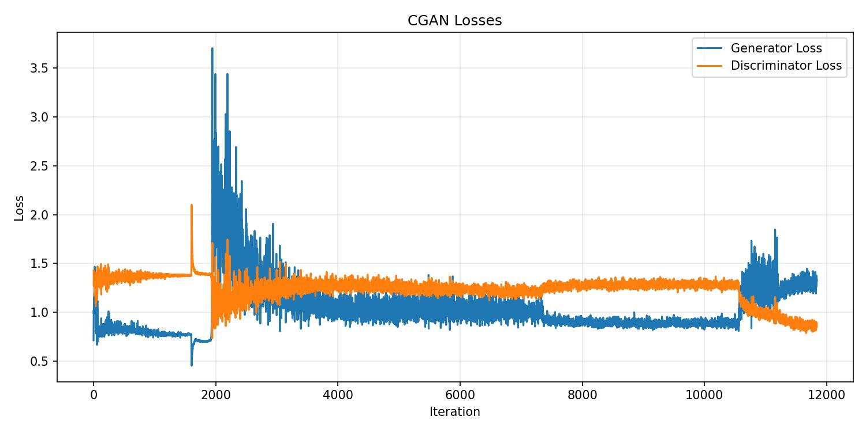
Figure 4: CGAN — Generator and Discriminator loss curves over 150 epochs.

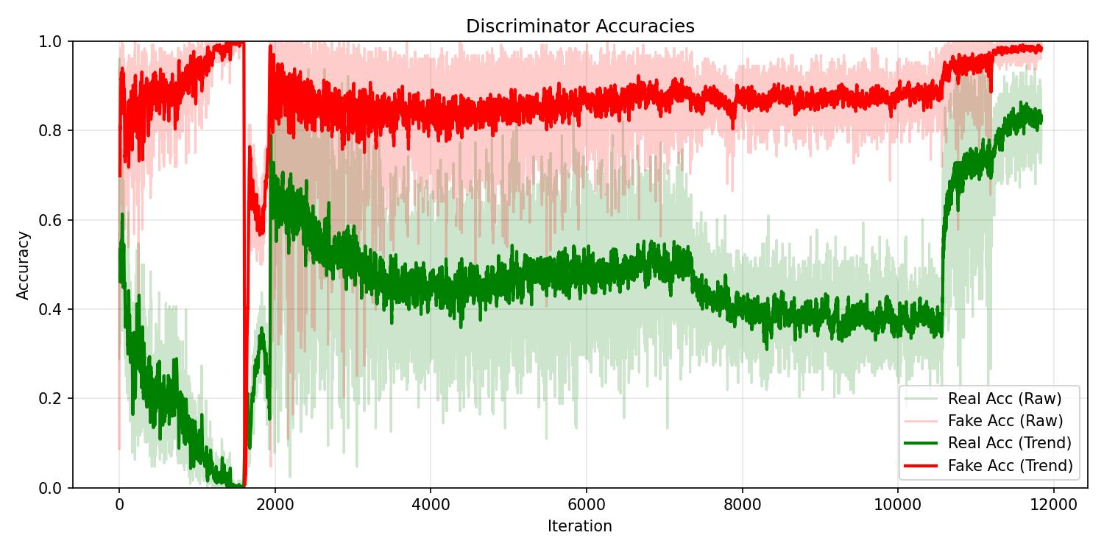
Figure 5: CGAN — Discriminator accuracy on real and fake samples over training.

The CGAN loss curves display more oscillation compared to DCGAN, which is expected given the additional conditioning complexity. The discriminator accuracy stabilises around 0.5-0.6 for real samples and shows the complementary pattern for fakes. Spectral normalisation helps prevent the discriminator from becoming too strong and suppressing generator gradients.

3.5 Visual Progression

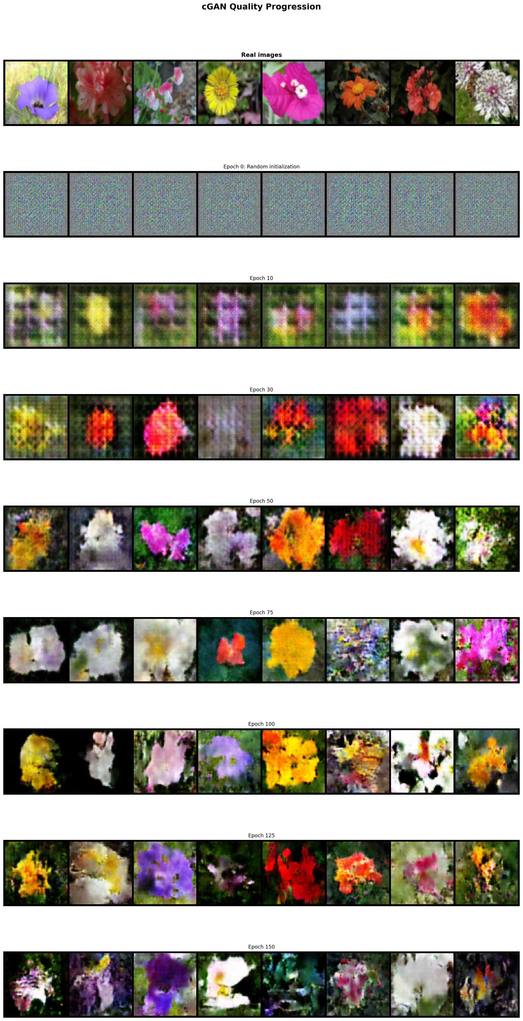
Figure 6: CGAN — Visual progression from epoch 0 to epoch 150 using a fixed latent vector conditioned on specific class labels.

The conditional generator shows a clear learning trajectory. Early epochs produce noise, while intermediate epochs (30-75) develop colour regions aligned with specific flower classes. By epoch 100-150, the generated images exhibit class-consistent attributes, with petals, colours, and spatial arrangements that are visually linked to individual Flowers102 classes. This confirms the effectiveness of label conditioning.

4. Exercise 3: WGAN-GP — Unconditional Generation

4.1 Conceptual Overview
This exercise replaces the standard BCE loss with the Wasserstein-1 objective and gradient penalty (WGAN-GP). The key modifications are: (1) removing the Sigmoid from the Critic output, (2) using InstanceNorm2d instead of BatchNorm2d in the Critic (as recommended to avoid correlation artefacts with gradient penalty), (3) updating the Critic n_critic=5 times per generator update, and (4) computing the gradient penalty on interpolated samples.

4.2 Architecture

Generator
Identical to the DCGAN generator but targeting 64×64 resolution: z (100) → FC → (1024, 4×4) → ConvT blocks: 1024→512→256→128→3 (Tanh output). BatchNorm2d is retained in the generator.

Critic
The Critic has four Conv2d layers with InstanceNorm2d(affine=True) and LeakyReLU(0.2), followed by a linear layer projecting to a single scalar (no Sigmoid): 3→64→128→256→512 → FC→1.

Gradient Penalty
A random interpolation coefficient α ~ Uniform(0,1) is sampled per batch. Interpolated images x̂ = α·x_real + (1-α)·x_fake are passed through the Critic, and the norm of the gradient with respect to x̂ is penalised to stay close to 1: GP = E[(||grad C(x̂)||_2 - 1)^2].

4.3 Hyperparameters

Parameter | Value
Latent Dimension | 100
Image Resolution | 64 × 64 px
Batch Size | 128
Learning Rate (G) | 0.0002
Learning Rate (C) | 0.0001
Optimiser | Adam (β1=0.5, β2=0.999)
Epochs | 100
Loss Function | Wasserstein Distance
Gradient Penalty Coefficient (λ) | 10
Critic Updates per G Update (n_critic) | 5
Critic Normalisation | InstanceNorm2d (affine=True)
Generator Normalisation | BatchNorm2d
Generator Activation | ReLU (hidden), Tanh (output)
Critic Activation | LeakyReLU(0.2)
Sample Interval | Every 100 steps
Checkpoint Interval | Every 5 epochs

4.4 Training Curves

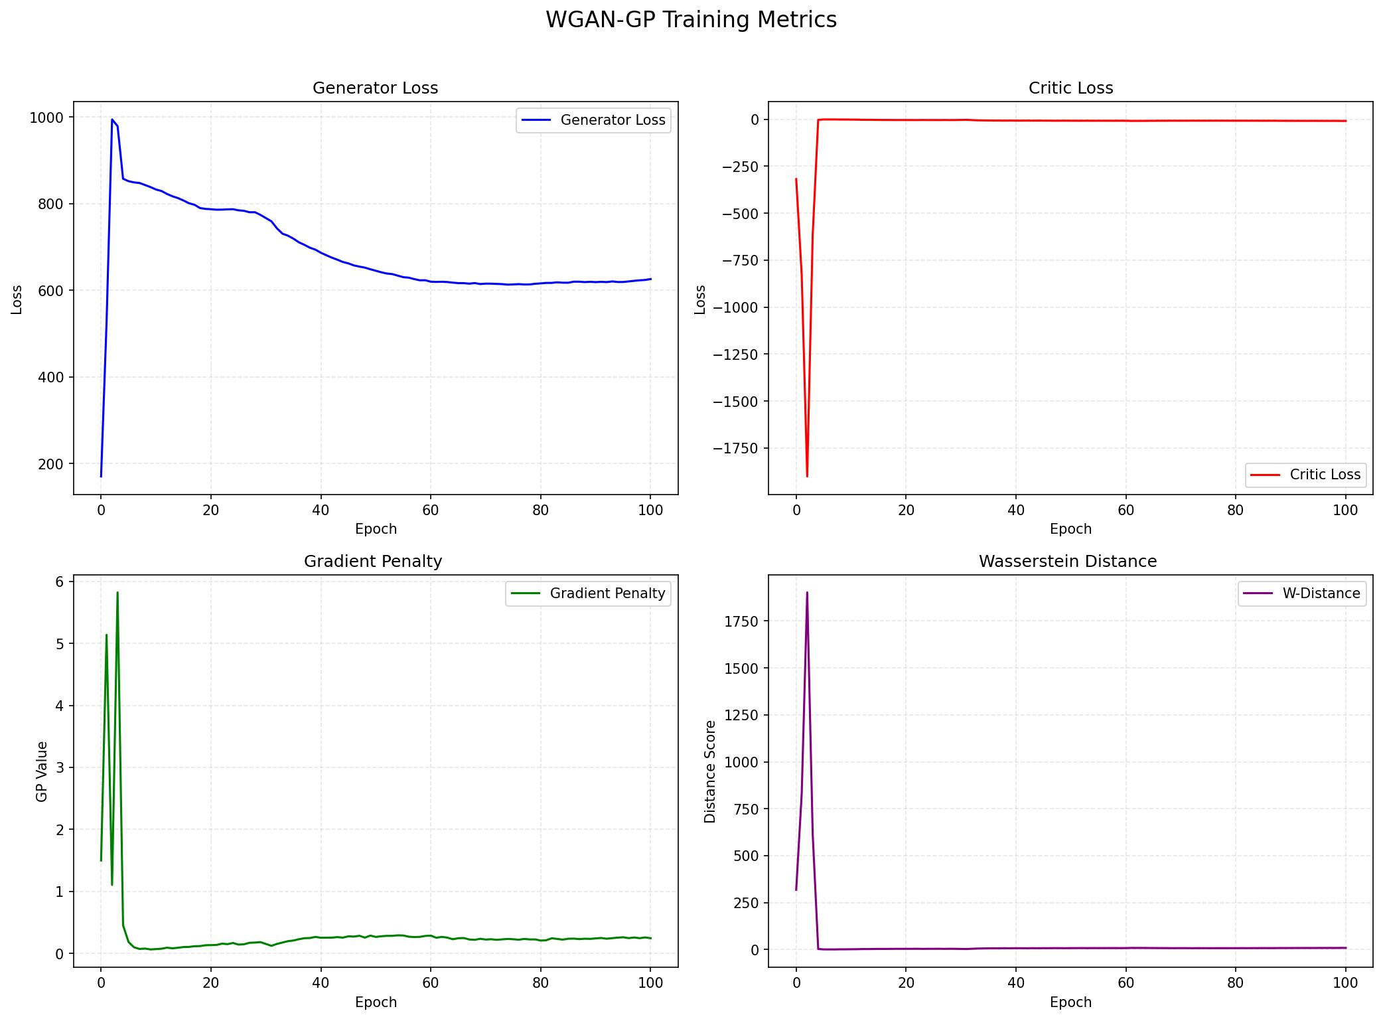
Figure 7: WGAN-GP — Critic loss (Wasserstein distance), Generator loss, and Gradient Penalty over 100 epochs.

Unlike BCE-based GANs, the Wasserstein distance provides a meaningful scalar metric of training progress. The critic loss trends toward increasingly negative values as training proceeds, while the generator loss decreases correspondingly. The gradient penalty remains bounded and stable around its target, confirming that the Lipschitz constraint is being effectively enforced throughout training. Note that discriminator accuracy is not applicable in the WGAN-GP setting since the critic produces unbounded real-valued scores rather than probabilities.

4.5 Visual Progression

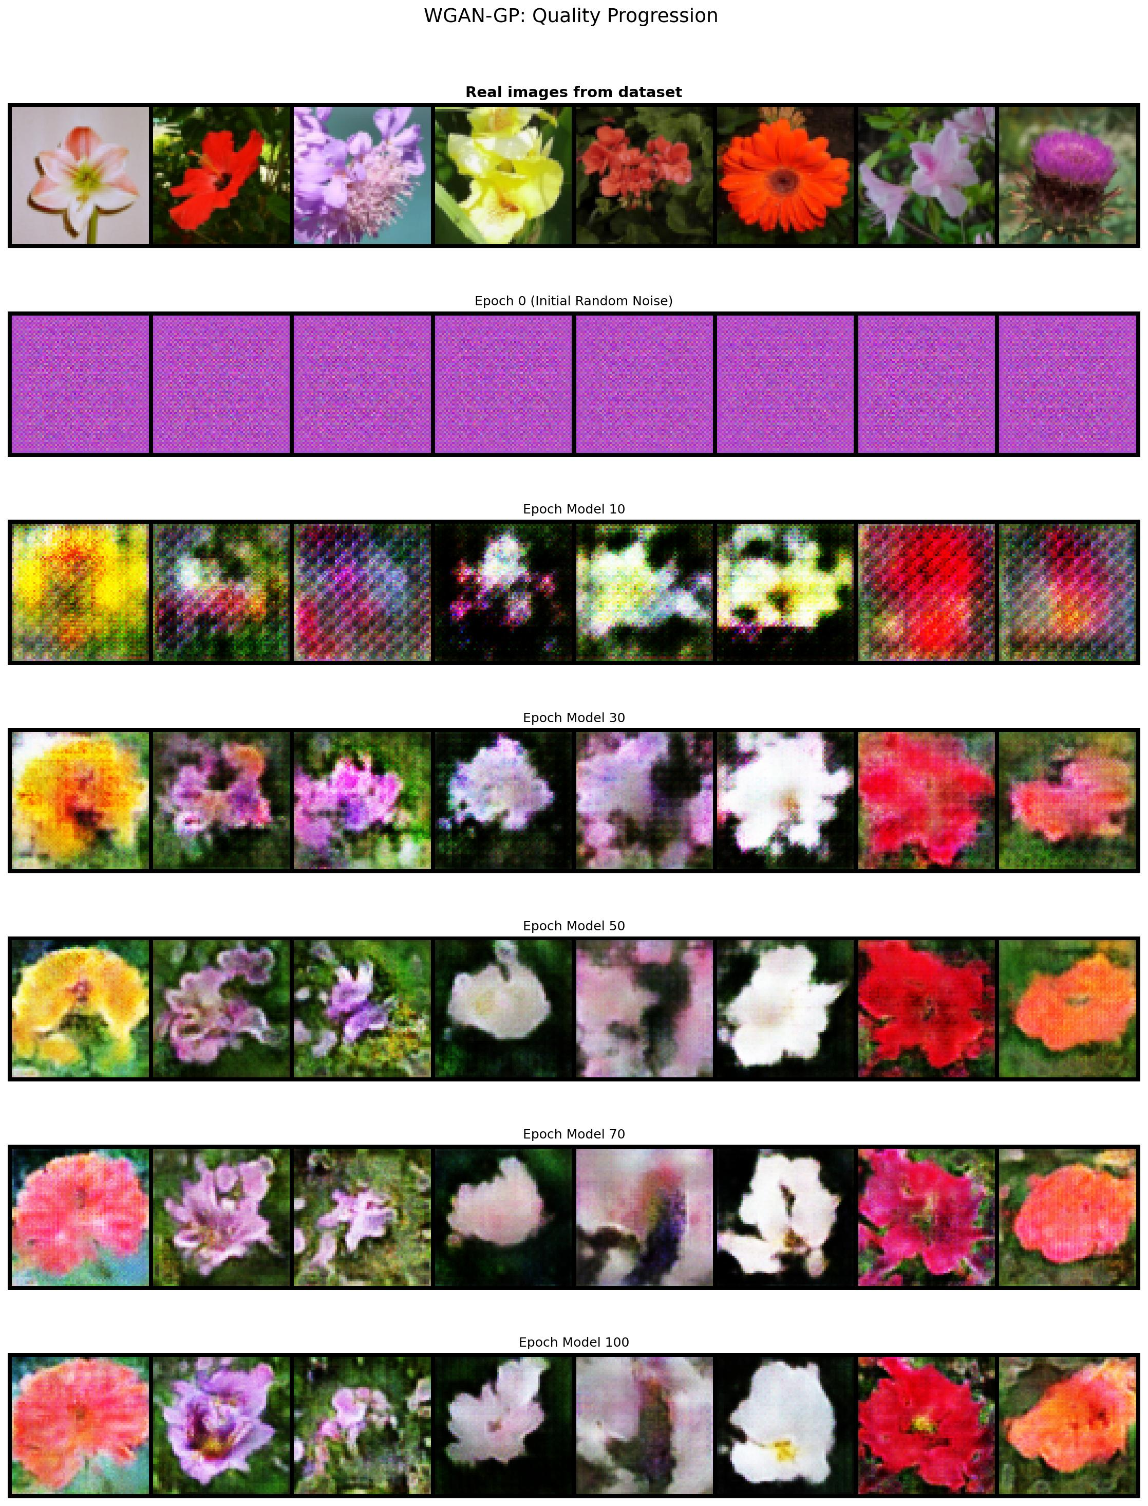
Figure 8: WGAN-GP — Visual progression from epoch 0 to epoch 100 using a fixed latent vector.

The WGAN-GP progression demonstrates more stable improvement compared to DCGAN. Early epochs produce structured noise patterns, and by epoch 30-50, flower-like structures emerge with greater spatial coherence. The final generated images at epoch 100 show detailed textures and well-defined colour regions. Mode collapse is notably absent, with the 25 fixed-z samples showing diverse flowers.

5. Exercise 4: WCGAN-GP — Conditional Generation

5.1 Conceptual Overview
The WCGAN-GP combines class conditioning (as in CGAN) with the Wasserstein-GP objective. Both the Conditional Generator and Conditional Critic receive class label embeddings. The gradient penalty is now computed on interpolated images conditioned on the corresponding class labels, ensuring the Lipschitz constraint is enforced in a class-aware manner. The critic learning rate is reduced (0.00005 vs 0.0002 for G) to provide a better training balance.

5.2 Architecture

Conditional Generator
Identical to CGAN Generator: Embedding(102, 50) → concat with z (100) → MLP 150→512→1024→8192 (reshape to 512×4×4) → ConvT: 512→256→128→64→3 (Tanh output). BatchNorm used throughout.

Conditional Critic
Four Conv2d blocks (3→128→256→512→1024, InstanceNorm2d, LeakyReLU) produce a 1024×4×4 feature map. This is flattened and concatenated with the label embedding (50-dim), then a single linear layer FC(1024×4×4 + 50 → 1) outputs the scalar score (no Sigmoid).

Conditional Gradient Penalty
The gradient penalty function compute_gradient_penalty receives both images and labels, passes the interpolated images through the conditional critic with the real labels, and penalises gradient norms deviating from 1.

5.3 Hyperparameters

Parameter | Value
Latent Dimension | 100
Image Resolution | 64 × 64 px
Batch Size | 128
Learning Rate (G) | 0.0002
Learning Rate (C) | 0.00005
Optimiser | Adam (β1=0.5, β2=0.999)
Epochs | 150
Number of Classes | 102
Embedding Dimension | 50
Loss Function | Wasserstein Distance
Gradient Penalty Coefficient (λ) | 10
Critic Updates per G Update | 5
Critic Normalisation | InstanceNorm2d (affine=True)
Generator Normalisation | BatchNorm2d
Generator Activation | ReLU (hidden), Tanh (output)
Critic Activation | LeakyReLU(0.2)
Sample Interval | Every 200 steps
Checkpoint Interval | Every 5 epochs

5.4 Training Curves

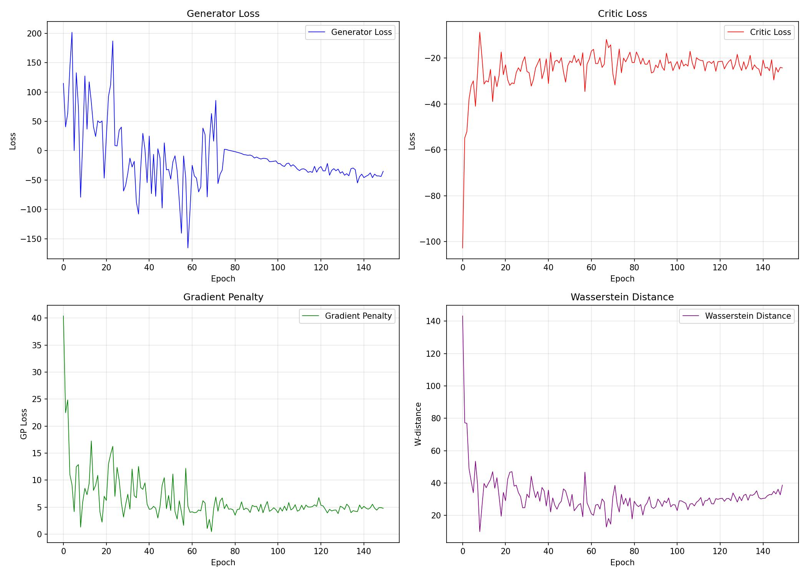
Figure 9: WCGAN-GP — Critic loss, Generator loss, Gradient Penalty, and Wasserstein Distance over 150 epochs.

The WCGAN-GP training curves show the characteristic Wasserstein distance decreasing trend, alongside a bounded gradient penalty. The significantly lower critic learning rate (0.00005) compared to the generator (0.0002) ensures that the critic does not overfit to real samples too quickly, maintaining a balanced adversarial dynamic. The Wasserstein distance serves as a reliable proxy for generation quality throughout training.

5.5 Visual Progression

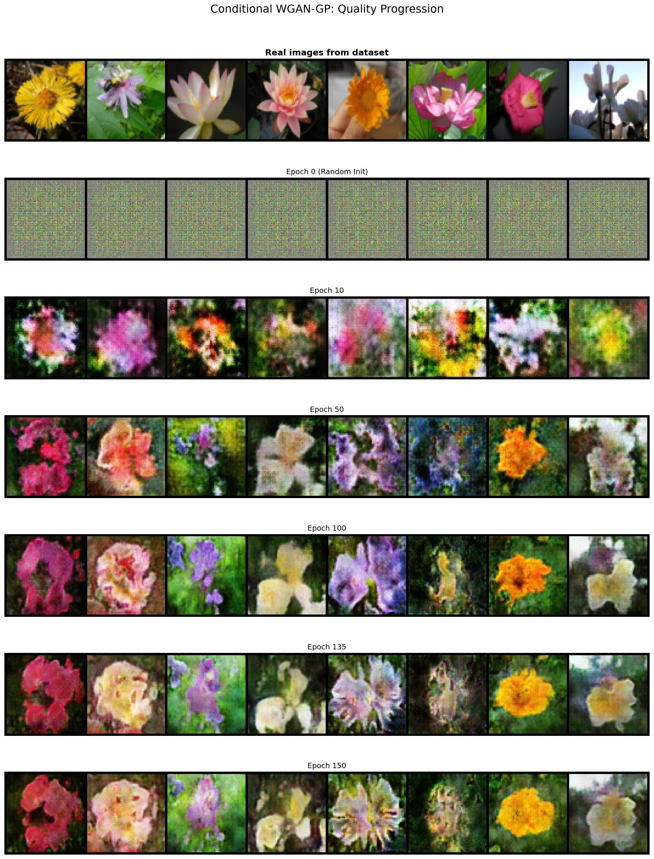
Figure 10: WCGAN-GP — Visual progression from epoch 0 to epoch 150 using a fixed latent vector with fixed class labels.

The WCGAN-GP visual progression combines the class-specificity of CGAN with the stability of WGAN-GP. Generated images develop class-consistent attributes (e.g., colour palette, petal shape) more reliably than the standard CGAN. By epoch 100-150, the outputs exhibit well-defined floral structures with minimal mode collapse across the displayed classes, demonstrating the synergistic benefit of combining conditional generation with the Wasserstein objective.

6. Comparative Discussion

6.1 Training Stability
The four models exhibit markedly different training dynamics. The vanilla DCGAN shows the highest variability in loss curves, with characteristic oscillations that reflect the adversarial equilibrium being continuously perturbed. The CGAN is similarly unstable, with additional complexity introduced by conditioning across 102 classes. In contrast, both WGAN-GP and WCGAN-GP benefit from the Wasserstein objective, which provides a more informative and stable gradient signal. The gradient penalty effectively prevents the critic from becoming too powerful, maintaining a productive training regime throughout.

6.2 Image Quality
In terms of visual quality at comparable training epochs, the WGAN-GP-based models (Ex.3 and Ex.4) generally produce sharper, more coherent images with fewer artefacts. The DCGAN at 128×128 resolution achieves high-resolution outputs but at the cost of increased training difficulty. The 64×64 models (CGAN, WGAN-GP, WCGAN-GP) show that even at lower resolution, meaningful flower structures can be learned.

6.3 Conditional vs. Unconditional Generation
Conditioning on class labels introduces a significant additional challenge: the model must not only learn a realistic image manifold but also associate specific visual features with 102 distinct classes. Both CGAN and WCGAN-GP achieve class-consistent generation by epoch 100+, though the WCGAN-GP does so more reliably. The unconditional models (DCGAN, WGAN-GP) have a simpler objective and tend to reach stable outputs faster per epoch, though they cannot control which flower class is generated.

6.4 Key Differences: BCE vs. Wasserstein Loss
The BCE-based models (DCGAN, CGAN) use a Sigmoid output in the discriminator, bounding the output to (0,1). This can cause vanishing gradients when the discriminator becomes too confident. The Wasserstein critics, by contrast, output unbounded scalars and are trained to maximise the gap between real and fake scores, providing gradients even in the early stages of training. This explains why the WGAN-GP models tend to recover more gracefully from suboptimal initialisation.

6.5 Summary Table

Model | Resolution | Epochs | Loss | Conditioning
DCGAN | 128×128 | 150 | BCE | No
CGAN | 64×64 | 150 | BCE | Yes (102 classes)
WGAN-GP | 64×64 | 100 | Wasserstein+GP | No
WCGAN-GP | 64×64 | 150 | Wasserstein+GP | Yes (102 classes)

6.6 Conclusions
All four GAN variants successfully learn to generate flower images from the Flowers102 dataset, each with distinct trade-offs. The DCGAN provides a solid baseline with relatively simple implementation. The CGAN enables class-controlled generation at the cost of additional training complexity. The WGAN-GP offers more stable training through the Wasserstein objective and gradient penalty, producing high-quality unconditional samples. The WCGAN-GP represents the most sophisticated configuration, combining class conditioning with Wasserstein training for stable, controllable generation across all 102 flower categories.

Future directions could include increasing resolution beyond 64×64, experimenting with progressive growing strategies, integrating self-attention mechanisms, or exploring more advanced architectures such as StyleGAN or BigGAN for further quality improvements.

