CIT336 Midterm Exam Spring 2016

Code/Database will be 50% of the final grade, and the questions will be the other 50%, with each question having a value of 5 points.

We’re going to create an application that allows us to keep track of all of the ice cream cones sold at an ice cream stand so that we can eventually check if there are any trends in how we’re selling ice cream.

The Pace Ice Cream Shop sells five different flavors of ice cream: vanilla, chocolate, strawberry, mint chocolate chip, and cotton candy. It sells 3 different sizes: one scoop, two scoop, and three scoops.

We want to keep track of how many scoops we’re selling of each flavor at what time of the day.

So first, we will create a database to store this information.

We need one table, called ‘sales’, that will store each order, including the flavor of ice cream, how many scoops of it, and at what time the sale took place.

1. What would be the SQL to create this database and table?

CREATE DATABASE Midterm_SQL;

USE Midterm_SQL;

CREATE TABLE sales(id int not null AUTO_INCREMENT PRIMARY KEY, flavor varchar(255), n_scoops int, purchase_time DATETIME);

Now that we have a database set up, we need to create a form to allow the cashier to enter the sales. It should look like this:



(Font is Arial, color is DeepSkyBlue)

Now we need to write a PHP file that will allow us to add the information from the form to the database.

2. What type of software do we need to have running on our computers to run PHP?

We need a local web server and a php interpreter to allow us to run PHP on our computers without having to put on a real website, allowing us to use PHP locally. One of these softwares is called “MAMP”, which lets you start/stop an apache server and mysql server for PHP and SQL use.

3. What type of variable must $link be if we’re using it throughout the document?

Now we will write an AJAX function to send that data to the database without refreshing the page.

4. We’re using a GET request in this situation. In what situations might we choose to use a POST request instead?

Whenever we want the information passed on the form to be secret, such as login and password. If a GET request was used, the login and password would be displayed in the URL. So we use the GET whenever we have no problem displaying the information passed on a form.

5. What is AJAX and why are we using it?

AJAX is Asynchronous JavaScript and XML, it’s a method to make websites more intuitive utilizing asynchronous information. We are using cause many times it can be a good and easy way to manage the database or stay in the same page when submitting something. It lets you control the behavior of the page. In the case of this exam, AJAX allow us to stay in the same page after submitting a form.

6. What is an HTTP request?

It is a HTTP Protocol that REQUESTS data from the server and the server generates a response.

7. Where do we tell the client-side code what to do with the response from the server?

In the success/error function. If the request is successful and we get a response, we can generate what happens in the success part. If not, we generate the error part in the AJAX structure.

Example:

success: function(response) {

alert("Operation was successful");

$("#clients_list").html(response);

},

error: function() {

alert("Something wrong went down");

}

8. Is the AJAX on the server-side or client-side? Is the PHP on the client-side or server-side?

AJAX is on the client-side. PHP is on the server-side. AJAX can send the request to the server. When the request is sent to the server, the PHP is called on the server side to get that request and generate a response to be sent back to the client side (AJAX).

Double-check in your database that the information is being submitted.

Make a few theoretical ice cream sales.

Now we just want to take a quick peek at the sales we’ve made. Write a PHP file that displays a table that shows all of those sales. Add a link to the main page to this table.

It should look like this:

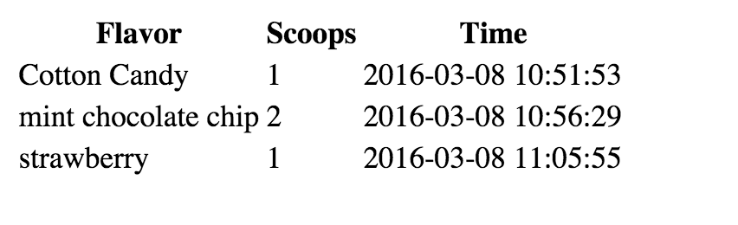

9. This application now does two of the functions of CRUD. Which two functions?

SELECT and INSERT functions from CRUD.

10. Give me an example of 3 key-value pairs from your data.

11. If you were going to add this application to Github, what would be the steps to do that? Include the commands.

git add . OR git add * specify what*

git pull origin master (need to pull so repository and folder can be synced)

git commit –m “message for commit “

git push origin master

12. What would be the benefits of using Github?

The benefits of using GitHub are that your work is always saved and you can switch between different versions of your work. You don’t need to worry about losing an older version of your work because GitHub allows you to go through every commit and every single change you did on your work and start from there. It’s a great version control mechanism.

Did you document your code? Put in comments that explain what your code is doing.

Zip up a file with all of your code and this document and upload it to Blackboard.

Great job! Next week we are going to look at taking this data, and creating graphs so we know when we’re selling the most of what flavors.