Berney Alec & Ferrari Teo

MLG – 20.04.2022

Voice recognation

Labo 3

# HOLD_OUT_VALIDATION” NOTEBOOK

**Q1. Determine where do we define all the parameters mentioned above.**

We can find them here :

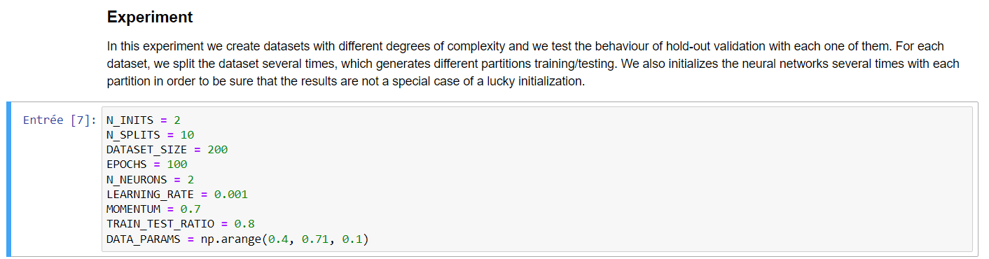

**Observe that we run the evaluation procédure on four different problems. Each problem is a two-class two-dimensional problem, where the two sets are more and more overlapped (e.g., the synthetic datasets are randomly generated using variances of 0.4, 0.5, 0.6 and 0.7).**

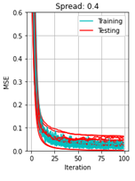**Q2. What are the cyan and red curves in those plots ? Why are they different ?**

As indicated in the first image (on the right) :

* The blue or cyan cruve, show the mean square error (MSE) evolution during **training**
* The red curve, show the mean square error (MSE) evolution during **testing**.

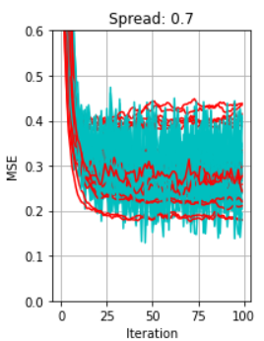**Q3. What happens with the training and test errors (MSE) when we have the two sets more overlapped ?**

We see that the MSE variation increases compared to lower spread data.

For a spread of 0.7, the MSE is also higher at his lowest point compared to lower spread data.

**Q4. Why sometimes the red curves indicate a higher error than the cyan ones ?**

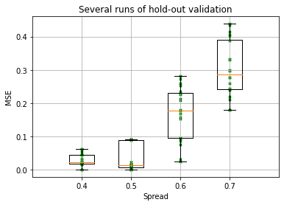Because the testing is done with values that haven’t been used for training.

**Q5. What is showing the boxplot summarizing the validation errors of the preceding experiments ?**

We see that the variation / gap between highest and lowest MSE is increasing with the spread of data. It is easily visible with the boxplot interquartile range also increasing with the spread of data. As already said before in the document, the MSE lowest point is also increasing.

# EXPLORE THE “CROSS_VALIDATION” NOTEBOOK

**Q1. Determine where do we define all the above-mentioned parameters.**

We can find them here:

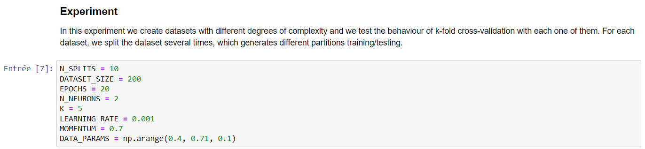

**Q2. What is the difference between hold-out and cross-validation? What is the new parameter that has to be defined for cross-validation?**

Hold-out use only a percentage of data to learn the model and keep the other part for testing. So, it doesn’t use all te data for learning, that is potentially a probleme.

Cross-validation use all the data to learn, but for each EPOCH of testing, will select the k ième data of the data set to test the model.

The new parameter from cross-validation is the value: K.

**Q3. Observe the boxplots summarizing the validation errors obtained using the cross-validation method and compare them with those obtained by hold-out validation**

For the cross-validation, we see that the variation / gap between lowest and higher point isn’t increasing with the spread of data. That was the case for hold-out method.

It can be easily seen by interquartile range.

But the lowest point of MSE is increasing in both méthodes.

The main difference is that cross-validation, by his low variation / gap, validate that the result.

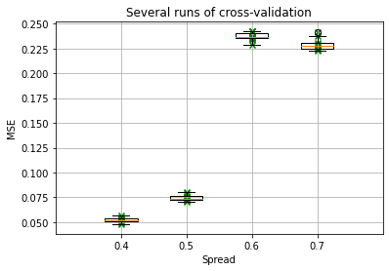

# Man vs Woman. Use only the natural voices of men and women to train a neural network that recognizes the gender of the speaker.

## Exploring number of epochs

We see that since 200 epochs, this stable, so we will take this number.

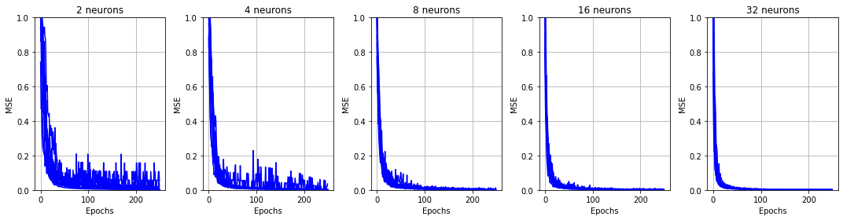

## Exploring number of hidden neurons

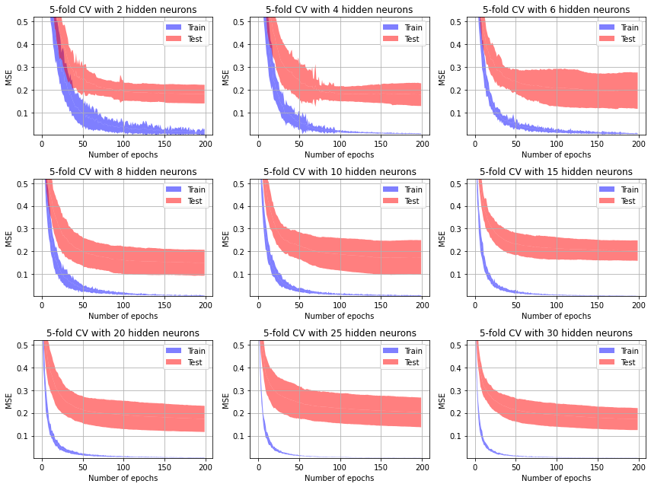

## Results

Paramètres:

* 8 hidden neurons
* Number of epochs = 200
* Learning rate = 0,001
* Momentum = 0.5
* N_Inits / N_Tests = 10
* K = 5

# Man vs Woman using both natural and synthetic voices.

## Exploring number of epochs

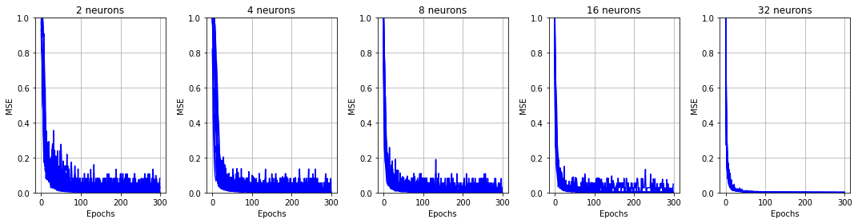

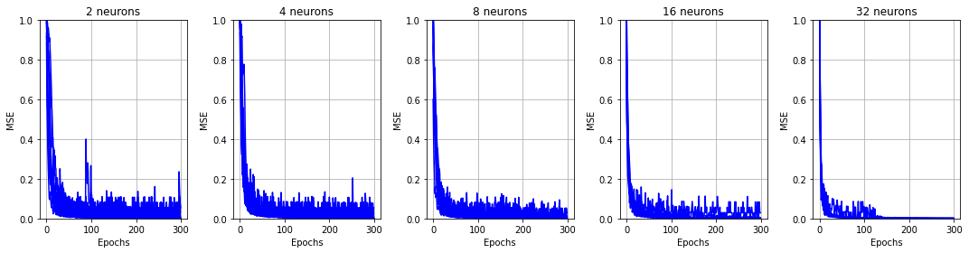

## Exploring number of hidden neurons

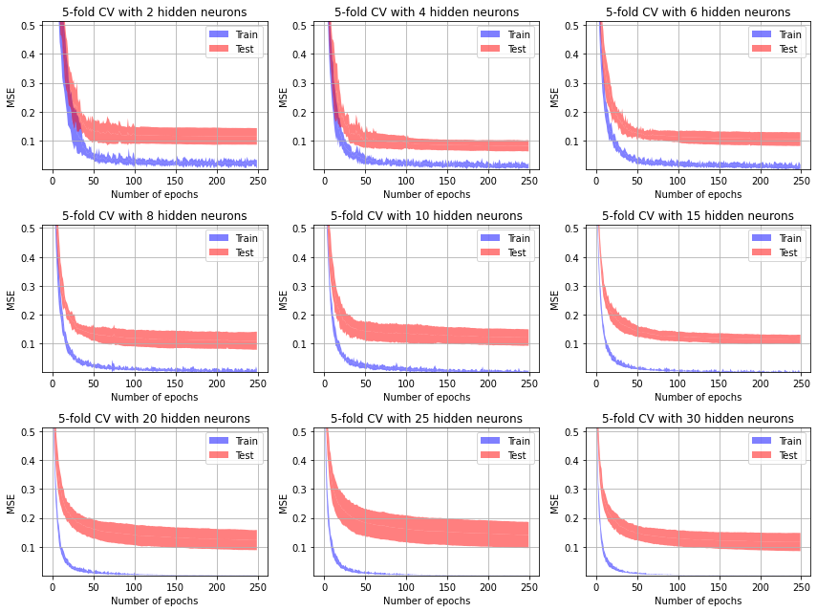

## Results

Paramètres:

* 4 hidden neurons
* Number of epochs = 250
* Learning rate = 0,001
* Momentum = 0,5
* N_Inits / N_Tests = 10
* K = 5

# Man vs. Woman vs. children. Use only the natural voices of men, women and children to train a neural network that.

## Exploring number of epochs

## Exploring number of hidden neurons

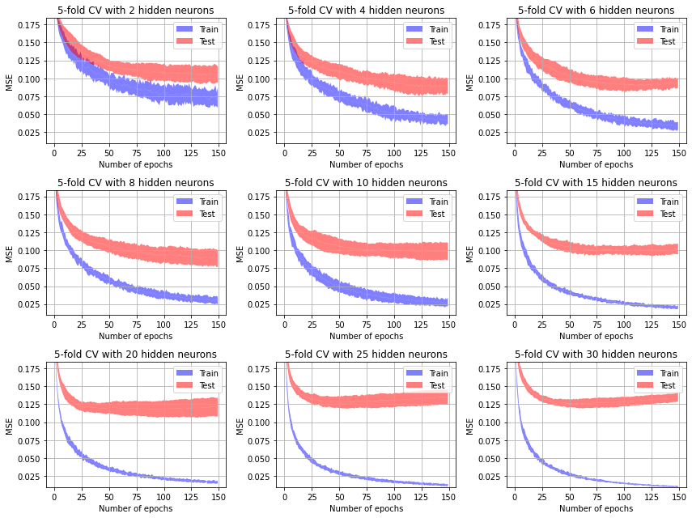

## Results

Paramètres:

* 8 hidden neurons
* Number of epochs = 150
* Learning rate = 0,001
* Momentum = 0,5
* N_Inits / N_Tests = 10
* K = 5

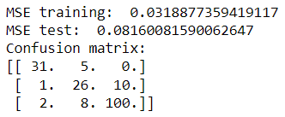

# Design a final experiment of your choice (e.g., using your own voice).

We chose to test all natural voice against all artificial ones.

## Exploring number of epochs

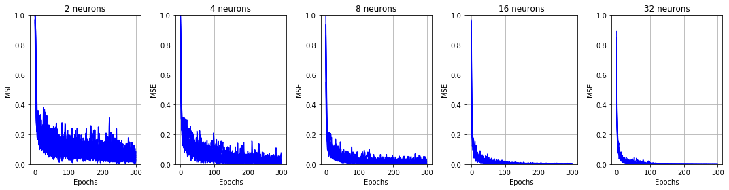

## Exploring number of hidden neurons

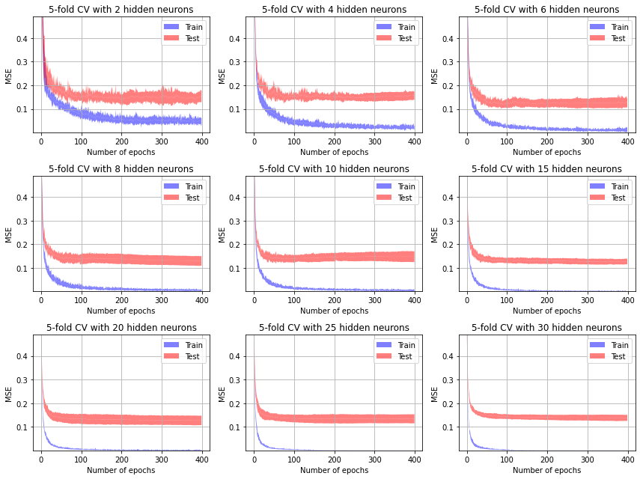

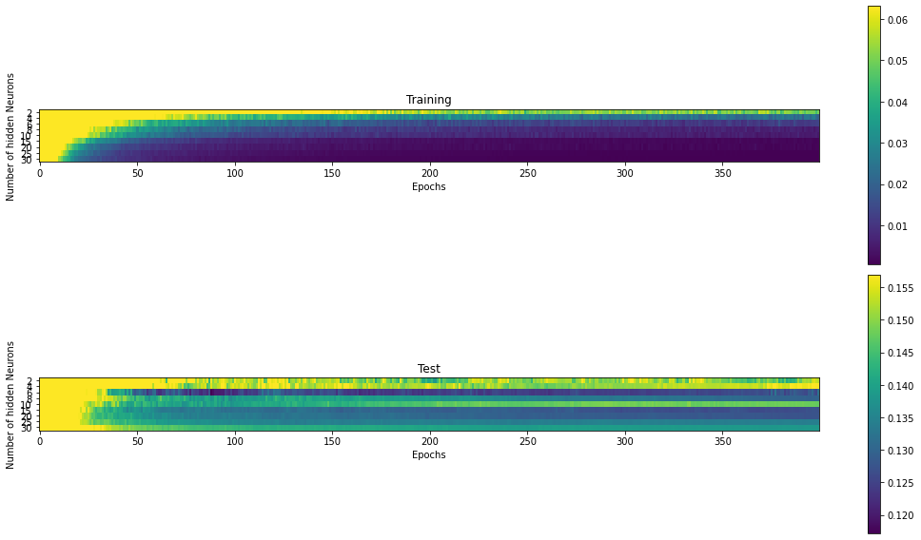

## Results

Paramètres:

* 6 hidden neurons
* Number of epochs = 400
* Learning rate = 0,001
* Momentum = 0,5
* N_Inits / N_Tests = 10
* K = 5

