Project 04: Knapsack

## Dynamic Programming

For Task 1B, we initially chose k = 9 to be the number of buckets in our hash table. Below is a comparison of times between the traditional approach (red) and the space efficient approach (blue) using a hash table.

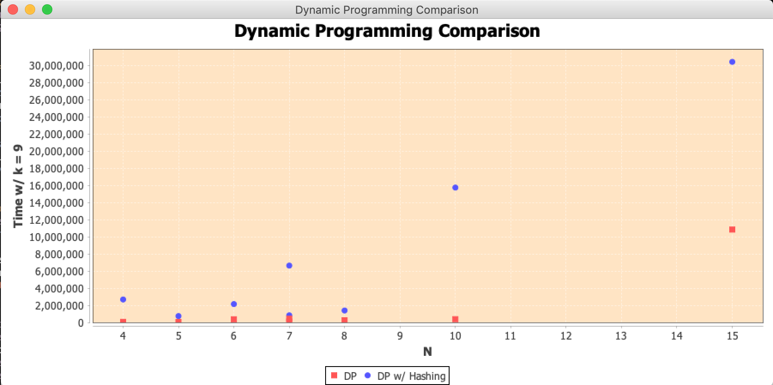

We then cranked up k = 100. When we ran the comparison again, the delta between the graphs (shown below) were much tighter.

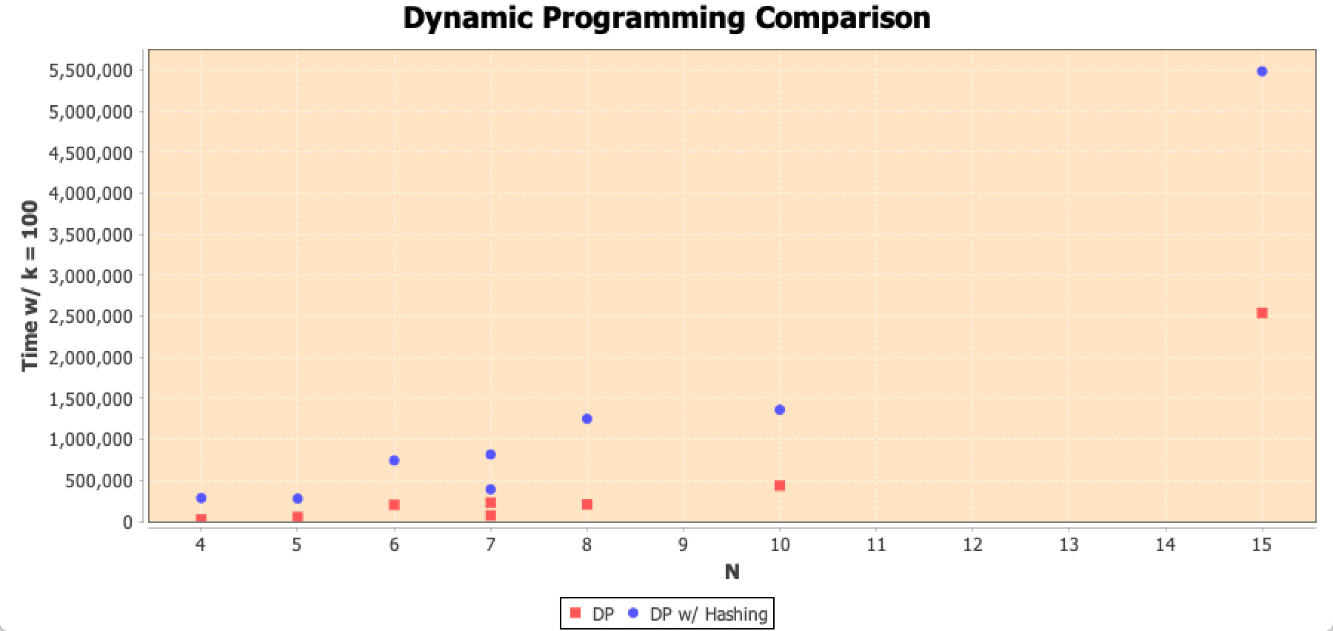

This is more likely due to less linked list nodes created per bucket, and any searches/inserts were done much faster then the initial value for k.

## ­­­­­Greedy

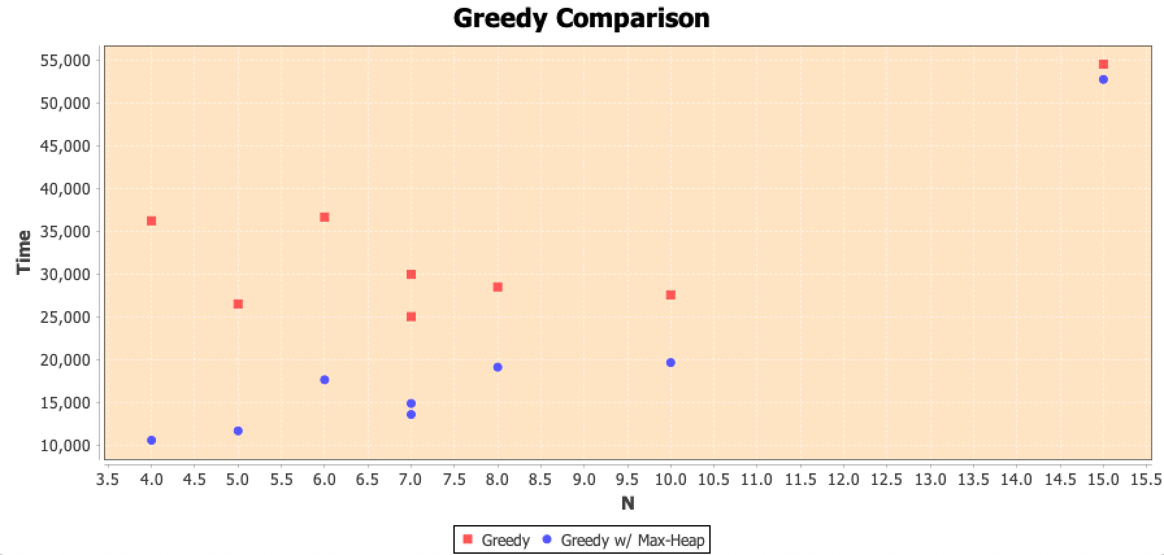

The graph above is a comparison of times between the greedy built-in sort approach (red) and the heap based greedy approach (blue). Turns out that using the max-heap approach is faster than using the built-in sort approach.