Evidence-to-Decision Tool Guide

Contents

Introduction 3

*What's this tool for?* 3

Figure 1 – Outline of the steps involved in the Evidence-to-Decision tool. 4

Start using the tool 5

Bookmarking your work 6

1. Define the Decision Context 7

2. Gather evidence 8

2.A. Identify potential actions 9

2.B. Assess desirable and undesirable effects on the focal target and uncertainty 10

2.B.i. Scientific literature 10

2.B.ii Decision-makers’ own data, written experience, and monitoring 11

2.B.iii Undocumented knowledge 11

2.C. Assess costs and risks 12

2.C.i. Assess financial and resource-based cost-effectiveness 12

2.C.ii. Assess the non-financial costs, risks, and benefits for non-target species, habitats, and stakeholders 12

2.D. Assess acceptability 13

2.E. Assess feasibility 13

2.F. Consider modifications 13

2.G. Summarise the evidence gathered 14

3. Make an Evidence-Informed Decision 15

3.A. Weigh up the evidence for and against different actions 15

3.B. Justify overall decision and next steps 16

3.C. Document and report decision 17

Top tips 18

Useful resources and guides 18

Glossary of terms 21

Appendix 24

Figure 2 – Diagram detailing a case study example of following the steps involved in using the Evidence-to-Decision tool. Note that Step 2 (B-G) is repeated for each action, with the figure only showing the assessment of evidence for one action. The size of each section is not meant to be a guide – this will vary for each decision being considered and the evidence available. For example, in some cases far more evidence from undocumented knowledge may be available, and very little evidence from the scientific literature. 24

Figure 3 – Level of Evidence hierarchy adapted from Mupepele et al. 2016. A useful diagram of different study designs can be found in Christie et al. 2021 (https://www.nature.com/articles/s41467-020-20142-y/figures/1). 25

Table 1 – Differences between different forms of evidence for the purposes of this tool. When we use the term ‘peer-reviewed’, we refer to the formal process of peer-review in scientific journals, rather than organisational peer-review that is undertaken by some government bodies and non-governmental organisations. 25

Table 2 – Different forms of bias and issues and how to assess them during critical appraisal. Adapted from here and here. 27

Table 3 – Important biases that may affect knowledge holders to consider when assessing the uncertainty associated with undocumented knowledge. Adapted from here, here, and here. These biases also affect decision-making and so are important to consider in later stages of this decision-making tool. 30

Table 4 – Eight types (motivational domains) of human values and examples from conservation (adapted from here). 31

Table 5 – Some possible approaches to counter and avoid biases affecting organisational decision-making (adapted from here, where you can find more possible techniques). 32

Acknowledgements 33

Copyright 33

# Introduction

## What's this tool for?

The Evidence-to-Decision tool has been co-designed between the Conservation Evidence group and practitioners from several organisations to help guide practitioners through the process of making an evidence-informed decision. The tool is structured to help you consider and combine several forms of evidence (e.g., scientific evidence, tacit knowledge, values, costs) to reach a transparent decision, documenting each stage of the process so that the logic and reasoning behind decisions can be open and traceable.

The tool is structured using three steps (Fig.1): 1. Define the Decision Context (i.e., What is the problem you want to solve?); 2. Gather Evidence (i.e., What actions are likely to be the most effective to address my problem in my local context?); 3. Make an Evidence-Informed Decision (i.e., What are the next steps? Which actions will be implemented based on the evidence you have assessed?). The diagram below lays out the detailed steps that this tool will guide you through.

This tool is best suited for use by individual landowners, reserve managers, and small NGOs working on specific projects to come to an evidence-informed decision for a specific problem. The tool was designed to streamline an evidence-informed decision-making process with limited time and resources. The tool can also be used to begin thinking about how to tackle major decisions, laying the foundation for a more in-depth decision-making process using other tools and frameworks (e.g., Structured Decision-Making, Multi-Criteria Decision Analysis, or Theory of Change etc.).

## Figure 1 – Outline of the steps involved in the Evidence-to-Decision tool.

# Start using the tool

To begin using the tool, click on 1. Define the Decision Context (see picture below). Throughout this tool you will be prompted to enter information which will be compiled and documented in a report which you will be able to download in the final step.

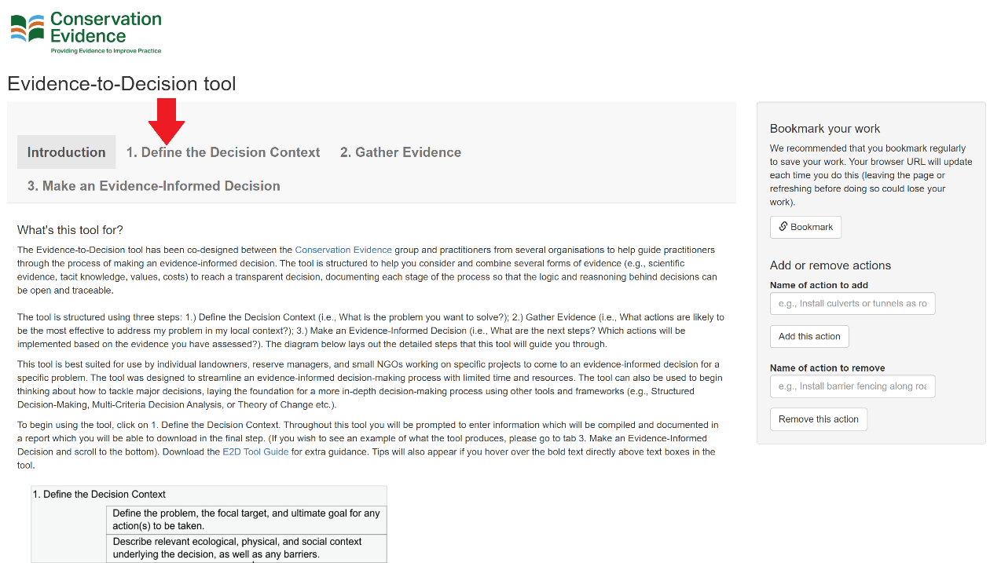

If you wish to see an example of what the tool produces, please go to tab 3. Make an Evidence-Informed Decision and scroll to the bottom and click the ‘Download example summary report’ button. Tips will appear to help you if you hover over the bold text directly above text boxes throughout the tool.

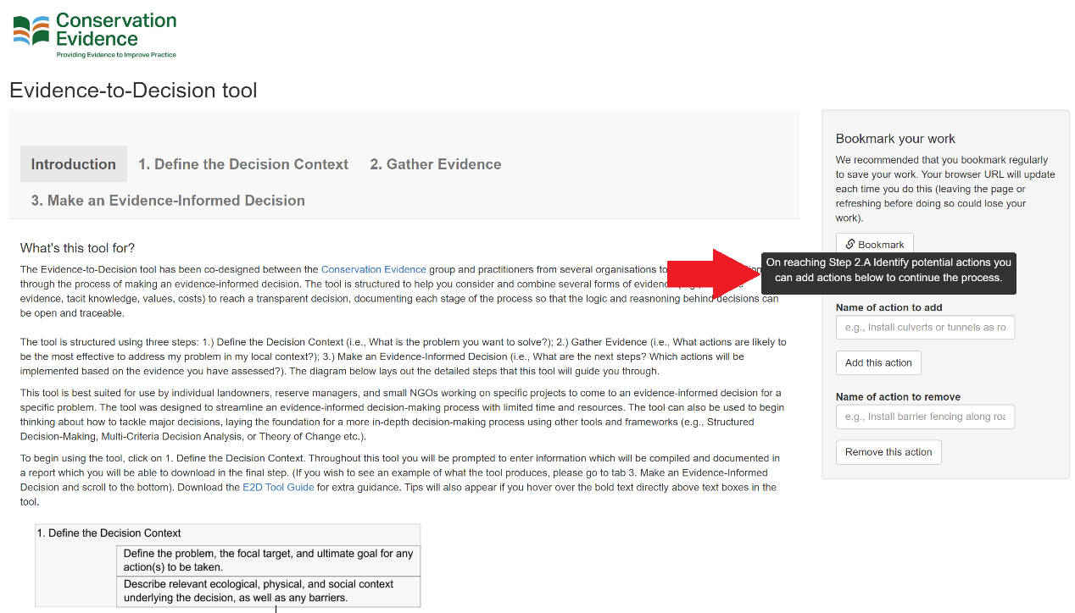

## Bookmarking your work

In the right hand menu, you will see a button that says ‘Bookmark’.

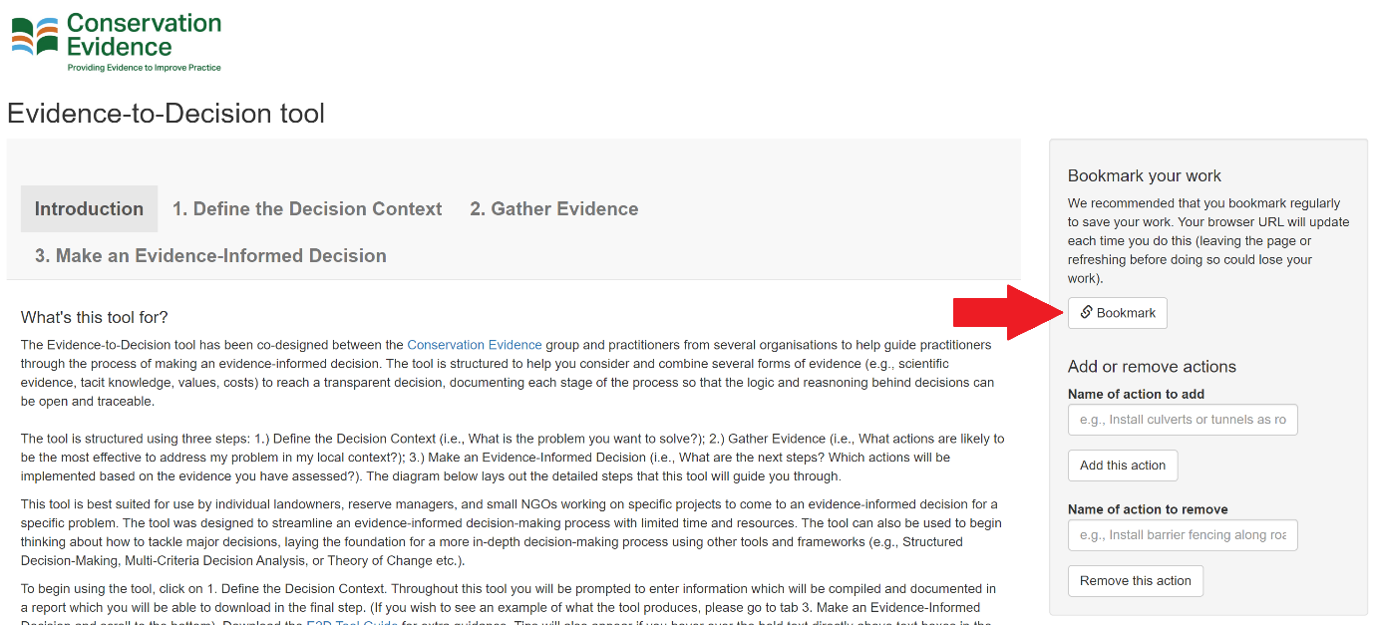

We recommend that users regularly bookmark their work, at least before you leave the application or your desk, to ensure you don’t lose any of the text you have entered into the tool. If you refresh or close your browser tab before doing so, the work will only be saved up until the last time you clicked this button.

The button changes the URL of the page, which is unique to you and the time you saved your work – if you leave the tool for long periods, it may be sensible to make a note of the URL somewhere (although on refreshing or closing your browser, you should still be able to navigate to this URL – for example, through your browser history). If you wished, you could also go back to previous versions of the tool (using previous URLs in your browser history) and so restore old text (a bit like version history on Word or Google Docs) – but bear in mind you need to have a record of the previous URLs you have generated.

## Define the Decision Context

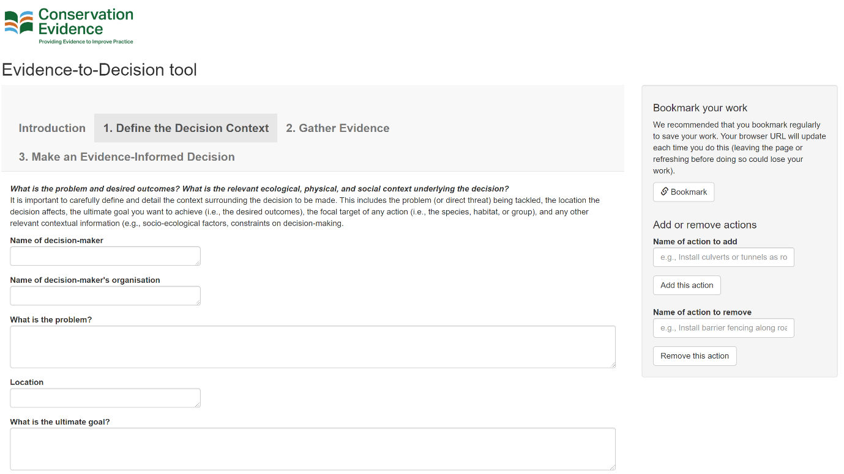We recommend that users spend adequate time carefully defining and clarifying the context surrounding the decision they want to make before proceeding to the next step.

What we mean by the Decision Context is the information on habitat types, species present, climate, location, background on relevant stakeholders, etc. that is relevant to making your decision. We include a section to consider the constraints on your decision-making such as regulatory structures/legislation, budget available, and personal/organisational values.

User testers found the phrasing of the decision context to be very important – for example, is the ultimate goal to control mink or to conserve water voles? The answer to this depends on the scale at which the user is thinking of making a decision. For example, if the decision context is that a practitioner is working on a specific project to eradicate mink to conserve water voles, their ultimate goal would be to control mink and focal target would be mink. Users would then consider different actions to control mink. If, however, their project is broader in scope, and they are scoping for ways to conserve water voles as part of a wider strategy, the ultimate goal would be to conserve water voles and the focal target would be water voles. Users would then consider different actions to conserve water voles, which may include controlling mink in different ways, as well as different methods of habitat restoration for example. The style in which users phrase and define their decision context is therefore their choice and will depend on the scale at which they are working.

## Gather evidence

Now you have defined exactly what decision you want to make and detailed the relevant background information to help focus your decision-making, it is time to gather evidence to help inform your decision. In this part of the tool, you will identify potential actions and then assess the evidence on each one for different decision-making factors (including effectiveness, costs and risks, acceptability, and feasibility). You will be able to consider modifications to improve each action based on this evidence and to summarise your evaluation of the evidence.

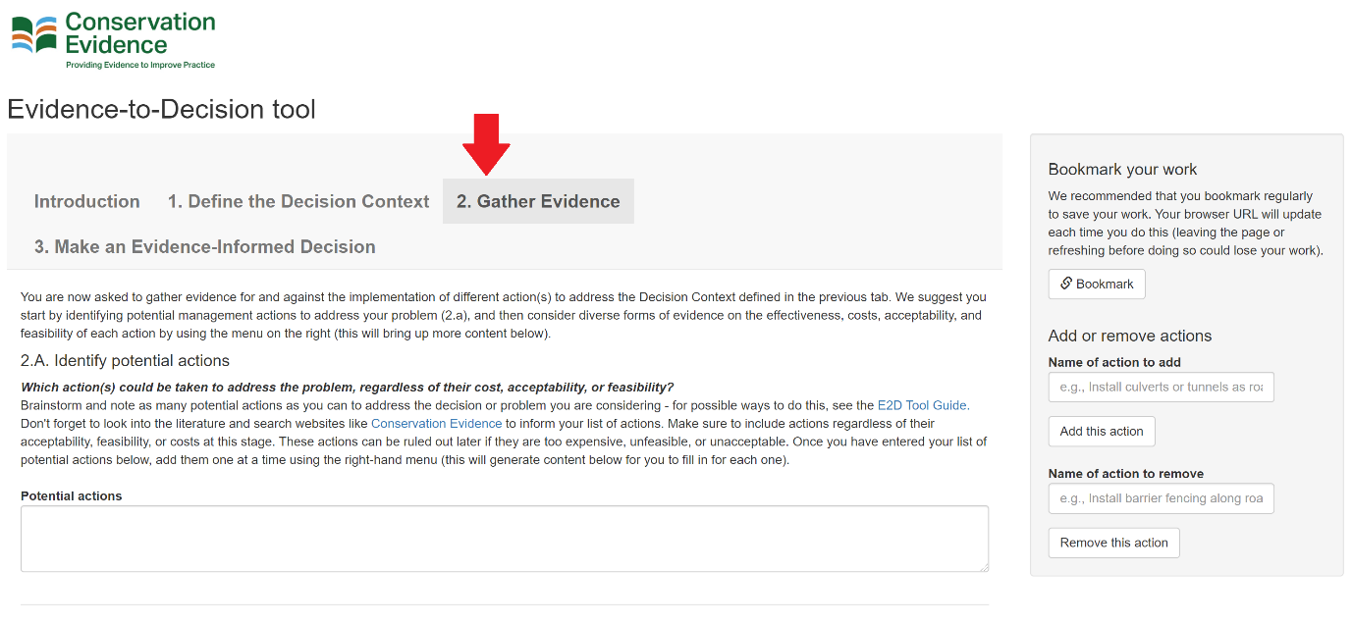

In each section (2.B-G as appropriate), you will also be able to score the local effectiveness, cost-effectiveness, costs and risks, acceptability, and feasibility of each action. Importantly, you will also be able to rate your certainty in your scores to account for the strength of evidence provided. This will generate a summary table in the final tab (3. Make an Evidence-Informed Decision) to help summarise your thinking and the evidence gathered. See the screenshot below to see what this looks like in the online tool.

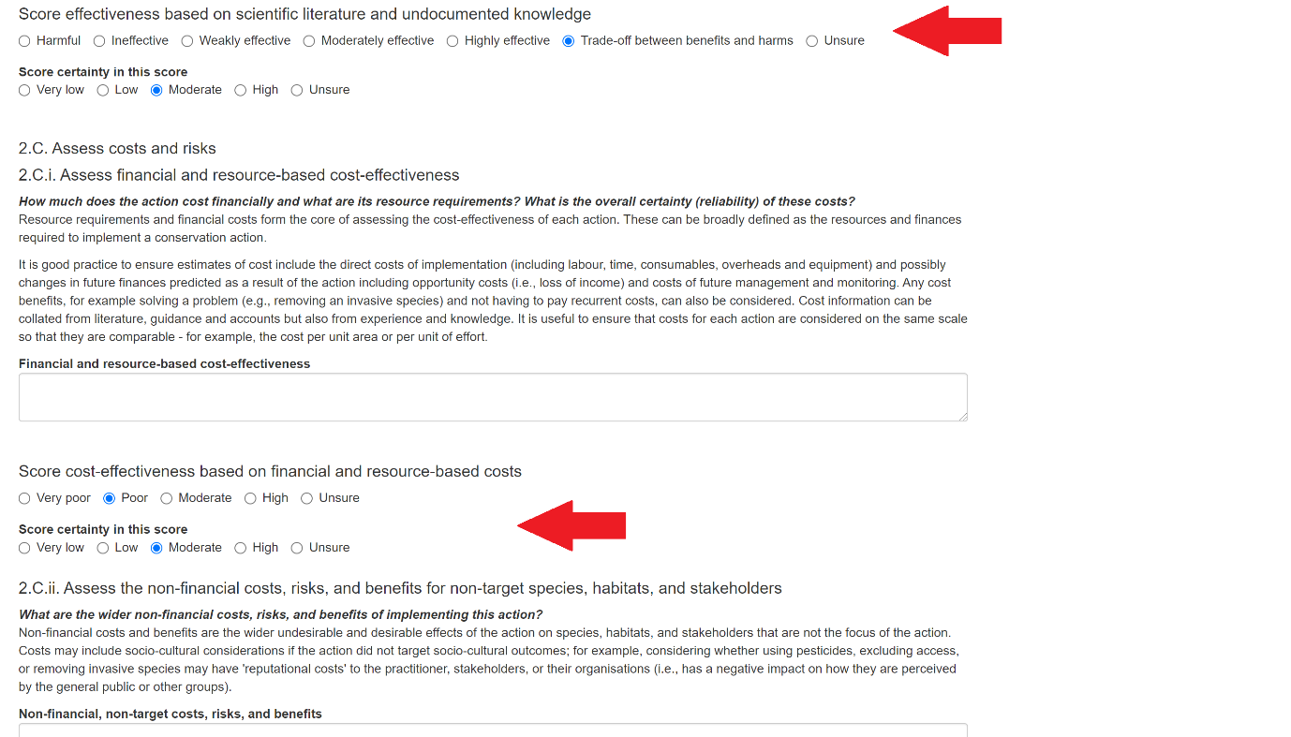

### 2.A. Identify potential actions

We would recommend ‘Solution Scanning’ to compile a list of potential actions, which typically involves searching the literature and consulting a wide group of experts and stakeholders to list possible actions or alternatives to deal with a threat or problem. We would recommend searching the Conservation Evidence database (www.conservationevidence.com) to find possible actions from the many thousands (both tested and untested) listed there. Alternatively, users could use the ‘vanishing options test’ to brainstorm a list of possible actions by iteratively listing and then removing actions – this helps us to think of more actions beyond those we may instinctively identify. Other possible include Red Teaming or Nominal Group Technique (see Table 5 in Appendix), but you may have your own techniques that you use within your organisation for brainstorming activities.

Once you have decided on your list of possible actions, you can add these one at a time using the button on the side menu. Each time you click 'add action' you will create tabs below to continue the process (Steps 2.B-G) where you assess the evidence on each action.

If you need to remove an action (e.g., because of a typo) simply enter the name of the action you wish to remove and click 'remove this action'. Removing an action will also remove the text you enter in the tab that appears below so be careful when doing this – it would be best to ensure all the names of actions are correct before going further in the tool.

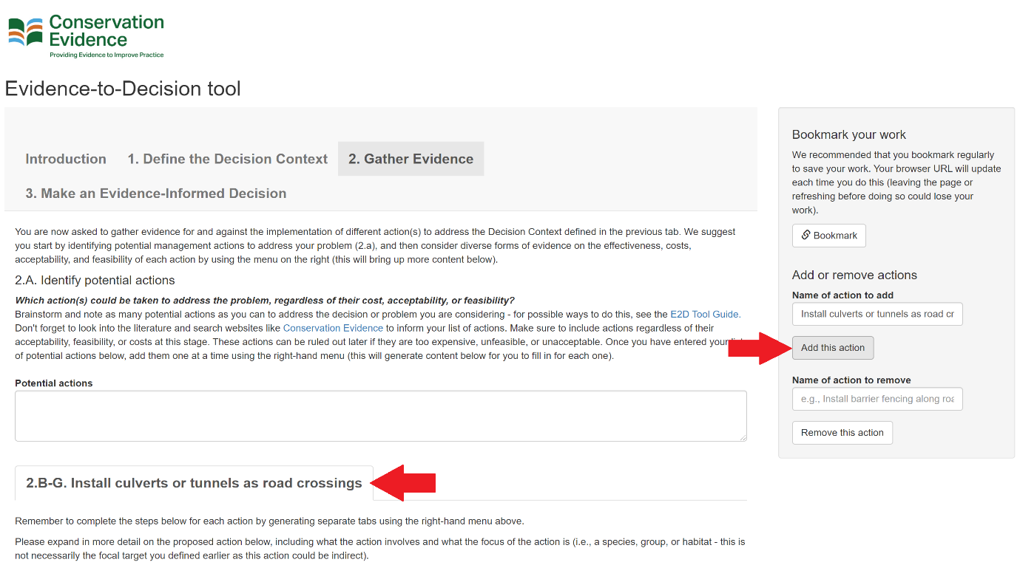

### 2.B. Assess desirable and undesirable effects on the focal target and uncertainty

Now you can assess the evidence on the likely effectiveness of each action in turn for your local context. Remember to do this for each action separately by ensuring you have added each action using the right-hand menu as shown previously. This section is concerned with the effectiveness of the action, regardless of the costs, risks, acceptability, or feasibility of the action, or effects on other species, groups, or habitats – i.e., ‘side-effects’. There will be space later for you to consider these other important pieces of evidence.

#### 2.B.i. Scientific literature

Evidence from the scientific literature typically comes from either the peer-reviewed literature, or the non-peer-reviewed literature (also called the ‘grey literature’; see Table 1). Evidence may also come from single primary research studies, or evidence syntheses by different organisations. We would recommend you consult good quality evidence syntheses such as those provided by the Collaboration for Environmental Evidence (CEE Systematic Reviews: <https://environmentalevidence.org/completed-reviews/>) and Conservation Evidence (containing summaries of evidence and expert assessments for thousands of actions and studies: [www.conservationevidence.com](http://www.conservationevidence.com)), who have tried to do some of the hard work for you in collating and summarising the evidence base. Other organisations will also likely have summaries of scientific evidence and it is important to gather evidence from the non-peer-reviewed literature too – Applied Ecology Resources is a useful resource for this launched in 2021: <https://www.britishecologicalsociety.org/applied-ecology-resources/search/>.

The key part to this section is to ensure that you report the source of the evidence used in your decision-making. This helps to make your decision-making process transparent and open so others can build upon what you have done in the future.

Another key part is to critically appraise the evidence you gather (e.g., using a framework like [‘That’s a claim!’](https://thatsaclaim.org/environmental/)). For example, the peer-reviewed literature may suffer from publication bias (the greater likelihood of positive and statistically significant results being published) more so than the non-peer-reviewed literature, whilst studies or syntheses may suffer from other potential biases (see Table 2). Critically appraisal is all about identifying these biases and considering how they affect your certainty in the findings provided by the evidence. For example, do syntheses and guidance documents use rigorous methods to collate and summarise evidence? Do they follow verified protocols and transparently report their methods and findings? Are their recommendations traceable back to the original sources of evidence? Users are not expected to go back to these original sources, as this would be too time-consuming, but are asked to think critically about how reliable a given synthesis is. An evidence hierarchy is provided in the tool (also in Fig.3, Appendix) to help you think about the relative reliability of different types of scientific evidence (e.g., a good quality systematic review provides much greater certainty than a good quality single study).

You may also wish to reflect on how relevant this evidence is to your local context. For example, is the evidence applicable to your species or location? Is the evidence based on an ecologically similar or relevant species or habitat? Was the action tested in a way that reflects how you would implement the action locally? Later on you will consider possible modifications to the action that could improve its local effectiveness (Step 2.F.), so it would also be useful for you to note information on alternatives or modifications tested or suggested by the scientific evidence.

#### 2.B.ii Decision-makers’ own data, written experience, and monitoring

As for the scientific literature, here we suggest you assess the reliability and relevance of any evidence derived from your own data, monitoring, or written experience (e.g., logbooks or notebooks) on the likely effectiveness of each action. This is separate to the grey or non-peer-reviewed literature as this evidence is usually internal (i.e., collected by the decision-maker or their organisation) rather than external, and is documented or recorded in the form of physical data or written observations – hence the distinction from undocumented knowledge (see Table 1).

#### 2.B.iii Undocumented knowledge

Since there is no one unified definition for the knowledge held by practitioners, indigenous people, and various other stakeholders, we have used the term ‘undocumented knowledge’. What we mean by this is information that is not published or written down, which typically includes a knowledge holder’s intuition, experience, wisdom, and values (also known as ‘tacit’ knowledge). For example, undocumented knowledge may include evidence that cannot be tied to a specific source or justified by a mechanism or explanation, but is simply ‘known’ by the knowledge holder.

We believe it is useful to consider both evidence from the scientific literature and from undocumented knowledge when making decisions, particularly because they can complement each other. In particular, undocumented knowledge can fill gaps in the scientific literature and help us consider how applicable scientific evidence is to our local context – particularly given that scientific evidence is often collated across local contexts and decision-makers are often interested in making decisions for a single context.

Just like scientific evidence, it is crucial to critically appraise and assess the uncertainty associated with undocumented knowledge. Several sources of bias could affect the reliability of evidence given by knowledge holders (see Table 3 and [here](https://www.allianceconservationevidence.org/s/ACES-Briefing-Biases.pdf)), including confirmation bias where people overestimate their abilities or expertise. We believe when assessing undocumented knowledge, users could pay particular attention to the experience, expertise, and skillset of the knowledge holder and whether they have vested interests related to the decision being made.

### 2.C. Assess costs and risks

Cost-effectiveness is an extremely important decision-making factor in conservation given the limited time and resources that are often available to implement actions. Here we ask you to carefully consider not just the financial and resource-based costs of actions, but also the wider costs, risks, and benefits that were not captured earlier (e.g., non-monetary costs or benefits, ‘side-effects’ etc.).

#### 2.C.i. Assess financial and resource-based cost-effectiveness

Resource requirements and financial costs can be broadly defined as any resources and finances required to implement a conservation action. Detailing information on costs here will help to assess later on whether the action is financially feasible (e.g., does the action greatly exceed a set budget?).

When recording costs, it is good practice to ensure estimates include the direct costs of implementation (including labour, time, consumables, overheads and equipment) and possibly predicted changes in future finances as a result of the action, including opportunity costs (i.e., loss of income) and costs of future management and monitoring. Cost benefits, for example solving a problem (e.g., removing an invasive species) and so not having to pay recurrent costs, are also important to consider, as well as financial benefits associated with the desired biodiversity outcome (e.g., ecotourism value, Non-Timber Forest Products or NTFPs).

We advise, where time allows, collating costs using a standardized framework, recording types of resources and costs, and further information (such as date, currency, donations received) that can aid future interpretation. We also suggest that the cost for each action should be included on the same scale so that they are comparable – for example, the cost per unit area or per unit of effort. For instance, the conservation of a rare habitat type within a wider landscape might compare the cost of grazing with livestock versus mowing, but the calculation of costs needs to account for the larger area that the livestock need to graze to gain enough nutrients.

Noting the uncertainty associated with costs is also important. This may stem from variability in costs across contexts, or uncertainty in the accuracy of cost information available – this can be expressed quantitatively or qualitatively if insufficient data is available. It may be helpful for users to note the likely maximum or minimum costs for the intervention based on their level of certainty – this ensures appropriate levels of uncertainty and financial risk are factored in when making a decision whether to implement each action.

#### 2.C.ii. Assess the non-financial costs, risks, and benefits for non-target species, habitats, and stakeholders

When talking about non-financial costs, risks, and benefits, we mean the potential undesirable and desirable effects of the action on species, habitats, and stakeholders that are not the focus of the action. Costs and risks, may include negative socio-cultural or political outcomes associated with the action; for example, considering whether using pesticides, excluding access, or removing invasive species may have costs for the practitioner, stakeholders or their organisations (e.g. reputational costs, loss of access, livelihood or health costs). Another example would be that restricting access to a site may negatively impact the attitude of the local community towards current and future conservation actions and ultimately reduce their effectiveness.

It is also important to consider whether there are any wider benefits (e.g., sociocultural) that an action may provide to local communities or stakeholders that align with the strategic aims of the practitioner or organisation (if these were not the focal target of the action). For example, farmers may wish to undertake certain conservation actions as part of being responsible stewards of their land and uphold traditional family legacies, or be seen as economically effective and efficient. In addition, if an action lends itself to positively impacting upon publication engagement and/or citizen science projects, this may be an important consideration to note. Linking the wider benefits of any action to the framework of Natural Capital Accounting () could also help to account for other non-financial benefits.

Costs, risks, and benefits on non-target species and habitats are also important to consider, such as whether particular types of grazing benefits the focal target (e.g., butterflies) but not other species (e.g., spiders) – i.e., ‘side-effects’ that an action may cause.

### 2.D. Assess acceptability

Considering acceptability is part of understanding whether each action aligns to the values held by the decision-maker and the key stakeholders (who were identified in Step 1: Define the decision context). Stakeholders will hold many human values which can be defined as concepts or beliefs about desirable end states or behaviours that guide their choices and evaluation of outcomes – eight types of values can be found in Table 4. It is outside the scope of this tool to elicit these values directly from key stakeholders, so we would suggest that the user and organisation gathers in this information (using suitable methods already used by organisations, e.g., formal consultations, focus groups etc.) and summarises this here.

Acceptability is important to consider, particularly where an action involves cooperation with stakeholders or community uptake of any actions. For example, any action that goes against the values held by the practitioner or key stakeholders could be unacceptable for ethical reasons, in terms of the potential non-financial or reputational costs or risks of the action. This is why it is important for users to consider whether, for example, a certain action would compromise or limit the social power held by a stakeholder, and make the action unacceptable? Or, for instance, if a stakeholder group values the enjoyment they get from spending time in part of a nature reserve, and an action limits access to the nature reserve, is this action unacceptable? Considering acceptability is key to understanding whether an action is likely to be supported by the local community, whether it may face barriers or opposition, and ultimately how feasible it may be to implement.

### 2.E. Assess feasibility

The feasibility of an is simply how likely it is that an action can be successfully accomplished and implemented. For example, would resistance to the action from key stakeholders could compromise its success? i.e., if an action is unacceptable to certain stakeholders, is it unfeasible to implement that action? This builds from the previous section on acceptability.

Considering access or availability of equipment, resources, or staff to undertake a management action will also be important; for example, an action may not be feasible if the equipment needed cannot be moved to the location of interest. Considering the costs and risks associated with each action, such as whether the action exceeds a strict budget or will be able to be approved by any stakeholders that must agree to its implementation.

### 2.F. Consider modifications

This section is designed to get you to think about how to maximise the likelihood that an action will be locally effective, cost-effective, acceptable, and feasible. For example, there may be strong evidence from the scientific literature to suggest that creating certain habitats for great crested newts and white-faced darters (dragonflies) will be beneficial, but a practitioner’s knowledge also suggests that these species have slightly different habitat preferences in this region, and so a modification to this action may be necessary for it to be locally effective.

Or an action such as an education campaign may not be acceptable to a key stakeholder if it is designed in a certain way, so modifications are necessary to ensure the action is acceptable. A structural action may also be too expensive to implement using certain materials and to be more cost-effective and ultimately more feasible, the action could be modified by using cheaper materials.

### 2.G. Summarise the evidence gathered

In this section, the tool prompts you to highlight the challenge of uncertainty and risks, in particular whether the evidence gathered is sufficient in its reliability and relevance to make robust conclusions.

This part of tool asks you to summarise and draw together the evidence from each of the previous sections, and what this suggests about the likely overall effectiveness of the action. At this summarisation stage (and in Step 3: Making an Evidence-Informed Decision), we would caution you to avoid certain biases that often affect organisational decision-making (such biases also affect undocumented knowledge; see Table 3) – there are several approaches to counter these decision-making biases in Table 5 (adapted from [here](https://www.allianceconservationevidence.org/s/Making_better_decisions_ACES.pdf) and [here](https://www.allianceconservationevidence.org/s/ACES-Briefing-Biases.pdf)).

## Make an Evidence-Informed Decision

Once you have completed Steps 2.B-G. for each action, you can move on to the final stage of the tool, Step 3. Make an Evidence-Informed Decision, where you will draw together what you have found to summarise and justify your decision and the next steps.

In the online tool, we provide a summary table that automatically displays the scores given by users in previous steps (2.B-G for each action) to allow a simple comparison across different decision-making factors. However, we suggest users do not solely rely on this table to make decisions and ensure they consider all the evidence they gathered previously. We also provide some summary text (from step 2.G) in which users have already provided a brief summary assessment of the evidence for and against each action. The summary table can help in assessing the certainty the user has in the evidence they have gathered, as darker yellow coloured cells represent greater levels of certainty in these assessments for each decision-making factor and action. 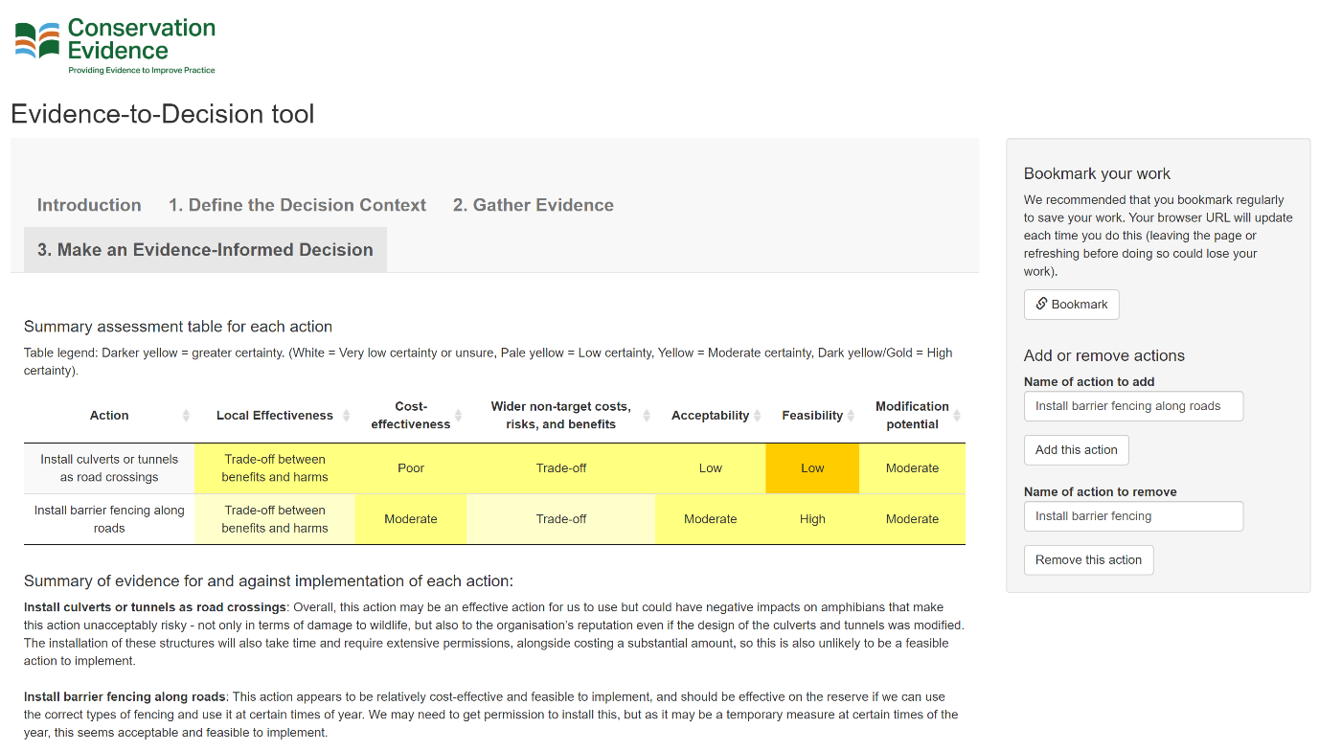

### 3.A. Weigh up the evidence for and against different actions

There are several ways to rapidly, but methodically narrow down the best actions to implement.

We would suggest that users could use the Mitigation and Conservation Hierarchy (see [here](https://academic.oup.com/view-large/figure/118141473/biy029fig1.jpeg)) to consider whether actions are: 1.) retaining biodiversity and avoiding impacts, 2.) minimizing impacts, 3.) restoring or remediating impacts or 4.) compensating for impact or renewing biodiversity. Actions that avoid and minimize threats should be prioritised, before restoration and compensatory measures are considered.

Users may also find it useful to consider whether actions have sufficient evidence on which to base a decision – for example, is the level of uncertainty associated with the evidence gathered too great, or is the action likely to be too risky to implement? Actions for which the evidence is too uncertain could be discarded for now – these could be returned to in the future if the practitioner decides to test the action themselves (e.g., as part of the next steps in the following section 3.B.), new evidence becomes available, or the decision justifies a more in-depth and detailed consideration of evidence.

It is also important to consider whether any action should be taken at all – inaction can sometimes be an optimal action! Do consider this based on the certainty you have in the evidence and the risks involved in undertaking any action.

If users believe there is sufficient certainty in the evidence on certain actions, users could start by eliminating actions that are unlikely to be cost-effective. For instance, there may often be strict limits for the amount of money available for implementing a conservation action, and so actions that are likely to substantially exceed these limits may not be considered further. Actions that are expensive and less effective than comparable alternatives (i.e., with very low relative cost-effectiveness) may also be discounted. Actions with the same or lower relative costs but greater effectiveness, or with the same relative effectiveness and lower costs are likely to be the ones considered further as they can be justified on the grounds of cost-effectiveness.

Actions could also be rejected if they are clearly unacceptable to the practitioner or key stakeholders. Similarly, actions that are clearly not feasible to implement may also be rejected. Considering previously gathered evidence on cost-effectiveness, acceptability, and feasibility will be important to making these judgments. For example, you may find that evidence drawn from the scientific literature and undocumented knowledge suggest an action is likely to provide beneficial outcomes to local wildlife, but its costs are too expensive as they exceed your current budget and/or the wider impacts of the action are unacceptable to key stakeholders.

For the purposes of this tool, we believe it may be useful to place actions in a prioritised order from most suitable to least suitable based on the most important factors in your decision-making – e.g., effectiveness, cost-effectiveness, acceptability, and/or feasibility. With more time and resources, we would advise a more detailed assessment of costs and cost-effectiveness using tools such as formal cost-effectiveness and multi-criteria decision analysis.

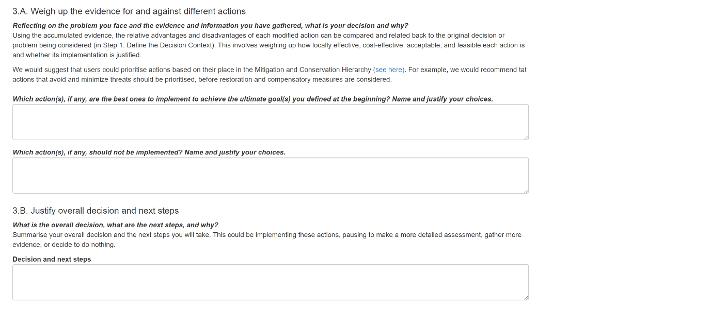

### 3.B. Justify overall decision and next steps

To decide on the next steps after reporting your overall decision, you may find it useful to consider drawing up a strategy to implement the actions you have selected to implement, or if there is too much uncertainty to make their decision, investing in the use of a more detailed Decision Support Framework (e.g., Structured Decision-Making – see a good example [here](https://doi.org/10.1111/cobi.13651)) to gather and assess the evidence more thoroughly.

You could also consider whether further research, consultation with stakeholders, or testing and reporting on the local effectiveness of actions could be undertaken. This could help to bolster your confidence in the evidence (particularly if little or no strong evidence exists), to pilot or test possible modifications to a particular action to check whether it is likely to be effective, get a better understanding of the risks of implementing an action, or consult more widely with stakeholders on ways to implement different actions to ensure they are acceptable.

We would strongly recommend that one of the next steps, if an action is to be implemented, is to ensure that the effectiveness of the action(s) is rigorously evaluated and reported to the wider community as part of the continual generation of evidence, regardless of the outcomes. Various journals now support practitioners in publishing reports of tests of conservation actions, including [Conservation Evidence journal](https://conservationevidencejournal.com/), [Ecological Solutions and Evidence](https://besjournals.onlinelibrary.wiley.com/journal/26888319), [Conservation Science and Practice](https://conbio.onlinelibrary.wiley.com/journal/25784854), and material stored in the British Ecological Society’s [Applied Ecology Resources](https://www.britishecologicalsociety.org/applied-ecology-resources/how-to-submit-content-to-aer/), [Panorama](https://panorama.solutions/en) (this is not an exhaustive list – there are many other places to publish reports).

### 3.C. Document and report decision

All the information that you have previously entered into the tool (from Steps 1-3) will be used to create a downloadable summary report (see below of how to create one) – you can also choose to download an example (see button above the one highlighted below).

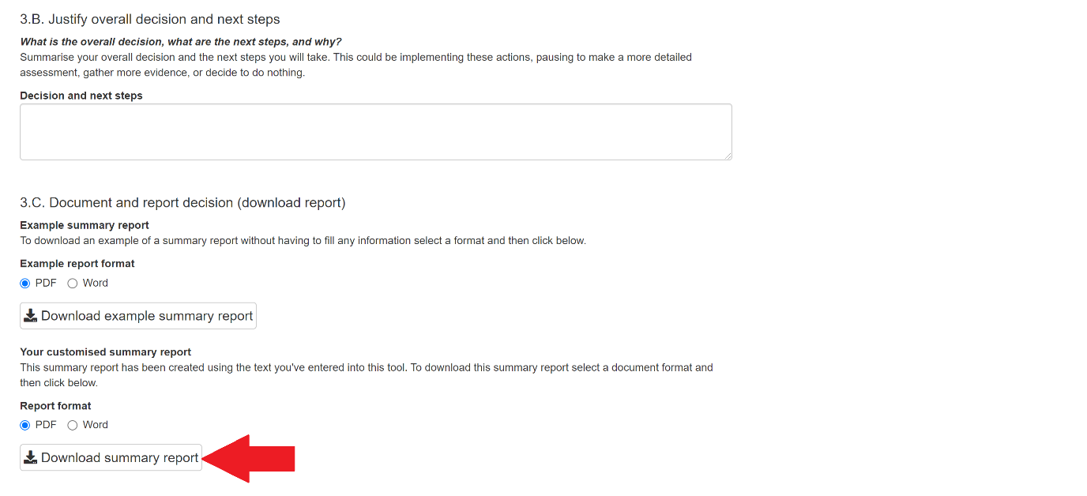

A key motivation behind this tool was to help you document the evidence, logic, and reasoning used to make decisions, enabling greater transparency in conservation decision-making. Our suggestion is that with repeated use of this tool (or adapting our template to your needs), you could compile and store reports in a ‘decision library’, enabling the dissemination and sharing of information on how past decisions were made, as well as to enable practitioners to revisit and reassess decisions based on new evidence or for new projects.

This use of the tool to create such reports documenting your decision-making lends itself to Adaptive Management, whereby the tool could be revisited based on the success of implemented actions. It is our hope that the tool can help link the ideas of Adaptive Management and Evidence-Based Conservation to improve decision-making in conservation.

Top tips

* You’ll see tips within the online tool if you hover over the bold text directly above text boxes.
* You can drag and enlarge text boxes by dragging the bottom right hand corner of them.
* Press bookmark to save your work at regular intervals (e.g., each time you finish a few sections of work).
* If you’re unsure of what the downloadable report may look like, you can download an example at the bottom of tab 3. Make an Evidence-Informed Decision.
* Figure 2 (Appendix) in this guide shows a case study example working through the Evidence-to-Decision tool based on Figure 1.

# Useful resources and guides

|  |  |
| --- | --- |
| Resource name and reference | Description |
| A decision-making bias typology  <https://www.mckinsey.com/~/media/mckinsey/business%20functions/strategy%20and%20corporate%20finance/our%20insights/the%20case%20for%20behavioral%20strategy/most_frequent_biases_in_business.ashx> | An infographic summary of different decision-making biases prepared by Dan Lovallo and Olivier Sibony. |
| Alliance for Conservation Evidence and Sustainability (ACES) website <https://www.allianceconservationevidence.org/> | A partnership of NGOs and academic institutions committed to transforming how we generate and use evidence to support effective community-based conservation. Their website contains lots of resources and evidence to help decision-makers in community-based conservation. |
| Applied Ecology Resources <https://www.britishecologicalsociety.org/applied-ecology-resources/> | A globally accessible open platform to share and discover information on the management of biodiversity and environment to support evidence-based decision making. |
| CEE Database of Evidence Reviews (CEEDER) <https://environmentalevidence.org/ceeder/> | An open access evidence service to help evidence consumers find reliable evidence reviews and syntheses to inform their decision making. |
| CEE Evidence Syntheses <https://environmentalevidence.org/completed-reviews/> | A digital library containing all systematic reviews and systematic maps that have been approved by CEE. |
| CEE Plain Language Summaries <https://environmentalevidence.org/policy-briefs/> | A list of easy-to-read summaries of recent CEE Systematic Reviews and Maps. |
| Collaboration for Environmental Evidence (CEE) <https://environmentalevidence.org/> | An open community of stakeholders working towards a sustainable global environment and the conservation of biodiversity. CEE seeks to promote and deliver evidence syntheses on issues of greatest concern to environmental policy and practice as a public service. They primarily conduct Systematic Reviews and Systematic Maps. |
| Conservation Evidence website [www.conservationevidence.com](http://www.conservationevidence.com) | A free, searchable evidence database designed to support decisions about how to maintain and restore global biodiversity. The project summarises evidence from the scientific literature (studies) about the effects of conservation actions such as methods of habitat or species management and produces synopses of evidence that review the effectiveness of all actions you could implement to conserve a given species group or habitat or to tackle a particular conservation issue. Expert panels assess the effectiveness (or not) of actions, based on the summarised evidence. They also publish new evidence in their online Conservation Evidence Journal. |
| Conservation Measures Partnership Resource Library <https://conservationstandards.org/resources/> | Website library of resources for a community of conservation-oriented NGOs, government agencies, funders, and private businesses that work collectively to guide conservation around the world. They are stewards of the [Conservation Standards](https://conservationstandards.org/about/), and seek better ways to design, manage, and measure the impacts of conservation action. |
| Nature-based Solutions Evidence Platform  <https://www.naturebasedsolutionsevidence.info/> | An evidence platform providing an interactive way to filter and search for evidence on nature-based solutions. |
| Panorama <https://panorama.solutions/en> | Website for a partnership promoting examples of inspiring, replicable solutions across a range of conservation and development topics, to enable cross-sectoral learning and upscaling of successes. |
| Tanner, L., Mahajan, S.L., Becker, H., DeMello, N., Komuhangi, C., Mills, M., Masuada, Y., Wilkie, D., Glew, L. Making better decisions: How to use evidence in a complex world (2020). The Research People and the Alliance for Conservation Evidence and Sustainability. <https://www.allianceconservationevidence.org/s/Making_better_decisions_ACES.pdf> | A guide to making better decisions in conservation management. |
| Tanner, L., Mahajan, S.L., Becker, H., DeMello, N., Komuhangi, C., Mills, M., Masuada, Y., Wilkie, D., Glew, L. Knowledge Brief: Decision-making biases (2020). The Research People and the Alliance for Conservation Evidence and Sustainability. <https://www.allianceconservationevidence.org/s/ACES-Briefing-Biases.pdf> | A briefing on how to avoid decision-making biases. |
| ‘That’s a claim! Key Concepts for thinking critically about environmental claims’ website <https://thatsaclaim.org/environmental/> | A website presenting a visual framework for thinking critically about claims, evidence, and choices and whether they are trustworthy or not. |
| Conservation Practice Benefit-Cost Templates by the US Department of Agriculture Natural Resources Conservation Service (USDA NRCS) <https://www.nrcs.usda.gov/wps/portal/nrcs/detail/national/technical/econ/data/?cid=nrcseprd1298864> | Templates containing basic qualitative benefit-cost information identified for all 175 NRCS Conservation Practices in the form of one-page documents. These are considered the first step towards an economic or financial analysis and designed so the user can easily review and discuss the benefits and costs of each conservation practice. |

# Glossary of terms

|  |  |
| --- | --- |
| Term | Definition |
| Acceptability | The degree to which an action aligns with the values held by the decision-maker and the key stakeholders. |
| Adaptive Management | Iterative concept of a cycle of problem definition, planning, implementation, monitoring, evaluation, knowledge-sharing, and adaptation, allowing practitioners, planners, and researchers to learn by doing. |
| Barriers | Problems, issues, or considerations, tangible or otherwise, that may prevent a decision being taken or an action being implemented. |
| Biases | Factors that can affect the reliability of evidence and lead to misleading conclusions about a hypothesis or question of interest. |
| Cost-effectiveness | The degree to which an action is effective in relation to its cost – i.e., the balance between its effectiveness and monetary cost. |
| Critical appraisal | Systematically evaluating evidence to establish whether it is valid, accurate and relevant |
| Evidence | Relevant information used to assess one or more hypotheses related to a question of interest. |
| Evidence hierarchy | Usually a pyramidal structure to visually display the relative strength of evidence that can be obtained from different sources of evidence. |
| Evidence syntheses | An standardised set of methods that produce summaries of evidence for practice and policy-making whilst minimising potential biases, as well as to identify gaps in the scientific literature. |
| Evidence-Based Conservation | A systematic way of reviewing, synthesising, analysing, and disseminating the scientific evidence on the effectiveness of different conservation management actions to provide best practice guidance. |
| Feasibility | The degree to which an action can be easily or successfully implemented. |
| Financial and resource-based costs | The resources and finances required to implement a conservation action. Costs may not always be negative – an action could have relatively more cost benefits. |
| Focal Target | The specific species, group, or habitat that a decision-makers wishes to affect using management actions. |
| Grey literature | A colloquial term used to refer to the literature reporting on management actions that is not published or peer-reviewed in scientific journals. We term this the non-peer-reviewed literature in this tool as it is less derogatory and more intuitive. |
| Local context | The characteristics or attributes of a particular locality or area – e.g., in terms of species, habitats, cultures. |
| Local effectiveness | The degree to which an action is effective in a particular local context. |
| Meta-analyses | Examination of data from a number of independent studies of the same subject, in order to determine overall trends, results, or patterns. |
| Modifications | Potential ways to change an action’s implementation, ultimately with the goal of improving its effectiveness, costs, acceptability, or feasibility. |
| Multi-criteria Decision Analysis | A method to explicitly evaluate multiple conflicting criteria in decision making. This often involves weighting several alternative actions by criteria. These criteria may then be weighted based on their importance, allowing the decision-maker to determine the optimal action. |
| Non-financial costs, risks, and benefits on non-targets | Any potential outcomes of an action that may affect anything that is not the specific focal target of the action, and that are not financial or resource-based. For example, socio-cultural or reputational costs, risks, or benefits, or side-effects on other species. |
| Observational studies | A study in which an investigator observes the effect of an action on an outcome without manipulation or intervention (i.e., usually retrospectively or using already defined groups of samples). Such studies are different to randomised controlled experiments where investigators intervene and look at the effects of an action on an outcome. |
| Peer-review | Structured process of scientists reading, checking, and giving their opinion on a piece of research conducted by another scientist or expert working in the same subject area before it is formally published by a journal. |
| Pre-prints | Scientific manuscripts that are yet to be peer-reviewed in a scientific journal. |
| Primary research | Research that directly collects data from the field – it may be qualitative or quantitative and involve various methods of data collection. |
| Publication bias | A type of bias in published, peer-reviewed research where the outcome of an experiment or research study influences whether it is published or disseminated. This typically comes in the form of greater reporting of positive or statistically significant results and underreporting of negative or neutral results. |
| Randomised controlled experiments | A scientific experiment or intervention study that randomly allocates samples into treatment and control groups to reduce certain biases when testing the effectiveness of an action. Treatment and control groups are compared in relation to a measured outcome. |
| Reference/Control | A group of subjects or samples to which no treatment (i.e., conservation action) has been applied. This should be as similar as possible to a treatment group, only differing in relation to receiving the treatment. |
| Relevance of evidence | The degree to which the evidence being considered is applicable or transferable to the local context of interest. |
| Reliability/quality of evidence | The degree to which the evidence being considered is likely to be valid and trustworthy. |
| Risks | The possibility for negative future outcomes based on implementing, or deciding to implement, an action. |
| Secondary research | Research that analyses primary research studies – i.e., analyses data or research that has been collected or published. |
| Solution scanning | A way of listing all the known possibilities for addressing a particular problem, or set of problems, before considering the evidence for and practicalities of recommending their adoption in a particular context. |
| Structured Decision-Making | An approach for careful and organised analysis of decisions based on clearly defined objectives, recognising the role of scientific evidence and tacit knowledge in decisions, dealing explicitly with uncertainty, and openly integrating societal values into decision making. |
| Study design | An organised method of collecting data to address a question or hypothesis of interest. |
| Subject-wide evidence synthesis | A set of methods that are used for systematically collecting and summarising knowledge for multiple interventions and outcomes simultaneously to reduce the long-term cost of evidence syntheses through economies of scale. |
| Synopses | An evidence synthesis product of Conservation Evidence that reviews the effectiveness of all the possible actions you could take to conserve a given species group or habitat or to tackle a particular conservation issue. <https://www.conservationevidence.com/synopsis/index> |
| Systematic Review | A complex piece of research that aims to identify, select and synthesise all the published research on a particular question or topic. Systematic reviews adhere to a strict scientific design based on pre-specified and reproducible methods and are widely regarded to provide reliable estimates about the effects of interventions if they are conducted to a high standard. |
| Tacit knowledge | Knowledge that is difficult to transfer to another person by means of writing it down or verbalizing it – we term this ‘undocumented knowledge’ in the tool. |
| Theory of Change | A comprehensive method to describe and illustrate how and why a desired change is expected to happen in a particular context. It focuses on mapping out or “filling in” the missing link between what a program or change initiative does (its activities or interventions) and how these lead to desired goals being achieved. |
| Ultimate goal(s) | The desired outcome(s) that a decision-makers wishes an action to achieve. |
| Undocumented knowledge | Information that is not published or written down, which typically includes a knowledge holder’s intuition, experience, wisdom, and values (sometimes called ‘tacit knowledge’). |
| Values | Concepts or beliefs about desirable end states or behaviours that guide their choices and evaluation of outcomes. Values that stakeholders hold will affect the acceptability of an action. |

# Appendix

## Figure 2 – Diagram detailing a case study example of following the steps involved in using the Evidence-to-Decision tool. Note that Step 2 (B-G) is repeated for each action, with the figure only showing the assessment of evidence for one action. The size of each section is not meant to be a guide – this will vary for each decision being considered and the evidence available. For example, in some cases far more evidence from undocumented knowledge may be available, and very little evidence from the scientific literature.

## Figure 3 – Level of Evidence hierarchy adapted from Mupepele et al. 2016. A useful diagram of different study designs can be found in Christie et al. 2021 (<https://www.nature.com/articles/s41467-020-20142-y/figures/1>).

## Table 1 – Differences between different forms of evidence for the purposes of this tool. When we use the term ‘peer-reviewed’, we refer to the formal process of peer-review in scientific journals, rather than organisational peer-review that is undertaken by some government bodies and non-governmental organisations.

|  |  |  |  |
| --- | --- | --- | --- |
| **Type** | **Subtypes** | **Description** | **Example** |
| Forms of evidence to assess local effectiveness | | | |
| Scientific literature | Peer-reviewed primary research | Documented, peer-reviewed, and published scientific research paper. | Scientific paper testing an action published |
| Evidence syntheses and summaries | Analyses of primary research that attempt to provide evidence-based recommendations by drawing on findings from multiple papers. Some of these may be formally peer-reviewed and some may not – as with primary research, the quality and ‘evidence-based’ nature of these syntheses varies. | Systematic reviews, meta-analyses, websites showing summaries of primary research (e.g., Conservation Evidence). Guidance documents provided by DEFRA and RSPB. |
| Non-peer-reviewed (‘grey’) literature | External non-peer-reviewed primary research, reports, data, or books. | Pre-prints, private reports, analyses, and data, published reports and data that are not peer-reviewed. See Applied Ecology Resources for a searchable database (https://www.britishecologicalsociety.org/applied-ecology-resources/search/). PANORAMA also provides a source of descriptive case studies (<https://panorama.solutions>). |
| Decision-makers’ own data, written experience, and monitoring | | Any internal primary research, reports, monitoring, notes, or data. | Monitoring data from a nature reserve on the effects of a conservation action, or logbooks or notes from implementing actions. |
| Undocumented knowledge | | Undocumented or ‘tacit’ knowledge that is simply known but difficult to attribute to a source or mechanism. | Intuition, experience, wisdom, stories, indigenous or local knowledge passed down through generations. |
|  |
| Additional Decision-making Factors | | | |  |
| Costs | Financial and resource-based costs | Data or evidence from the scientific literature, or undocumented knowledge on the time, money, and resources required to implement an action. | Budget report. |  |
| Non-financial costs and risks | Data or evidence from the scientific literature, or undocumented knowledge on the possible positive and negative effects of the action on non-target species, habitats, and stakeholders. | Primary research study on costs of an action. Opinions of stakeholders. Changes in value of natural capital. |  |
| Values | | Information describing the feelings, identity, or opinions held by stakeholders. | Elicited values from stakeholders such as that preserving traditions is important to the local community group. |  |
| Acceptability | | Information on how well the effects of an action align with the values held by stakeholders. | It is judged to be unacceptable to implement an action that would limit access of local people to an area used for a local tradition. |  |
| Feasibility | | Information, partly drawn from costs and acceptability, on whether the action can be implemented given the available resources, time, and conditions | It is judged an action is not feasible based on the logistical difficulties in moving heavy equipment to the required location. |  |

## Table 2 – Different forms of bias and issues and how to assess them during critical appraisal. Adapted from [here](https://doi.org/10.1890/15-0595) and [here](https://doi.org/10.1093/conphys/cox043).

|  |  |  |  |  |
| --- | --- | --- | --- | --- |
|  | Type of biases and issues | Description | Considerations | Reference |
| Reliability or Internal validity | Allocation bias | Bias introduced from how treatments are assigned to different sampling units. | Was the assignment of control and impact (or treatment) groups randomised? | Lohr, 2004  Higgins et al., 2011 |
| Attrition bias | Differences in withdrawals of sampling units (e.g., individuals, sites, groups, animals) and bias created from incomplete outcome data. | Are the number of withdrawals/non-response/drop-outs stated? Are the reasons for this discussed? What is the impact likely to be on study results? | Bilotta et al., 2014  Jadad et al., 1996 |
| Selection bias | Biases resulting from how sampling units for impact and control groups are selected. Often occurs where impact and control groups have different baseline levels. Related to allocation bias. | Was the sample area representative for the population defined? Was the assignment of control and impact (or treatment) groups randomised? Was pairing or stratification used? | Philips et al., 2009  Kunz and Oxman, 1998 |
| Performance bias | Systematic difference in how impact and control groups are treated. Often hard to control for in ecological studies where blinding may be difficult or impossible. | Was the sampling blinded? I.e., was the investigator unaware of the treatment that was being applied? | Collaboration for Environmental Evidence, 2013.  Cook et al. 2017 |
| Measurement or Detection bias | Bias introduced from differences in how measurements are made of impact and control groups. Often hard to control for in ecological studies where blinding may be difficult or impossible. | Were outcomes equally measured and determined  between groups? | Bilotta et al. 2014  Collaboration for Environmental Evidence, 2013. |
| Pseudoreplication | Replicates are not statistically independent. | Were there sufficient independent replicates of treatment and reference  groups? | Hurlbert, 1984. |
| Inappropriate controls | Perfect control should be identical to the impact or treatment group except for the absence of the impact. In reality, controls are rarely perfect, but unrealistic or unrepresentative controls can lead to spurious results. | Was the control used appropriate to determine the effect of interest? | Smokorowski and Randall, 2017  Cooke et al. 2013 |
| Low statistical power | If the sample size used is too small, there may be insufficient statistical power to detect the true effect of a conservation intervention, if it exists. | Was the sample size appropriate? Did the researchers use a statistical power analysis to test this? | Peterman, 1990  Anderson et al., 2001 |
| Relevance or External validity | Different population or use of surrogates | The results of a study on a specific population (e.g., species or age group) may not be applicable or transferable to the population of interest. | Is the population or subject studied applicable to the one of interest? If a surrogate or proxy was used, is it reliable? | Caro and O’Doherty, 1999. |
| Different implementation of action or experimental levels | The way the conservation action is implemented or the treatment that is applied in the experiment may be different to the desired action of interest. | Is the way the study tested the conservation intervention realistic? Is the level or degree of the intervention relevant? | Cooke et al., 2013  Cook et al., 2017 |
| Relevance of metric or outcome measured | The metrics or outcomes used to measure the effectiveness of a conservation action may be different to those of interest. | Are the outcomes measured relevant? Do they use appropriate metrics? | Cook et al., 2017  Mupepele et al., 2016 |
| Scale-mismatch | The scale at which a conservation action is measured or implemented may be different to the scale of interest. | Does the scale at which the study tested the intervention align with the scale of interest? | Cooke et al., 2014  Cook et al., 2017 |
| Different setting | The results of a study within a specific setting (physical, ecology, or sociocultural) may not be applicable or transferable to the setting of interest. | Is the intervention tested on an ecologically relevant species or habitat, in a socio-politically relevant context or location? | Mupepele et al., 2016 |

## Table 3 – Important biases that may affect knowledge holders to consider when assessing the uncertainty associated with undocumented knowledge. Adapted from [here](https://www.allianceconservationevidence.org/s/Making_better_decisions_ACES.pdf), [here](https://www.allianceconservationevidence.org/s/ACES-Briefing-Biases.pdf), and [here](https://www.mckinsey.com/~/media/mckinsey/business%20functions/strategy%20and%20corporate%20finance/our%20insights/the%20case%20for%20behavioral%20strategy/most_frequent_biases_in_business.ashx). These biases also affect decision-making and so are important to consider in later stages of this decision-making tool.

|  |  |  |
| --- | --- | --- |
| Category | Bias | Description |
| Action-oriented biases | Optimism bias | Tendency to overestimate chances of success and underestimate chances of failure or negative impacts. |
|  |
| Stability biases | Sunk bias | Tendency to invest time or resources in an unhelpful, futile, or detrimental activity because of previous investments.  Also called the Concorde Fallacy. |  |
| Status quo bias | Tendency to support actions that are currently being implemented and not to change because of the added effort required. |  |
| Loss aversion | Tendency to be risk-averse, more so than a rational calculation suggests, feel costs more acutely when they are equal in size to benefits. |  |
| Social biases | Groupthink | Tendency to adopt opinions and thoughts of more vocal and influential people in a group (sometimes so-called ‘experts’ that are overconfident in their expertise). |  |
| Dunning-Kruger Effect | Tendency for those with low ability at tasks to overestimate their ability. A miscalibration between how good you think you are, and how good you really are (Dunning, 2011). |  |
| Pattern- matching biases | Confirmation bias | Tendency to gather evidence that supports our original viewpoint or opinions. |  |
| Champion bias | Tendency to be swayed by the track record of person presenting evidence. |  |
| Interest bias | Inappropriate attachments | Emotional attachment to something that is part of a decision leading to bias when evaluating the decision. |  |
| Misaligned individual incentives | Adopting self-serving views that benefit oneself and not the wider group that the decision affects. |  |
| Temporal bias | Shifting baseline syndrome | Tendency to think about costs and benefits relative to a baseline which depends upon the age, experience, location, and social context of the person making the decision. |  |

## Table 4 – Eight types (motivational domains) of human values and examples from conservation (adapted from [here](https://doi.org/10.1037/0022-3514.53.3.550)).

|  |  |
| --- | --- |
| Type | Descriptions and examples |
| Enjoyment | Pleasure and happiness taken from a place or activity, for example, visiting a woodland. |
| Security | Feeling safe, healthy, and secure in an environment. For example, physical and mental health benefits of outdoor exercise in a nature reserve. |
| Achievement | Need for individuals to experience success, for example, local groups trying to win a competition with links to nature. |
| Self-direction | Gratification gained from self-sufficiency, independence, autonomy, and intellectualism. For example, farmers acting as stewards of their land and opposing actions that might impinge on their autonomy. |
| Restrictive conformity | Positive social interactions from being obedient, polite, clean, and self-controlled. For example, respecting senior partners and stakeholders who have lived and worked in the area affected by a conservation action for a long time. |
| Prosocial | Positive and active concern for others’ welfare (e.g., altruism, benevolence, kindness). For example, protecting the rights and feelings of particular stakeholders. |
| Social Power | Feelings of dominance, status, influence, and authority. For example, leaders of local committees or groups whose influence could be challenged by a conservation action. |
| Maturity | Goals reached through age and experience (e.g., wisdom, tolerance, appreciation for the natural world). For example, respecting the wisdom and perspectives of older stakeholders. |

## Table 5 – Some possible approaches to counter and avoid biases affecting organisational decision-making (adapted from here, where you can find more possible techniques).

|  |  |  |
| --- | --- | --- |
| Approach | Description | Additional information |
| WRAP model | An acronym for: Widen frames, Reality test assumptions, Attain detachment, Prepare for failure.  Link: https://litfl.com/wrap-decision-making-approach/ | This model helps teams to test their assumptions, reduce biases, and consider what failure might look like for them. |
| Delphi method | These techniques are quantitative methods designed to counter Groupthink bias (Table 3), whereby the opinions of experts are elicited during multiple rounds in an interactive process.  Link: https://www.betterevaluation.org/en/evaluation-options/delphitechnique | Opinions are often provided privately and then shared anonymously. After multiple rounds, a convergence of opinions should be achieved whilst minimising the bias introduced by individuals being influenced by more senior, more vocal, or overconfident individuals. |
| Red teaming | With origins in the armed forces, this technique is essentially designed to help people see a situation from different perspectives.  Link: https://whatis.techtarget.com/definition/red-teaming | Red teaming encourages teams to challenge assumptions and explore alternatives fully. Playing Devil’s advocate and acting as your own worst enemy are covered in this approach. |
| Nominal Group Technique | In NGT, individuals of a team come up with ideas, and then share these one-by-one with the group. Each idea is discussed and then votes are tallied for each idea to determine the winner(s).  Link: https://www.cdc.gov/healthyyouth/evaluation/pdf/brief7.pdf | The idea of this technique is to allow each individual to come up with ideas on their own, free from the influence of others. Individuals then get given equal influence in inputting ideas to the wider group, with a moderator ensuring each idea is discussed and voted on democratically. |

# Acknowledgements

This tool was created by Alec Christie, University of Cambridge, and I would like to thank the following people and organisations (in no particular order) who tested and provided feedback on it: Michael Winter from the University of Exeter; David O'Brien from NatureScot; Matthew Grainger from the Norwegian Institute for Nature Research; Paul Tinsley-Marshall, Steve Weeks, Alison Ruyter and Rory Harding from the Kent Wildlife Trust; Thomas White, Harriet Downey, and William Sutherland from the University of Cambridge; Tom McPherson from Ingleby Farms; Karen Hornigold at the Woodland Trust; Conservation Evidence; Winifred Frick and Jon Flanders at Bat Conservation International; Kathy Wormald at Froglife; the Medway Valley Countryside Partnership; Bedfordshire, Buckinghamshire, and Oxfordshire Wildlife Trust; Catherine McNicol at Gloucestershire Wildlife Trust; the 2019 cohort of Master's in Conservation Leadership students, University of Cambridge. Thanks also to three anonymous reviewers and Nick Salafsky for their comments to improve the tool. Everyone's help in contributing to its development was invaluable.

# Copyright

[Creative Commons Licence](http://creativecommons.org/licenses/by-sa/4.0/)The Evidence-to-Decision Tool by [Alec P. Christie and Conservation Evidence](https://www.evidence2decisiontool.com/shiny/evidence2decisiontool/) is licensed under a [Creative Commons Attribution-ShareAlike 4.0 International License](http://creativecommons.org/licenses/by-sa/4.0/). Based on a work at <https://github.com/alecchristie888/shiny-server>.

This means you need to appropriately attribute us and then share using the same license, but do look at the link to Creative Commons to read the details.