Project Phase 1

Engel, Alec

# summary(student)  
# glimpse(student)  
# skim(student)

student = student %>% dplyr::select(-X1) %>%   
 mutate_if(is.character,as_factor) %>%   
 mutate(Mo_Sold = as_factor(Mo_Sold)) %>%  
 mutate(Mo_Sold = fct_recode(Mo_Sold, "Jan" = "1", "Feb" = "2", "Mar" = "3", "Apr" = "4", "May" = "5", "Jun" = "6",   
 "Jul" = "7", "Aug" = "8", "Sep" = "9", "Oct" = "10", "Nov" = "11", "Dec" = "12")) %>%  
 mutate(BsmtFin_SF_1 = Total_Bsmt_SF - BsmtFin_SF_2 - Bsmt_Unf_SF)

# ggplot(student, aes(Lot_Frontage)) + geom_histogram()  
# ggplot(student, aes(Lot_Area)) + geom_histogram()  
# ggplot(student, aes(Year_Built)) + geom_histogram()  
# ggplot(student, aes(Year_Remod_Add)) + geom_histogram()  
# ggplot(student, aes(Mas_Vnr_Area)) + geom_histogram()  
# ggplot(student, aes(BsmtFin_SF_1)) + geom_histogram()  
# ggplot(student, aes(BsmtFin_SF_2)) + geom_histogram()  
# ggplot(student, aes(Bsmt_Unf_SF)) + geom_histogram()  
# ggplot(student, aes(Total_Bsmt_SF)) + geom_histogram()  
# ggplot(student, aes(First_Flr_SF)) + geom_histogram()  
# ggplot(student, aes(Second_Flr_SF)) + geom_histogram()  
# ggplot(student, aes(Low_Qual_Fin_SF)) + geom_histogram()  
# ggplot(student, aes(Gr_Liv_Area)) + geom_histogram()  
# ggplot(student, aes(Bsmt_Full_Bath)) + geom_histogram()  
# ggplot(student, aes(Bsmt_Half_Bath)) + geom_histogram()  
# ggplot(student, aes(Full_Bath)) + geom_histogram()  
# ggplot(student, aes(Half_Bath)) + geom_histogram()  
# ggplot(student, aes(Bedroom_AbvGr)) + geom_histogram()  
# ggplot(student, aes(Kitchen_AbvGr)) + geom_histogram()  
# ggplot(student, aes(TotRms_AbvGrd)) + geom_histogram()  
# ggplot(student, aes(Fireplaces)) + geom_histogram()  
# ggplot(student, aes(Kitchen_AbvGr)) + geom_histogram()  
# ggplot(student, aes(TotRms_AbvGrd)) + geom_histogram()  
# ggplot(student, aes(Fireplaces)) + geom_histogram()  
# ggplot(student, aes(Garage_Cars)) + geom_histogram()  
# ggplot(student, aes(Garage_Area)) + geom_histogram()  
# ggplot(student, aes(Wood_Deck_SF)) + geom_histogram()  
# ggplot(student, aes(Open_Porch_SF)) + geom_histogram()  
# ggplot(student, aes(Enclosed_Porch)) + geom_histogram()  
# ggplot(student, aes(Three_season_porch)) + geom_histogram()  
# ggplot(student, aes(Screen_Porch)) + geom_histogram()  
# ggplot(student, aes(Pool_Area)) + geom_histogram()  
# ggplot(student, aes(Misc_Val)) + geom_histogram()  
# ggplot(student, aes(Year_Sold)) + geom_histogram()  
# ggplot(student, aes(Longitude)) + geom_histogram()  
# ggplot(student, aes(Latitude)) + geom_histogram()

student = student %>% filter(Lot_Frontage < 175) %>%  
 filter(Lot_Area < 40000) %>%  
 filter(Mas_Vnr_Area < 400) %>%  
 filter(BsmtFin_SF_1 < 1600) %>%  
 filter(BsmtFin_SF_2 < 400) %>%  
 filter(Bsmt_Unf_SF < 2250) %>%  
 filter(Total_Bsmt_SF < 2750) %>%  
 filter(Bsmt_Half_Bath < 1.1) %>%  
 filter(Full_Bath > 0) %>%  
 filter(Half_Bath < 1.1) %>%  
 filter(Pool_Area < 1) %>%  
 filter(First_Flr_SF < 2750) %>%  
 filter(Second_Flr_SF < 1400) %>%  
 filter(Low_Qual_Fin_SF < 600) %>%  
 filter(Gr_Liv_Area < 3750) %>%  
 filter(Kitchen_AbvGr < 3) %>%  
 filter(Fireplaces < 4) %>%  
 filter(Garage_Cars < 4) %>%  
 filter(Garage_Area < 1250) %>%  
 filter(Wood_Deck_SF < 550) %>%  
 filter(Open_Porch_SF < 350) %>%  
 filter(Enclosed_Porch < 300) %>%  
 filter(Three_season_porch < 240) %>%  
 filter(Screen_Porch < 400) %>%  
 filter(Misc_Val < 1000)

ggplot(student, aes(Year_Built)) + geom_histogram()

## `stat_bin()` using `bins = 30`. Pick better value with `binwidth`.

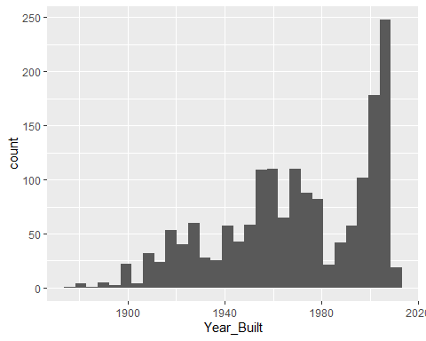

ggplot(student, aes(Year_Remod_Add)) + geom_histogram()

## `stat_bin()` using `bins = 30`. Pick better value with `binwidth`.

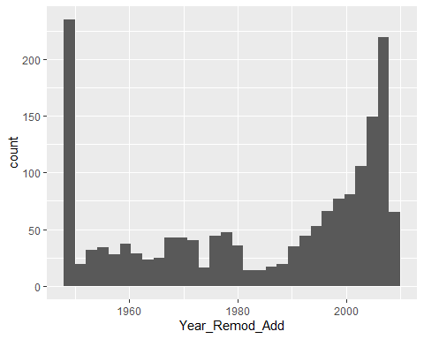

ggplot(student, aes(Total_Bsmt_SF)) + geom_histogram()

## `stat_bin()` using `bins = 30`. Pick better value with `binwidth`.

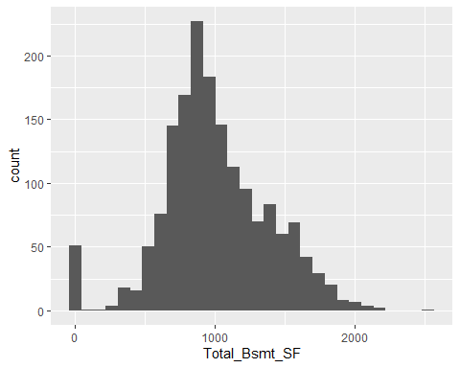

ggplot(student, aes(First_Flr_SF)) + geom_histogram()

## `stat_bin()` using `bins = 30`. Pick better value with `binwidth`.

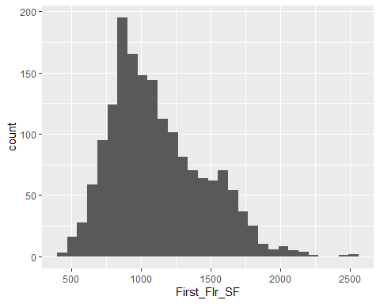

ggplot(student, aes(Full_Bath)) + geom_histogram()

## `stat_bin()` using `bins = 30`. Pick better value with `binwidth`.

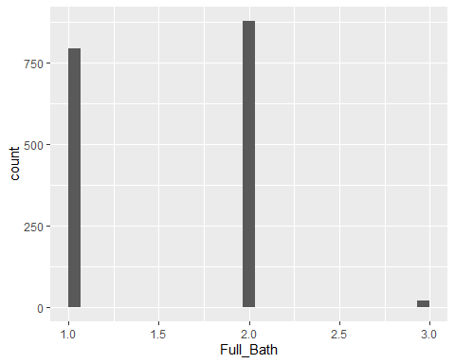

ggplot(student, aes(Garage_Cars)) + geom_histogram()

## `stat_bin()` using `bins = 30`. Pick better value with `binwidth`.

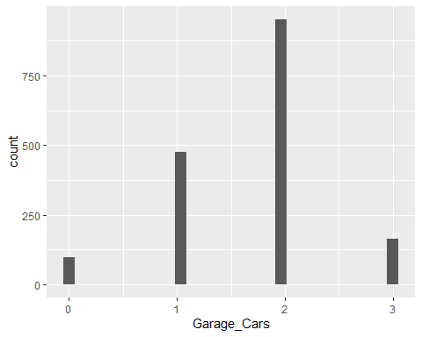

set.seed(123)  
student_split = initial_split(student, prob = 0.80, strata = Above_Median)  
train = training(student_split)  
test = testing(student_split)

p1 = ggplot(train, aes(x = MS_SubClass, fill = Above_Median)) + geom_bar(position = "fill")  
p2 = ggplot(train, aes(x = MS_Zoning, fill = Above_Median)) + geom_bar(position = "fill")  
p3 = ggplot(train, aes(x = Street, fill = Above_Median)) + geom_bar(position = "fill")  
p4 = ggplot(train, aes(x = Alley, fill = Above_Median)) + geom_bar(position = "fill")  
grid.arrange(p1,p2,p3,p4)

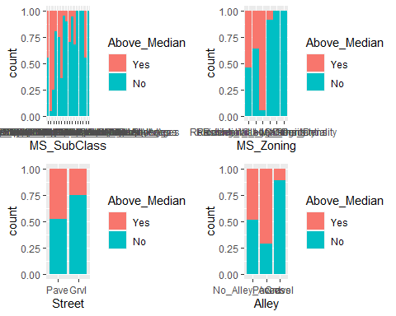

p1 = ggplot(train, aes(x = Lot_Shape, fill = Above_Median)) + geom_bar(position = "fill")  
p2 = ggplot(train, aes(x = Land_Contour, fill = Above_Median)) + geom_bar(position = "fill")  
p3 = ggplot(train, aes(x = Utilities, fill = Above_Median)) + geom_bar(position = "fill")  
p4 = ggplot(train, aes(x = Lot_Config, fill = Above_Median)) + geom_bar(position = "fill")  
grid.arrange(p1,p2,p3,p4)

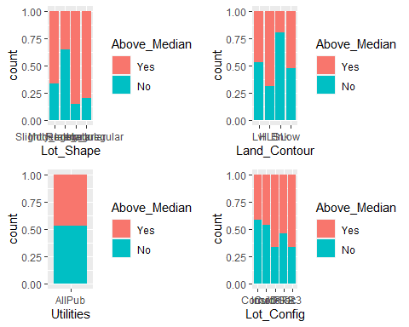

p1 = ggplot(train, aes(x = Land_Slope, fill = Above_Median)) + geom_bar(position = "fill")  
p2 = ggplot(train, aes(x = Condition_1, fill = Above_Median)) + geom_bar(position = "fill")  
p3 = ggplot(train, aes(x = Condition_2, fill = Above_Median)) + geom_bar(position = "fill")  
grid.arrange(p1,p2,p3)

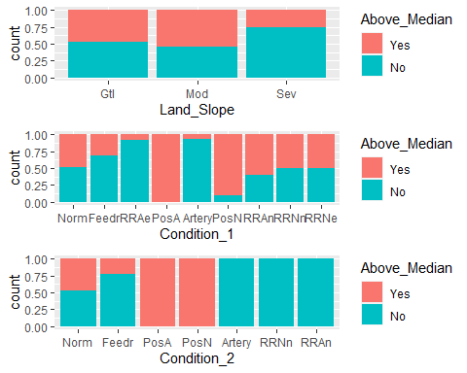

p1 = ggplot(train, aes(x = Bldg_Type, fill = Above_Median)) + geom_bar(position = "fill")  
p2 = ggplot(train, aes(x = House_Style, fill = Above_Median)) + geom_bar(position = "fill")  
p3 = ggplot(train, aes(x = Overall_Qual, fill = Above_Median)) + geom_bar(position = "fill")  
p4 = ggplot(train, aes(x = Overall_Cond, fill = Above_Median)) + geom_bar(position = "fill")  
grid.arrange(p1,p2,p3,p4)

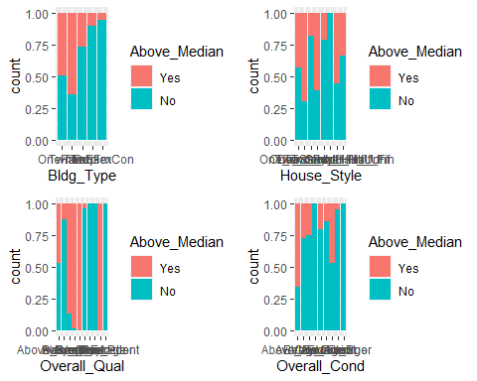

p1 = ggplot(train, aes(x = Roof_Style, fill = Above_Median)) + geom_bar(position = "fill")  
p2 = ggplot(train, aes(x = Roof_Matl, fill = Above_Median)) + geom_bar(position = "fill")  
p3 = ggplot(train, aes(x = Exterior_1st, fill = Above_Median)) + geom_bar(position = "fill")  
p4 = ggplot(train, aes(x = Exterior_2nd, fill = Above_Median)) + geom_bar(position = "fill")  
grid.arrange(p1,p2,p3,p4)

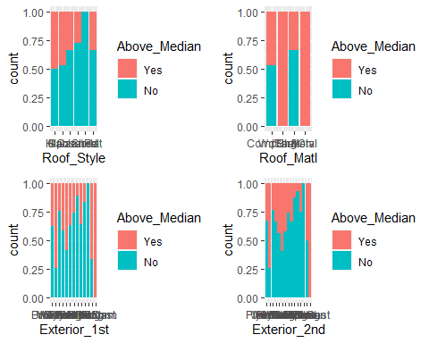

p1 = ggplot(train, aes(x = Mas_Vnr_Type, fill = Above_Median)) + geom_bar(position = "fill")  
p2 = ggplot(train, aes(x = Exter_Qual, fill = Above_Median)) + geom_bar(position = "fill")  
p3 = ggplot(train, aes(x = Exter_Cond, fill = Above_Median)) + geom_bar(position = "fill")  
p4 = ggplot(train, aes(x = Foundation, fill = Above_Median)) + geom_bar(position = "fill")  
grid.arrange(p1,p2,p3,p4)

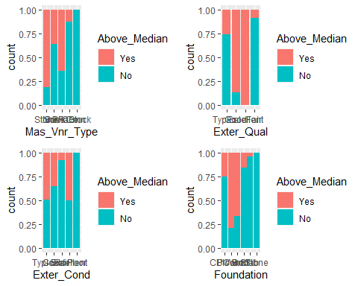

p1 = ggplot(train, aes(x = Bsmt_Qual, fill = Above_Median)) + geom_bar(position = "fill")  
p2 = ggplot(train, aes(x = Bsmt_Cond, fill = Above_Median)) + geom_bar(position = "fill")  
p3 = ggplot(train, aes(x = Bsmt_Exposure, fill = Above_Median)) + geom_bar(position = "fill")  
p4 = ggplot(train, aes(x = BsmtFin_Type_1, fill = Above_Median)) + geom_bar(position = "fill")  
grid.arrange(p1,p2,p3,p4)

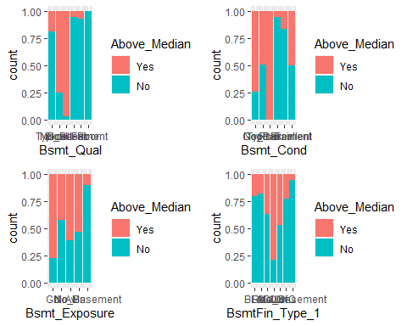

p1 = ggplot(train, aes(x = BsmtFin_Type_2, fill = Above_Median)) + geom_bar(position = "fill")  
p2 = ggplot(train, aes(x = Heating, fill = Above_Median)) + geom_bar(position = "fill")  
p3 = ggplot(train, aes(x = Heating_QC, fill = Above_Median)) + geom_bar(position = "fill")  
p4 = ggplot(train, aes(x = Central_Air, fill = Above_Median)) + geom_bar(position = "fill")  
grid.arrange(p1,p2,p3,p4)

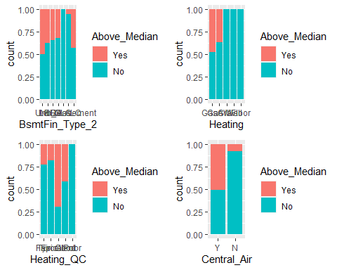

p1 = ggplot(train, aes(x = Electrical, fill = Above_Median)) + geom_bar(position = "fill")  
p2 = ggplot(train, aes(x = Kitchen_Qual, fill = Above_Median)) + geom_bar(position = "fill")  
p3 = ggplot(train, aes(x = Functional, fill = Above_Median)) + geom_bar(position = "fill")  
p4 = ggplot(train, aes(x = Fireplace_Qu, fill = Above_Median)) + geom_bar(position = "fill")  
grid.arrange(p1,p2,p3,p4)

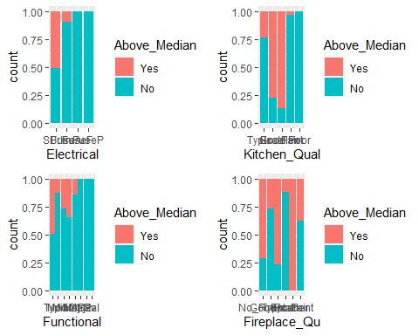

p1 = ggplot(train, aes(x = Garage_Type, fill = Above_Median)) + geom_bar(position = "fill")  
p2 = ggplot(train, aes(x = Garage_Finish, fill = Above_Median)) + geom_bar(position = "fill")  
p3 = ggplot(train, aes(x = Garage_Qual, fill = Above_Median)) + geom_bar(position = "fill")  
p4 = ggplot(train, aes(x = Garage_Cond, fill = Above_Median)) + geom_bar(position = "fill")  
grid.arrange(p1,p2,p3,p4)

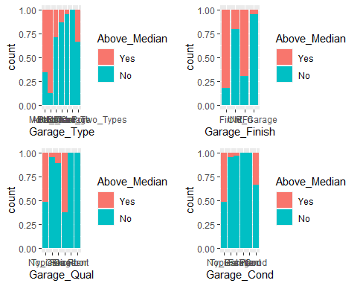

p1 = ggplot(train, aes(x = Paved_Drive, fill = Above_Median)) + geom_bar(position = "fill")  
p2 = ggplot(train, aes(x = Pool_QC, fill = Above_Median)) + geom_bar(position = "fill")  
p3 = ggplot(train, aes(x = Fence, fill = Above_Median)) + geom_bar(position = "fill")  
p4 = ggplot(train, aes(x = Misc_Feature, fill = Above_Median)) + geom_bar(position = "fill")  
grid.arrange(p1,p2,p3,p4)

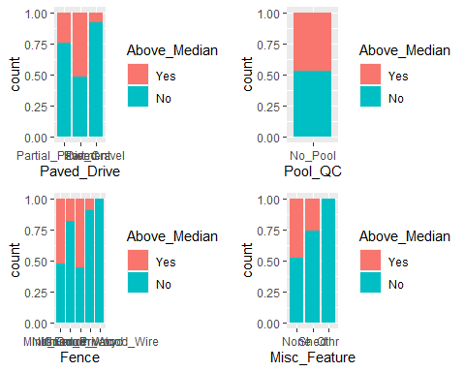

p1 = ggplot(train, aes(x = Mo_Sold, fill = Above_Median)) + geom_bar(position = "fill")  
p2 = ggplot(train, aes(x = Sale_Type, fill = Above_Median)) + geom_bar(position = "fill")  
p3 = ggplot(train, aes(x = Sale_Condition, fill = Above_Median)) + geom_bar(position = "fill")  
grid.arrange(p1,p2,p3, ncol = 2)

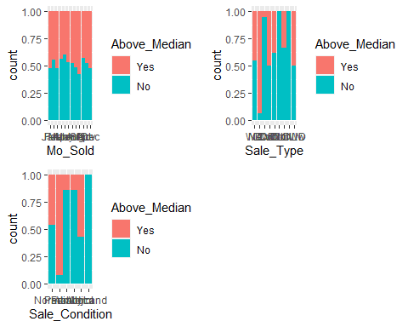

p1 = ggplot(train, aes(x = Above_Median, y = Lot_Frontage)) + geom_boxplot() + geom_jitter(alpha = 0.08) + theme_bw()  
p2 = ggplot(train, aes(x = Above_Median, y = Lot_Area)) + geom_boxplot() + geom_jitter(alpha = 0.08) + theme_bw()  
p3 = ggplot(train, aes(x = Above_Median, y = Year_Built)) + geom_boxplot() + geom_jitter(alpha = 0.08) + theme_bw()  
p4 = ggplot(train, aes(x = Above_Median, y = Year_Remod_Add)) + geom_boxplot() + geom_jitter(alpha = 0.08) + theme_bw()  
grid.arrange(p1,p2,p3,p4)

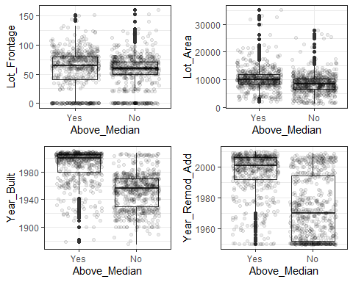

p1 = ggplot(train, aes(x = Above_Median, y = Mas_Vnr_Area)) + geom_boxplot() + geom_jitter(alpha = 0.01) + theme_bw()  
p2 = ggplot(train, aes(x = Above_Median, y = BsmtFin_SF_1)) + geom_boxplot() + geom_jitter(alpha = 0.08) + theme_bw()  
p3 = ggplot(train, aes(x = Above_Median, y = Bsmt_Unf_SF)) + geom_boxplot() + geom_jitter(alpha = 0.08) + theme_bw()  
p4 = ggplot(train, aes(x = Above_Median, y = Open_Porch_SF)) + geom_boxplot() + geom_jitter(alpha = 0.08) + theme_bw()  
grid.arrange(p1,p2,p3,p4)

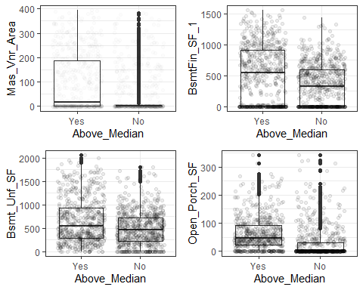

p1 = ggplot(train, aes(x = Above_Median, y = Total_Bsmt_SF)) + geom_boxplot() + geom_jitter(alpha = 0.08) + theme_bw()  
p2 = ggplot(train, aes(x = Above_Median, y = First_Flr_SF)) + geom_boxplot() + geom_jitter(alpha = 0.08) + theme_bw()  
p3 = ggplot(train, aes(x = Above_Median, y = Second_Flr_SF)) + geom_boxplot() + geom_jitter(alpha = 0.08) + theme_bw()  
p4 = ggplot(train, aes(x = Above_Median, y = Low_Qual_Fin_SF)) + geom_boxplot() + geom_jitter(alpha = 0.08) + theme_bw()  
grid.arrange(p1,p2,p3,p4)

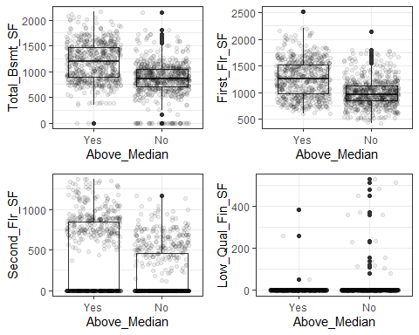

p1 = ggplot(train, aes(x = Above_Median, y = Gr_Liv_Area)) + geom_boxplot() + geom_jitter(alpha = 0.08) + theme_bw()  
p2 = ggplot(train, aes(x = Above_Median, y = Bsmt_Full_Bath)) + geom_boxplot() + geom_jitter(alpha = 0.08) + theme_bw()  
p3 = ggplot(train, aes(x = Above_Median, y = Bsmt_Half_Bath)) + geom_boxplot() + geom_jitter(alpha = 0.08) + theme_bw()  
p4 = ggplot(train, aes(x = Above_Median, y = Full_Bath)) + geom_boxplot() + geom_jitter(alpha = 0.08) + theme_bw()  
grid.arrange(p1,p2,p3,p4)

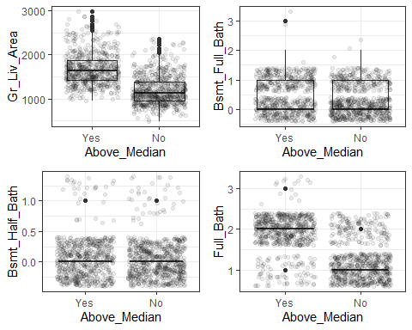

p1 = ggplot(train, aes(x = Above_Median, y = Half_Bath)) + geom_boxplot() + geom_jitter(alpha = 0.08) + theme_bw()  
p2 = ggplot(train, aes(x = Above_Median, y = Bedroom_AbvGr)) + geom_boxplot() + geom_jitter(alpha = 0.08) + theme_bw()  
p3 = ggplot(train, aes(x = Above_Median, y = Kitchen_AbvGr)) + geom_boxplot() + geom_jitter(alpha = 0.08) + theme_bw()  
p4 = ggplot(train, aes(x = Above_Median, y = TotRms_AbvGrd)) + geom_boxplot() + geom_jitter(alpha = 0.08) + theme_bw()  
grid.arrange(p1,p2,p3,p4)

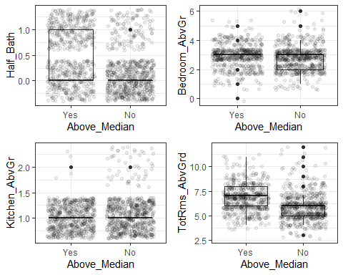

p1 = ggplot(train, aes(x = Above_Median, y = Fireplaces)) + geom_boxplot() + geom_jitter(alpha = 0.08) + theme_bw()  
p2 = ggplot(train, aes(x = Above_Median, y = Garage_Cars)) + geom_boxplot() + geom_jitter(alpha = 0.08) + theme_bw()  
p3 = ggplot(train, aes(x = Above_Median, y = Garage_Area)) + geom_boxplot() + geom_jitter(alpha = 0.08) + theme_bw()  
p4 = ggplot(train, aes(x = Above_Median, y = Wood_Deck_SF)) + geom_boxplot() + geom_jitter(alpha = 0.08) + theme_bw()  
grid.arrange(p1,p2,p3,p4)

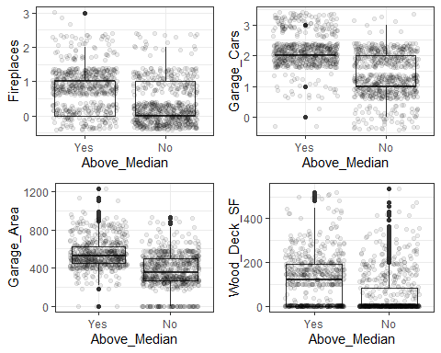

p1 = ggplot(train, aes(x = Above_Median, y = Year_Sold)) + geom_boxplot() + geom_jitter(alpha = 0.08) + theme_bw()  
p2 = ggplot(train, aes(x = Above_Median, y = Longitude)) + geom_boxplot() + geom_jitter(alpha = 0.08) + theme_bw()  
p3 = ggplot(train, aes(x = Above_Median, y = Latitude)) + geom_boxplot() + geom_jitter(alpha = 0.08) + theme_bw()  
grid.arrange(p1,p2,p3,ncol = 2)

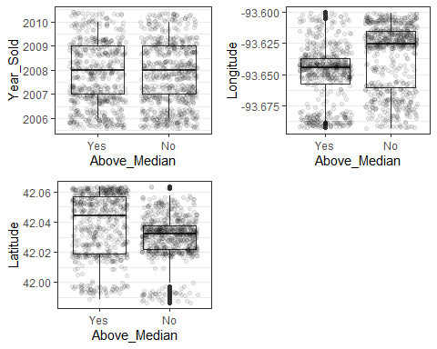

ggplot(train, aes(x = Neighborhood, y = Above_Median)) + geom_boxplot() + geom_jitter(alpha = 0.1) + theme_bw() +  
 theme(axis.text.x = element_text(angle = 90))

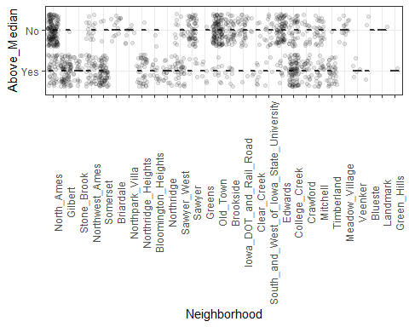

student_recipe = recipe(Above_Median ~., train) %>%  
 step_other(Neighborhood,threshold = .02) %>%  
 step_other(MS_SubClass,threshold = .02) %>%  
 step_other(Overall_Qual,threshold = .02) %>%  
 step_other(Overall_Cond,threshold = .02) %>%  
 step_other(Exterior_1st,threshold = .02) %>%  
 step_other(Exterior_2nd,threshold = .02) %>%  
 step_other(Condition_1,threshold = .02) %>%  
 step_other(Condition_2,threshold = .02) %>%  
 step_other(Functional,threshold = .02) %>%  
 step_other(Sale_Type,threshold = .02) %>%  
 step_dummy(all_nominal(), -all_outcomes())  
  
rf_model = rand_forest() %>%  
 set_engine("ranger", importance = "permutation") %>%  
 set_mode("classification")  
  
student_wflow =  
 workflow() %>%  
 add_model(rf_model) %>%  
 add_recipe(student_recipe)  
  
set.seed(123)  
student_fit = fit(student_wflow, train)

trainpredrf = predict(student_fit, train)  
head(trainpredrf)

## # A tibble: 6 x 1  
## .pred_class  
## <fct>   
## 1 Yes   
## 2 No   
## 3 Yes   
## 4 Yes   
## 5 Yes   
## 6 Yes

confusionMatrix(trainpredrf$.pred_class, train$Above_Median,   
 positive = "Yes")

## Confusion Matrix and Statistics  
##   
## Reference  
## Prediction Yes No  
## Yes 593 7  
## No 7 662  
##   
## Accuracy : 0.989   
## 95% CI : (0.9816, 0.994)  
## No Information Rate : 0.5272   
## P-Value [Acc > NIR] : <2e-16   
##   
## Kappa : 0.9779   
##   
## Mcnemar's Test P-Value : 1   
##   
## Sensitivity : 0.9883   
## Specificity : 0.9895   
## Pos Pred Value : 0.9883   
## Neg Pred Value : 0.9895   
## Prevalence : 0.4728   
## Detection Rate : 0.4673   
## Detection Prevalence : 0.4728   
## Balanced Accuracy : 0.9889   
##   
## 'Positive' Class : Yes   
##

testpredrf = predict(student_fit, test)  
head(testpredrf)

## # A tibble: 6 x 1  
## .pred_class  
## <fct>   
## 1 Yes   
## 2 Yes   
## 3 Yes   
## 4 No   
## 5 Yes   
## 6 Yes

confusionMatrix(testpredrf$.pred_class, test$Above_Median,   
 positive = "Yes")

## Confusion Matrix and Statistics  
##   
## Reference  
## Prediction Yes No  
## Yes 175 6  
## No 24 216  
##   
## Accuracy : 0.9287   
## 95% CI : (0.8998, 0.9514)  
## No Information Rate : 0.5273   
## P-Value [Acc > NIR] : < 2.2e-16   
##   
## Kappa : 0.8564   
##   
## Mcnemar's Test P-Value : 0.001911   
##   
## Sensitivity : 0.8794   
## Specificity : 0.9730   
## Pos Pred Value : 0.9669   
## Neg Pred Value : 0.9000   
## Prevalence : 0.4727   
## Detection Rate : 0.4157   
## Detection Prevalence : 0.4299   
## Balanced Accuracy : 0.9262   
##   
## 'Positive' Class : Yes   
##

student_fit %>% pull_workflow_fit() %>% vip(geom = "point")

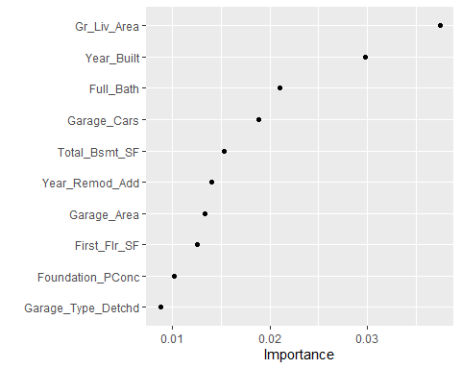

ggplot(student, aes(x = Above_Median, y = Gr_Liv_Area)) + geom_boxplot() + geom_jitter(alpha = 0.08) + theme_bw()

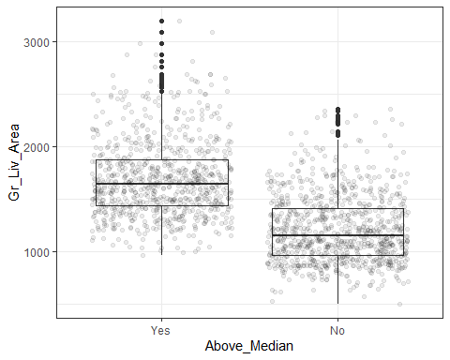

ggplot(student, aes(x = Above_Median, y = Year_Built)) + geom_boxplot() + geom_jitter(alpha = 0.08) + theme_bw()

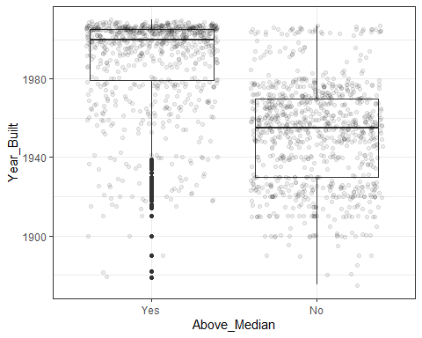

ggplot(student, aes(x = Above_Median, y = Full_Bath)) + geom_boxplot() + geom_jitter(alpha = 0.08) + theme_bw()

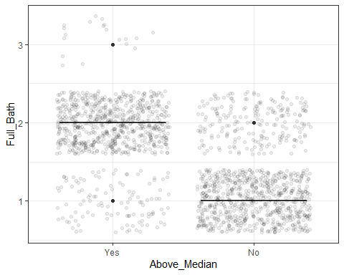

ggplot(student, aes(x = Full_Bath, fill = Above_Median)) + geom_bar(position = "fill")

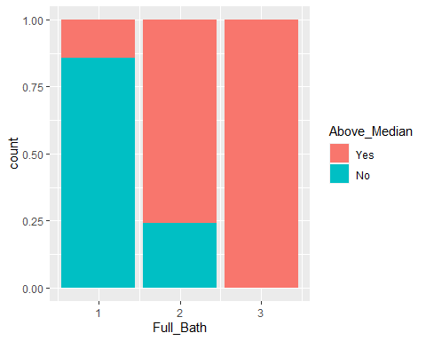

t3 = table(student$Above_Median, student$Full_Bath)  
prop.table(t3, margin = 2)

##   
## 1 2 3  
## Yes 0.1437579 0.7585421 1.0000000  
## No 0.8562421 0.2414579 0.0000000

ggplot(student, aes(x = Above_Median, y = Garage_Cars)) + geom_boxplot() + geom_jitter(alpha = 0.08) + theme_bw()

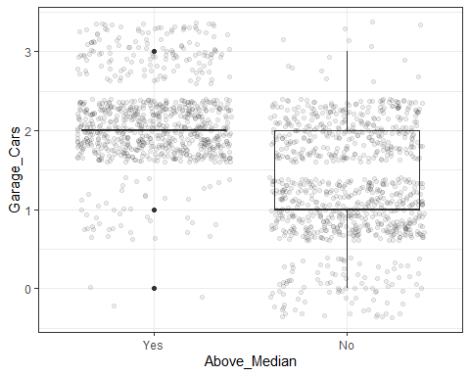

ggplot(student, aes(x = Garage_Cars, fill = Above_Median)) + geom_bar(position = "fill")

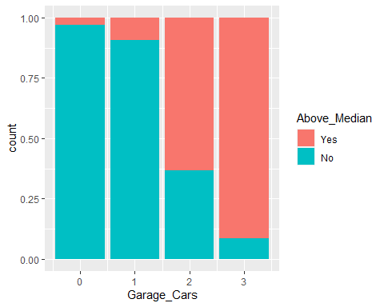

t4 = table(student$Above_Median, student$Garage_Cars)  
prop.table(t4, margin = 2)

##   
## 0 1 2 3  
## Yes 0.03061224 0.09224319 0.63340336 0.91411043  
## No 0.96938776 0.90775681 0.36659664 0.08588957

p1 = ggplot(student, aes(x = Above_Median, y = Gr_Liv_Area)) + geom_boxplot() + geom_jitter(alpha = 0.08) + theme_bw()  
p2 = ggplot(student, aes(x = Above_Median, y = Year_Built)) + geom_boxplot() + geom_jitter(alpha = 0.08) + theme_bw()  
p3 = ggplot(student, aes(x = Above_Median, y = Garage_Cars)) + geom_boxplot() + geom_jitter(alpha = 0.08) + theme_bw()  
p4 = ggplot(student, aes(x = Above_Median, y = Full_Bath)) + geom_boxplot() + geom_jitter(alpha = 0.08) + theme_bw()  
grid.arrange(p1,p2,p3,p4)

