Project Phase2

Engel, Alec

3/6/2021

Load in data set

# summary(student)  
# glimpse(student)  
# skim(student)

Data cleaning to adjust for bad values, convert characters into factors and remove unnecessary variables.

student = student %>% dplyr::select(-X1, -Utilities, -Roof_Matl, -Electrical, -Longitude, -Latitude, -Misc_Feature, -Misc_Val, -MS_Zoning, -Condition_2, Roof_Style, -Kitchen_AbvGr, -Roof_Style, -Mas_Vnr_Type, -Mas_Vnr_Area, -Bsmt_Cond, -Heating, -Sale_Type, -Lot_Frontage, -Alley, -Condition_1, Exterior_2nd, -Bsmt_Exposure, -BsmtFin_Type_2, -Low_Qual_Fin_SF, -Bsmt_Half_Bath, -Exterior_2nd, -Fireplace_Qu, -Pool_Area) %>%   
 mutate_if(is.character,as_factor) %>%   
 mutate(Mo_Sold = as_factor(Mo_Sold)) %>%  
 mutate(Mo_Sold = fct_recode(Mo_Sold, "Jan" = "1", "Feb" = "2", "Mar" = "3", "Apr" = "4", "May" = "5", "Jun" = "6",   
 "Jul" = "7", "Aug" = "8", "Sep" = "9", "Oct" = "10", "Nov" = "11", "Dec" = "12")) %>%  
 mutate(BsmtFin_SF_1 = Total_Bsmt_SF - BsmtFin_SF_2 - Bsmt_Unf_SF)

Eliminate outliers

student = student %>%  
 filter(Lot_Area < 40000) %>%  
 filter(BsmtFin_SF_1 < 1600) %>%  
 filter(BsmtFin_SF_2 < 400) %>%  
 filter(Bsmt_Unf_SF < 2250) %>%  
 filter(Total_Bsmt_SF < 2750) %>%  
 filter(Full_Bath > 0) %>%  
 filter(Half_Bath < 1.1) %>%  
 filter(First_Flr_SF < 2750) %>%  
 filter(Second_Flr_SF < 1400) %>%  
 filter(Gr_Liv_Area < 3750) %>%  
 filter(Fireplaces < 4) %>%  
 filter(Garage_Cars < 4) %>%  
 filter(Garage_Area < 1250) %>%  
 filter(Wood_Deck_SF < 550) %>%  
 filter(Open_Porch_SF < 350) %>%  
 filter(Enclosed_Porch < 300) %>%  
 filter(Three_season_porch < 240) %>%  
 filter(Screen_Porch < 400)

Train and test split

set.seed(123)  
student_split = initial_split(student, prob = 0.75, strata = Above_Median)  
train = training(student_split)  
test = testing(student_split)

5 K Folds

set.seed(123)  
folds = vfold_cv(train, v = 5)

Basic recipe

student_recipe = recipe(Above_Median ~., train) %>%  
 step_other(Neighborhood,threshold = .02) %>%  
 step_other(MS_SubClass,threshold = .02) %>%  
 step_other(Overall_Qual,threshold = .02) %>%  
 step_other(Overall_Cond,threshold = .02) %>%  
 step_other(Exterior_1st,threshold = .02) %>%  
 step_other(Functional,threshold = .02) %>%  
 step_dummy(all_nominal(), -all_outcomes()) %>%  
 step_nzv(all_predictors())  
  
ctrl_grid = control_stack_grid()  
ctrl_res = control_stack_resamples()

***Student Log Regression***

# student_log_model =   
# logistic_reg(mode = "classification") %>%  
# set_engine("glm")  
#   
# student_log_recipe = student_recipe %>%  
# step_dummy(all_nominal(), -all_outcomes())  
#   
# logreg_wf = workflow() %>%  
# add_recipe(student_log_recipe) %>%   
# add_model(student_log_model)  
#   
# set.seed(123)  
# log_res =  
# tune_grid(  
# logreg_wf,  
# resamples = folds,  
# grid = 200,  
# control = ctrl_grid  
# )

# saveRDS(log_res,"log_res.rds")

log_res = readRDS("log_res.rds")

***Student Classification Tree Model***

# tree_model = decision_tree(cost_complexity = tune()) %>%  
# set_engine("rpart", model = TRUE) %>%  
# set_mode("classification")  
#   
# tree_recipe = student_recipe  
#   
# tree_workflow = workflow() %>%  
# add_model(tree_model) %>%  
# add_recipe(tree_recipe)  
#   
# set.seed(123)  
# tree_res =  
# tree_workflow %>%  
# tune_grid(  
# resamples = folds,  
# grid = 200,  
# control = ctrl_grid  
# )

# saveRDS(tree_res,"tree_res.rds")

tree_res = readRDS("tree_res.rds")

Classification Tree Model Accuracy Chart

tree_res %>%  
 collect_metrics() %>%  
 ggplot(aes(cost_complexity, mean)) +  
 geom_line(size = 1.5, alpha = 0.6) +  
 geom_point(size = 2) +  
 facet_wrap(~ .metric, scales = "free", nrow = 2)

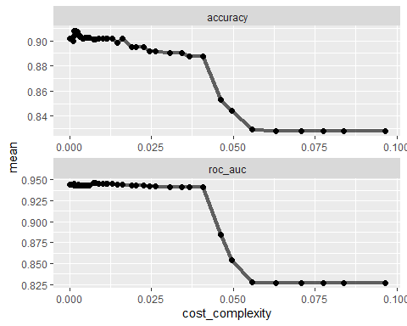

***Student Random Forest Model***

# rf_recipe = student_recipe  
#   
# rf_model = rand_forest(mtry = tune(), min_n = tune(), trees = 200) %>%  
# set_engine("ranger", importance = "permutation") %>%  
# set_mode("classification")  
#   
# rf_wflow =  
# workflow() %>%  
# add_model(rf_model) %>%  
# add_recipe(rf_recipe)  
#   
# set.seed(123)  
# rf_res = tune_grid(  
# rf_wflow,  
# resamples = folds,  
# grid = 200,  
# control = ctrl_grid  
# )

# saveRDS(rf_res,"rf_res.rds")

rf_res = readRDS("rf_res.rds")

Random Forest Model Accuracy Chart

rf_res %>%  
 collect_metrics() %>%  
 filter(.metric == "accuracy") %>%  
 mutate(min_n = factor(min_n)) %>%  
 ggplot(aes(mtry, mean, color = min_n)) +  
 geom_line(alpha = 0.5, size = 1.5) +  
 geom_point() +  
 labs(y = "Accuracy")

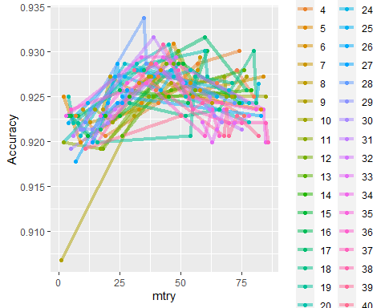

***Student Neural Network Model***

# nn_recipe = student_recipe %>%  
# step_normalize(all_predictors(), -all_nominal()) %>%  
# step_dummy(all_nominal(), -all_outcomes())  
#   
# nn_model =  
# mlp(hidden_units = tune(), penalty = tune(),  
# epochs = tune()) %>%  
# set_mode("classification") %>%  
# set_engine("nnet", verbose = 0)  
#   
# nn_workflow <-  
# workflow() %>%  
# add_recipe(nn_recipe) %>%  
# add_model(nn_model)  
#   
# set.seed(123)  
# neural_res <-  
# tune_grid(nn_workflow,  
# resamples = folds,  
# grid = 200,  
# control = ctrl_grid)

# saveRDS(neural_res,"neural_res.rds")

neural_res = readRDS("neural_res.rds")

Neural Network Model Epochs/Hidden_units/Penalties Charts #1

neural_res %>%  
 collect_metrics() %>%  
 filter(.metric == "accuracy") %>%  
 dplyr::select(mean, hidden_units, penalty, epochs) %>%  
 pivot_longer(hidden_units:epochs,  
 values_to = "value",  
 names_to = "parameter"  
 ) %>%  
 ggplot(aes(value, mean, color = parameter)) +  
 geom_point(show.legend = FALSE) +  
 facet_wrap(~parameter, scales = "free_x") +  
 labs(x = NULL, y = "Accuracy")

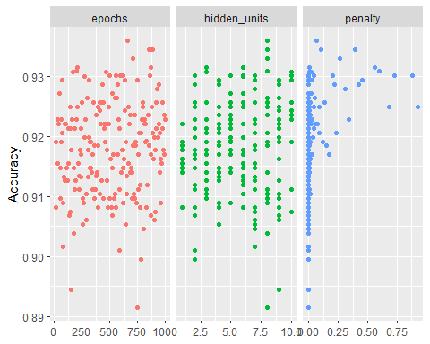

Neural Network Model Epochs/Hidden_units/Penalties Charts #2

neural_res %>%  
 collect_metrics() %>%  
 filter(.metric == "accuracy") %>%  
 mutate(hidden_units = factor(hidden_units)) %>%  
 ggplot(aes(penalty, mean, color = epochs)) +  
 geom_line(alpha = 0.5, size = 1.5) +  
 geom_point() +  
 facet_wrap(~hidden_units, ncol =2 ) +   
 labs(y = "Accuracy")

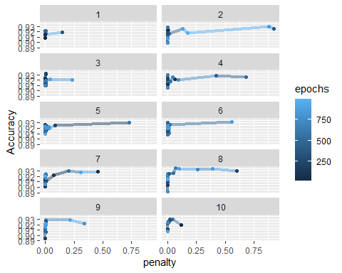

***Student Neural Network Model with Parameter Tuning***

# neural_grid = grid_regular(  
# hidden_units(range = c(7,8)),  
# penalty(range = c(-10,-1)),  
# epochs(range = c(625,925)),  
# levels = 5  
# )  
#   
# student_nn_recipe = student_recipe %>%  
# step_normalize(all_predictors(), -all_nominal()) %>%  
# step_dummy(all_nominal(), -all_outcomes())  
#   
# student_nn_model =  
# mlp(hidden_units = tune(), penalty = tune(),  
# epochs = tune()) %>%  
# set_mode("classification") %>%  
# set_engine("nnet", verbose = 0)  
#   
# student_nn_workflow <-  
# workflow() %>%  
# add_recipe(student_nn_recipe) %>%  
# add_model(student_nn_model)  
#   
# set.seed(123)  
# neural_tune_res <-  
# tune_grid(student_nn_workflow, resamples = folds, grid = neural_grid, control = ctrl_grid)

# saveRDS(neural_tune_res,"neural_tune_res.rds")

neural_tune_res = readRDS("neural_tune_res.rds")

Neural Network Parameter Tuned Epochs/Hidden_units/Penalties Charts

neural_tune_res %>%  
 collect_metrics() %>%  
 filter(.metric == "accuracy") %>%  
 dplyr::select(mean, hidden_units, penalty, epochs) %>%  
 pivot_longer(hidden_units:epochs,  
 values_to = "value",  
 names_to = "parameter"  
 ) %>%  
 ggplot(aes(value, mean, color = parameter)) +  
 geom_point(show.legend = FALSE) +  
 facet_wrap(~parameter, scales = "free_x") +  
 labs(x = NULL, y = "Accuracy")

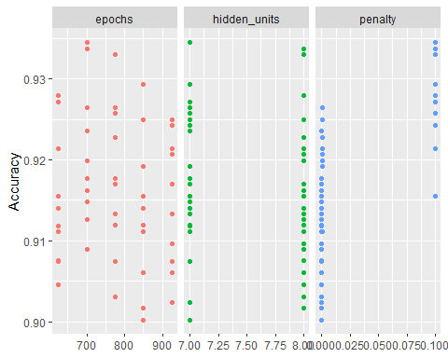

Neural Network Parameter Tuned Model Epochs/Hidden_units/Penalties Charts #2

neural_tune_res %>%  
 collect_metrics() %>%  
 filter(.metric == "accuracy") %>%  
 mutate(hidden_units = factor(hidden_units)) %>%  
 ggplot(aes(penalty, mean, color = epochs)) +  
 geom_line(alpha = 0.5, size = 1.5) +  
 geom_point() +  
 facet_wrap(~hidden_units, ncol =2 ) +   
 labs(y = "Accuracy")

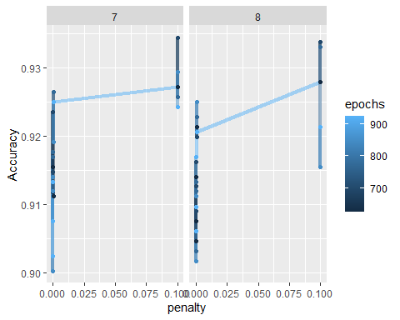

\***Student XGBOOST Model**

# xgboost_recipe2 <- student_recipe %>%  
# #step_novel(all_nominal(), -all_outcomes()) %>%  
# step_dummy(all_nominal(), -all_outcomes(), one_hot = TRUE) %>%  
# step_zv(all_predictors())  
#   
# xgboost_spec2 <-  
# boost_tree(trees = tune(), min_n = tune(), tree_depth = tune(), learn_rate = tune(),  
# loss_reduction = tune(), sample_size = tune()) %>%  
# set_mode("classification") %>%  
# set_engine("xgboost")  
#   
# xgboost_workflow2 <-  
# workflow() %>%  
# add_recipe(xgboost_recipe2) %>%  
# add_model(xgboost_spec2)  
#   
# set.seed(123)  
# xgboost_tune_res <-  
# tune_grid(xgboost_workflow2, resamples = folds, grid = 200, control = ctrl_grid)

# saveRDS(xgboost_tune_res,"xgboost_tune_res.rds")

xgboost_tune_res = readRDS("xgboost_tune_res.rds")

\***Student XGBOOST Model with Parameter Tuning**

# tgrid = expand.grid(  
# trees = 100,  
# min_n = 1,  
# tree_depth = c(1,2,3,4),  
# learn_rate = c(0.01, 0.1, 0.2, 0.3, 0.4),  
# loss_reduction = 0,  
# sample_size = c(0.5, 0.8, 1))  
#   
# xgboost_recipe <-  
# student_recipe %>%  
# step_dummy(all_nominal(), -all_outcomes(), one_hot = TRUE) %>%  
# step_zv(all_predictors())  
#   
# xgboost_spec <-  
# boost_tree(trees = tune(), min_n = tune(), tree_depth = tune(), learn_rate = tune(),  
# loss_reduction = tune(), sample_size = tune()) %>%  
# set_mode("classification") %>%  
# set_engine("xgboost")  
#   
# xgboost_workflow <-  
# workflow() %>%  
# add_recipe(xgboost_recipe) %>%  
# add_model(xgboost_spec)  
#   
# set.seed(123)  
# xgb_res <-  
# tune_grid(xgboost_workflow,  
# resamples = folds,  
# grid = tgrid,  
# control = ctrl_grid)

# saveRDS(xgb_res,"xgb_res.rds")

xgb_res = readRDS("xgb_res.rds")

***Stacking*** Building Stack

student_stacks = stacks() %>%  
 add_candidates(tree_res) %>%  
 add_candidates(rf_res) %>%   
 add_candidates(xgb_res) %>%  
 add_candidates(neural_tune_res) %>%  
 add_candidates(log_res)  
 # add_candidates(neural_res)  
 # add_candidates(xgboost_tune_res)

fitting a Lasso model to the stack.

student_blend =   
 student_stacks %>%   
 blend_predictions(metric = metric_set(accuracy))

##   
## Attaching package: 'rlang'

## The following objects are masked from 'package:purrr':  
##   
## %@%, as_function, flatten, flatten_chr, flatten_dbl, flatten_int,  
## flatten_lgl, flatten_raw, invoke, list_along, modify, prepend,  
## splice

##   
## Attaching package: 'vctrs'

## The following object is masked from 'package:dplyr':  
##   
## data_frame

## The following object is masked from 'package:tibble':  
##   
## data_frame

Strongest Resulting Models

autoplot(student_blend, type = "weights")

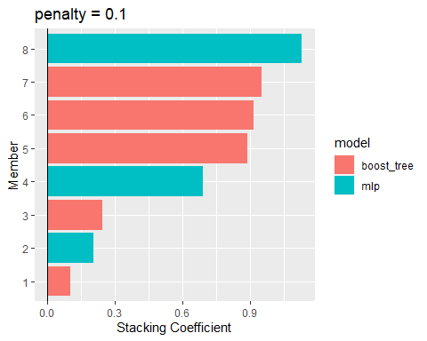

Fitting the stack to training data

#student_blend <- # student_blend %>% # fit_members()

Training data predictions

trainpredstack = predict(student_blend, train)  
head(trainpredstack)

## # A tibble: 6 x 1  
## .pred_class  
## <fct>   
## 1 Yes   
## 2 No   
## 3 Yes   
## 4 Yes   
## 5 Yes   
## 6 Yes

Training data confusion matrix

confusionMatrix(trainpredstack$.pred_class, train$Above_Median,   
 positive = "Yes")

## Confusion Matrix and Statistics  
##   
## Reference  
## Prediction Yes No  
## Yes 676 3  
## No 4 690  
##   
## Accuracy : 0.9949   
## 95% CI : (0.9895, 0.9979)  
## No Information Rate : 0.5047   
## P-Value [Acc > NIR] : <2e-16   
##   
## Kappa : 0.9898   
##   
## Mcnemar's Test P-Value : 1   
##   
## Sensitivity : 0.9941   
## Specificity : 0.9957   
## Pos Pred Value : 0.9956   
## Neg Pred Value : 0.9942   
## Prevalence : 0.4953   
## Detection Rate : 0.4924   
## Detection Prevalence : 0.4945   
## Balanced Accuracy : 0.9949   
##   
## 'Positive' Class : Yes   
##

Test data predictions

testpredstack = predict(student_blend, test)  
head(testpredstack)

## # A tibble: 6 x 1  
## .pred_class  
## <fct>   
## 1 Yes   
## 2 Yes   
## 3 Yes   
## 4 No   
## 5 Yes   
## 6 Yes

Test data confusion matrix

confusionMatrix(testpredstack$.pred_class, test$Above_Median,   
 positive = "Yes")

## Confusion Matrix and Statistics  
##   
## Reference  
## Prediction Yes No  
## Yes 204 18  
## No 22 213  
##   
## Accuracy : 0.9125   
## 95% CI : (0.8827, 0.9367)  
## No Information Rate : 0.5055   
## P-Value [Acc > NIR] : <2e-16   
##   
## Kappa : 0.8249   
##   
## Mcnemar's Test P-Value : 0.6353   
##   
## Sensitivity : 0.9027   
## Specificity : 0.9221   
## Pos Pred Value : 0.9189   
## Neg Pred Value : 0.9064   
## Prevalence : 0.4945   
## Detection Rate : 0.4464   
## Detection Prevalence : 0.4858   
## Balanced Accuracy : 0.9124   
##   
## 'Positive' Class : Yes   
##

Comparison of model performance on test set

test = test %>% bind_cols(predict(student_blend,.))

Stacked model compared to constituent models

member_testpreds =   
 test %>%  
 dplyr::select(Above_Median) %>%  
 bind_cols(predict(student_blend, test, members = TRUE))

map_dfr(member_testpreds, accuracy, truth = Above_Median, data = member_testpreds) %>%  
 mutate(member = colnames(member_testpreds))

## # A tibble: 10 x 4  
## .metric .estimator .estimate member   
## <chr> <chr> <dbl> <chr>   
## 1 accuracy binary 1 Above_Median   
## 2 accuracy binary 0.912 .pred_class   
## 3 accuracy binary 0.906 .pred_class_xgb_res_1_11   
## 4 accuracy binary 0.906 .pred_class_xgb_res_1_15   
## 5 accuracy binary 0.908 .pred_class_xgb_res_1_24   
## 6 accuracy binary 0.899 .pred_class_xgb_res_1_27   
## 7 accuracy binary 0.902 .pred_class_xgb_res_1_53   
## 8 accuracy binary 0.893 .pred_class_neural_tune_res_1_13  
## 9 accuracy binary 0.906 .pred_class_neural_tune_res_1_27  
## 10 accuracy binary 0.904 .pred_class_neural_tune_res_1_20

Implementation of stack on competition set

# competition = read_csv("ames_competition.csv")

# competition = competition %>%  
# mutate_if(is.character,as_factor) %>%   
# mutate(Mo_Sold = as_factor(Mo_Sold)) %>%  
# mutate(Mo_Sold = fct_recode(Mo_Sold, "Jan" = "1", "Feb" = "2", "Mar" = "3", "Apr" = "4", "May" = "5", "Jun" = "6",   
# "Jul" = "7", "Aug" = "8", "Sep" = "9", "Oct" = "10", "Nov" = "11", "Dec" = "12")) %>%  
# mutate(BsmtFin_SF_1 = Total_Bsmt_SF - BsmtFin_SF_2 - Bsmt_Unf_SF)

# competitionpredstack = predict(student_blend, competition)  
# head(competitionpredstack)

# kaggle = competition %>% dplyr::select(X1)  
#   
# kaggle = bind_cols(kaggle, competitionpredstack)  
#   
# kaggle

# write.csv(kaggle, "kaggle_submit4.csv", row.names=FALSE)