**Project Visualization Descriptions**

I was fortunate enough to receive approval for a work-related dataset for this project. I created mapping charts internally for client IDs and primary CSR’s (client service representatives) confidentiality. The data I used primarily contained client IDs, 2019 revenues, 2020 revenues, 2020 fee charges, CSRs, and time spent by CSRs working on each client. After formulating a storyboard plan on paper, the main stories I wanted to tell with this data was if time resources spent per client revenues are worth it, show year over year client increases and decreases, and 2021 trajectories along with ways to increase future revenues. Through this process I created eighteen visualizations and condensed the relevant ones into four dashboards.

**Time/Revenue Table Comparison**

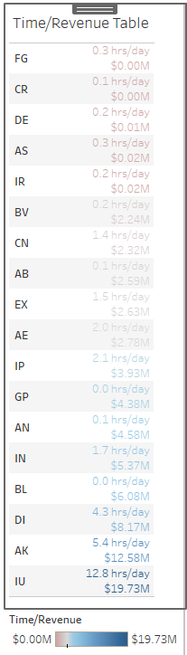

This visualization helps to highlight clients we are spending time on that generate no revenue or not substantial enough revenue for the amount of time spent. The challenge was pointing those specific clients out and determining who to filter for but with hue variations and re-sorting from lowest revenue produced at the top, I believe I was able to create a clear message. I’ve color coded the red with those items and also included blue clients in which high revenue positively correlates to time spent to give some comparison perspective. Clients FG and CR aren’t generating any revenue and need to be offboarded. Clients GP, AN, and BL are generating tremendous revenue for how few hours need to be spent on them per day.

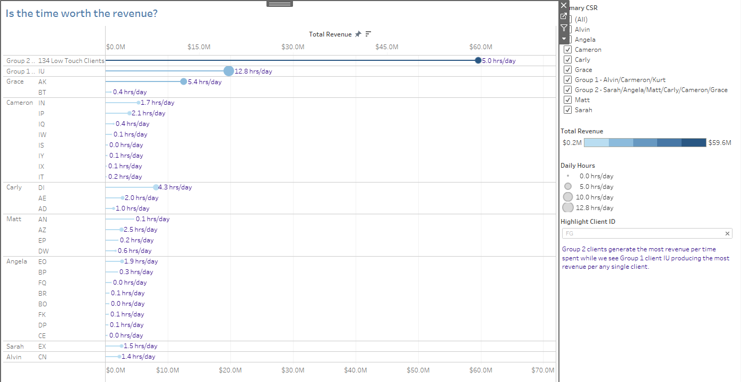**Lollipop Chart to Compare Time and Revenue Per Primary CSR Groups**

This lollipop visualization helps to show primary CSR hours spent per day with specific clients. We can also view each client’s revenue produced with lollipop circles at the end having radius sizing in relation to hours spent by CSRs. I believe this visualization far exceeds the traditional bar chart which I had originally thought to create for this comparison. I’ve also sorted by highest revenue of primary CSR which highlights the importance of Group 1 and Group 2. Although Alvin and Kurt have minimal if any individual client revenue or hours, I’ve worked to clearly label the key of each group to show which CSRs also have a hand in those groups. Saturation of blue colors also plays a role in showing much greater revenue amongst Group 2 clients along with their minimal 5 hours per day as opposed to Group 1’s 12.8 hours per day working on the one client IU. This one client however is clearly important as it single handedly generated $19.7M in 2020.

**Scatter Plot with Trend Lines for Client Revenue vs. Daily Hours**

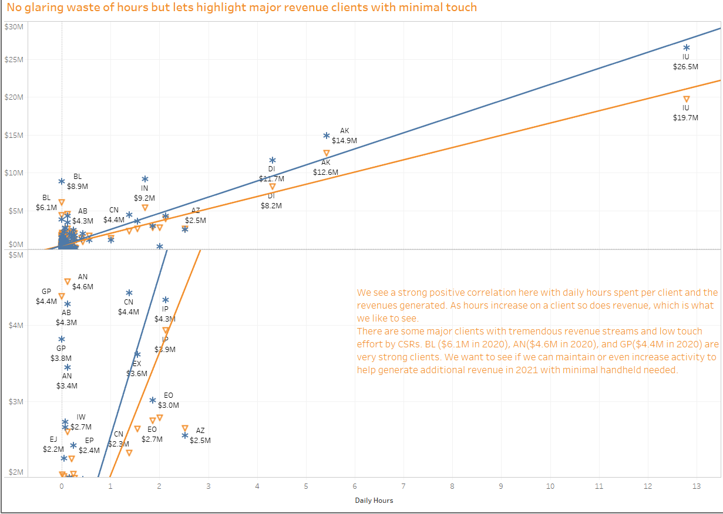

I’ve incorporated two charts in one here with the correlation of client revenue and time spent on a client by CSRs. The top chart is overall comparisons with 2019 and 2020 while the bottom chart has been zoomed in on to clearly visualize relatively decent revenue generating clients and time spent to maintain them. The story being told here is that a clear positive correlation exists with time and revenues per client which is what we want to see. If there were any clients with 2020 revenues close to the y-axis of $0 and any time spent (moving to the right across the x-axis), we would have a problem and need to figure out why we are spending time on clients that generate us no money. That however was not the case here. On the positive side, I was able to highlight specific clients that generate millions of dollars in revenue but CSRs spend little to no time maintaining. I would say that these findings should receive a deeper dive to be sure they are accurate and if they are, further investigate ways to maintain or even increase revenue generated by these specific clients.

**Box Plot with Whiskers and Jitter to Plot Revenues Amongst All Clients**

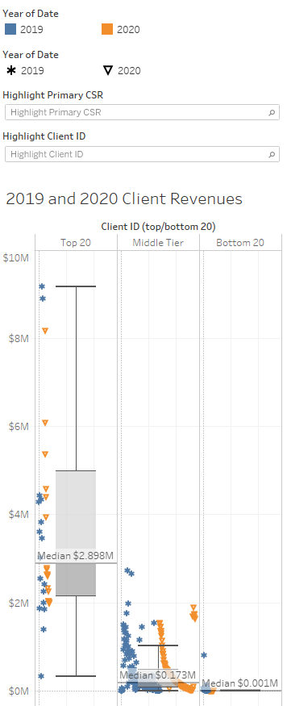

This boxplot was a clear indication of how top weighted our business is. We see almost all revenues generated from top 20 clients with a median close to $3M, moderately low revenue figures generated from middle tier clients with a median of $.17M, and bottom 20 clients which typically earn below $.001M. This graphic is also zoomed in a bit with y-axis max of $10M in order to focus the viewer on the middle and lower tier client data points that are vastly lower than the top 20 ones. Blue and orange hue variations and shapes also help tell the story of drop-off from 2019 to 2020 revenues. You can clearly see with the jitter applied that orange data points seem to be slightly below correlating blue ones.

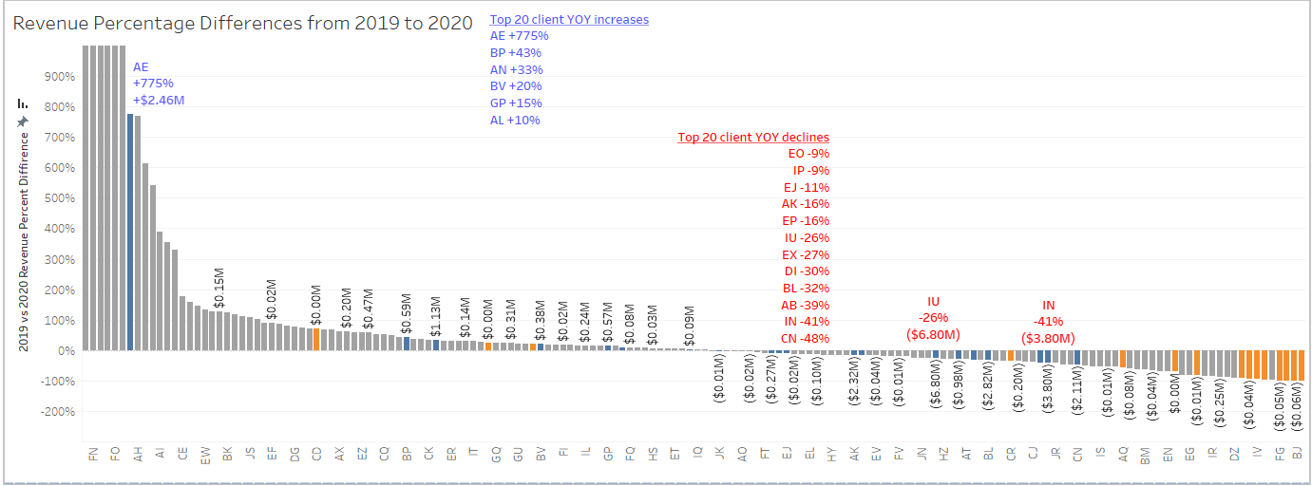**Diverging Bars of Revenue Percentages and Dollar Amounts**

Greatest client revenue change from 2019 to 2020 is the key focus in this chart. Hue was used yet again to highlight top 20 and bottom 20 clients. Blue and red variations were also included to detail greatest percentage changes from year over year. Money details were also added to this chart because even though a client may have increased or decreased by a large percentage, if their revenue was low to begin with then it really wouldn’t represent that large of a revenue loss or gain money wise. A deeper dive into client AE is needed here to determine why the major revenue increase in 2020 and to determine ways to replicate with other clients in 2021. I’ve also stated that we need to revisit the work done with clients IU, IN, AK, BL, and CN to determine cause for $2M plus revenue declines in 2020 and reach out to each client to see if we can get any of those revenues back.

**Year Over Year Slope Graphs with Hue Variations for Biggest Increase/Decrease and Top/Bottom Clients**

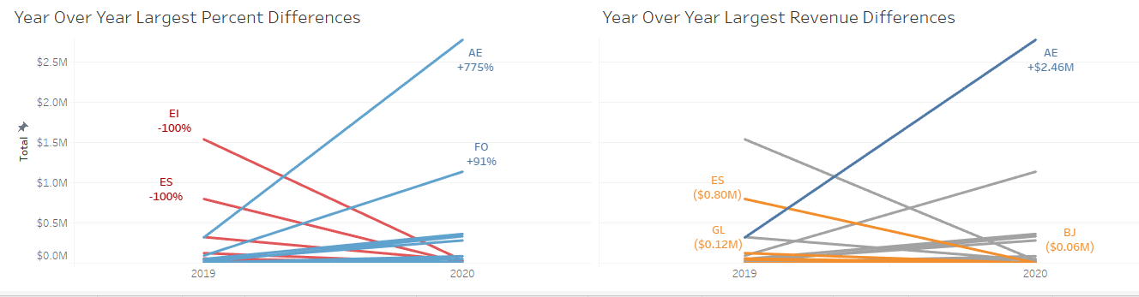

Two slope graphs were created here to show similar data in different capacities as it relates to change in 2019 and 2020 revenues per client. The slope graph on the left was used to show percentage change as well as using colors red and blue to show clients with biggest rises and biggest falls in revenues from 2019 to 2020. A similar slope graph on the right was also generated to show biggest rises and falls but labeled in money details as well as colored to show which may be top 20 or bottom 20 clients. Client AE experienced superior growth while clients EI and ES appear to have left the firm along with serious decline in revenues for client’s ES and GL. Each slope graph tell a different story while being closely related and using the same y-axis.

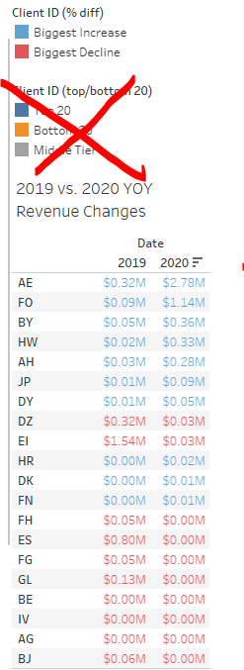**Table for Largest Revenue Changes**

This table is clear in showing exact revenue difference figures from 2019 to 2020. Colors red and blue were used to highlight decreased revenue vs increased revenues specifically. We can see now that several clients went to zero in 2020 which most likely means we no longer are doing business with them. We also see client EI with a large drop off down from $1.54M in 2019 to $.03M in 2020 and would want to do a little more digging there to see why. Overall, there were not many clients with increased revenues year over year but to highlight a few there were clients AE, FO, BY, and HW with the largest spikes. Although somewhat of a basic chart, I can see where this clutter free and simplicity relates to ideas from our “Storytelling with data” reading materials for this course.

**Overall Downward Trending Revenue Slope Graph**

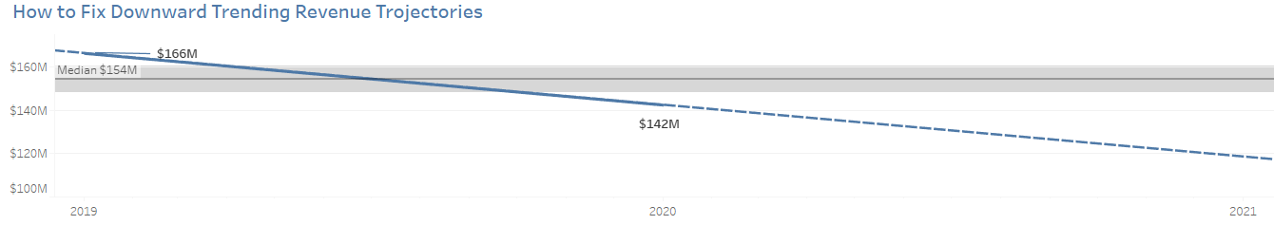

Simplicity was used yet again here to display overall downward trend of our firm’s overall revenue figures. An analytical forecast within tableau was also used here to show a dotted line of projected further decline in 2021. Trend lines were difficult to obtain here and I believe with just one yoy change example this was inevitably going to trend in the same direction for 2021’s forecast. This will obviously need to be further investigated to turn our slope graph back upwards in the direction of the median amount of $154M.

**Tiered Bar Chart with Totals for Top 13 Client Revenue Splits**

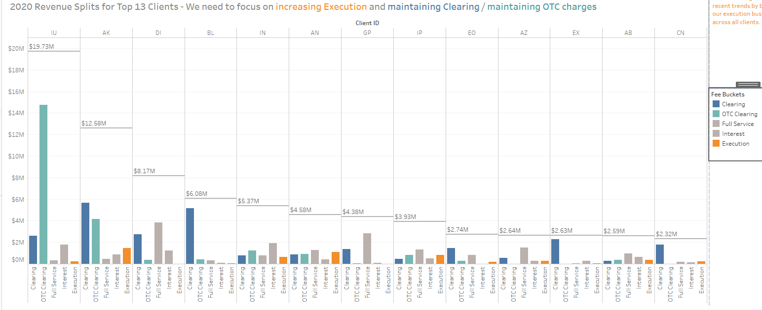

This may be my most powerful and detailed chart of them all. It tells the story of how to correct our downwards revenue trend by highlighting potential growth areas for fees being charged or not charged on top clients. We can see a breakdown of overall fees per top client in 2020 and who generated the most amount of money in each category as well as wholistically. Client IU was clearly an outlier when it came to OTC clearing fees but also generated a large amount of clearing fees as shown to the far left being the highest fee source overall. The lowest fee source is colored orange and is where I want the viewer to focus on as a potential area for growth. We can vastly increase revenues across the board if we can find a way to generate additional Execution fees to the level of all other fees.

Appendix Visualizations

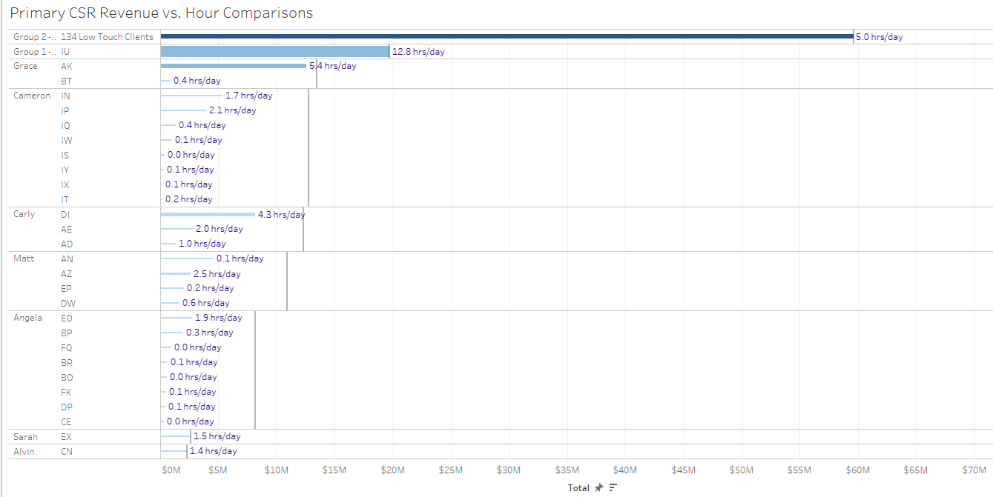

This was my original bar chart that turned into a lollipop chart. It was not used because I felt more detail could have been provided with the lollipop chart as sizing of the ends seemed more relevant than sizing of the individual bar widths.

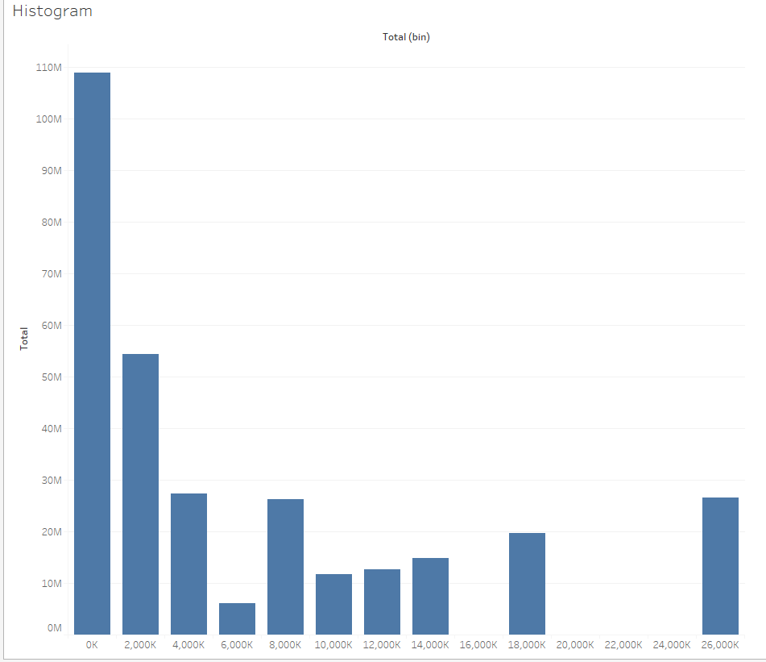

This histogram with revenue amongst different clients did not seem relevant or detailed enough to align with the stories I was attempting to tell in each dashboard.

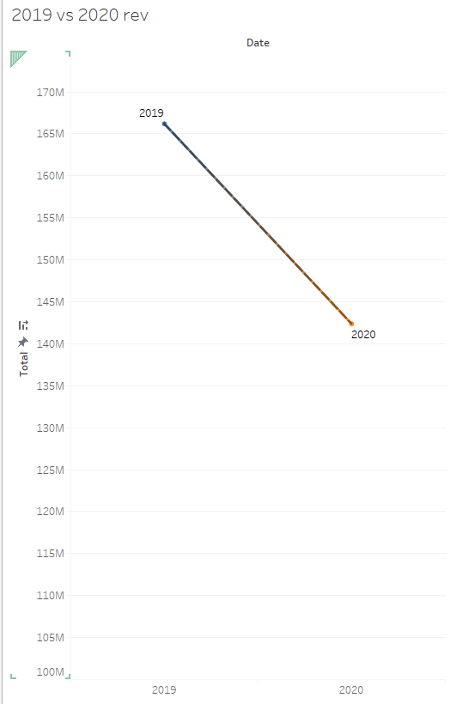

This slope graph was the first of its kind and was not incorporated into my dashboards as a better one with 2021 forecasted was produced and used instead.

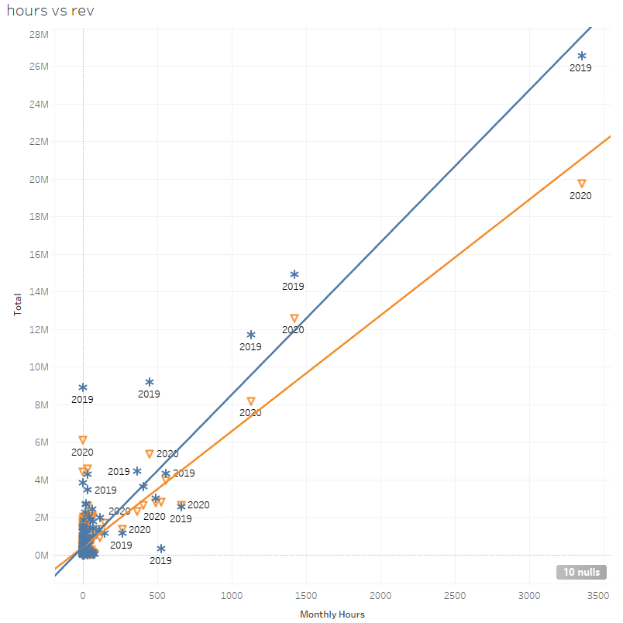

Hours per month seemed for me to be difficult for an audience to understand. I later created a calculated field for hours per date and also used two charts one on top of the other with a zoomed in version and clearer detailed labels to get a better idea at what we were looking for.

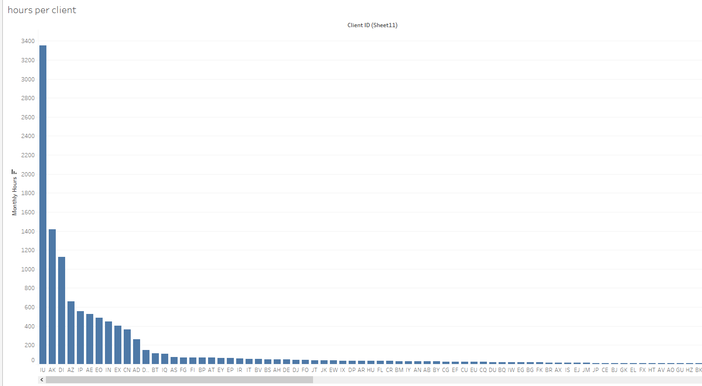

This was a basic original version of showing which clients generated the most amount of revenues. This idea was later detailed in additional scatterplots and groups were created to show top 20 and bottom 20 clients instead. There were obviously too many clients included in this chart as well (all of them it appears).

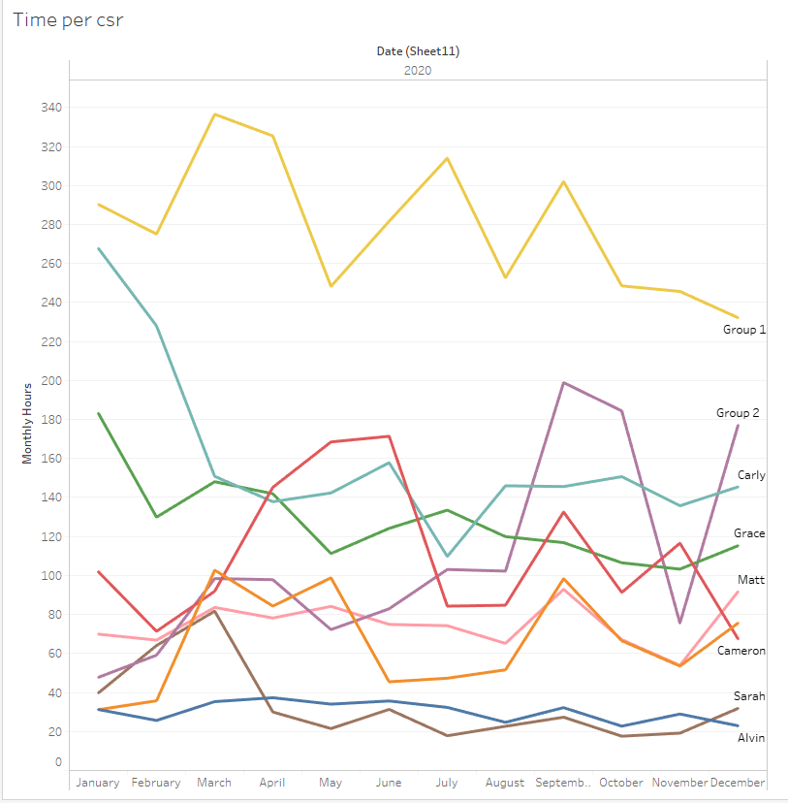

This “spaghetti graph” seeped useful at first in determining which CSR spent time on their respective clients. In the end, I did not see it as being useful because of Group 1 and Group 2 also being worked on by some of these individual CSRs. All should have roughly 8 hours recorded daily across the board and this comparison didn’t seem fair to me. There are also some instances where CSRs are primary coverage for one client while others are primary for five or more. This could easily lead to a misleading visualization and biased with specific CSRs.

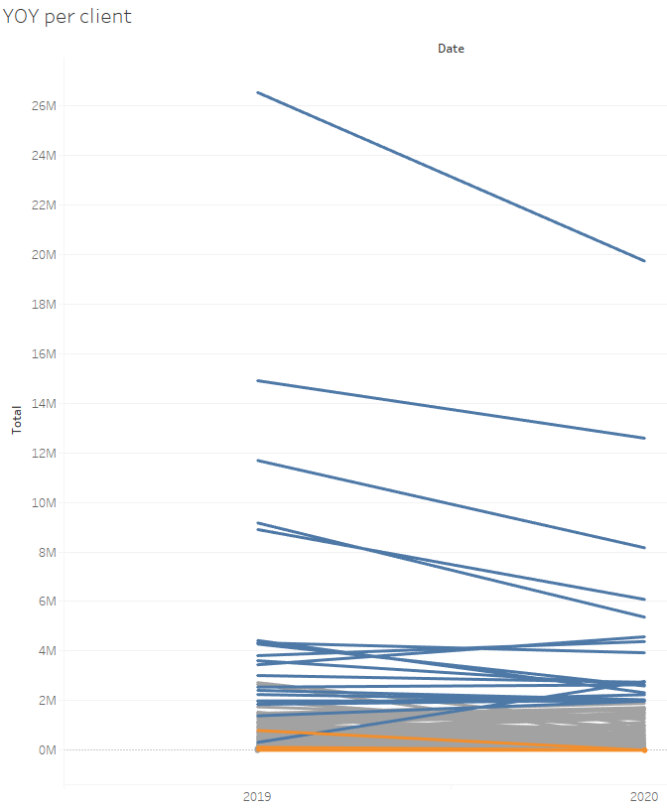

I originally though to use this slope graph but later found that diverging bar chart with revenue increases and decreases was more detailed. Although overall trends come across relatively clean here, there is not much room to add details.