**Minimum Wage Analysis**

Through working with this dataset, I was able to find a pattern of minimum wage pay moving away from the Midwest/west coast, the states of Alaska and California furthest away from minimum wage salaries, and a strong trend relating to the housing crisis of 2008. I tried to tell a story that would back up the housing crisis trend of employees losing jobs and being forced into hourly jobs that would have been at or below minimum wage. This story was exemplified with the spike in minimum wage percentages from 2008 to 2012.

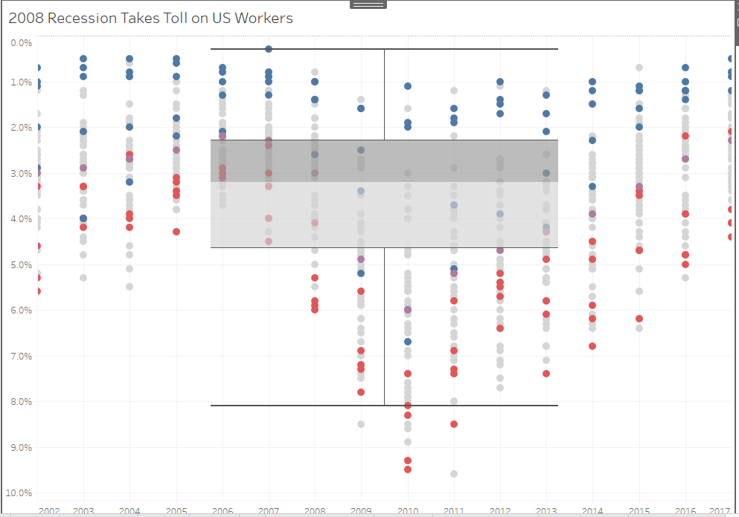

Another story related to upward trends of employment away from minimum wage for California and Montana while South Carolina and Kentucky had a downward trend of employment towards and below minimum wage.

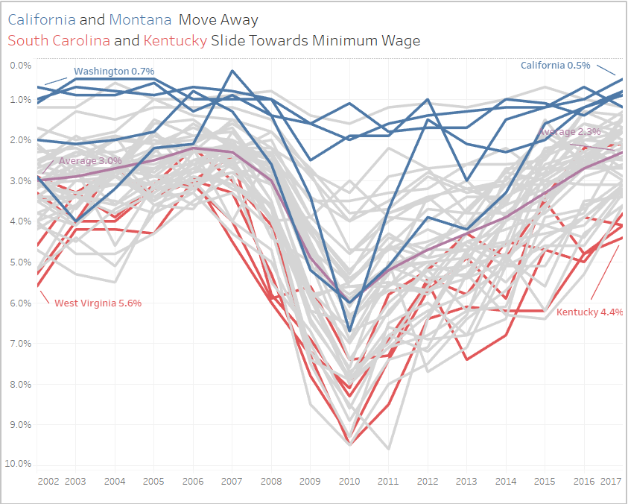

These maps did a great job geographically showing the migration away from minimum wage for midwest and west coast states and towards the south where the colors are shaded darker for higher percentages at or below minimum wage.

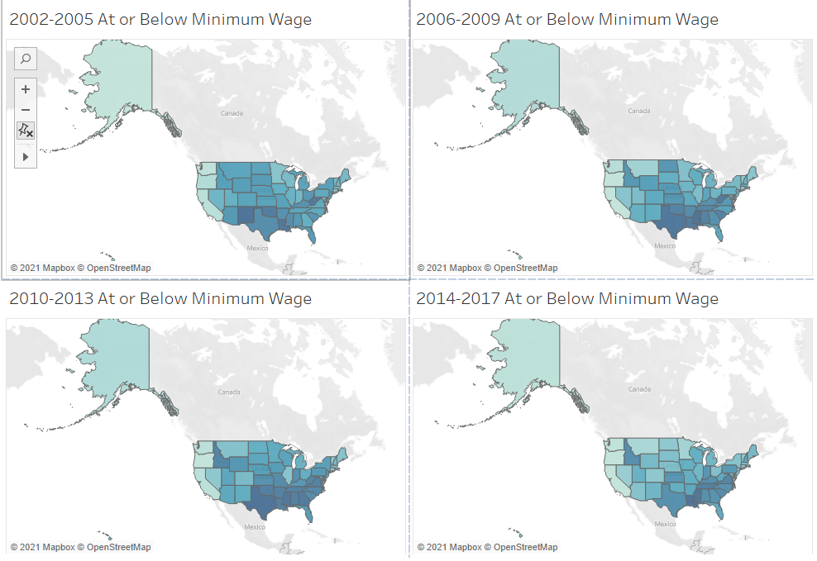

I also found that this overall average trend chart told a lot. We can again see the dip around and shortly after the 2008 crash but a steady movement away from minimum wage since. While the overall trend line shows negative correlation, we can assume the 2008 incident as an outlier and a positive trend since.

