Alec Freeman
Project 4 Report
Kernel | C | Degree | Gamma | Mean Accuracy | Std Accuracy
rbf | 10.0 | – | scale | 0.963800 | 0.002455
rbf | 1.0 | – | scale | 0.956500 | 0.003610
poly | 10.0 | 2 | – | 0.956000 | 0.003195
poly | 1.0 | 2 | – | 0.950400 | 0.003908
poly | 10.0 | 3 | – | 0.949300 | 0.004309
poly | 1.0 | 3 | – | 0.945800 | 0.004333
rbf | 0.1 | – | scale | 0.917800 | 0.006025
poly | 0.1 | 2 | – | 0.911699 | 0.008494
linear | 1.0 | – | – | 0.907700 | 0.001750
linear | 0.1 | – | – | 0.907700 | 0.001750
linear | 10.0 | – | – | 0.907700 | 0.001750
poly | 0.1 | 3 | – | 0.886899 | 0.008204
rbf | 0.1 | – | 0.01 | 0.112500 | 0.000016
rbf | 1.0 | – | 0.01 | 0.112500 | 0.000016
rbf | 10.0 | – | 0.01 | 0.112500 | 0.000016
rbf | 0.1 | – | 0.001 | 0.112500 | 0.000016
rbf | 1.0 | – | 0.001 | 0.112500 | 0.000016
rbf | 10.0 | – | 0.001 | 0.112500 | 0.000016
Best configuration: Kernel rbf
C 10.0
Degree -
Gamma scale
Mean Accuracy 0.9638
Std Accuracy 0.002455
Name: 11, dtype: object
Test Accuracy: 0.9674
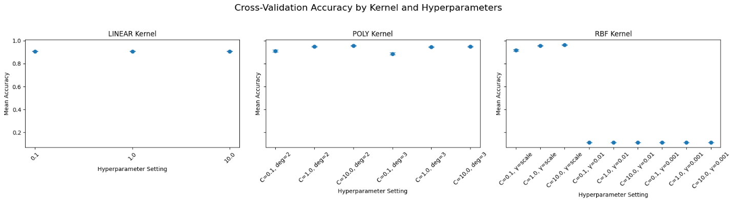
Explanation of hyperparameter tuning and kernel effects:
Kernel:
The rbf kernel performed best because the rbf kernel is highly flexible and allows the model to form nonlinear decision boundaries, and the MNIST dataset can be better represented with a nonlinear model rather than a linear model. Linear kernels assume the data can be separated with a straight line, but this isn’t a complex enough assumption for images of handwritten digits in MNIST. Polynomial kernels are not as complex and are limited by a fixed degree compared to rbf which maps data into an infinite-dimensional feature space.
C:
Higher C values performed best. Higher C value forces a low tolerance for misclassification and yields a narrower margin. The MNIST dataset is clean or has very little noise or mislabeled data. As a result, when there is a higher C, there is no overfitting to noise or mislabeled data, so a higher C will have more precise margins that better classifies the data. Because C = 0.1 and 1 are lower, they allow more errors to data that is relatively noiseless, so it is less complex and captures less details of the data leading to underfitting.
Gamma:
For rbf kernel’s, gamma=’scale’ performed better than 0.01 and 0.001 because the ‘scale’ setting results in adapting the influence of a single training example according to the data. Since ‘scale’ adaptively is tuned to the data it provides good balance to the shape of the decision boundary that reflects the data. The other two static parameter settings severely underfit the data by giving a two smooth decision boundary that can’t capture the complexity of MNIST.
Degree:
For polynomial kernel, increasing the degree from 2 to 3 resulted in lower accuracy most likely because a degree 3 polynomial introduces some unnecessary complexity which may cause overfitting. RBF is considered more complex than a degree 3 polynomial but still achieves better accuracy because RBF is a universal approximator and can fit any continuous function given the right parameters, or gamma values. A degree 3 polynomial has a fixed form which a model must follow while RBF along with its parameters, gamma and C, can flexibly separate the data without overfitting by localizing the influence of training examples.

Discussion:
1. The rbf kernel performed the best, and it performed the best when it had settings C = 10.0 and Gamma = scale.

2. Changes to C had no effect on performance for rbf’s with a Gamma equal to 0.01 or 0.001. Changes to C also had no effect on performance for linear kernels.
Changing C from 1.0 to 10 resulted in only a slight increase in performance, of around .5%, for polynomial and rbf kernels with Gamma = scale. However, from 0.01 to 10 there was a much larger increase in performance or accuracy of around 5 to 6%.
Changing Gamma between 0.01 and 0.001 (and even ‘auto’) resulted in achieving the same very bad performance of 11.25% accuracy. However, when the Gamma value was changed to be ‘scale’ or 1/(n_features * Variance of the training data), then the performance drastically improved to the best accuracy out of all models.
Changing the polynomial degree from 2 to 3 worsened performance by around 3% for when C = 0.1. It also worsened performance for C = 1 and 10, but this performance or accuracy reduction was much less, around 0.5%.

3. One insight about the structure of the MNIST dataset that I got from this experiment is that it is better represented by non-linear decision boundaries, and it can not be perfectly separated by a linear decision boundary or hyperplane. This is because of the Linear kernel performing worse than the more complex kernels, rbf and polynomial, when these kernels are set with the optimal hyperparameters.
Another insight about the structure of the MNIST dataset that can be made is that MNIST is highly structured, and its decision boundaries are balanced. Choosing of a gamma parameter is a very important factor in the performance of rbf kernels on the MNIST dataset. This is evident from the data because when the ‘scale’ gamma value is used it yielded the best hyperparameter configurations out of all configurations but when 0.01 and 0.001 and ‘auto’ were used, they all yielded configurations with terrible accuracy. It can be claimed that because the ‘scale’ parameter, which supports balanced influence of a training example and a balanced decision boundary, performed so well, MNIST has a balanced structure, but it can also be said that the MNIST dataset is also highly structured because gamma parameters that didn’t adjust to the data’s scale and spread caused extreme underfitting.
A final insight that can be made is that MNIST has a small amount of noise. This is because as the C value increases to 10, the accuracy increases. A higher C has tighter margins and more precisely classifies the points at the risk of overfitting and capturing noisy points, but since C’s accuracy increases as C’s value increases to 10, it suggests that given the tradeoff between overfitting and a better classifier when increasing C, increasing C to 10 benefits the accuracy on MNIST more than it hurts it. This further suggests that MNIST has a small amount of noise that can cause overfitting.

