CS 6350
ASSIGNMENT ____2_______
Names of students in your group: Alec Freeman
NetID: ahf210002
Number of free late days used: _________2___________
Sources/references list:
Collaborative Filtering - Spark 4.1.1 Documentation
ML Tuning - Spark 4.1.1 Documentation
Classification and regression - Spark 4.1.1 Documentation
ML Pipelines - Spark 4.1.1 Documentation
SMS Spam Collection - UCI Machine Learning Repository

1.1. Results:
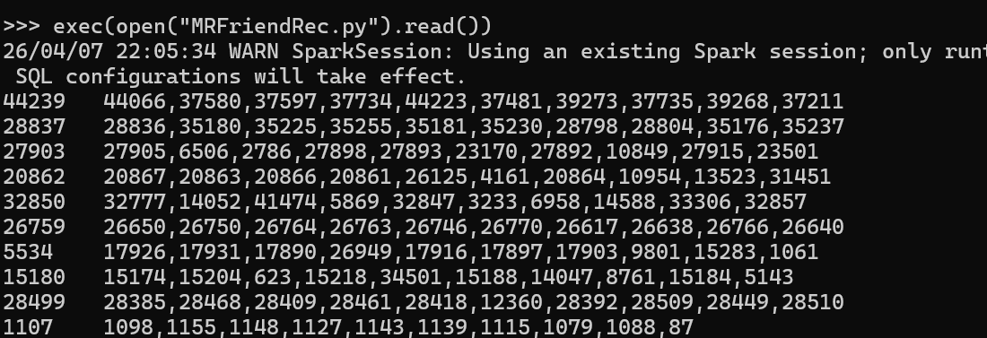
1.2 Results:
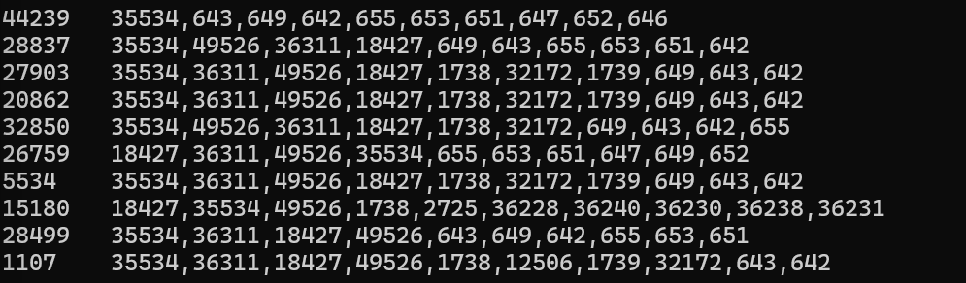

1. 1.2 Data preprocessing steps and modeling approach
To preprocess the data, each line of the data is initially split on the tab to obtain the user ID and the friend list. The friend list is then further separated or tokenized on commas and then for each friend, for a user, the tuple (user, f, 1.0) is added to a new RDD which is then converted to a DataFrame. A pipeline is used to construct the recommendation model. In the pipeline, StringIndexer is applied to the user and item columns to get the integer indexed columns userIndex and itemIndex, required by ALS. The final stage of the pipeline is the ALS collaborative filtering model, where latent factors are learned for users and items. The CrossValidator is applied using the pipeline, a RegressionEvaluator, and hyperparameter grid, including parameters rank, regularization, and maxIters, to train each model and select the model with the lowest RMSE using 3-fold cross validation. Using this best model, 50 recommendations for friends were produced, removing existing friends, and giving the top 10.

2. Compare recommendations.
The two methods produced very different recommendations for the same 10 sampled users. MapReduce recommendations varied considerably across users, reflecting each user’s specific local network and close neighbors. ALS recommendations were largely similar across all 10 users, with popular node IDs such as 35534 in this sample appearing in nearly every recommendation list because such nodes have many connections to other nodes and are therefore rpopular, making them the primary user suggested to be a friend with.

2.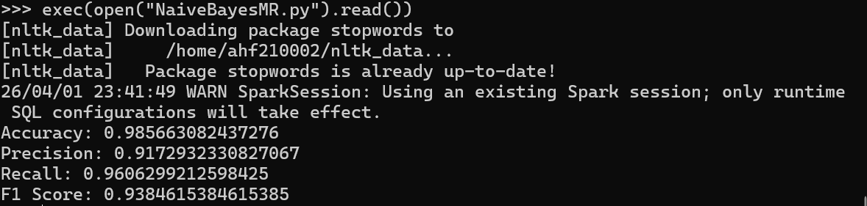
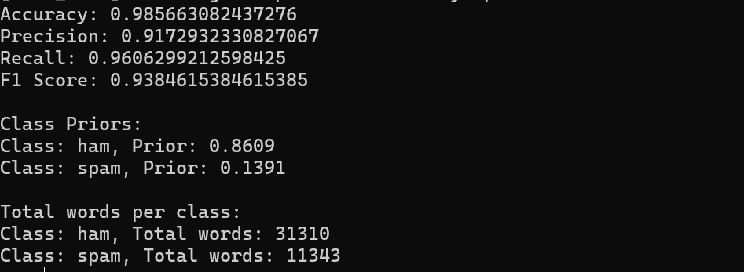

Psuedocode of MapReduce:
PRIOR CALCULATION
INPUT: train = lines of (class, list of words) tuples
For each line in train :
Emit (class, 1)
Reduce by key (class):
For each class:
Sum = sum all x_{i} for tuples of the form (class, x_{i})
Class_counts[class] = sum
Total_docs = number of lines
For each class in class_counts:
Priors[class] = class_counts[class] / total_docs

COMPUTE P(word | class)
Count words per class
For each line/document in train:
For each word in line:
Emit ((class, word), 1)
Reduce by key ((class, word)):
For each (class,word):
Sum=Sum all x_{i} for tuples of the form ((class, word), x_{i})
Word_counts[(class, word)] = sum
Compute Total Words Per Class
For each ((class , word), count) in word_counts:
Emit (class, count)
Reduce by key (class):
Sum = sum all count_{i} for tuples (class, count_{i})
Total_words_per_class[class] = sum
Compute Vocab Size
Vocab_size = number of distinct words in word_counts
Compute P(word | class) with Laplace Smoothing
For each ((class, word), count) in word_counts:
P(word | class) = (count + 1) / (Total_words_per_class[class] + Vocab_size)

Summary:
The Naïve Bayes classifer was trained on 80% of the SMS Spam Collection dataset and tested on the remaining 20%. Preprocessing was done and involved lowercasing the letters in documents, tokenization, stopword removal according to the nltk set of stopwords, and stemming. A document can either be considered spam or not spam (ham). We can consider spam to be positive and ham to be negative. The prior probabilities of each class were P(ham) = 0.86 and P(spam) = 0.14. Laplace smoothing was applied when calculating P(word | class) for unseen words. During the prediction phase, each document had a score computed for each class which was equal to log P(class) + sum(i=1 -> n){(log P(wi|class))}. The maximum of the 2 class scores of the document was used to choose the class for that document.
The mode achieved an accuracy of 98.5%, meaning it predicted the correct class of the two possible 98.5% of the time. It achieved 91.7% precision which means the model rarely labels ham messages as spam and a high percentage of messages classified as spam are truly spam. A Recall of 96% was achieved meaning that 96% of actual spam messages are detected and labeled as spam. The model hasa high F1-score of 0.94 which means the model has balanced performance and avoids mislabeling documents as spam and catches most spam when spam occurs.

