Exercise02: Java Swing

**Objectives:**

* To learn to use JList and to play with the model and view for JList.
* To use Dialog, Menu, and Toolbars.
* To learn to use JTree and to understand it's model and view.
* To learn to use basic JTable.

**Work with your group (or by yourself). Each group to upload only one submission.**

# Warm Up: Try Some Examples

1. First, open blackboard, go to Course Contents, and then download exercise02.zip file into your workspace (U:\workspace or something like that!). Then, unzip.
2. Open Eclipse, create a new Java Project, and then copy the "*.java" files from your unzipped folder to the src folder of your project.
3. Play with each of the given examples. Each of them has some "TODO" comments. Try following the instructions and observe what happens.

You should now be reasonably ok with Lists, Dialogs, Menus, and Toolbars.

Note that the assignment assumes you have understood these examples.

# The main assignment!

1: Run Eclipse and make sure that the workspace is set to U:\workspace (your COMS home directory).

2. Go to File->New->Project->Java Project. For the project name, type in “Lab2-Swing” and click Finish. You should see the project “Lab2-Swing” built and shown in the “Package Explorer”.

3. Right-click on Lab1-Swing, New->Package. Call the package “cs.iastate.edu.cs319”.

4. Now, choose the drop-down item associated with Windows Builder Pro from the toolbar (it should be the second left item in the toolbar). Go to Swing->JFrame. Name the JFrame “Lab2Swing”. Also, make sure that Source Folder and Package are set correctly.

5. You will see a new file named "Lab2Swing.java" was created by Windows Builder with some java code in it.

6. At the bottom of the editor, there are two tabs: Source and Design. If you go to the Design view, you will get a visualized view of your application corresponding to what the user of the application will see. You will also have access to “Structure”, “Properties”, and “Palette” that facilitate building and editing the JFrame visually.

7. Right-click on the window->Set Layout-> Absolute Layout.

## Tabbed Swing Application

Have three tabs in the Lab2Swing (using JTabbedPane). The first tab is called List, the second one is called Tree, and the third one is called Table. Set the title of the window to “Tabbed Swing Application”. When the “X” button on the top right corner is pressed, the application terminates. It should be similar to the following:

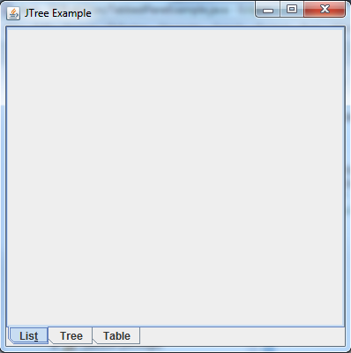

## List Panel

The objective in this part is to create a List (i.e. JList component) in the first tab to read and show the contents of an external “.txt” file. The file is called “companies.txt” (located in the .zip file of the lab) and in each line of the file, there is a company name. It can be assumed that the file is located inside the current directory. This has to be done in the following way: you create a class called DataModel which extends from javax.swing.AbstractListModel class. In the DataModel file, you need to read the “companies.txt” file and fill an array (ArrayList) of Strings that stores the names of the companies. This DataModel class will be used as the model for the list.

When an item from the list is selected, the background color of the selected item is changed to yellow. There are also two buttons Add and Remove. As the names suggest they are responsible for adding and removing items to/from the list. Remember that any changes to the list has to be reflected on the “companies.txt” file as well (i.e., if we add a new item to the list, it gets added to the file and if we remove a company, it gets removed from the file). When you press the Add button, a dialog box pops up as shown in the figure to ask about the new company name. Remove button removes the selected item from the list and companies.txt. Finally, make sure the list is scrollable (make use of JScrollPane).

The end result would be similar to the following figure:

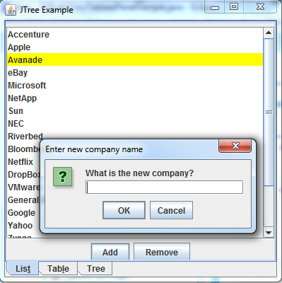

**CheckList for JList**

**[ ] JList is scrollable**

**[ ] JList shows the contents of the companies.txt file**

**[ ] DataModel class reads companies.txt file and fills the array inside the class**

**[ ] DataModel class extends AbstractListModel class**

**[ ] Add and Remove button are there**

**[ ] Add adds a new company and Remove removes a company name from both the list and companies.txt (write code in DataModel to accomplish this)**

**[ ] When Add button is pressed, a dialog box is shown to ask about the new company name**

**[ ] Whenever an item is selected, the background color is changed to yellow.**

**[ ] The JList looks similar to the given figure.**

## Tree

The objective in this part is to create a Tree (i.e. JTree component) in the second tab to build and show the following hierarchy:

Animals

🡪Mammals

🡪🡪Human

🡪🡪Kangaroo

🡪🡪Elephant

🡪🡪Goat

🡪Reptiles

🡪🡪Lizard

🡪🡪Boa

🡪🡪Iguana

🡪Birds

🡪🡪Duck

🡪🡪Pigeon

🡪🡪Turkey

🡪🡪Goose

🡪Insects

🡪🡪Termite

🡪🡪Ladybug

🡪🡪Fly

🡪🡪Ant

🡪Aquatic

🡪🡪Sword Fish

🡪🡪Shark

🡪🡪Whale

In addition, it is possible to add and remove new animal to each of the categories (Mammals, Reptiles, Birds, Insects, Aquatic). The new animal should get added to the category that is the current selection. For example, if Reptiles (or any of its children nodes) is selected and Add button is pressed, the new animal gets added to Reptiles. Remove button removes the selected item from the tree. If the selected item has any children, all its children are removed as well. If the selected item is the root of the tree, the entire tree is removed. Also, make sure the tree is scrollable.

The end result would be similar to this:

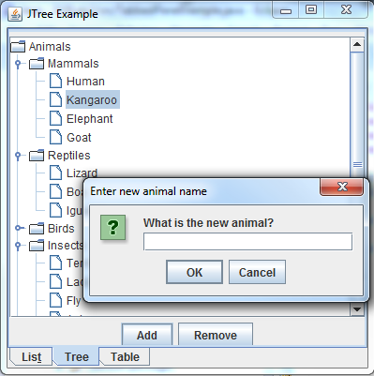

**CheckList for JTREE**

**[ ] JTree is there and is scrollable**

**[ ] JTree includes all the nodes and the hierarchy as specified**

**[ ] Add and Remove buttons are there**

**[ ] Add button adds new items properly to the correct category**

**[ ] Remove button properly removes the selected item (and its children if any)**

**[ ] The JTree looks similar to the given figure**

## Table

We have NOT read or learnt about JTable. However, there are lots of great tutorials on the web. Here is an example <http://docs.oracle.com/javase/tutorial/uiswing/components/table.html>

We will assume you will be able to read and learn to use JTable (which is similar to JList and JTree) from these tutorials.

The objective in this part is to create a Table (i.e. JTable component) in the third tab to read and show some contents. The following is the columns of the table:

String[] columnNames = {"First Name",

"Last Name",

"Age",

"Sex",

"Vegetarian"};

And the followings are the contents that are going to be shown in the table:

Object dataValues[][] = {

{"Kathy", "Smith", 25, ‘F’, false}

{"John", "Doe", 43, ‘M’, false}

{"Sue", "Black", 61, ‘F’, true}

{"Jane", "White", 17, ‘F’, true}

{"Joe", "Brown", 32, ‘M’, false}

{"Abby", "Dawn", 41, ‘F’, false}

{"Mila", "Manson", 26, ‘F’, true}

{"Jack", "Schmitt", 32, ‘M’, true}

}

Make sure the table is scrollable (make use of JScrollPane). The end result would like the following:

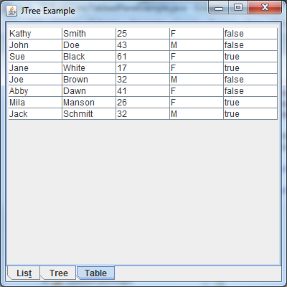

**CheckList for JTable**

**[ ] JTable is there and is scrollable**

**[ ] JTable has all the five columns**

**[ ] JTable shows the contents properly**

**[ ] JTable looks similar to the given figure**

# Submission:

Zip your Eclipse project and submit on black board. Remember there is only one submission per group. Make sure to include all the files that are needed in order to run your program.