Alec Felix

CMSC 204: Prof. Thai

Balanced Trees Lab

**Write Up:**

In this lab we sketched a Binary Search Tree and an AVL Tree using the given combination of integers: [50, 29, 38, 21, 41, 24, 49, 45, 9, 30, 7]. The Binary Search Tree(BST sketch was very straight forward. All it took was comparing the nodes already in the tree with the node I was inserting and following down the tree to insert.

For the AVL I followed the same procedure, however after inserting the node I marked the heights of each node. If the difference in heights of the |left-right| child nodes was greater 1 then I knew I needed to readjust the nodes to balance the tree. What I didn't fully understand was the different rotations. However, I was able to look at the subtree that was unbalanced and could tell which way to reorganize the nodes, so it was balanced again.

Only after looking at the Animations of the AVL reorganization could I see how the rotations were done. However, while sketching the AVL on my own I did notice a few patters for reorganizing the tree are reused based on the direction the tree is unbalanced. This allowed me to not have to keep calculating the node heights because I could recognize an unbalanced subtree and reorganize it.

**Assignment:**

Binary Search Tree Sketch Online BST Tool:

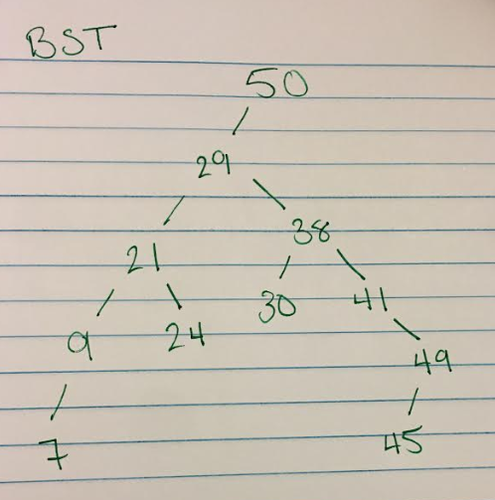 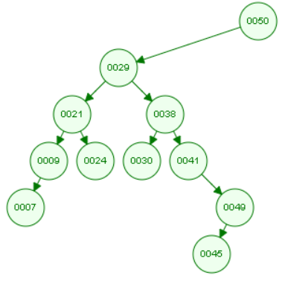

AVL Tree Sketch

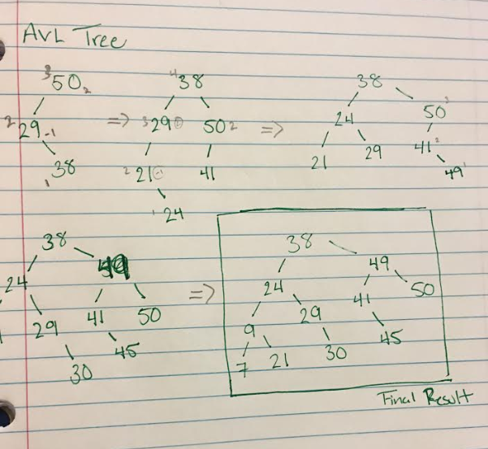 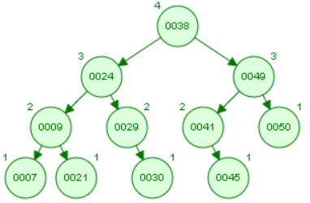

Github: