Executing CoW (Coffee on Wednesdays)

1. Log in to your Gmail account. If you are executing this for a closed Google Group, like classmates at a school or teammates at a company, make sure you’ve logged into the Gmail account that is a part of your target Google Group.
2. Create a Google Sheet with the names of your community members down Column A and their email addresses down Column B. Do not include a header row; make sure the first name on the list is in cell A1. Also make sure that the names include first and last names if the community is large so that people will know who you mean if you reference a name. Save this spreadsheet as “Community Names”. I recommend making a project folder and calling it “Coffee on Wednesdays”.
3. Go to the “[CoW (Coffee on Wednesdays)](https://docs.google.com/forms/d/1YeURefwInYSyoL9mZZfncnqxoRv0SDI6rehAktD-HJ0/edit?usp=sharing)” Form, make a copy (open it, click on the three vertically aligned dots next to “Send”, and choose “Create a copy”), and save the copy into your project folder. You can reword the title bar at the top of the form, and you can change the picture to whatever you want.
4. If you’re executing for a closed Google Group, open the form and go into Settings (gear icon), and under “Requires sign in”, select the “Restrict to users in …” button. This will protect the Yearbook from folks outside your group getting in and writing things. Click on “Save”. Otherwise, just make sure you’re collecting email addresses from this Form. You can do that through Google’s automatic collection or through creating your own question. More comments on this in the FAQ in the Digital Yearbook Readme file.

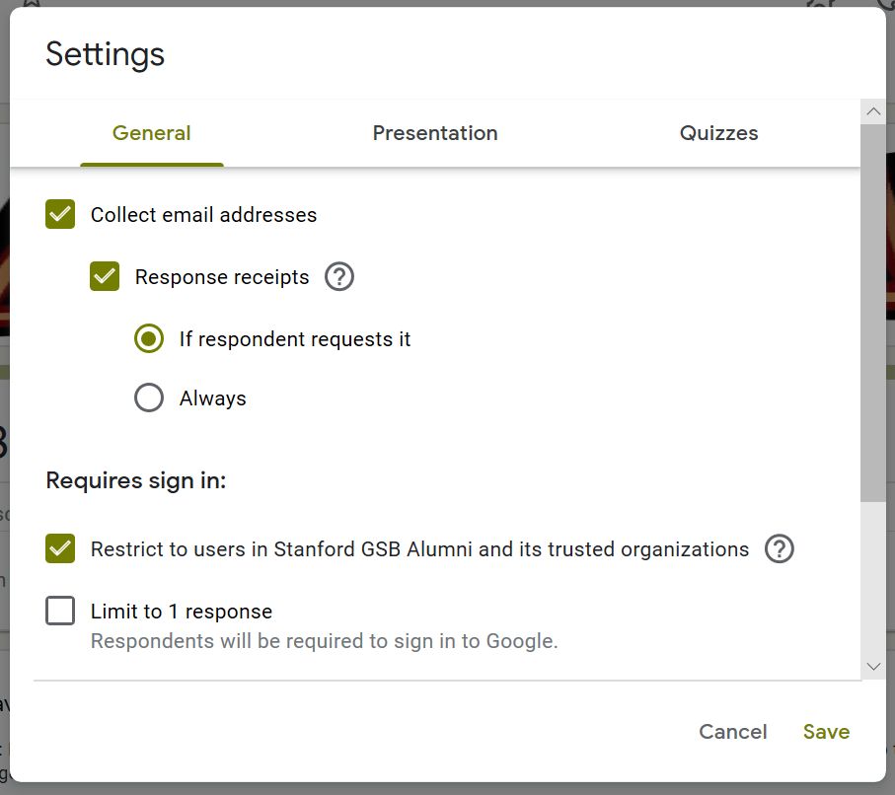

1. Click on the “responses” tab at the top of the form, and then click on the green Google Sheets icon. Select the “Create a new Spreadsheet” option, and click “Create”. 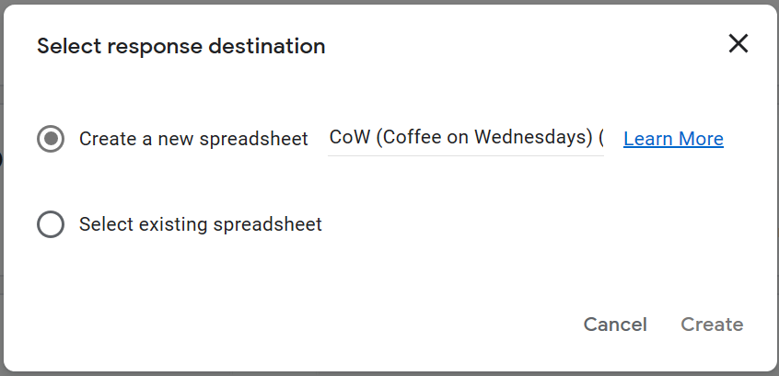

You’ll now have a new Sheet in your Google Drive project folder called “CoW (Coffee on Wednesdays) (Responses)”.

1. Open the new “CoW (Coffee on Wednesdays) (Responses)” sheet, and click and hold on Column C at the top of the column. Drag it to trade its position with Column B.

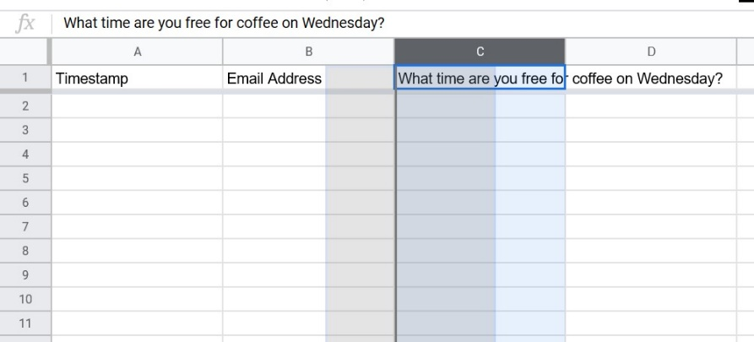

As you drag Column C left, you’ll see a dark line appear between Column A and Column B.

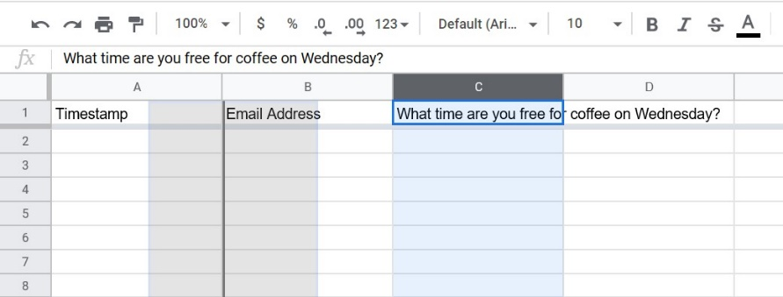

When you finish, the columns should look like this:

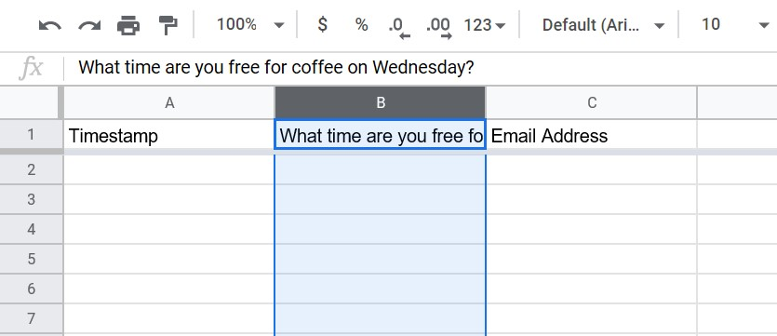

1. Paste the following formula into cell D1 (don’t include the quotations): ”=counta(C1:C850)”

This column indicates the condition of each request: matched, duplicate (ignored), no match found, or blank for pending.

1. Paste the following formula into cell E1 (don’t include the outermost quotations): ”=arrayformula(if(ROW(A:A)=1,"chatter date",if(ISTEXT(C:C),text(if(weekday(today(),2)=1,today()+2,if(weekday(today(),2)=2,today()+1,if(weekday(today(),2)=3,today()+7,if(weekday(today(),2)=4,today()+6,if(weekday(today(),2)=5,today()+5,if(weekday(today(),2)=6,today()+4,today()+3)))))),"mmmm dd, yyyy"),)))”
2. Paste the following formula into cell F1 (don’t include the outermost quotations):

“=arrayformula(if(ROW(A:A)=1,"start time",if(istext(B:B),if(month(E:E) > 2, if(day(E:E) > 12, if(month(E:E) < 11,if(B:B="9-10AM","8:00:00 PST",if(B:B="10-11AM","9:00:00 PST",if(B:B="11-12PM","10:00:00 PST",if(B:B="11AM-12PM","10:00:00 PST",if(B:B="12-1PM","11:00:00 PST",if(B:B="1-2PM","12:00:00 PST",if(B:B="2-3PM","13:00:00 PST",if(B:B="3-4PM","14:00:00 PST","unrecognized time")))))))),if(B:B="9-10AM","9:00:00 PST",if(B:B="10-11AM","10:00:00 PST",if(B:B="11-12PM","11:00:00 PST",if(B:B="11AM-12PM","11:00:00 PST",if(B:B="12-1PM","12:00:00 PST",if(B:B="1-2PM","13:00:00 PST",if(B:B="2-3PM","14:00:00 PST",if(B:B="3-4PM","15:00:00 PST","unrecognized time"))))))))),if(B:B="9-10AM","9:00:00 PST",if(B:B="10-11AM","10:00:00 PST",if(B:B="11-12PM","11:00:00 PST",if(B:B="11AM-12PM","11:00:00 PST",if(B:B="12-1PM","12:00:00 PST",if(B:B="1-2PM","13:00:00 PST",if(B:B="2-3PM","14:00:00 PST",if(B:B="3-4PM","15:00:00 PST","unrecognized time"))))))))),if(B:B="9-10AM","9:00:00 PST",if(B:B="10-11AM","10:00:00 PST",if(B:B="11-12PM","11:00:00 PST",if(B:B="11AM-12PM","11:00:00 PST",if(B:B="12-1PM","12:00:00 PST",if(B:B="1-2PM","13:00:00 PST",if(B:B="2-3PM","14:00:00 PST",if(B:B="3-4PM","15:00:00 PST","unrecognized time"))))))))),)))”

Note: During daylight savings time (3/8 - 11/1), the start and end times will show up an hour earlier than the requested meeting times. That's necessary in order to make the Google Calendar app invite times work correctly.

1. Paste the following formula into cell G1 (don’t include the outermost quotations): “=arrayformula(if(ROW(A:A)=1,"end time",if(istext(B:B),if(month(E:E) > 2, if(day(E:E) > 12, if(month(E:E) < 11,if(B:B="9-10AM","9:00:00 PST",if(B:B="10-11AM","10:00:00 PST",if(B:B="11-12PM","11:00:00 PST",if(B:B="11AM-12PM","11:00:00 PST",if(B:B="12-1PM","12:00:00 PST",if(B:B="1-2PM","13:00:00 PST",if(B:B="2-3PM","14:00:00 PST",if(B:B="3-4PM","15:00:00 PST","unrecognized time")))))))),if(B:B="9-10AM","10:00:00 PST",if(B:B="10-11AM","11:00:00 PST",if(B:B="11-12PM","12:00:00 PST",if(B:B="11AM-12PM","12:00:00 PST",if(B:B="12-1PM","13:00:00 PST",if(B:B="1-2PM","14:00:00 PST",if(B:B="2-3PM","15:00:00 PST",if(B:B="3-4PM","16:00:00 PST","unrecognized time"))))))))),if(B:B="9-10AM","10:00:00 PST",if(B:B="10-11AM","11:00:00 PST",if(B:B="11-12PM","12:00:00 PST",if(B:B="11AM-12PM","12:00:00 PST",if(B:B="12-1PM","13:00:00 PST",if(B:B="1-2PM","14:00:00 PST",if(B:B="2-3PM","15:00:00 PST",if(B:B="3-4PM","16:00:00 PST","unrecognized time"))))))))),if(B:B="9-10AM","10:00:00 PST",if(B:B="10-11AM","11:00:00 PST",if(B:B="11-12PM","12:00:00 PST",if(B:B="11AM-12PM","12:00:00 PST",if(B:B="12-1PM","13:00:00 PST",if(B:B="1-2PM","14:00:00 PST",if(B:B="2-3PM","15:00:00 PST",if(B:B="3-4PM","16:00:00 PST","unrecognized time"))))))))),)))”

During daylight savings time (3/8 - 11/1), the start and end times will show up an hour earlier than the requested meeting times. That's necessary in order to make the lame Calendar app invite times work correctly.

1. Open the “[Mets](https://docs.google.com/spreadsheets/d/10ELIVAoKHl3FPNCdeaZr3d9jD60lk3k-PmRJg-zATNI/edit?usp=sharing)” Google Sheet. Right click on the “Mets” tab at the bottom when you open the file, and choose “Copy to” 🡪 “Existing spreadsheet”. Select “CoW (Coffee on Wednesdays) (Responses)” as the destination spreadsheet, and then click on “Open spreadsheet”. Make sure “Mets” is added in as the second tab.
2. Open the “[Matches](1.%09https:/docs.google.com/spreadsheets/d/1nrCC83v0HVCC1n-qataLgyj-_W84nYiI0yqzZSWd-Ik/edit?usp=sharing)” Google Sheet. Right click on the “Mets” tab at the bottom when you open the file, and choose “Copy to” 🡪 “Existing spreadsheet”. Select “CoW (Coffee on Wednesdays) (Responses)” as the destination spreadsheet, and then click on “Open spreadsheet”. Make sure “Matches” is added in as the third tab.
3. Open the “[Rewards](https://docs.google.com/spreadsheets/d/1eQKOGaiylbm2e5YizaU0ydBO2wxugzzY1rWRTS1eJ9E/edit?usp=sharing)” Google Sheet. Right click on the “Mets” tab at the bottom when you open the file, and choose “Copy to” 🡪 “Existing spreadsheet”. Select “CoW (Coffee on Wednesdays) (Responses)” as the destination spreadsheet, and then click on “Open spreadsheet”. Make sure “Rewards” is added in as the fourth tab.
4. In the “CoW (Coffee on Wednesdays) (Responses)” Google Sheet, click on the “Tools” tab. Then select “Script editor”.

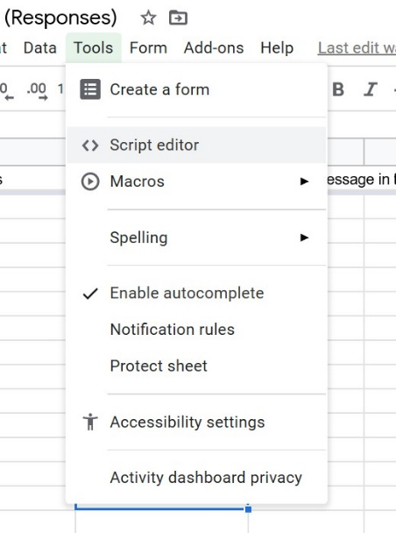

1. Delete what’s in there. Open the “CoW (Coffee on Wednesdays) (Responses) Script” from this project folder on Github and paste that into the script editor. CNTL + S to save. Follow the instructions at the top of the code.
2. You are now ready to get started! Go to your copy of the “CoW (Coffee on Wednesdays)” Google Form and click on “Send”. Copy the link. Draft an email to your community from your email app introducing the Coffee on Wednesdays concept, and include the link in your email. You might want to bcc everyone rather than include all the email addresses in the regular address bar. If it’s a Google Group, you likely have set up a single email address that sends to everyone in the group. If so, use that! When you send your email, people will be able to follow the link fill out the form. Everyone who elects to indicate a time when they’d like to meet another community member on the soonest upcoming Wednesday will then receive a calendar invite a few days in advance at a time they indicated matching them with someone else at random from the group. The script will make sure that no matches between two people happen more than once.
3. Set yourself a weekly reminder so that every Wednesday, you can send out another such email to the community asking them to join in for the following Wednesday if they like.