Executing the Digital Yearbook

1. Log in to your Gmail account. If you are executing this for a closed Google Group, like classmates at a school or teammates at a company, make sure you’ve logged into the Gmail account that is a part of your target Google Group.
2. Create a Google Sheet with the names of your community members down Column A and their emails addresses down Column B. Do not include a header row; make sure the first name on the list is in cell A1. Also make sure that the names include first and last names if the community is large so that people will know who you mean if you reference a name. Save this spreadsheet as “Community Names”. I recommend making a project folder and calling it “Digital Yearbook”.
3. Create a copy of [The Digital Yearbook Form](https://docs.google.com/forms/d/1Su0eqthD-tpI-NKTagPM8W6G79PYph6JoNxl0S0G7vI/edit?usp=sharing) (open it, click on the three vertically aligned dots next to “Send”, and choose “Create a copy”) and save the copy into your project folder. You can reword the title bar at the top of the form, and you can change the picture to whatever you want.
4. If you’re executing for a closed Google Group, open the form and go into Settings (gear icon), and under “Requires sign in”, select the “Restrict to users in …” button. This will protect the Yearbook from folks outside your group getting in and writing things. Click on “Save”. Otherwise, just make sure you’re collecting email addresses from this Form. You can do that through Google’s automatic collection or through creating your own question. More comments on this in the FAQ in the Digital Yearbook Readme file.

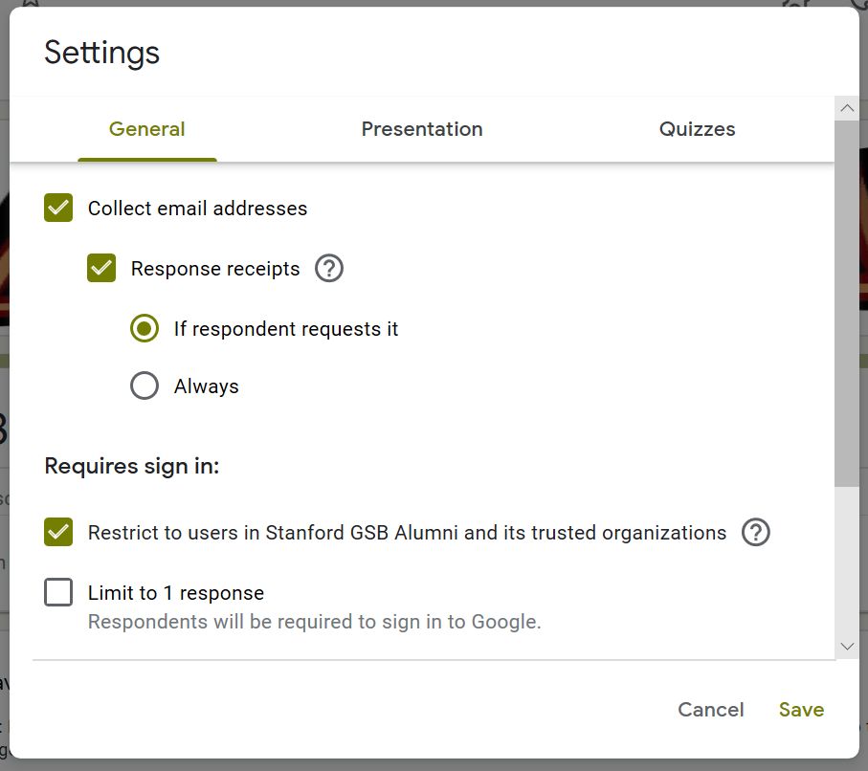

1. Click on the “responses” tab at the top of the form, and then click on the green Google Sheets icon. Select the “Create a new Spreadsheet” option, and click “Create”.

You’ll now have a new Sheet in your Google Drive project folder called “The Digital Yearbook (Responses)”.

1. Open the “[Digital Yearbook Reference Sheet](https://docs.google.com/spreadsheets/d/1nDnR66JXtzs6LWh_78LOsfqgB-mx4o8lIBTXH8_ckZU/edit?usp=sharing)”. Right click on the “reference Sheet” tab at the bottom when you open the file, and choose “Copy to” 🡪 “Existing spreadsheet”. Select “The Digital Yearbook (Responses)” as the destination spreadsheet, and then click on “Open spreadsheet”. Make sure “reference sheet” is added in as the second tab.

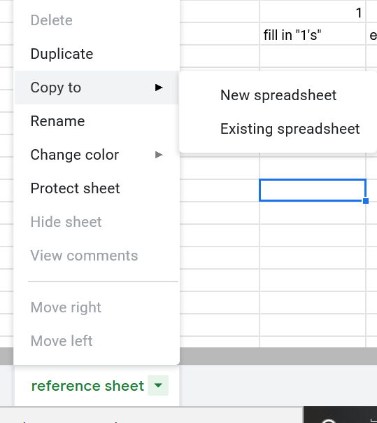

1. Fill in the “reference sheet” as depicted here:

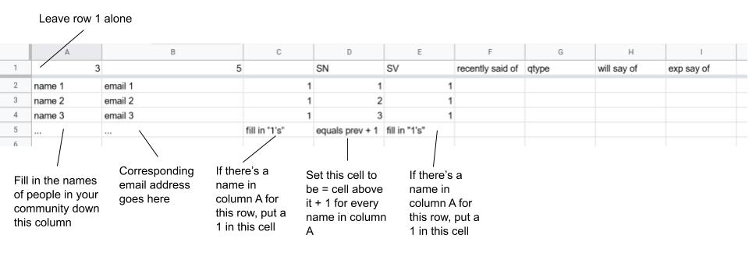

Where I’ve written in “name 1” and “email 1” etc as placeholders, you should delete and write over with actual names and emails. Just make sure that you leave row 1 the way it is.

1. Open the “[q1](https://docs.google.com/spreadsheets/d/1Oao8MEuEXSns6Kfyr24vEk3_-eHO-LPlaqPBWE9wtkk/edit?usp=sharing)” spreadsheet. Right click on the “q1” tab at the bottom when you open the file, and choose “Copy to” 🡪 “Existing spreadsheet”. Select “The Digital Yearbook (Responses)” as the destination spreadsheet, and then click on “Open spreadsheet”. Make sure “q1” is added in as the third tab.
2. Where I’ve written in “name 1”, “name 2”, etc as placeholders, you should delete and write over with actual names and emails. Fill them in across row 1 and down column A.

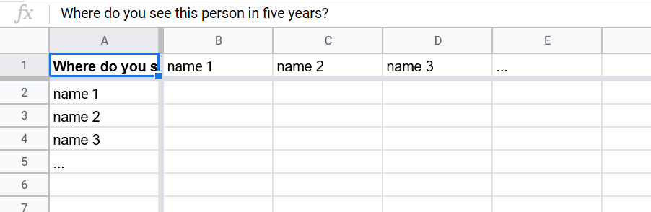

1. Repeat steps 8 and 9 with the “[q2](https://docs.google.com/spreadsheets/d/1ijasEExr4jKid_N0r0dxnVT17vdSAmpdRn9srduELik/edit?usp=sharing)”, “[q3](https://docs.google.com/spreadsheets/d/1PnxTdYHHkOpzQDw4cnJxghtRJ8GYWWinIHhKk8pcOLE/edit?usp=sharing)”, and “[q4](https://docs.google.com/spreadsheets/d/1roHrSDN1Vv8WHA9y_GaM52Kr8gKgzV9MAr43Jp9xAv8/edit?usp=sharing)” spreadsheets. Make sure you’re pasting people’s names in from the same master list, so you don’t have typos or inconsistencies. When you finish, your tabs along the bottom of “The Digital Yearbook (Responses)” should look like this:



1. Go back to your copy of The Digital Yearbook Form, and click on the three vertically oriented dots to the right of the “Send” button. Select “Script editor”. Follow the instructions at the top of that code (paste in the Spreadsheet ID of your copy of the Digital Yearbook Reference Sheet, and alter the email content as you see fit in the automatically sendable emails when you scroll down in the script).
2. Hooray! You’re all done with the main part. Now you just have to get the Yearbook started. This part is much simpler. Create a copy of “[The Digital Yearbook Starter](https://docs.google.com/forms/d/1M1pg_rRUrqrpldiudNEtHC7AtGGNIGPtklk5MmE95Z8/edit?usp=sharing)” (open it, click on the three vertically aligned dots next to “Send”, and choose “Create a copy”) and save it in your Google Drive project folder. You can reword the title bar at the top of the form, and you can change the picture to whatever you want.
3. As before, if you’re executing for a closed Google Group, open the form and go into Settings (gear icon), and under “Requires sign in”, select the “Restrict to users in …” button. This will protect the Yearbook from folks outside your group getting in and writing things. Click on “Save”. Otherwise, just make sure you’re collecting email addresses from this Form. You can do that through Google’s automatic collection or through creating your own question. More comments on this in the FAQ in the Digital Yearbook Readme file.
4. As before, click on the “responses” tab at the top of the form, and then click on the green Google Sheets icon. Select the “Create a new Spreadsheet” option and then click “Create”. You’ll now have a new Sheet in your Google Drive project folder called “The Digital Yearbook Starter (Responses)”.
5. Open the “The Digital Yearbook Starter (Responses)” and click on the “Tools” tab. Then select “Script editor”.

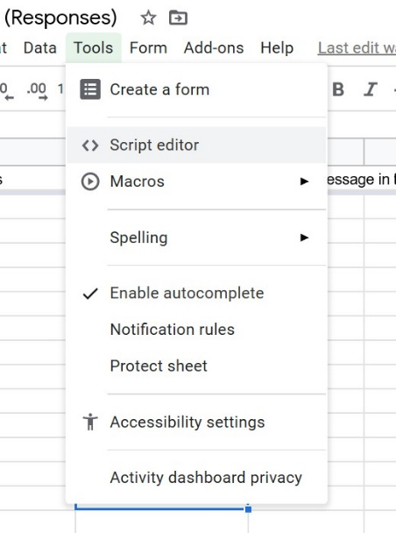

1. Delete what’s in there. Open the “The Digital Yearbook Starter (Responses) Script” from this project folder on Github and paste that into the script editor. CNTL + S to save. Follow the instructions at the top of the code (paste in the Spreadsheet ID of your copy of the Digital Yearbook Reference Sheet, and alter the email content in the automatically sendable email when you scroll down in the script).
2. Remember the “Community Names” sheet you made at the beginning of this guide? Open that, right click on the tab at the bottom, select “Copy to” 🡪 “Existing spreadsheet”, and then select “The Digital Yearbook Starter (Responses)”. Make sure the Community Names tab is the second tab in “The Digital Yearbook Starter (Responses)”.
3. Now you’re ready to kick the whole thing off with an email. Go to your copy of the Digital Yearbook Starter form and click on “Send”. Copy the link. Draft an email to your community introducing the Digital Yearbook concept, and include the link in your email. Then, when you send that email, people will be able to follow the link fill out the form. Everyone who elects to start off via the form will then automatically receive a follow-up email from you asking them to write something nice about someone. That person will then get an email showing what the nice thing was that was said about them and who said it – along with a prompt to fill out the survey about someone else. Remember, people can skip to the next person if they can’t think of anything for a given person, and people can opt out completely if they don’t want to receive emails about this or otherwise participate.
4. Once you think it’s done (to get the code to stop executing automatically, you can just delete it or comment it out) or when it finishes automatically, you can go into the sheet and collect all the responses and put them into a Digital Yearbook that you share with the entire community. My grad school class of ~400 did this and enjoyed it.