Supplementary Materials WEIRD CHILDES

Camila Scaff

2024-02-26

## SM1 :Partial correlations of the four dimensions of interest

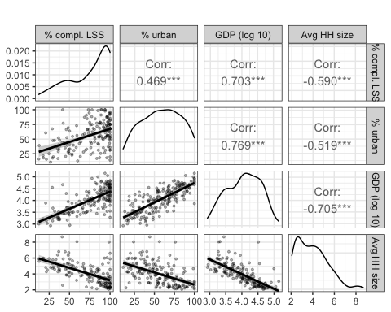

Evidence of partial correlations of the four continous dimensions of interest. The diagonal shows density of the distribution of each of the variables. Panels below the diagonal show the scatter plot for the two variables involved (e.g., proportion completed highschool and percentage urban for the second row, first column). Those above the diagonal show the Pearson correlation for the two variables involved. Education is represented by proportion of the population completing lower secondary school; industrialization by proportion of the population living in urban (as opposed to rural) sites; richness by GDP per capita.

## SM2 Flowchart

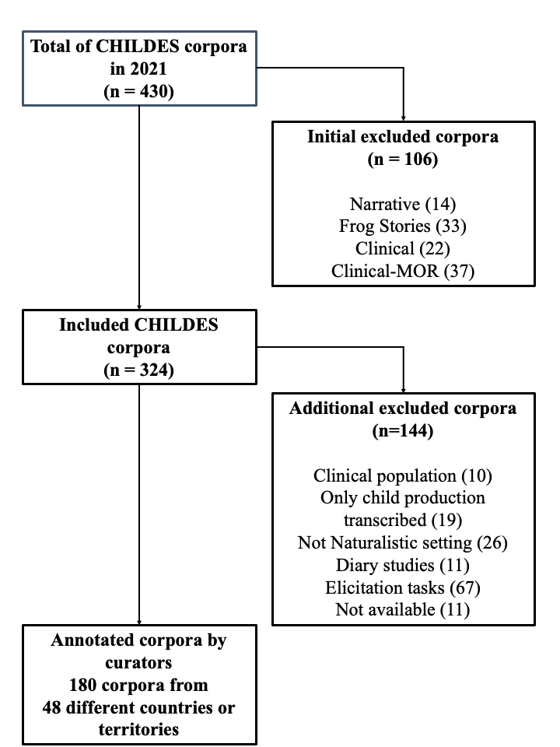

Flowchart

## SM3: Sources used for Density plot

The goal of the country-level analysis is to assess the representativeness of our sub-sample of CHILDES against world statistics. For this, we first identified the country where the recordings were collected. The following variables were used for this level of analysis, all derived from official sources including the World Bank, Our World in Data (WDI), and the United Nations (UN). For each macro-dimension described in the Introduction, we looked for relevant world statistics available (see the annotated code for more details about the indicators). SES For the SES dimension we choose two measures representing education and income. For the education measure, we turned to Our World in Data (WDI), an organization that collates information from various official sources. We downloaded information on the proportion of the population that had completed lower secondary school (data from 2007-2015; Our World in Data, 2022a; see Supplementary Materials (SMX) for figures using the proportion of the population completing high school instead). For the income measure, we relied on the World Development Indicators (WDI) from the World Bank, available via the WDI package in R (Vincent Arel-Bundock, 2021). We choose the Gross Domestic Product (GDP) per capita (based on log 10), a measure that represents how relatively rich countries are based on 2017 US dollars purchasing power parity. It is expressed in 2017 US dollars.

Urbanization We used the percentage of the population living in urban areas indicator, from the WDI from the World Bank. It represents the proportion of the population that was rural, so we estimated the complement to 100% to conceptually align this variable to the others. We employed indicators for the year 2011 because this was the year in which we had the maximum amount of data available for those variables. Family structure We used two measures pertaining to household size from the UN database on Household Size and Composition 2022 (data from 2000-2022 United Nations, 2022). First, the average number of household members, and second, the average number of members under the age of 15.

(#tab:tab1)

| Dimension | Macro.level.variable | Source |
| --- | --- | --- |
| SES | Percent of the population completing lower secondary school* | Data from 2007-2015; Our World in Data, 2022a |
| SES | GDP per capita (log 10) | World Development Indicators (WDI) from the World Bank, available via the WDI package in R (Vincent Arel-Bundock, 2021) |
| Urbanization | Percent of the population living in urban areas | WDI from the World Bank. It represents the proportion of the population that was rural, so we estimated the complement to 100% to conceptually align this variable to the others. We employed indicators for the year 2011 because this was the year in which we had the maximum amount of data available for those variables. |
| Family structure | Average household size | UN database on Household Size and Composition 2022 (data from 2000-2022 United Nations, 2022) |
| Family structure | Average number of member under 15 in households | UN database on Household Size and Composition 2022 (data from 2000-2022 United Nations, 2022) |
| Language | NA | NA |

## SM4: Distribution of CHILDES participants by country and continent

(#tab:tab2) Descriptives

| country | TimesRepeated | TotalParticipants_country |
| --- | --- | --- |
| Argentina | 1 | 1 |
| Austria | 1 | 1 |
| Belgium | 4 | 40 |
| Brazil | 1 | 1 |
| Canada | 3 | 8 |
| China | 7 | 174 |
| Croatia | 1 | 3 |
| Czech Republic | 1 | 6 |
| Denmark | 2 | 3 |
| Egypt | 1 | 10 |
| Estonia | 8 | 32 |
| France | 11 | 51 |
| Germany | 7 | 55 |
| Greece | 2 | 6 |
| Hong Kong | 2 | 8 |
| Hungary | 4 | 10 |
| Iceland | 1 | 1 |
| India | 1 | 1 |
| Indonesia | 1 | 8 |
| Iran | 2 | 5 |
| Ireland | 2 | 7 |
| Israel | 7 | 123 |
| Italy | 5 | 10 |
| Jamaica | 1 | 2 |
| Japan | 6 | 140 |
| Kuwait | 1 | 70 |
| Lesotho | 1 | 4 |
| Mexico | 2 | 2 |
| Netherlands | 6 | 22 |
| Norway | 2 | 11 |
| Papua New Guinea | 1 | 5 |
| Poland | 1 | 4 |
| Portugal | 2 | 8 |
| Romania | 2 | 6 |
| Russia | 1 | 1 |
| Serbia | 1 | 8 |
| Singapore | 1 | 55 |
| Slovenia | 1 | 20 |
| South Africa | 1 | 2 |
| South Korea | 2 | 4 |
| Spain | 23 | 211 |
| Spain & Hungary | 1 | 1 |
| Sweden | 3 | 9 |
| Sweden & Portugal | 1 | 3 |
| Switzerland | 1 | 1 |
| Taiwan | 1 | 4 |
| Thailand | 1 | 18 |
| Turkey | 1 | 1 |
| United Kingdom | 11 | 560 |
| United States | 30 | 405 |

(#tab:tab3) Descriptives

| region | TimesRepeated | TotalParticipants_continent |
| --- | --- | --- |
| Africa | 3 | 16 |
| Americas | 38 | 419 |
| Asia | 33 | 611 |
| Europe | 105 | 1090 |
| Oceania | 1 | 5 |

## SM5: Table of urban indicators by country, using most recent date available (2022)

This indicator is based in the World Bank staff estimates based on the United Nations Population Division’s World Urbanization Prospects: 2018 Revision.

(#tab:tab4) Urban indicator by country included in CHILDES sample

| Country | % Urban |
| --- | --- |
| Argentina | 92.35 |
| Austria | 59.26 |
| Belgium | 98.15 |
| Brazil | 87.56 |
| Canada | 81.75 |
| Switzerland | 74.09 |
| China | 63.56 |
| Czech Republic | 74.38 |
| Germany | 77.65 |
| Denmark | 88.37 |
| Egypt | 42.97 |
| Spain | 81.30 |
| Estonia | 69.61 |
| France | 81.51 |
| United Kingdom | 84.40 |
| Greece | 80.36 |
| Hong Kong | 100.00 |
| Croatia | 58.22 |
| Hungary | 72.55 |
| Indonesia | 57.93 |
| India | 35.87 |
| Ireland | 64.18 |
| Iran | 76.81 |
| Iceland | 93.99 |
| Israel | 92.76 |
| Italy | 71.66 |
| Jamaica | 57.01 |
| Japan | 91.96 |
| South Korea | 81.43 |
| Kuwait | 100.00 |
| Lesotho | 29.94 |
| Mexico | 81.30 |
| Netherlands | 92.89 |
| Norway | 83.66 |
| Papua New Guinea | 13.58 |
| Poland | 60.13 |
| Portugal | 67.38 |
| Romania | 54.49 |
| Russia | 75.13 |
| Singapore | 100.00 |
| Serbia | 56.87 |
| Slovenia | 55.75 |
| Sweden | 88.49 |
| Thailand | 52.89 |
| Turkey | 77.02 |
| Taiwan | NA |
| United States | 83.08 |
| South Africa | 68.34 |
| Sweden & Portugal | NA |
| Spain & Hungary | NA |

## SM6: Different languages or language combinations (for bilingual and multilingual children)

[1] “Afrikaans” “Arabic (Egyptian or Kuwaiti)”  
[3] “Basque” “Cantonese”  
[5] “Catalan” “Cree”  
[7] “Croatian” “Czech”  
[9] “Danish” “Dutch”  
[11] “Dutch/English, Dutch/French” “Dutch/Italian”  
[13] “English” “English/Cantonese”  
[15] “English/Dutch” “English/French”  
[17] “English/Hebrew” “English/Japanese”  
[19] “English/Japanese/Danish” “English/Mandarin”  
[21] “English/Mandarin/Cantonese” “English/Russian”  
[23] “English/Spanish” “Estonian”  
[25] “Farsi” “French”  
[27] “French/Russian” “German”  
[29] “German/Spanish” “Greek”  
[31] “Hebrew” “Hungarian”  
[33] “Hungarian/Catalan/Spanish” “Hungarian/Farsi/English”  
[35] “Icelandic” “Indonesian”  
[37] “Irish” “Italian”  
[39] “Italian/German” “Italian/Japanese”  
[41] “Jamaican” “Japanese”  
[43] “Korean” “Mandarin”  
[45] “Norwegian” “Nungon”  
[47] “Polish” “Portuguese (Brazilian or European)” [49] “Portuguese/Swedish/English” “Romanian”  
[51] “Russian” “Serbian”  
[53] “Sesotho” “Slovenian”  
[55] “Spanish” “Spanish/Catalan”  
[57] “Spanish/Galician” “Swedish”  
[59] “Taiwanese” “Tamil”  
[61] “Thai” “Turkish”  
[63] “Welsh”

## SM7: Number of participants and Language

(#tab:country_participants) Number of participants by Language

| Language | Number of Corpus | Number of participants |
| --- | --- | --- |
| Afrikaans | 1 | 2 |
| Arabic (Egyptian or Kuwaiti) | 2 | 80 |
| Basque | 2 | 46 |
| Cantonese | 1 | 8 |
| Catalan | 4 | 17 |
| Cree | 1 | 1 |
| Croatian | 1 | 3 |
| Czech | 1 | 6 |
| Danish | 1 | 2 |
| Dutch | 7 | 23 |
| Dutch/English, Dutch/French | 1 | 34 |
| Dutch/Italian | 1 | 4 |
| English | 30 | 447 |
| English/Cantonese | 1 | 9 |
| English/Dutch | 1 | 1 |
| English/French | 2 | 12 |
| English/Hebrew | 1 | 1 |
| English/Japanese | 1 | 1 |
| English/Japanese/Danish | 1 | 1 |
| English/Mandarin | 1 | 55 |
| English/Mandarin/Cantonese | 3 | 11 |
| English/Russian | 1 | 22 |
| English/Spanish | 5 | 12 |
| Estonian | 8 | 32 |
| Farsi | 2 | 5 |
| French | 11 | 46 |
| French/Russian | 1 | 1 |
| German | 6 | 46 |
| German/Spanish | 1 | 9 |
| Greek | 2 | 6 |
| Hebrew | 6 | 122 |
| Hungarian | 3 | 8 |
| Hungarian/Catalan/Spanish | 1 | 1 |
| Hungarian/Farsi/English | 1 | 2 |
| Icelandic | 1 | 1 |
| Indonesian | 1 | 8 |
| Irish | 2 | 7 |
| Italian | 3 | 8 |
| Italian/German | 2 | 2 |
| Italian/Japanese | 1 | 1 |
| Jamaican | 1 | 2 |
| Japanese | 8 | 148 |
| Korean | 2 | 4 |
| Mandarin | 5 | 157 |
| Norwegian | 2 | 11 |
| Nungon | 1 | 5 |
| Polish | 1 | 4 |
| Portuguese (Brazilian or European) | 3 | 9 |
| Portuguese/Swedish/English | 1 | 3 |
| Romanian | 2 | 6 |
| Russian | 2 | 2 |
| Serbian | 1 | 8 |
| Sesotho | 1 | 4 |
| Slovenian | 1 | 20 |
| Spanish | 14 | 75 |
| Spanish/Catalan | 3 | 6 |
| Spanish/Galician | 1 | 66 |
| Swedish | 3 | 9 |
| Taiwanese | 1 | 4 |
| Tamil | 1 | 1 |
| Thai | 1 | 18 |
| Turkish | 1 | 1 |
| Welsh | 2 | 475 |

## SM8: Further ackowledgments

We would like to thank the curators of the corpora who replied to our email: Andra Kütt, Caroline Rowland, Carrie Dyck, David Dickinson, Dominique Bassano, Juana Liceras, Klára Matiasovitsová, Luigi Rizzi, Maria João Freitas, Michelle McGillion, Sanne Kuijper, Sinead McNally, Tina Hickey, Ur Shlonsky, Zhang Yibin, Amy Strekas, Donna Thal , Frank Wijnen, Gaja Jarosz, Gerardo Aguado Alonso, Jane Herbert, Jasmina Moskovljević Popović, Jing Zhou, Pilar Prieto, Rebecca Burns, Stephen Matthews, Teresa da Costa, Ulrich Frauenfelder, Uri Tadmor, Virginia Yip, Yvan Rose, Ana Isabel Ojea Lopez, Andra Kütt, Bob Wilson, Christophe Parisse, Elena Lieven, Elena Nicoladis, Elizabeth Nixon, Filip Smolik, Folkert Kuiken, Huang Yue-Yuan, Janet Bang, Jeannine Goh, Julian Pine, Linhui Li, Luigi Rizzi, Maja Roch, Mara Steinberg Lowe, Marguerite Mackenzie, Michelle White, Nada Ševa, Nicola Botting, Stephanie Durrleman, Stephen Matthews, Virginia Yip, Yvan Rose, 404 Not Found, Airi Kapanen, Alan Cruttenden, Alison Henry, Aliyah Morgenstern, Amye Warren-Leubecker, Ana Lúcia Santos, Ana Maria Guimarães, Andra Kütt, Andrea Biró, Andrea Feldman, Angela Grimm, Ann Peters, Anna Chromá, Anna Theakston, Anne Van Kleeck, Anne-Marie Schaerlaekens, Annick De Houwer, Annick DeHouwer, Antje van Oosten, Aparna Nadig, Astrid Klammler, Aurora Bel Gaya, Aviya Hacohen, Ayhan Aksu Koç, Barbara Davis, Barbara Pearson, Bernadette Plunkett, Bernd Möbius, Bob Jones, Brian MacWhinney, Britta Lintfert, Carina Koroschetz, Carmen Silva-Corvalán, Caroline Rowland, Catherine Snow, Cécile De Cat, Charles Watkins, Chiara Roggero, Chien-ju Chang, Christian Champaud, Christiane von Stutterheim, Christina Gildersleeve-Neumann, Christine Howe, Claartje Levelt, Claudine Hammelrath, Colleen Huebner Morisset, Conxita Lleo, Conxita Lleó, Cornelia Hamann, Darinka Anđelković, David Gil, Dmitar Popov, Donella Antelmi, Donna Jackson-Maldonado, Dorit Ravid, Eithne Guilfoyle, Ekaterina Protassova, Elena Pizzuto, Elena Tribushinina, Elena V. M. Lieven, Elisabet Serrat Sellabona, Eliseo Diez-Itza, Elizabeth Bates, Eon-Suk Ko, Eva Bar-Shalom, Eve Clark, Evelien Krikhaar, Feyza Altinkamis, Francisco De Lacerda, Frank Wijnen, Fred Genesee, Frenette Southwood, Gerard Bol, Ghada Khattab, Gina Conti-Ramsden, Gisela Szagun, Giuseppe Cappelli, Gordana Hržica, Gordon Wells, Habibeh Samadi, Hanna Batoréo, Hannah Sarvasy, Harriet Jisa, Heather Goad, Heba Salama, Heidi Feldman, Heike Behrens, Helen Körgesaar, Hervé Hunkeler, Hintat Cheung, Hiro Yuki Nisisawa, Hrafnhildur Ragnarsdóttir, Hye-Ree Ghim, Igor Žagar, Iliana Reyes, Inge Zink, Ioana Goga, Isabelle Barrière, Isabelle Maillochon, Jacqueline Sachs, Jacqueline van Kampen, Jan Edwards, Jane S. Tsay, Javier Aguado Orea, Jean Berko Gleason, Jean Quigley, Jean-Adolphe Rondal, Jeannine Goh, Jeroen Aarssen, Jing Zhou, Jody Tommerdahl, Joe Pater, Johanna Nicholas, Jóhanna Thelma Einarsdóttir, Johanne Paradis, John Neil Bohannon III, Jordan Zlatev, José L. Linaza, Ju-Yeon Ryu, Judit Navracsics, Julian Pine, Julie Brittain, Julie McMillan, Jürgen Weissenborn, Kaja Kohler, Karina Hess Zimmermann, Karme Beek, Katerina Palasis, Katherine Demuth, Katherine Nelson, Kathy Post, Keith Sawyer, Kim Plunkett, Klaus Wagner, L. Haggerty, Laetitia de Almeida, Larisa Avram, Larry F. Guthrie, Leonor Scliar-Cabral, Liliana Tolchinsky, Linda Kelly, Linhui Li, LinHui Li, Lise Menn, Livia Tonelli, Lois Bloom, Lori Van Houten, Lorraine McCune, Lynn S. Bliss, Madalena Cruz-Ferreira, Madeleine Leveillé, Magda Krupa-Kwiatkowska, Magdalena Smoczynska, Maigi Vija, Maja Roch, Manuela Wagner, Marc Bornstein, Margaret Deuchar, Maria del Carmen Aguirre Martínez, Maria Emma Ticio, María Jesús Pérez-Bazán, Maria-Llanos Luque Sánchez, Marie-Thérèse Le Normand, Mariko Hayashi, Marilyn Vihman, Marta Fernández Vázquez, Martha Shiro, Marty Demetras, Mary Ann Evans, Mary Beckman, Mary Erbaugh, Masayuki Yokoyama, Mats Andrén, Max Miller, Megan Devlin, Melanie Soderstrom, Melissa Redford, Melita Kovacevic, Michael Brent, Michael Forrester, Milagros Fernández Pérez, Miquel Serra, Mirco Fasolo, Mireas Llinas, Mireia Llinàs-Grau, Mitsuhiko Ota, Mohamed Lahrouchi, Monique Vion, Myron Korman, Nan Bernstein Ratner, Naomi Hamasaki, Naomi Yamaguchi, Natalia Gagarina, Neil Smith, Neiloufar Family, Nina Gram Garmann, Norio Naka, Not Found, Núria Esteve-Gibert, Oksana Bailleul, Ondene Van Dulm, Oralia Rodríguez Arredondo, Outi Bat-El, Pamela Rollins, Patrick Suppes, Paul Fletcher, Paula Fikkert, Péter Bodor, Petra Bos, Petra Hendriks, Petra Sleeman, Rangaswamy Narasimhan, Raquel Fernández Fuertes, Reili Argus, Richard Sprott, Richard Weist, Roberto Soto Valle, Roger Brown, Ron Gillam, Rosa Graciela Montes, Roy Higginson, Ruth Berman, Sam Leung, Seba Al-Hindawy, Shaima AlQattan, Sharon Inkelas, Silvia Nieva, Silvia Romero Contreras, Sirli Zupping, Sophie Kern, Sotaro Kita, Stan Kuczaj, Steven Gillis, Sudaporn Luksaneeyanawin, Susan Ellis Weismer, Susan Gelman, Susan R. Braunwald, Susana Correia, Susana López Ornat, Susanne Miyata, Sven Strömqvist, Takeo Ishii, Tamirand De Lisser, Tania Ionin, Thea Cameron-Faulkner, Thomas Doukas, Thomas Lee, Tina Ringstad, Twila Tardif, Ursula Stephany, Valentin Remedi, Victoria Marrero, Virginia C. Gathercole, Virginia Gathercole, Virginia Valian, Virginia Yip, William Hall, William Snyder, Xiangjun Deng, Yasuhiro Shirai, Yonata Levy, Yoshiki Ogawa, Yow Wei Quin, and Yow Wei Quin.

## Package and environment version

## R version 4.1.0 (2021-05-18)  
## Platform: x86_64-apple-darwin17.0 (64-bit)  
## Running under: macOS Big Sur 10.16  
##   
## Matrix products: default  
## BLAS: /Library/Frameworks/R.framework/Versions/4.1/Resources/lib/libRblas.dylib  
## LAPACK: /Library/Frameworks/R.framework/Versions/4.1/Resources/lib/libRlapack.dylib  
##   
## locale:  
## [1] en_US.UTF-8/en_US.UTF-8/en_US.UTF-8/C/en_US.UTF-8/en_US.UTF-8  
##   
## attached base packages:  
## [1] stats graphics grDevices utils datasets methods base   
##   
## other attached packages:  
## [1] RColorBrewer_1.1-3 rjson_0.2.21 ggthemes_4.2.4 GGally_2.1.2   
## [5] plotly_4.10.0 ggpubr_0.4.0 kableExtra_1.3.4 stringr_1.5.1   
## [9] scales_1.2.0 purrr_1.0.2 tidyr_1.3.1 dplyr_1.1.4   
## [13] ggplot2_3.3.6 papaja_0.1.2.9000 tinylabels_0.2.4   
##   
## loaded via a namespace (and not attached):  
## [1] httr_1.4.3 splines_4.1.0 jsonlite_1.8.8 viridisLite_0.4.0  
## [5] carData_3.0-5 datawizard_0.9.1 highr_0.11 yaml_2.3.9   
## [9] bayestestR_0.13.1 pillar_1.9.0 backports_1.5.0 lattice_0.20-44   
## [13] glue_1.7.0 digest_0.6.36 ggsignif_0.6.1 rvest_1.0.2   
## [17] colorspace_2.0-3 Matrix_1.3-3 htmltools_0.5.8.1 plyr_1.8.7   
## [21] pkgconfig_2.0.3 broom_1.0.6.9000 xtable_1.8-4 mvtnorm_1.1-3   
## [25] webshot_0.5.3 svglite_2.1.0 emmeans_1.7.5 tibble_3.2.1   
## [29] mgcv_1.8-35 generics_0.1.3 farver_2.1.1 car_3.1-0   
## [33] withr_3.0.0 lazyeval_0.2.2 cli_3.6.3 magrittr_2.0.3   
## [37] effectsize_0.8.6 estimability_1.3 evaluate_0.24.0 fansi_1.0.6   
## [41] nlme_3.1-152 rstatix_0.7.0 xml2_1.3.3 tools_4.1.0   
## [45] data.table_1.14.2 lifecycle_1.0.4 munsell_0.5.0 compiler_4.1.0   
## [49] systemfonts_1.0.4 rlang_1.1.4 grid_4.1.0 parameters_0.21.3  
## [53] rstudioapi_0.13 htmlwidgets_1.5.4 labeling_0.4.2 rmarkdown_2.27   
## [57] gtable_0.3.0 abind_1.4-5 reshape_0.8.9 R6_2.5.1   
## [61] knitr_1.48 fastmap_1.2.0 utf8_1.2.4 insight_0.19.7   
## [65] stringi_1.8.4 Rcpp_1.0.9 vctrs_0.6.5 tidyselect_1.2.1   
## [69] xfun_0.46 coda_0.19-4