Observation Report: Fate of the Population for R = 4
This report analyzes the discrete logistic growth model under extreme conditions. When the growth factor is set to R = 4, the environment is at its maximum chaotic limit. The fate of the population depends entirely on its starting size (P0).

1. Experimental Charts
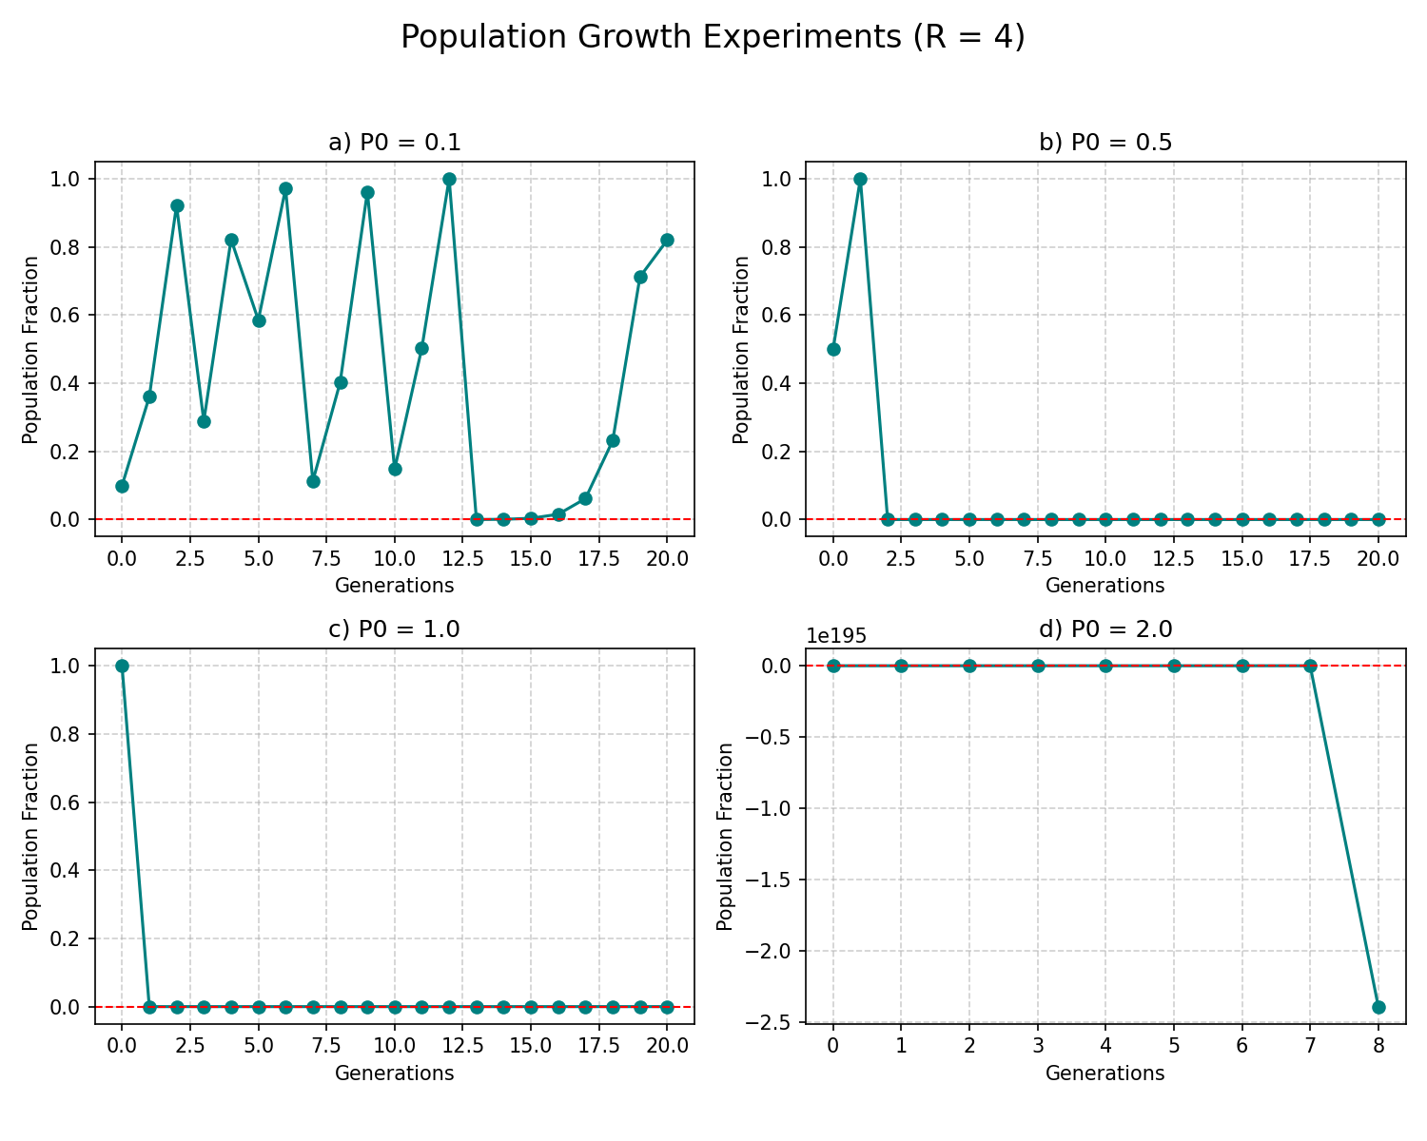

2. Detailed Observations

a) Starting Population: P0 = 0.1 (10% capacity)
FULL CHAOS. The population quickly shoots up, then fluctuates wildly between 0 and 1. It never stabilizes and never repeats the same pattern. It constantly bounces between near-extinction and overpopulation.

b) Starting Population: P0 = 0.5 (50% capacity)
DELAYED EXTINCTION. Because R=4 is so high, starting at exactly 50% causes the population to hit exactly 1.0 (100% capacity) in generation 1. Having consumed absolutely all resources, it crashes to exactly 0.0 in generation 2. Extinction is permanent.

c) Starting Population: P0 = 1.0 (100% capacity)
INSTANT EXTINCTION. The population begins already at the absolute maximum limit of the environment. There are zero resources left for reproduction. It instantly drops to 0.0 in generation 1.

d) Starting Population: P0 = 2.0 (200% capacity)
MATHEMATICAL COLLAPSE. The population starts at double what the environment can support. In the formula, the (1 - 2.0) term creates a negative multiplier (-1). The population instantly drops into impossible negative numbers and spirals rapidly into negative infinity. Biologically, the environment was so severely over-consumed that total ecosystem collapse occurred instantly.

