Population Survival Report

1. Simulation Parameters
Initial Population: 0.5
Sequence of 15 states (S): B, B, B, B, A, B, A, C, C, C, A, C, C, B, A
Weights (R factors): A = 1.5, B = 0.5, C = 3.3

2. Population Evolution Plot
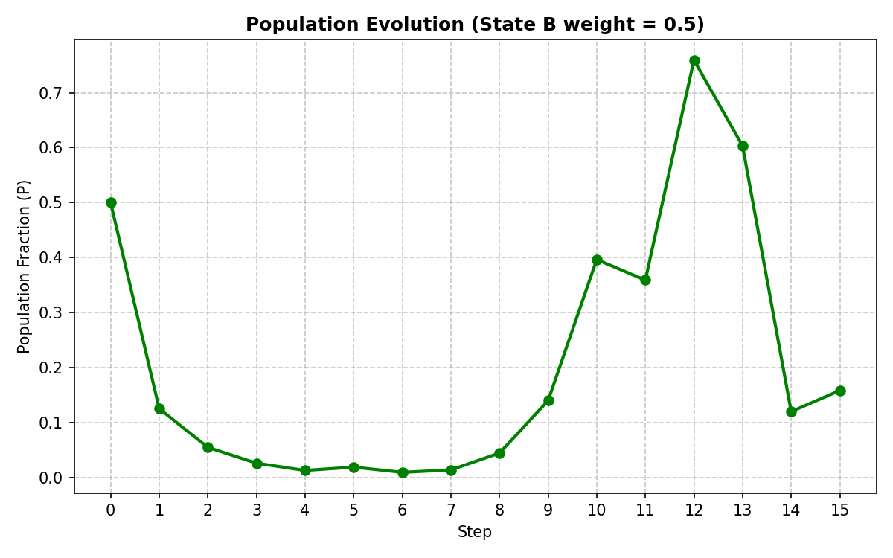

3. Answer to the Question
Yes, the population survives.
Even though State B has an R value of 0.5 (which is a declining, extinction-level growth rate), the environment dynamically shifts out of State B back to State A (R=1.5) or State C (R=3.3). During the periods where State B is dominant, the population drops significantly. However, it never fully reaches zero because mathematically, multiplying by 0.5 simply halves the population with each step. As long as the environment eventually transitions to a favorable state (like C), the population bounces back. By the end of step 15, the population fraction remains positive and active.In conclusion, a population can survive temporary environmental hardships (State B) as long as the system dynamically returns to favorable conditions. Long-term survival depends entirely on the balance and frequency of these recovery phases.

