PowerShell Script "RefundBWCopy.ps1" to read "ScheduleGroup.csv" only if it's being created "today"; "Cost" is greater than Zero; and "Total Color Pages" of the job is Zero.  Upon reading the job, this script add up all the filtered job per user and adjust the balance of the user using server command "adjust-user-account-balance-if-available"   
  
Create a input file as mentioned below:

 I have created a schedule report from PaperCut-Web-Admin--> Reports --> Schedule/Email Reports with Below properties.

The Criteria I selected are mentioned below. Please change them as per your requirement:

Specific Group

Job Type = Copy

Refunded = Not Refunded

Format = CSV

Period = Daily

Name = ScheduleGroup

As per below screen shot:

​​​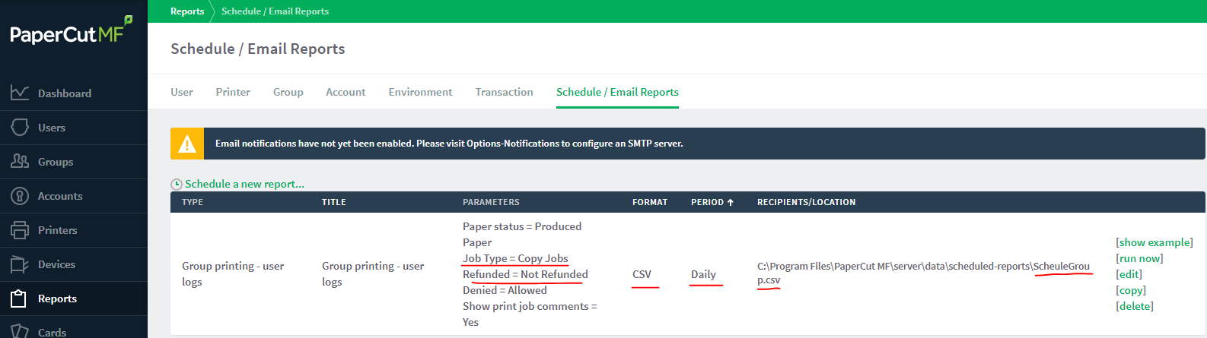​  
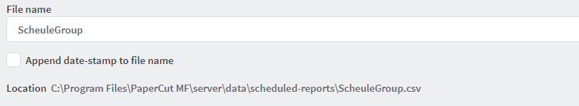   
  
The Schedule Reports job runs every midnight at 00:55 AM, I can schedule the script "RefundBWCopy.ps1" to run once every day around 4:00 AM, so that it can refund the number of jobs passed through pre-defined filter criteria of report and script.  
The method I am using has a limitation that is a user submit a color copy and B/W copy in same login session of the copier, it will not refund that job. I have done to avoid complications. you may edit the script to suit your requirement.

Note:

1. The script needs to be modified based on filename and location of the report defined in Scheduled Report (i.e. $reportLoc and $reportCsv)

3. Please understand each line of the script and test it under  a test environment before deploying it in production environment.

4. Please take a database backup before you run the script for the first time, so that you can revert the changes in case something goes wrong.

     Here is the step to take database backup: <https://www.papercut.com/products/ng/manual/common/topics/sys-backups.html>