Here are the  steps to run the script with template:  
  
1. Go to PaperCut Server Web-admin; navigate to options > Advanced.

**1.1** Scroll to "**Security**" section to set "**Allowed XML Web Services caller**" as ==>

IP address of Machine on which you will run the Python Script. You can also set it as the wild character as '*' for 'any ip'.

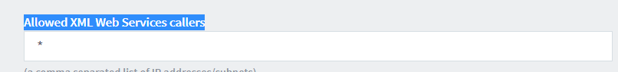

1.2 On the Same page Under "Actions" Tab, click on "Config Editor", Search for "token"

Set "auth.webservices.auth-token" Value as the password. In Script I have set as "token". IF you are setting it something else. please keep a not of that as we will require to change that in Python script before running. I will explain that later bleow.

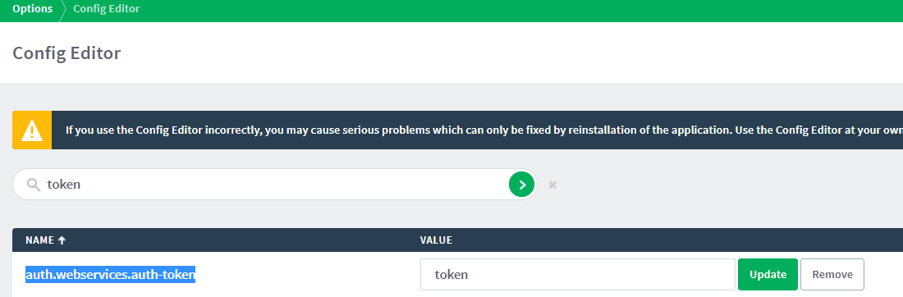

2. Install Python 3.x on your Windows Computer. and Create c:\tmp folder on your Windows Computer.  
  
4. Fill the JobLogs_template.csv with job details, and put it in C:/tmp folder.. Here is the link to field specifications: <https://www.papercut.com/products/ng/manual/common/topics/tools-importing-jobs.html>.

Note: - No Need to change date format as per the guide, Python Script should be able to covert the date to yyyyMMddTHHmmss format

Here is the screenshot for one :

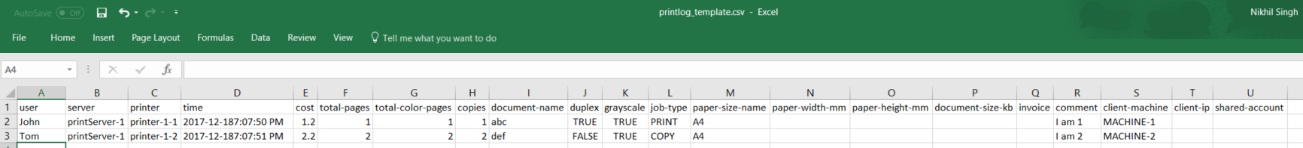

5. Open the "ImportJobLogs.py" on any text editor Change following:

   1. Replace the localhost with IP/Hostname of your PaperCut Application Server  
    host_name = **'localhost'**   
    port = 9191  
    print("Connecting to server {0} on port {1} ...".format(host_name, port))  
    server = client.Server('http://%s:%d/rpc/api/xmlrpc' % (host_name, port))  
2. CHNAGE as per your admin password or auth token you set in Setp 1 above:  
    token = 'token'

6. Execute the Python Script with the command:  
   python ImportJobLogs.py  
7. Once script completed successfully. Login to PaperCut Web-admin with admin user; navigate to "Logs "> "Jobs Logs" and check if jobs are reflecting.