# DIABLOS 1.0 USER DOCUMENTATION

Jonathan Fujii, Brendon Kieser, Cameron McKeown, Alex Petzold, Rico Williams

Updated 4/29/19

Contents

**DIABLOS 1.0 USER DOCUMENTATION** 1

**Startup Guide** 2

Installing 2

Creating a Course 2

Importing Course Information 2

Naming Your Course 3

Importing Your Course Student Roster 3

Basic Information Completed 3

Importing Course Photos 3

Full Setup Completed 3

**Usage Guide** 3

Accessing Your Course 3

Course Home Page 4

Cold Call 4

Cold Call Information 4

Removing a Student from the Queue 4

Flash Photos 5

Flash Photos Usage 5

Editing the Course Roster 5

Course Name Editing 6

Course Roster Editing 6

Course Photos Editing 6

Course Roster Exporting 7

Remove Course 7

Exiting the Application 7

# Startup Guide

Read this and follow the steps to quickly get started and get a functioning course ready.

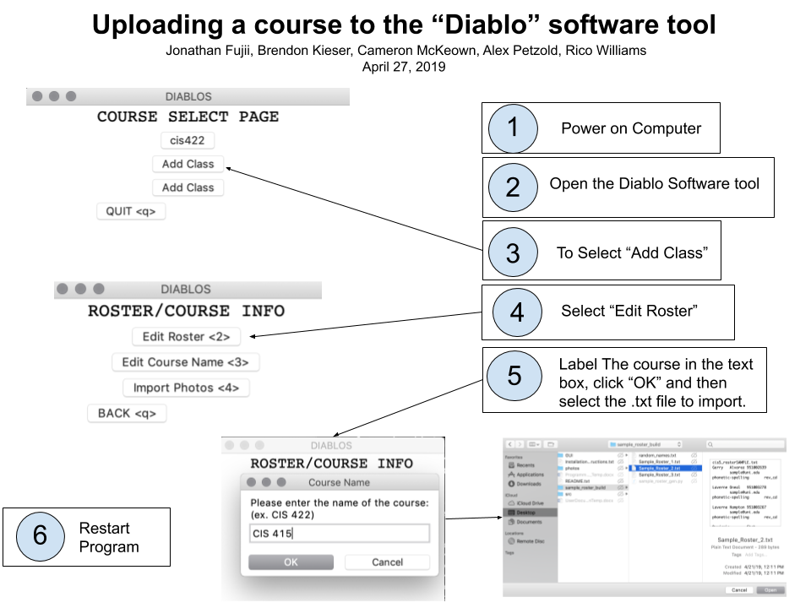

## Installing

Please refer to the Installation_Instructions.txt file before continuing with the rest of this Quick Start guide. It is essential that all needed dependencies are installed before the program is launched.

## Creating a Course

Once the program has been successfully started, the Course Selection window will open.

There will be three course buttons labeled <Add Course> and a quit button. To create a new course, either click on any of the three course buttons with the mouse cursor or press their assigned hotkey of <1>, <2>, or <3> respectively.

## Importing Course Information

Next, the Course & Roster Info window will open and course setup will begin.

### Naming Your Course

First, activate the Edit Roster button by either pressing the <1> key on the keyboard, or by clicking on the button. (Note: If using the former method, make sure the window is in focus for the keystroke to register properly.)

After activated, a window and text field will pop up. Input the desired name for your course into the text field and click ok or hit the <Enter> key on your keyboard to continue onto the next step.

### Importing Your Course Student Roster

Upon confirming the course name, a directory window will pop up. Navigate to the desired roster txt file that you want to use for this course and select it. Once the roster txt file has been selected, confirm by clicking OK or hitting the <Enter> key on your keyboard.

***Roster.txt format Example:***

CIS_499

<First Name> <tab> <Last Name> <tab> <UOID> <tab> <email> <tab> <phonetic> <tab> rev_cd

### Basic Information Completed

Once the course name and roster file have been imported your course will have been successfully made and you will need to restart the application for the changes to take effect. It is at this stage where you can optionally import photos to use for the flashcard component of this application. If you do not want to use the flashcard component you can exit the application now by hitting the Back button in the application and then the Quit button. You can also skip to the **Usage** **Guide** part of this documentation.

### Importing Course Photos

To import course photos, please activate the Import Photos button by either clicking it or pressing <2> on the keyboard. Upon doing so you will be taken to your directory. Once there, select the folder that the photos have been placed in and confirm your selection by either clicking the OK button or pressing the <Enter> key on your keyboard.

### Full Setup Completed

After you have selected the folder that your photos for the course are in, you will be taken back to the Create Course screen. Activate the Back button by either clicking it or pressing the <q> key on the keyboard. This should take you back to the Course Select screen. Press the <q> key on the keyboard again or click the Quit button to exit the application.

# Usage Guide

## Accessing Your Course

Once you have setup your course, upon launching the application you should now see your course on the Select Course window. Simply click the button that your course’s name is on or press its respective assigned key on the keyboard.

## Course Home Page

After selecting your course, you will be taken to its respective Course Home page. At the top you should see the name of the course you selected in large header font. It is from here that you can either start the course’s Cold Call, FlashPhotos, or edit the course’s information.

## Cold Call

To start your course’s Cold Call, select the Cold Call button by either clicking it or pressing the <1> key on your keyboard. Your course’s Cold Call window will now appear on the screen.

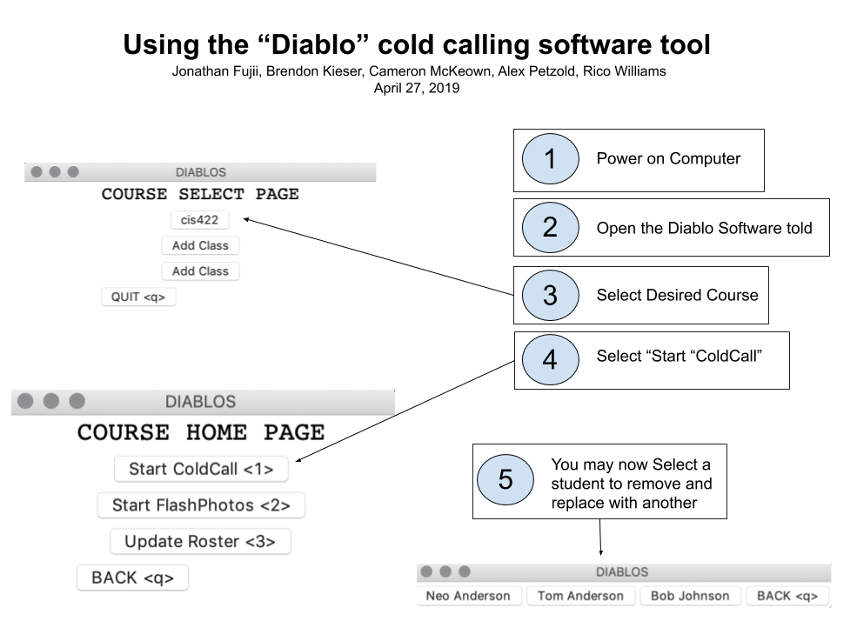

### Cold Call Information

On the window will be four buttons, three buttons labeled with the names of students in the course, and the fourth is a back button. These first three students shown are within the queue’s “deck”: the first three positions of the queue. Students priority in this “deck” to be called upon are ordered highest to lowest going left to right. (i.e. the first student in the queue to be called on is the one on the farthest left.) You can exit the Cold Call window at any time by either clicking the button labeled <q> or pressing the <q> button on the keyboard.

### Removing a Student from the Queue

To remove a student from the deck for any reason, simply click the button that the student’s name is on, or press that button’s assigned key. (e.g. If Molly Anderson is to be removed from the deck and is on the button labeled [2. Molly Anderson], clicking said button or pressing the <2> key on the keyboard will successfully remove her from the deck.)

After removing any one of the three students from the deck, a new student will be added to the end of the deck from the queue. (e.g. If Molly Anderson was second in priority, George Taki was third in priority, and Rina Scully was fourth in priority, upon removing Molly Anderson from the deck, George Taki would become second in priority and Rina Scully would become third in priority and visible on the deck)

## Flash Photos

To start your course’s Flash Photos, select the FlashPhotos button by either clicking it or pressing the <2> key on your keyboard. Your course’s Flash Photos window will now appear on the screen.

### Flash Photos Usage

There are three photos within the Flash Photos, each one is taken from the imported course photos. Pressing the <Space> bar will reveal the names for the photos. After this, you can cycle these photos for new ones by pressing the <Space> bar again. These photos will be selected at random.

## Editing the Course Roster

To edit your course’s information, select the Edit Course Roster button by either clicking it or pressing the <3> key on your keyboard. Your course’s information window will now appear on the screen. Please note that all information updates require the application to be restarted to take effect.

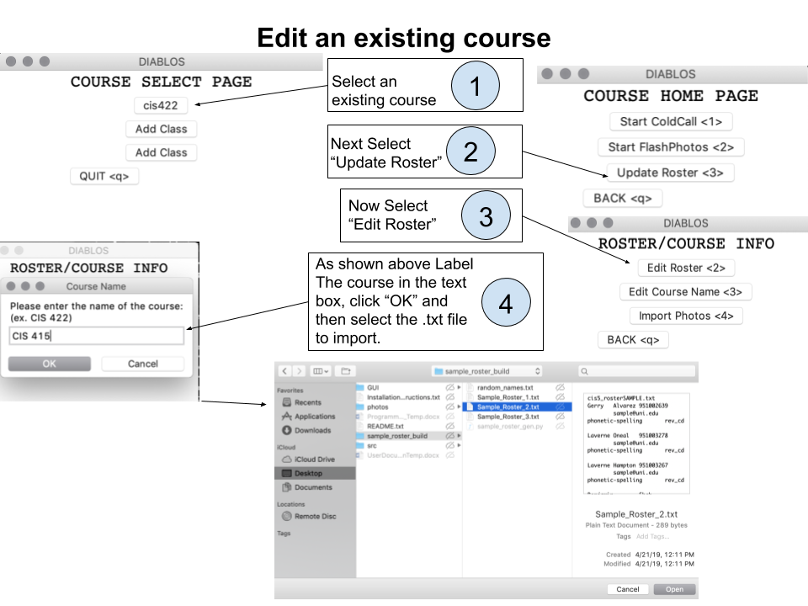

### Course Name Editing

In case you want to update your course’s name, select the Edit Roster button by either clicking it or pressing the <1> key on your keyboard. You will be taken to a window where you can update your course’s name. Press OK to hit Enter to confirm the changes. On the next window, click Cancel if you don’t want to update your roster.

### Course Roster Editing

In case you want to update your course’s roster, select the Edit Roster button by either clicking it or pressing the <1> key on your keyboard. You will be taken to a window where you can update your course’s name. Press Cancel if you do not want to update your course’s name and want to simple edit the roster. On the next window you can import your roster. Please revisit the **Importing Course Information** part of this document if you desire more details.

### Course Photos Editing

To import course photos, please activate the Import Photos button by either clicking it or pressing <2> on the keyboard. Upon doing so you will be taken to your directory. Once there, select the folder that the photos have been placed in and confirm your selection by either clicking the OK button or pressing the <Enter> key on your keyboard.

### Course Roster Exporting

To export your course roster to a txt file, please activate the Export Roster button by either clicking it or pressing <4> on the keyboard. Upon doing so you will be taken to your directory chooser. Select the folder you wish your roster txt file to be exported to and confirm the selection. Upon doing so an information window will display your chosen directory destination for the roster file and it will be exported there under the name <Course Name>.txt

### Remove Course

If you want to remove your course from the application, select the Remove Course button by either clicking it with the mouse cursor or pressing the <3> key on your keyboard. Upon doing so you will get a confirmation page asking whether you want to remove it or not. If you want to continue, press the OK button, otherwise select the cancel button. Remember that removing a course is permanent and that if you wish to undo it, you will have to reimport all class information as detailed in the **Importing Course Information** part of this document.

## Exiting the Application

To exit the application, click the back button or press <q> until you get back to the Select Course window. From there click the quit button or press <q> to exit the application.