Governance in action – your safety agent net playbook

Designing policies and workflows to keep multi-agent systems accountable

Part 1. Building the agent chain

Step 1. Identify key risks:
- Regulatory Risk: Data delays (latency) cause traders to execute transactions that exceed permitted legal or regulatory limits.
- Operational Risk: Desynchronization between real-time market data streams and execution logic due to network failures or message loss.
- Reputational Risk: The erroneous execution of unauthorized portfolio adjustments that damage the firm’s credibility and client trust.

Step 2. Define governance controls
Risk category | Proposed control | Expected outcome
Regulatory risk | Automated pre-trade compliance hard-stop | Intercepts and blocks any transaction that violates regulatory rules or position limits before it reaches the market.
Operational risk | Latency Heartbeat Monitor & Circuit Breaker | Automatically pauses trade execution agents if market data feeds exceed acceptable delay thresholds.
Reputational risk | Human-in-the-Loop (HITL) Checkpoint for High-Value Trades | Requires explicit manual sign-off for any order exceeding predefined capital thresholds.

Step 3. Escalation diagram
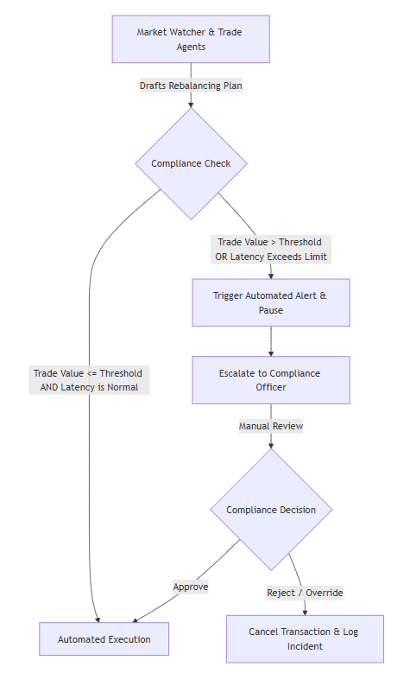

Step 4. Policy summary
All multi-agent portfolio rebalancing activities must maintain immutable audit logs recording every data input, agent decision rationale, and execution timestamp for regulatory accountability. Comprehensive logs are securely retained for post-incident analysis and compliance reviews. Automated alerts generated by latency spikes or rule violations are routed immediately to the designated on-duty compliance analyst for priority review. A manual override is strictly triggered whenever trade volumes exceed pre-established financial thresholds, when market data feeds experience anomalous delays, or when the Compliance Agent flags an ambiguous transaction pattern. Under these conditions, agent execution halts automatically until an authorized Compliance Officer explicitly approves or cancels the operation, ensuring a secure balance between automated efficiency and risk mitigation.

Deliverable 2. Short methodology
- Risk Identification Process: Risks were identified by systematically mapping out the failure modes within the multi-agent trading chain, focusing heavily on the root causes of the recent near-miss incidents specifically data latency and compliance validation gaps.
- Control Prioritization: Controls were prioritized based on potential impact and severity, implementing preventive barriers (such as automated pre-trade hard-stops and latency circuit breakers) before detective measures (like alerts and logging).
- Key Trade-Off Made: A critical trade-off was made between system autonomy and execution speed versus regulatory safety. Introducing mandatory human-in-the-loop checkpoints and strict latency circuit breakers reduces the system's overall transaction speed and operational autonomy, but this friction is necessary to eliminate catastrophic non-compliant trade execution risks.

Deliverable 3. Analysis
The governance plan achieves an effective balance between regulatory compliance, business agility, and system autonomy by utilizing a risk-tiered architecture. Routine, low-value portfolio rebalancing operations execute with full agent autonomy to preserve speed and market responsiveness. However, deterministic guardrails—such as pre-trade compliance hard-stops and automated latency circuit breakers—intervene selectively when predefined risk thresholds are crossed. By restricting manual intervention to high-consequence exceptions, the framework prevents operational bottlenecks while ensuring absolute regulatory adherence. This design proves that rigorous risk management and compliance do not require sacrificing the core operational benefits of automated business agility.

Deliverable 4. Reflection
Managing risk in multi-agent systems revealed that individual agent intelligence does not guarantee collective safety; complex interactions, cascading messages, and data delays can introduce severe systemic vulnerabilities that single-agent frameworks miss.
To adapt this playbook for a larger, more complex deployment, I would implement the following scaling strategies:
- Decentralized Consensus Monitors: Introduce peer-monitoring mechanisms where specialized audit agents cross-verify trade intent before execution.
- Dynamic Threshold Adjustments: Implement adaptive risk limits that scale automatically based on real-time market volatility and liquidity conditions.
- Tiered Hierarchical Oversight: Structure compliance oversight into distinct tiers—automated local circuit breakers for micro-anomalies, and human-in-the-loop escalation boards for systemic risks—to prevent operational bottlenecks as node volume grows.

