Deliverable 1. Final workflow canvas
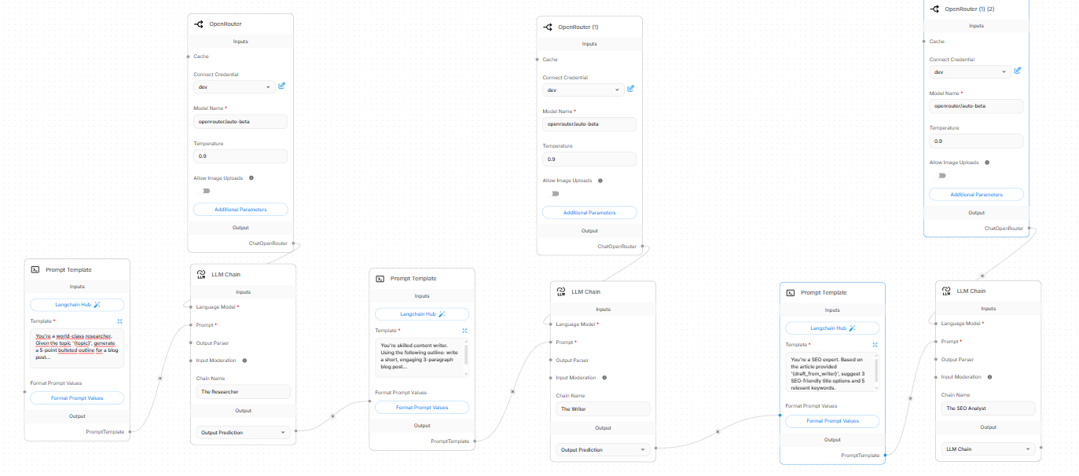
Deliverable 2. Agent prompt engineering
- Researcher prompt:
You're a world-class researcher. Given the topic '{topic}', generate a comprehensive 5-point bulleted outline for an in-depth blog post. For each point, include a clear heading, a brief description of what the section should cover, and a suggested key takeaway or actionable insight for the reader.
This prompt transforms the abstract {topic} input into a structured, modular blueprint containing explicit headings, descriptions, and takeaways that downstream writing agents can directly execute paragraph by paragraph.
- Writer prompt
You're a skilled content writer. Using the following outline:
{content}
Write a short, engaging 3-paragraph blog post that adopts an authoritative yet conversational tone. Ensure the narrative flows seamlessly from introducing the core problem in paragraph one, to delivering actionable solutions in paragraph two, and closing with an inspiring, future-focused takeaway in paragraph three.
This prompt transforms the structured JSON or bulleted {content} outline into a cohesive, reader-ready narrative by mapping distinct structural beats directly to a controlled three-paragraph arc for downstream optimization.
- SEO analyst prompt
You're an expert SEO strategist. Based on the following article draft:
'{draft_from_writer}'
Analyze the content's search intent, target audience, and core themes, then provide:
1. 3 SEO-friendly, high-converting title options (optimizing for click-through rate while including primary keywords).
2. 5 high-impact, relevant keywords (a mix of short-tail and long-tail terms) optimized for search volume and ranking potential.
This prompt transforms the raw text {draft_from_writer} input into targeted metadata assets—high-converting titles and keyword pairs—designed to maximize search engine visibility and click-through rates.
Deliverable 3. Communication protocol analysis
The constructed Simple Sequential Chain operates as a deterministic communication protocol, standardizing how information cascades across nodes.
- Major Advantage: Predictability and modularity. By enforcing a strict one-way linear flow, debugging errors becomes straightforward because each agent handles a strictly isolated phase of production.
- Significant Limitation: Lack of feedback loops. Downstream agents cannot request structural changes from upstream roles if an outline proves sub-optimal during drafting.
Breaking down the content creation task required balancing granular context injection with creative freedom. The most critical consideration during prompt design was semantic contract alignment—ensuring the output schema of one node explicitly mirrored the expected input variables of the next. For instance, the researcher's structural elements had to map precisely to the writer's organizational constraints, preventing token misalignment and semantic drift across the handoffs.

