HTML & CSS — Navigation Bar and Card Design

Student Information
- Name: David Ale
- Student ID: 2542156
- Course/Module: HTML / CSS
- Level: Undergraduate / Level 4
- Assignment Title: Building a Navigation Bar and Responsive Card Layout Using HTML & CSS

Project Description
This project is a single-page responsive website designed for Northlight Code Academy, an online learning platform offering practical coding courses for beginners.
The website consists of four main sections:
- Header & Navigation Bar: Built using semantic HTML (<header>, <nav>) and CSS Flexbox. It features a brand logo, navigation links with smooth hover underline animations, and a responsive toggle menu button for smaller screens.
- Hero / Intro Section: Introduces the platform mission statement with a clean dark layout.
- Card Layout Section: Displays 6 course cards in a CSS Grid layout. Each card features an image, tag badge, title, course description, metadata (difficulty and duration), and an action button with smooth hover effects.
- Footer Section: Contains contact information, class schedules, and copyright notices.
The entire layout is fully responsive and adjusts across mobile, tablet, and desktop viewports.

Technologies Used
- HTML5: Semantic tags (<header>, <nav>, <main>, <section>, <article>, <footer>)
- CSS3: Flexbox, CSS Grid, Media Queries, Custom CSS Variables (:root), Transitions, and Hover States

Learning Resources
No. | Resource | Topic Learned | What I Learned | How I Applied It
1 | Teacher's Lecture Notes | Semantic HTML & CSS Selectors | Learned why semantic HTML tags (<header>, <nav>, <article>) are better for accessibility and SEO compared to generic <div> tags. | Structured the entire page using semantic elements and applied modular class selectors in CSS.
2 | MDN Web Docs | CSS Flexbox Alignment | Learned how Flexbox manages one-dimensional horizontal alignment, spacing items across axes using justify-content and align-items. | Built the header navigation bar (.navbar) using display: flex; justify-content: space-between; to align the logo and navigation links cleanly.
3 | MDN Web Docs | CSS Grid Layout | Learned how CSS Grid arranges items in two-dimensional space using grid-template-columns, repeat(), and fractional units (fr). | Created the course catalog container (.card-grid) using display: grid; grid-template-columns: repeat(3, 1fr); for a balanced desktop layout.
4 | YouTube Tutorial (Traversy Media) | Responsive Web Design & Media Queries | Learned how to write @media queries to reconfigure CSS layouts dynamically based on device viewport width thresholds. | Configured breakpoint rules at 992px (2 cards per row) and 600px (1 card per row with a collapsible mobile menu).

Screenshots

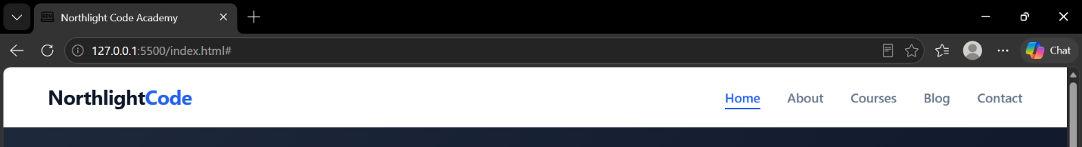

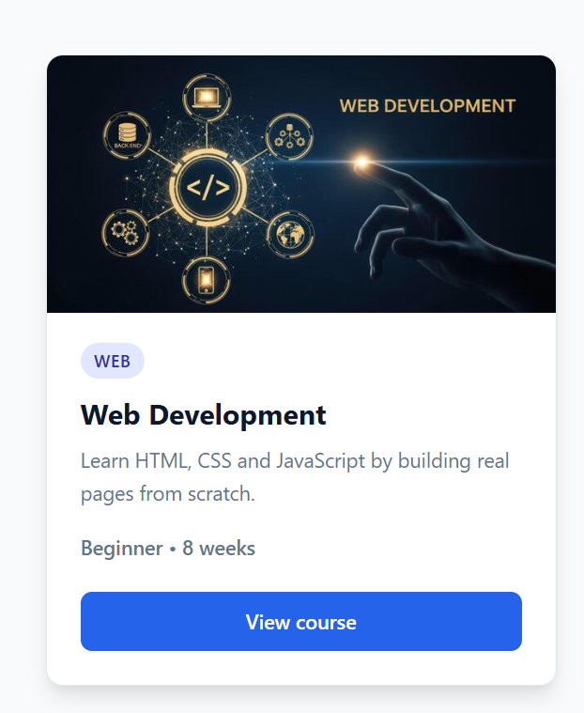

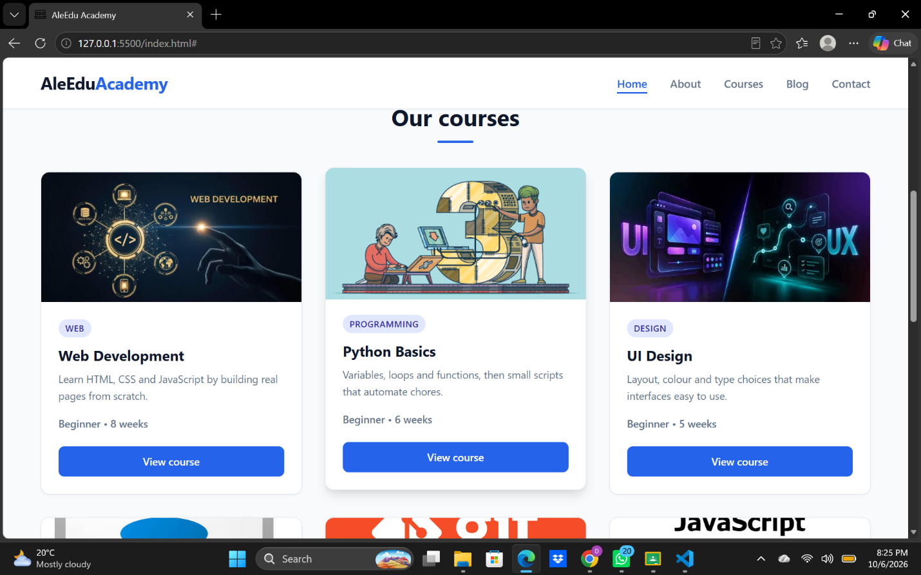

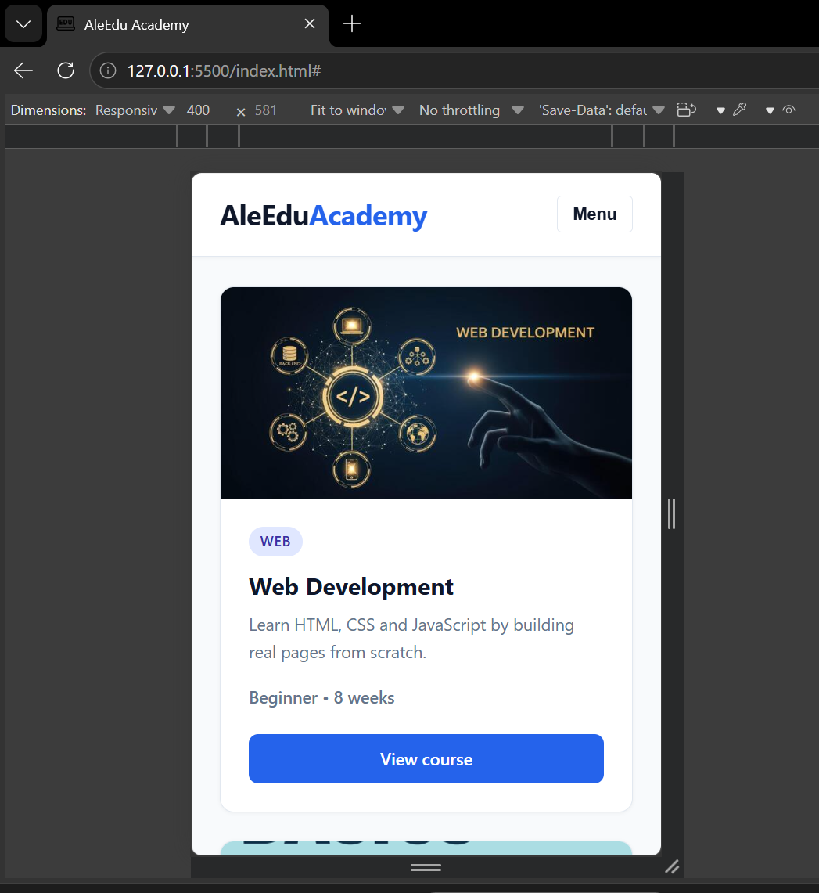

Key Concepts Learned
- Semantic HTML Structure:
Instead of wrapping every layout element in generic <div> containers, I used <header>, <nav>, <main>, <section>, <article>, and <footer>. This improves screen reader accessibility and structural clarity.
- Flexbox vs. CSS Grid Choice:
  - Flexbox was chosen for the Navigation Bar and Card Contents because they require 1-dimensional horizontal/vertical alignment.
  - CSS Grid was chosen for the Courses Section because it requires a 2-dimensional grid arrangement with consistent column widths and gaps across rows.
- Equal Height Card Mechanics:
By applying display: flex; flex-direction: column; to .card-body and adding flex-grow: 1; to the course description paragraph, all card content expands evenly, ensuring all action buttons align perfectly along the bottom row.
- Image Handling with object-fit:
To prevent card thumbnails from distorting, I applied height: 160px; and object-fit: cover; to .card img, preserving natural aspect ratios while filling the image wrapper cleanly.
- Responsive Media Queries:
Implemented breakpoint logic using @media (max-width: 992px) and @media (max-width: 600px) to transition card arrangements smoothly from 3 columns 2 columns 1 column.

Challenges and Solutions

Challenge 1: Cards were uneven in height due to varying description lengths
- Problem: Some course descriptions had two lines of text while others had three, causing the bottom action buttons (View course) to align unevenly across the row.
- Solution: Applied display: flex; flex-direction: column; to the .card-body container and set flex-grow: 1; on the text element (.card-body p:not(.meta)). This forces the description area to absorb extra vertical space and pushes the button down consistently.

Challenge 2: Mobile navigation links overflowing on small screens
- Problem: On screen widths below 600px, horizontal navigation links overcrowded the header bar.
- Solution: Added a mobile menu toggle button (.nav-toggle) and styled .nav-links to hide by default on small screens (display: none). Added a lightweight JavaScript toggle listener that appends an .open class (display: flex; flex-direction: column;) when clicked.

AI Usage Disclosure
AI assistance (Gemini) was used during this project to double-check semantic HTML best practices, debug CSS flexbox alignment behaviors, and review media query syntax. All code was customized, integrated, and verified independently to ensure complete understanding for practical evaluation.

GitHub Repository
Repository Link: https://github.com/YOUR-USERNAME/html-css-assignment

