AS Computer Science · Unit 1 · Topic 2
Truth Tables & Notation — Lesson 1 Check
Name: ______________________________________________ Date: ______________
Circle the correct answer for each question.
1. What is the correct order of operations for evaluating a Boolean expression?
A. Brackets → NOT → AND → OR
B. Brackets → AND → NOT → OR
C. NOT → Brackets → OR → AND
D. Brackets → OR → AND → NOT
2. Which symbol represents the OR operator?
A. . (dot)
B. + (plus)
C. ⊕
D. ¬
3. What is the value of A.B when A = 1 and B = 0?
A. 0
B. 1
C. Undefined
D. It depends on the order they're written in
4. For A + B, in how many of the four input combinations is the result 1?
A. 1
B. 2
C. 3
D. 4
5. How many rows does a truth table for NOT A need?
A. 1
B. 2
C. 4
D. 8
6. A XOR B is true when...
A. Both inputs are the same
B. Both inputs are different
C. At least one input is 1
D. Both inputs are 1
7. A truth table has 4 inputs. How many rows does it need?
A. 4
B. 8
C. 16
D. 32
8. When building a 3-input truth table (A, B, C) from scratch, which row should you list first?
A. 111
B. 000
C. 100
D. It doesn't matter, any order works
9. Using the “find the 1s” method, what term would you write for a row where A = 0 and B = 1?
A. A.B
B. Ā.B
C. A.B̄
D. Ā.B̄
10. A truth table's output is 1 only on two rows: A=1,B=0 and A=0,B=1. What's the resulting expression?
A. A.B̄ . Ā.B
B. A.B̄ + Ā.B
C. (A+B̄).(Ā+B)
D. A + B
11. A truth table's output is 1 on exactly one row: A=0, B=0 (all other rows are 0). Which expression does this table show?
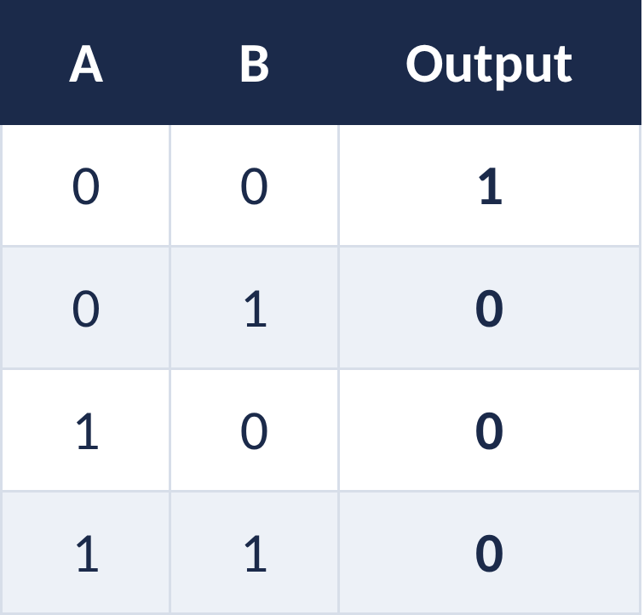
A. Ā.B̄
B. A.B
C. Ā+B̄
D. A⊕B
12. Which expression does this truth table show?
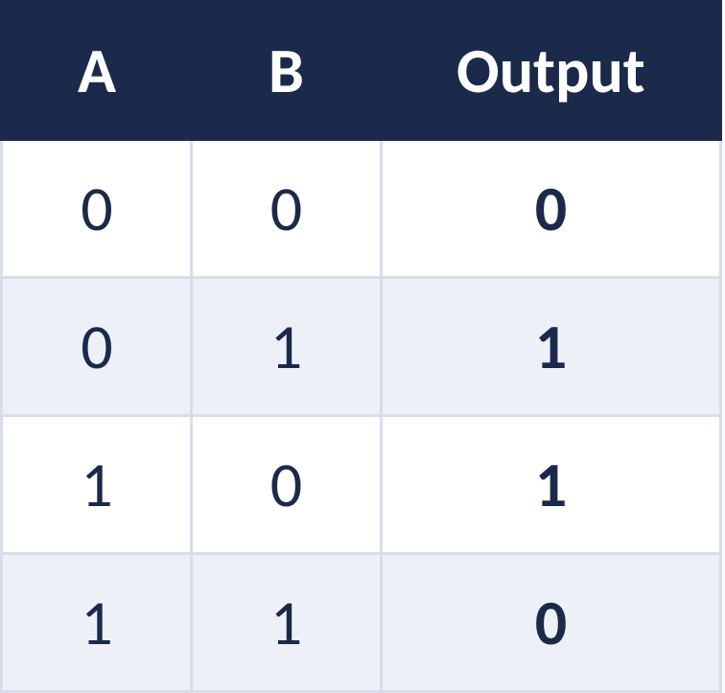
A. A + B
B. A ⊕ B
C. A . B
D. Ā + B̄
13. Which expression does this truth table show?
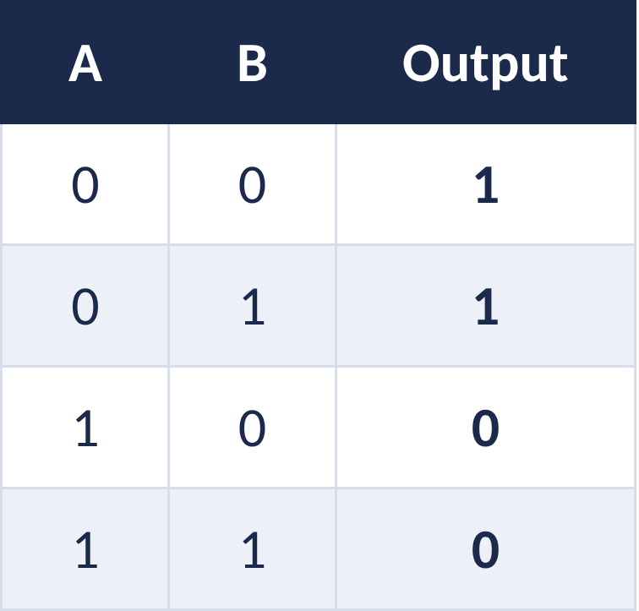
A. Ā
B. B̄
C. A
D. Ā.B̄
14. Which expression does this truth table show?
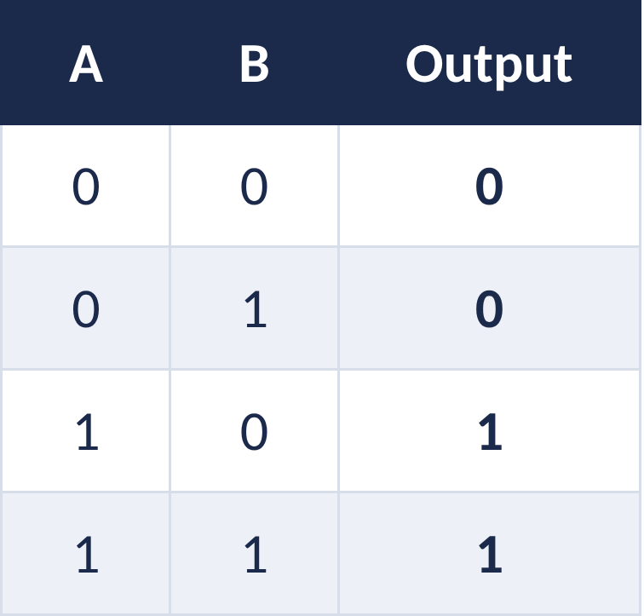
A. A
B. B
C. A.B
D. A + B

Answer key
For teacher use or self-marking — includes a short explanation for each answer.
Q | Answer | Why
1 | A | Brackets are evaluated first, then NOT, then AND, then OR — the same order as BIDMAS, with AND behaving like × and OR behaving like +.
2 | B | + represents OR. The dot (.) represents AND, ⊕ represents XOR, and ¬ (or an overline) represents NOT.
3 | A | AND is only true (1) when both inputs are 1. Since B = 0 here, the result is 0.
4 | C | OR is only 0 when both inputs are 0. It's 1 for the other three combinations: (0,1), (1,0) and (1,1).
5 | B | NOT only has one input, so there are only two possible values (0 and 1) — 2 rows.
6 | B | XOR (“exclusive or”) is true exactly when the two inputs differ from each other.
7 | C | The number of rows is 2 to the power of the number of inputs. With 4 inputs, that's 2⁴ = 16 rows.
8 | B | Good practice is to list every combination systematically, starting at 000 and counting up in binary to 111, so you never miss a row or repeat one.
9 | B | Use the letter if the input is 1, and NOT the letter if it's 0. Here A = 0 → Ā, and B = 1 → B, giving Ā.B.
10 | B | Once you have a term for each 1-row, OR them together: A.B̄ + Ā.B. This pattern is worth recognising — it's the same as XOR.
11 | A | Only one row is 1, so there is only one term to write: A=0 gives Ā, B=0 gives B̄, combined with AND: Ā.B̄.
12 | B | Output is 1 whenever the two inputs are different (01 and 10) and 0 whenever they're the same (00 and 11) — that's the definition of XOR.
13 | A | Output is 1 whenever A = 0, regardless of what B is — B doesn't affect the result at all, so the simplest expression is just Ā.
14 | A | Output matches column A exactly — it's 0 when A=0 and 1 when A=1, regardless of B. So the expression is simply A.

