Chapter 3: Data and Methodology
3.1. Data Sources and Harmonization
The study constructs a panel dataset using AI occupational score US-based (Felten et al., 2021), and European industry-level employment and output data to analyzed the impact of Generative AI on European labor productivity. The primary data sources used on the analysis are as follows:
- AI Exposure Scores (Source: Felten et al., 2021): The foundational metric is the AI Occupational Exposure (AIOE) index, which links 52 human abilities (from O*NET) to ten specific AI applications.
- Labor Force Structure (Source: Eurostat LFS): Employment counts by occupation (ISCO-08) and economic activity (NACE Rev. 2) for European countries.
- Productivity Metrics (Source: Eurostat National Accounts): Real Gross Value Added (Chain-linked volumes, 2010 reference) and Total Hours Worked by industry and year.

3.2. Data Processing and Cleaning
Before constructing the AIIE index (AI industry exposure index), raw data from Eurostat and Felten et al. went through cleaning and harmonization process to ensure consistency across occupations in Europe
3.2.1. Preprocessing and Endogeneity Controls
Raw Eurostat data were first standardized. Observation values (OBS_VALUE) containing non-numeric flags were forced into NaN’s and excluded to prevent calculation errors. Categorical variables (Job Names, NACE codes) were forced to string type.
The Exogeneity Restriction (2022 Baseline):
A critical methodological decision was to restrict the industry weighting calculations to the year 2022. This serves two econometric purposes:
- Avoidance of Endogeneity: Generative AI adoption (post-2023) may cause firms to alter their labor composition. If we used post-2023 employment shares to calculate exposure, the independent variable would be endogenous to the outcome. Using 2022 weights ensures the exposure measure reflects the structural susceptibility of the industry prior to the shock.
- Serial Correlation: Fixing the weights minimizes autocorrelation in the residuals that might arise from fluctuating labor shares during the shock period of 2023-2024.
3.2.2. The Crosswalk and Exclusions
To bridge the US-based AI scores with European labor data, the following transformations were applied:
- ISCO-08 Aggregation: US SOC codes were mapped to the 4-digit ISCO-08 standard. To minimize matching errors between specific job titles, these were aggregated to the 1-digit Major Group level (Groups 1–9).
- I excluded Armed Forces Occupations (ISCO Group 0) from the dataset because military employment operates under a different logic than the private market. Including these roles would have distorted the estimates for Public Administration (Sector O), as military productivity is not driven by the same economic forces as the civilian workforce
- Code Standardization: Eurostat ISCO codes often contain prefixes. I had to strip them to numeric keys (1-9) derived from the AI scores.
3.2.3. Variable Construction Logic
Two primary variables were constructed from the cleaned data:
1. The AI Industry Exposure (AIIE) Index:
To calculate the exposure for a Country-Industry pair (IC), we utilized an "Exposure Mass"
approach:
$$Exposure Mass_{IC}= \sum_{o=1}^{9}{\left(Employment_{o,IC}×Score_{o}\right)}$$
$$AIIE_{IC}=\frac{Exposure Mass_{IC}}{Total Employment_{IC}}$$

This weighted average ensures that an industry's score reflects the AI exposure of its actual workforce composition, rather than a simple average of job titles.
2.Real Labor Productivity (Ycit):
To ensure unit consistency, the productivity variable was constructed as:
$$Y_{cit}=\frac{\text{GVA (Millions)}}{\text{Hours (Thousands)}}×1,000$$

This transformation aligns the numerator and denominator to produce a final metric in Euros (€) per Hour Worked, adjusted for inflation (Chain-linked volumes).
3.3. Construction of the AI Industry Exposure (AIIE) Index
3.3.1. Occupational Standardization (The Crosswalk)
We first mapped the granular US SOC codes to the International Standard Classification of Occupations (ISCO-08). To ensure robust matching, we aggregated detailed occupations into the 9 Major ISCO-08 Groups (1-digit level).
- Group 1: Managers
- Group 2: Professionals
- Group 3: Technicians and Associate Professionals
- Group 4: Clerical Support Workers
- Group 5: Service and Sales Workers
- Group 6: Skilled Agricultural, Forestry and Fishery Workers
- Group 7: Craft and Related Trades Workers
- Group 8: Plant and Machine Operators and Assemblers
- Group 9: Elementary Occupations
This aggregation mitigates measurement error arising from minor differences between US and European job titles.
3.3.2. Normalization
Before aggregation, the raw AI scores were normalized to a [0,1] scale for easy interpretation of the metric.
For any given occupation o, the normalized score So is calculated as:
$$S_{o}=\frac{S_{raw}-\min\left(S\right)}{\max\left(S\right)-\min\left(S\right)}$$

3.3.3. Industry Weighting
The final AI Industry Exposure (AIIE) index for industry i in country c is constructed as a weighted average of the occupational exposure scores. The weights are determined by the share of workers in each occupational group within that specific industry.
$${\text{AIIE}}_{ic}= \sum_{o=1}^{9}{\left(\frac{{\text{Emp}}_{o,i,c}}{{\text{TotalEmp}}_{i,c}}×S_{o}\right)}$$

Where:
${\text{Emp}}_{o,i,c}$is the number of workers of occupation type o in industry i.
- Crucially, we utilize 2022 weights (pre-ChatGPT) to establish a structural baseline. This avoids endogeneity, ensuring our measure reflects the industry's underlying exposure rather than its subsequent reaction to the technology.
3.3.4. Validation of the Index
Figure 3.1 (below) displays the calculated AIIE scores by NACE Rev. 2 Sector. The distribution aligns with theoretical expectations:
- Highest Exposure: top 3 highest sectors: Information & Communication (J), Professional/Scientific Activities (M), and Financial Activities (K) these sectors usually rely on technology and according to the graph they are high exposure score which makes economic sense
- Lowest Exposure: top 3 lowest sectors Agriculture (A), Construction (F), and Mining (B) It also makes sense because these sectors are not usually occupied by professionals that will use technology
- 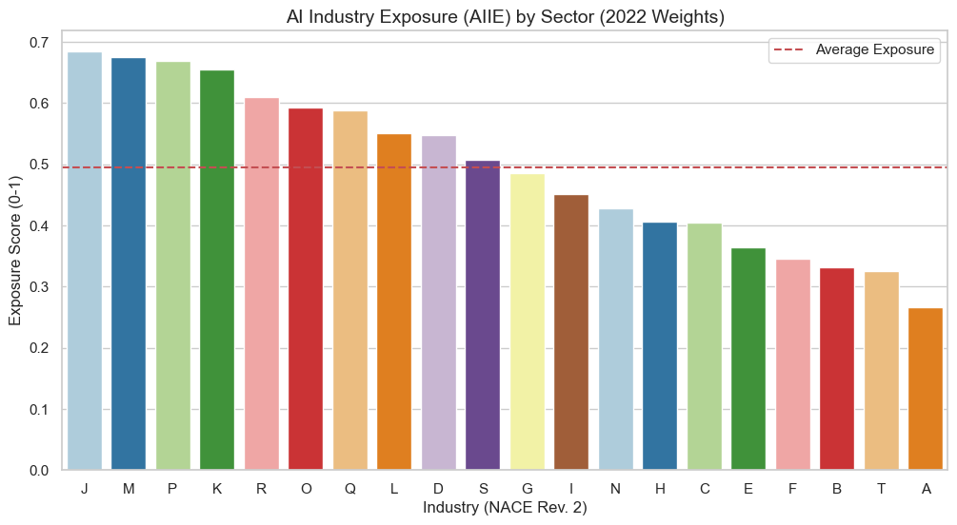

3.4. Outcome Variables
The dependent variable of interest is Labor Productivity, defined as real economic value generated per unit of labor.
$$\text{Labor }{\text{Productivity}}_{cit}=\frac{\text{Real }{\text{GVA}}_{cit}×1,000,000}{\text{Total Hours }{\text{Worked}}_{cit}×1,000}$$

- Numerator: Gross Value Added (B1G) in Chain-Linked Volumes (Millions of Euros).
- Denominator: Total Hours Worked (Thousands of Hours).
- Unit Correction: The multipliers ensure the final metric is expressed in Euros per Hour.
As shown in the histograms (Figure 3.2), the raw productivity distribution is highly right-skewed. To satisfy the normality assumptions of OLS regression and to interpret coefficients as elasticities (percentages), we apply a natural logarithm transformation:
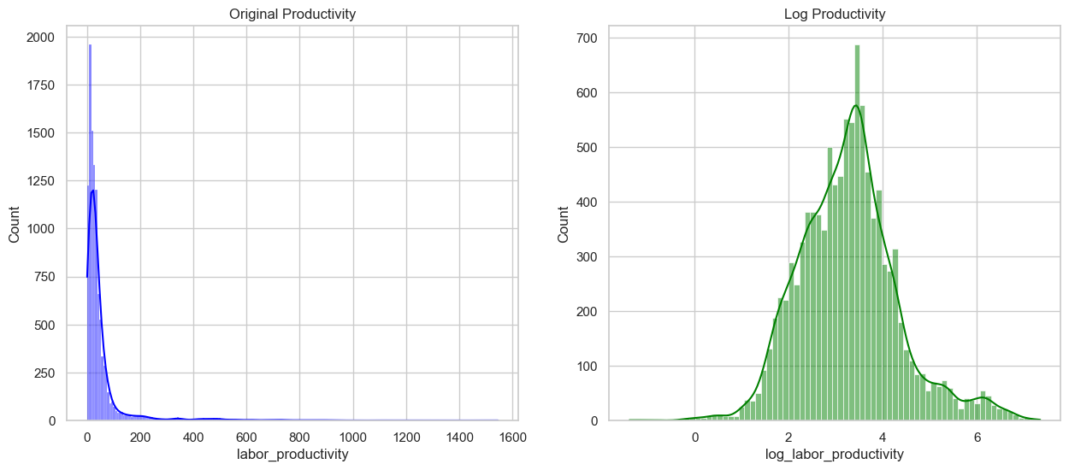

3.5. Econometric Strategy
To identify the causal impact of Generative AI, we employ a Difference-in-Differences (DiD) specification with a continuous treatment intensity. We exploit the release of ChatGPT (late 2022) as an exogenous shock that differentially affected industries based on their pre-existing exposure profile.
The baseline regression equation is:
$$\ln\left(Y_{ict}\right)= β_{1\left({\text{AIIE}}_{i}×{\text{Post2022}}_{t}\right)}+ δ_{i}+ γ_{t}+ ϵ_{ict}$$

Where:
${\text{AIIE}}_{i}$: The AI exposure intensity for industry “i”.
Post 2022: A dummy variable equal to 1 for years 2023–2024.
$δ_{i}$: Industry-Country Fixed Effects (controls for time-invariant characteristics like "Finance is always high-value").
$γ_{t}$: Time Fixed Effects
$β_{1}$: This measures the causal impact of GenAI.

3.5.1. Parallel Trends Assumption
The validity of the DiD estimator relies on the assumption that, in the absence of the treatment, high- and low-exposure industries would have followed similar productivity trends.
Figure 3.3 (Parallel Trends Check) visualizes the average productivity for High-Exposure (Top quartile) vs. Low-Exposure (Bottom quartile) industries from 2008 to 2024.
- Pre-2022: Both groups exhibit parallel trajectories
- Post-2022: we expect to see a spike on the high exposure line however on our graph we don’t see any significant spike which we will explore later on the modeling part
