Chapter 4: Empirical Results and Discussion
4.1. Econometric model strategy
To estimate the impact of Generative AI on the European labor market, we employed a Difference-in-Differences (DiD) strategy with a continuous treatment. The model exploits the release of ChatGPT (late 2022) as an exogenous shock, interacting it with the pre-existing AI Industry Exposure (AIIE) index.
A fixed effect model with a Difference-in- difference interaction was chosen to estimate the impact of generative AI on European productivity, where the release of ChatGPT (late 2022) was taken as an exogenous shock, interacting with the AI Industry Exposure (AIIE) index

$$\ln\left(Y_{ict}\right)= β_{1\left({\text{AIIE}}_{i}×{\text{Post2022}}_{t}\right)}+ δ_{i}+ γ_{t}+ ϵ_{ict}$$

Where:
${\text{AIIE}}_{i}$: The AI exposure intensity for industry “i”.
Post 2022: A dummy variable equal to 1 for years 2023–2024.
$δ_{i}$: Industry-Country Fixed Effects (controls for time-invariant characteristics like "Finance is always high-value").
$γ_{t}$: Time Fixed Effects
$β_{1}$: This measures the causal impact of GenAI.
Standard errors are clustered at the industry level to account for serial correlation.
4.2. Main Results: The Productivity Paradox

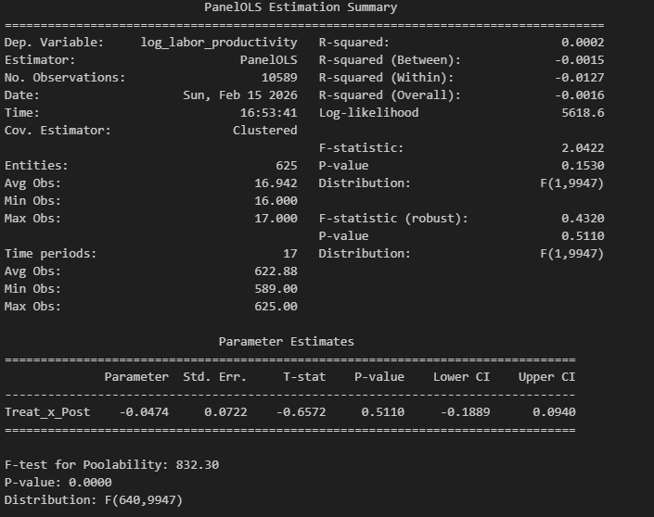

Table 1 (Model 1) presents the impact of AI exposure on Labor Productivity (Real GVA per hour worked).
Finding 1: No Structural Break in Efficiency.
If we take a look on the interaction term (Treat_x_post) is negative coefficient (-0.0474) and statistically significant p-value 0.5110
Interpretation: the negative coefficient on our interaction term suggests negative or no growth in productivity meaning there was no difference in productivity gain between low and high ai industries following the release of ChatGPT
Take away from this model results:
We would expect to see a productivity gain in a positive and statistically significant coefficient however the results show the opposite following the productivity J-curve terminology meaning the companies in the European union are still in an investment period and we don’t see immediate jump in productivity for the short period we have after ChatGPT release (2023-2024)

4.3. Component regression: The "Scale Effect"
The results from model 1 weren’t convincing enough for the analysis, so we had to dig more and try and decompose the Y variables into its 2 components (real output) as GVA and (labor inputs) as hours worked, we can explore the results in model 2 and 3

Finding 2: Significant Output Expansion.
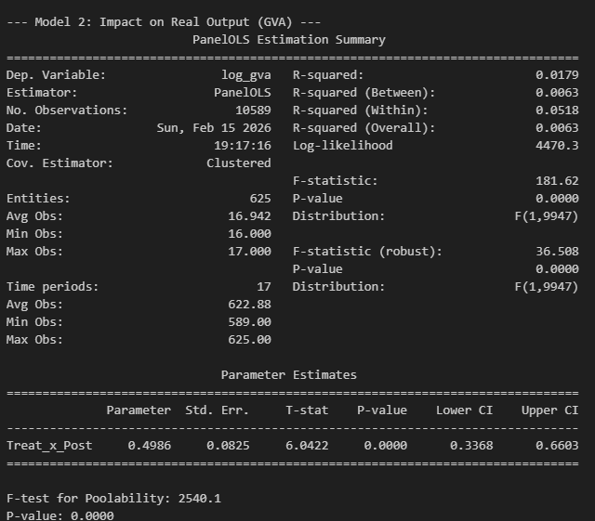

Model 2 uses Log GVA as dependent variable, if we take a look again at the interaction term(Treat_x_post) is positive coefficient (0.4986) and statistically significant p-value <0.05

Interpretation: the positive coefficient in our interaction term suggests that following the ChatGPT release shock high exposure industries experienced massive increase in real output. where a 1 unit increase in our AI index is associated with approximately 49.8% increase in output relative to the Pre-2023 period
).
Finding 3: Complementarity and Hiring Booms.
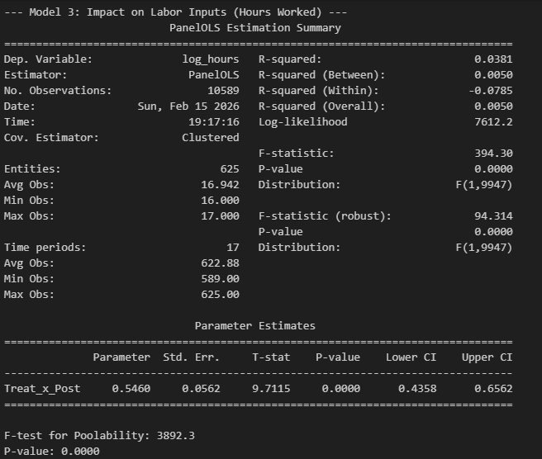
Model 3 uses Log Hours Worked as dependent variable and the interaction term (Treat_x_post)
Is positive (0.5460) and statistically significant p-value <0.05

- Interpretation: High-AI industries significantly increased their labor demand.
From model 2 and 3 we can explain the null results in our baseline model 1 ( null coefficient on the interaction term ) . since both the components of out Y variable GVA and hours worked grew at Nealy identical rate about 50% the ratio of productivity remained flat
4.4. Robustness Check: Controlling for Pre-Existing Trends
A potential concern might rise from the previous conclusion in part 4.3, we can assume that High exposure industries which they are tech industries like IT and finance were simply growing at a faster rate than low ai exposure industries regardless of generative AI emergence .to address this potential concern we run a robustness check controlling for a linear group trend under (Group_trend)
Finding 4: The Result Persists. 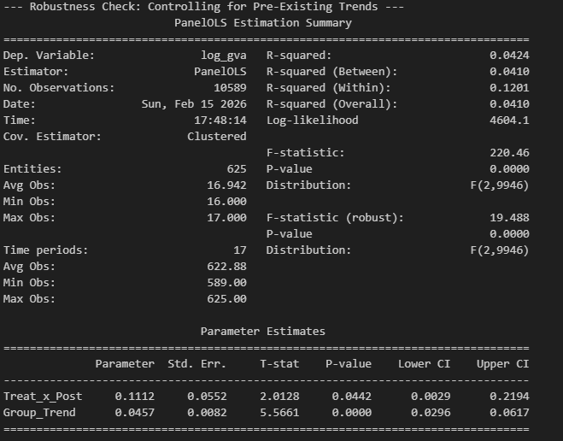

model 4 robustness check uses Log GVA as dependent variable and our (Treat_x_Post) interaction remains positive 0.1112 and statistically significant even after controlling for preexisting growth trend p-value 0.0442
interpretation: even after even after condoling for preexisting growth trend , a positive growth effect was still happening in high exposure industries compared to low exposure industries of about 11% on output outside of the long-term growth behavior of these industries
4.5. Discussion
The results provide strong empirical evidence against the "Displacement Effect" (AI replacing workers). Instead, the data supports a "Productivity J-Curve" or "Expansionary" hypothesis.
- Complementarity over Substitution:
We see hours rising alongside output which contradicts substitution this finding suggest that AI is complementing the labor and increasing the value of work encouraging firms to hire more in Europe
- The "Solow Paradox":
We see the AI age everywhere in the hiring and output statistics, but not yet in the productivity statistics. This is likely due to implementation lags. Firms are currently in the "investment phase”, hiring staff and upgrading software. This increases labor inputs immediately, while the efficiency gains (doing more with less) may take several years to materialize.
- Sectoral Divergence:
The high coefficients for Output and Labor suggest that the European economy is undergoing a rapid structural shift. Resources (capital and labor) are being aggressively reallocated toward high-AI sectors. While individual worker efficiency hasn't spiked yet, the sectoral volume is thriving.
Conclusion:
The "ChatGPT Shock" in Europe has manifested as an economic expansion shock, not an efficiency shock. High-exposure industries are growing larger.
Model comparison
