Formative Assessment

9056593

23/01/2015

Appropriate background to the project to set the scene for the project itself.
Array comparative genomic hybridisation (CGH) is a commonly used diagnostic test in clinical genetics. The test utilises many probes (up to 60,000) attached to a glass slide. Each probe consists of many copies of an oligonucleotide 40-60 base pairs long, designed to target a specific region of the genome. Samples are hybridised to the array in a competitive reaction, usually a diagnostic sample in competition with a reference sample.

The diagnostic sample and reference samples are labelled with a fluorescent dye (patient Cy5 and reference Cy3). Once hybridised the array is scanned producing a high resolution image of the array (Ahn et al., 2010). This image undergoes feature extraction to calculate the signal intensities at each probe and associated quality scores.

This data can then be analysed for copy number variation (CNV) by applying one of a number of available algorithms: The probe scores are normalised, split into segments of equal copy number and each segment assigned a copy number status (Hupe, 2004).

During the data normalisation the signal intensities are calculated and given quality scores. Dividing the signal intensity of Cy5 by that of Cy3 produces a ratio where equal copy number is 1. This ratio is then logged (base 2) to produce the log2 ratio where equal copy number is 0, loss of material is shown with a negative number and gain of material positive.

Copy number variation represents a deviance in copy number from a reference genome which typically contains 2 copies of a DNA segment (Roy and Motsinger Reif, 2013).
CNVs can occur in recombination and replication events. CNVs can be benign polymorphisms or associated with Mendelian, sporadic and complex disease possibly through gene dosage, disruption, fusion or positional effects (Zhang et al., 2009).

In 2009 Array CGH started replacing karyotyping as the method for detection of CNV in NHS diagnostic genetic services. Array CGH offers a higher resolution, less reliance on analyst interpretation/skill and the advantage of a high throughput practical workflow, however few trusts actually have this test commissioned due to the higher cost. Guy’s and St Thomas’ NHS Trust adopted a patient to patient hybridisation approach (using 8x60K Agilent array design) which halves the cost of consumables by replacing the reference sample with another patient sample (Ahn et al., 2010).

As array CGH compares two samples the use of a normal reference sample infers any CNV detected is from the patient. Hybridising two patients removes this assumption, producing two challenges:
- Is a CNV is a duplication in one patient, or a deletion in the second patient?
- If both patients have the same CNV relatively no difference would be found, not detecting the CNV.

The first challenge can be overcome by comparing the signal intensities of each dye across the imbalance and across normal regions. One patient will have different signal intensity in this region and one will have no difference.

The second challenge requires “a careful consideration of patient referral information” to reduce the risk of this occurring. Hybridisation partners are mismatched on phenotype (Ahn et al., 2010). This assumes that patients with differing referral reasons eg heart vs. renal defects will not have the same underlying CNV.

The product of the increased resolution of arrays is a higher abnormality pick up rate than karyotyping.

The aim of this project is to create a tool which is run during data processing/analysis and uses signal intensity (as opposed to log signal ratio) to detect CNV independently of the hybridisation partner.
The Cy3 and Cy5 signal intensities can be compared to a reference set of signal intensities created from previous arrays. Results from each hybridisation partner can be compared to identify any shared CNV which may not be identified using the signal ratio.

What has been done previously in this area, a short literature review, including references
Array design
The arrays, reagents, equipment and software used to process and analyse are manufactured by Agilent Technologies (Agilent Technologies, Accessed 7 January 2015 a). The probe design is stored on the online probe catalogue/custom array design tool eArray (Agilent Technologies, Accessed 14 January 2015 b).

A request/suggestion for a tool similar to that which this project aims to create was sent and declined by Agilent.

Raw array data
The feature extraction produces a tab delimited text file of 10-15mb in size.
This file is split into three sections: metadata about the array run, background measurements and then a number of measurements for each probe.

Each probe has a name, genomic location and physical position on the array and 35 measurements including the signal intensity, probe saturation and background readings for each dye.

Use of algorithms in CNV calling.
If all goals of this project are met the tool produced will have much the same role as the aberration detection algorithms, taking feature extracted data and looking for CNV.

There are a number of algorithms which are in use for CNV calling from CGH data. These algorithms are recursive binary segmentation methods which break down chromosomes into segments of equal copy number. Examples include Z-scores, circular binary segmentation (CBS), aberration detection method (ADM 2), nexus and hidden Markov model (HMM).

Z-score algorithm
Z-scores are a statistical measure of deviation from the mean for a normally distributed population. The Z-score algorithm starts off by giving a Z-score to signal log ratio for each probe. Any probes above a user defined Z-cut off can be classified as an outlier, or significantly away from mean.

The number of probes classified as above (R) and below this threshold (R’) and total number of measurements (N) are recorded and used when calculating the moving average of small windows of the genome.

These ‘windows’ can be specified as a number of adjacent measurements or a fixed size eg every 1MB. Within each window the abundance of probes which log ratios which deviate from the mean is measured (r:r’).
A Z-score is then calculated measuring the significance of the over-abundance of probes with a deviant score in this window (Agilent Technologies, 2012).

Aberration Detection Method (ADM-1/ADM-2)
These algorithms are designed by Agilent. These algorithms do not used fixed windows but segments the genome into intervals of equal copy number using signal log ratio scores from adjacent probes to best define interval breakpoints.

ADM-1
Firstly the data is normalised by subtracting the mean log ratio and dividing by the variance, creating a normally distributed population with a mean of 0.
Each chromosome is then broken into intervals of equal copy number and intervals are assigned a score (S(I)) which denotes the difference from the mean. A user defined threshold is set and any intervals which are above this are called as an aberration.
The interval with the highest score is selected and the same process is performed on this segment to further define breakpoints. This is repeated for all intervals with an S(I) above the threshold.

The ADM-2 algorithm builds on ADM-1 by including probe quality information to weight probe signal log ratios when assigning S(I).

Circular binary segmentation (CBS)
Circular binary segmentation (CBS) also uses adjacent probe log ratio scores to create intervals which, as opposed to ADM-1/2 (which classifies segments as aberrant or not), are grouped into intervals with equal copy number.

Each chromosome is made into a circle (Figure 1). This allows for two break points to be identified which increases the resolution of detection. When two breakpoints are detected the interval of potential different copy number is removed, and the flanking regions are joined to form a new circle. This allows a t-test to be performed between the mean log ratios on each interval.

Definition of an interval is determined using permutation testing, creating intervals using various breakpoints and looking for the most significant P value. If this P value is above a threshold an interval is created and the process is repeated for all intervals until no more changes are found.
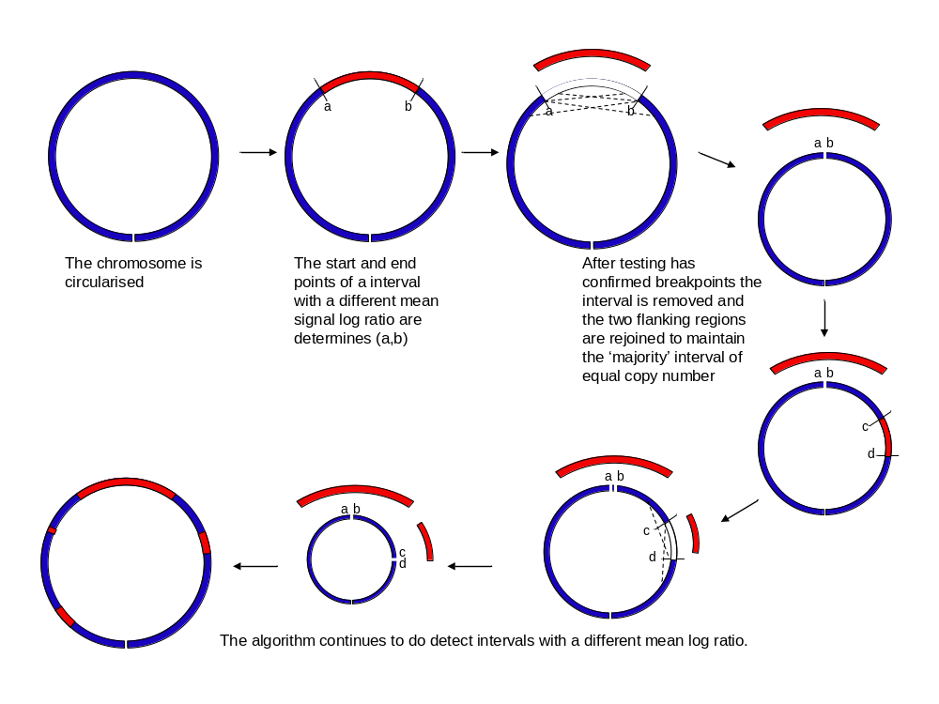A number of checks are performed to ensure the correct end points have been found including edge effect correction, change point pruning and estimation of the log score distribution.
Figure 1 - Circular binary segmentation algorithm

Hidden Markov Model
The hidden Markov model (HMM) can also be applied to determine the aberration state of probes. HMM uses observations (signal log ratios) to determine the state of a hidden or latent value (copy number). The HMM has a chain property which takes into account the state of the previous probe.

Firstly the data is segmented: the Haar wavelet is used to normalise the data before breakpoints are defined using preset parameters (FDR threshold). This step also calculates probabilities and probability distribution parameters used in later steps.

The HMM is then applied. The forward-backward algorithm is used to calculate the posterior probabilities of the states. Baum-Welch learning uses these to ensure that each state has a well defined value.
Finally the Viterbi algorithm is used to assign a state to each probe.

Performance
Each algorithm performs differently depending on the signal:noise ratio and the size of the aberration (Willenbrock and Fridlyand, 2005).
Circular binary segmentation (CBS) is rated as one of the most consistent performers albeit one of the most computationally demanding (Lai et al., 2005; Willenbrock and Fridlyand, 2005). Some algorithms performance varies greatly depending on user defined parameters which may be difficult to establish (Lai et al., 2005).

The algorithms described above are global segmentation methods which compare segments to the whole genome. Recently local segmentation methods have been described which looks for CNV using high resolution data sets (Niu and Zhang, 2012). These algorithms have higher power than global algorithms but are less robust so an approach utilising both algorithms may produce the best performance (Roy and Motsinger Reif, 2013).

Data storage and manipulation
This tool will require easy access to a vast collection of data. A database is an efficient tool for this role. Relational databases are collections of tables where each row is an instance and each column is an attribute. Tables can be linked to store data in a simple and efficient manner. This can include the use of look up tables to speed up data searches.

Databases are queried using Structured Query Language (SQL). Databases are stored in a server such as MySQL server which can be installed locally or on a server to allow access from remote machines. A graphical ‘front end’ is often used to display the data, commonly seen in Microsoft Access or an internet browser.

SQL queries can be used to extract and manipulate data. Programming languages such as Python have connectors (such as MySQLdb (Dustman, 2014)) which allows a Python script to interact and call SQL commands.

Modules, or packages, can be added to increase the functions available within Python including mathematical packages NumPy and SciPy (van der Walt et al., 2011).

An additional software package which may prove useful is statistical software R (R Foundation for Statistical Computing, 2014). Many of the CNV algorithms described above can be implemented within R such as CBS within DNAcopy (Seshan and Olshen, Accessed 15 January 2015 ).

The rationale for the project
One fear preventing adoption of a patient to patient approach in a clinical setting is the fear of missing a diagnosis due to shared CNV in hybridisation partners (Dunlop and Miller, 2015).

In a clinical setting it is important to have a high test sensitivity and specificity. Any missed diagnoses due to the patient to patient approach would be a false negative, a type two error, reducing the power of the test.
The chance of two patients having the same aberration (without phenotype mismatching) has been calculated as 1 in 6000.

Whilst the chance of this occurring is low, and is mediated with strategies such as mismatched phenotypes, with 4000 arrays performed each year this may occur every 1.5 years (without phenotype mismatching).

Creation of a worksheet at the start of an array run must involve phenotype mismatching performed by a registered clinical scientist. The process occurs twice a week and takes 3 hours for a full run of 96 samples and can be complicated by limited or vague phenotype information.

Simplifying the creation of a worksheet will save time, possibly reassigned to a lower grade staff member and may also be automated saving further time.

A project plan with some timelines as to how it will be achieved, this could take the form of a Gantt chart.
- Investigate the data to see how it can be used. This can include a rough plan for how this data can be extracted to form a control range and what fields are required during the analysis.
- Plan what the tool is required to do and how.
  - How to make the calls?
  - Create a signal log ratio between the sample and reference and run this through the algorithm?
  - Perform a Z-score between sample and reference?
  - How to compare the two hybridisation partner results
  - Which regions/probes to be assessed?
- Design and build a database to hold the information. Scope to include any future redesigns of the array should be considered.
- Build tool to populate the database, including manipulation of raw data. The make up of the control sample should be defined to see if any additional information is required:
  - Should any samples be excluded –how to filter out calls/abnormal patients/high DLRS?
  - Would these be excluded before addition to database or can this selection be performed after?
- The tool to perform the CNV calling is then required. This will require a script (python) to interact with the database. The steps may be:
  - Add latest array to database
  - Perform comparison (this will require thorough testing to get the correct thresholds so it doesn’t miss any CNV or make too many incorrect calls.)
  - Create segments of CNV
  - Assess hybridisation partners for shared CNVs.
- It may prove simpler to initially test limited regions of the genome. This can be expanded upon as testing proceeds. Testing should include positive results eg same patient hybridisations.
- (If not already done) migrate onto the server, and made as user friendly as possible including how the tool takes commands and outputs data. Automation can be considered.
The timeframe for the above stages is shown in Table 1.
Table 1 - Gantt chart depicting project milestones
Other commitments: |  | (Uni 1 week) |  | (AL 3 weeks) |  |  |  |  |  |  | Uni?
Task | Jan-15 | Feb-15 | Mar-15 | Apr-15 | May-15 | Jun-15 | Jul-15 | Aug-15 | Sep-15 | Oct-15 | Nov-15 | Dec-15 | Jan-16 | Feb-16 | Mar-16 | Apr-16
Formative assessment
Literature review
Investigate data - which fields will be required. Is any additional information required? How to form a control population
Formulate a plan for tool- how will calls be made? How will compare hybridisation partners, Which regions/probes
Design and build database
Create tool to populate database. Depending on plan may just involve insertion of previous samples. Exclusion criteria should be considered
Tool to perform CNV analysis calling. Steps may be:1) add latest array to database. 2) perform comparison 3) create segments of CNV 4)compare hybridisation partners
May need to expand scope to include whole genome
Investigate how the tool can be hosted, run and potentially automated
Write up report
Final changes
Print, bind and submit

Consideration of some of the potential risks – eg IT provision, access to servers
There is sufficient hardware to create the tools:
- Trust PC (Windows XP) which has mySQL server, an SQL client, Perl/Python, R, Rstudio and Eclipse IDE installed with lots of network storage available. An admin account which allows installation of software is available.
- One PC and one laptop (both dual booted Windows 7 and Linux) are also available on the Kings College London University network with the above installed, adequate storage space and with no restrictions on what can be installed.
- Trust network. SQLserver is installed on the network. This server can be accessed from an admin account.

A database will hold results for signal intensities for a large number of arrays. This should be hosted on the trust network but can be developed initially on a local machine. Each array file (containing probe scores for two patients) is >10mb so this database will become large upon addition of existing arrays therefore movement of the project between networks should be minimised. Any requirements (eg Linux) which will be required once the database is populated should be considered.

The server has daily backups which will allow for previous versions to be accessed if required. Version control (Git) will be used however the Trust PC is Windows XP which is not supported by the Github client for Windows.

Python and all required libraries will be required on the machine where the tool will be run from. It may be best to store the python scripts within the database to keep them secure but run them on a local machine. The connection between Python on the local machine and the server based database will require investigation.

Funds are available from the training budget to purchase any additional software if required or attend any courses which may help undertake the project.
References
Agilent Technologies (2012) Aglient Workbench - CGH Interactive Analysis User Guide. [online]. Available from: http://www.chem.agilent.com/library/usermanuals/public/g3800-90042_cgh_interactive.pdf (Accessed 20 October 2014). [online]. Available from: http://www.chem.agilent.com/library/usermanuals/public/g3800-90042_cgh_interactive.pdf (Accessed 20 October 2014).
Agilent Technologies (Accessed 7 January 2015 a ) CGH & CGH+SNP Microarrays [online]. Available from: http://www.genomics.agilent.com/en/CGH-CGH-SNP-Microarrays/;jsessionid=Hz91Jt8CfVWDlHljTS2ytPCJG1R3P9xvNZqtS8JrtxP0wrThNLbH!867729385?pgid=AG-PG-9 (Accessed 7 January 2015).
Agilent Technologies (Accessed 14 January 2015 b ) eArray [online]. Available from: https://earray.chem.agilent.com/earray/ (Accessed 14 January 2015).
Ahn, J. W. et al. (2010) Validation and implementation of array comparative genomic hybridisation as a first line test in place of postnatal karyotyping for genome imbalance. Molecular Cytogenetics. [Online] 39.
Dunlop, J. & Miller, J. (2015) Why haven’t you adopted a patient to patient approach?.
Dustman, A. (2014) MySQLdb1 [online]. Available from: https://github.com/farcepest/MySQLdb1 (Accessed 15 January 2015).
Hupe, P. (2004) GLAD-Introduction [online]. Available from: http://bioinfo-out.curie.fr/projects/glad/node2.html (Accessed 7 January 2015).
Lai, W. R. et al. (2005) Comparative analysis of algorithms for identifying amplifications and deletions in array CGH data. Bioinformatics (Oxford, England). [Online] 21 (19), 3763.
Niu, Y. S. & Zhang, H. (2012) THE SCREENING AND RANKING ALGORITHM TO DETECT DNA COPY NUMBER VARIATIONS. The annals of applied statistics. [Online] 6 (3), 1306–1326.
R Foundation for Statistical Computing (2014) R: A Language and Environment for Statistical Computing. Vienna, Austria: . [online]. Available from: http://www.R-project.org/.
Roy, S. & Motsinger Reif, A. (2013) Evaluation of calling algorithms for array-CGH. Frontiers in Genetics. [Online] 4. [online]. Available from: http://www.ncbi.nlm.nih.gov/pmc/articles/PMC3829466/ (Accessed 6 January 2015).
Seshan, V. & Olshen, A. (Accessed 15 January 2015 ) DNAcopy : DNA copy number data analysis. R package version 1.40.0. [online]. Available from: http://master.bioconductor.org/packages/release/bioc/html/DNAcopy.html (Accessed 15 January 2015).
Van der Walt, S. et al. (2011) The NumPy Array: A Structure for Efficient Numerical Computation. Computing in Science Engineering. [Online] 13 (2), 22–30.
Willenbrock, H. & Fridlyand, J. (2005) A comparison study: applying segmentation to array CGH data for downstream analyses. Bioinformatics. [Online] 21 (22), 4084–4091.
Zhang, F. et al. (2009) Copy Number Variation in Human Health, Disease, and Evolution. Annual Review of Genomics and Human Genetics. [Online] 10 (1), 451–481.

