November 2015 - Draft dissertation structure.
This project is the creation of a tool (service development).
A progress update
Section 1 is an introduction which covers the background of array cgh, and it’s application in a clinical setting, compared to karyotyping. This leads into the current implementation at Guys and the rationale for this project/tool. This isn’t complete.
Section 2 describes the structure of the tool with chapters for requirements gathering, the array design (what to be captured and unusual situations), database structure, how the data is imported.
Section 3 (I may combine sections 2 and 3): Now there is a system to enter and hold the data the focus is then how to analyse the data.
We pursued a simple Z score analysis so the first chapter is the creation of a normal reference range. The next chapters are how a single probe is assessed (Z score) and then how probes are combined into segments of equal copy number. These chapters include the Z score cut off between normal and abnormal and parameters (eg minimum number of probes in an aberration) which are required to balance the sensitivity and specificity. I’m still working on this – it’s providing tricky!
In order to set these parameters I’ve created some true positive cases (arrays with shared imbalances) which will be another chapter.
Once I have sorted these parameters I plan to run some new true positive cases through the system to check it’s not over trained on my current set. I will then run it on normal cases as a final validation with a chapter for each of these steps.
The final few chapters will contain documentation, future management and hopefully a unit test.
The discussion will be a quick summary, why I chose the approach I have and then what the next steps will be to implement the tool.
There are a few comments with an update of progress or questions.
I also plan on using LaTEX but after I’ve had feedback on my draft!
Thanks,
Aled
Introduction
Array comparative genomic hybridisation (CGH) is a commonly used diagnostic test in clinical genetics. The test utilises many probes (from 44,000 to 1,000,000) affixed to a glass slide. Each probe consists of many copies of an oligonucleotide 40-60 base pairs long, designed to target a specific region of the genome. Samples are hybridised to the array in a competitive reaction, usually a diagnostic sample in competition with a reference sample.

The diagnostic and reference samples are labelled with a fluorescent dye (patient Cy5 and reference Cy3). Once hybridised the array is scanned, capturing the excitation of each dye, producing a high resolution image of the array (Ahn et al., 2010). This image undergoes feature extraction to calculate the signal intensities at each probe and associated quality scores.

This data can then be analysed for copy number variation (CNV) by applying one of a number of available algorithms: The probe scores are normalised, split into segments of equal copy number and each segment assigned a copy number status (Hupe, 2004).

During data normalisation the signal intensities are calculated and given quality scores. Dividing the signal intensity of Cy5 by that of Cy3 produces a ratio where equal copy number is 1. This ratio is then logged (base 2) to produce the log2 ratio where equal copy number is 0, loss of material is indicated by a negative number and gain of material positive.

CNV is a deviation in copy number from a reference genome which typically contains 2 copies of a DNA segment (Roy and Motsinger Reif, 2013).
CNVs can occur in recombination and replication events. CNVs can be benign polymorphisms or associated with Mendelian, sporadic and complex disease possibly through gene dosage, disruption, fusion or positional effects (Zhang et al., 2009).

In 2009 Array CGH started replacing karyotyping as the method for detection of CNV in NHS diagnostic genetic services. Array CGH offers a higher resolution, less reliance on analyst interpretation/skill and the advantage of a high throughput practical workflow, however few trusts actually have this test commissioned due to the higher cost. Guy’s and St Thomas’ NHS Trust adopted a patient to patient hybridisation approach (using 8x60K Agilent array design) which halves the cost of consumables by replacing the reference sample with another patient sample (Ahn et al., 2010).

As array CGH compares two samples the use of a reference sample infers any CNV detected is from the patient. Hybridising two patients removes this assumption, producing two challenges:
- Is a CNV is a duplication in one patient, or a deletion in the second patient?
- If both patients have the same CNV relatively no difference would be found, not detecting the CNV.

The first challenge can be overcome by comparing the signal intensities of each dye across the imbalance and across normal regions. The sample where the signal intensities within the imbalance are markedly different from the normal regions contains the imbalance.

The second challenge requires “a careful consideration of patient referral information” to reduce the risk of this occurring. Hybridisation partners are mismatched on phenotype (Ahn et al., 2010). This assumes that patients with differing referral reasons eg heart vs. renal defects will not have the same underlying CNV.

The product of the increased resolution of arrays is a higher abnormality pick up rate than karyotyping (25% vs 3.7%) (Ahn et al., 2013; Jordan, 2012).

Project Aims
The aim of this project is to create a tool which is run during data processing/analysis and uses signal intensity (as opposed to the log ratio) to detect CNV, independent of the hybridisation partner.

The Cy3 and Cy5 signal intensities can be compared to a reference set of average signal intensities created from previous arrays.

Any imbalance found within each hybridisation partner can be compared to identify any overlapping regions which may not be identified using the signal ratio.
Array design
The arrays, reagents, equipment and software used to process and analyse are manufactured by Agilent Technologies (Agilent Technologies, Accessed 7 January 2015 a). The probe design is stored on the online probe catalogue/custom array design tool eArray (Agilent Technologies, Accessed 14 January 2015 b).

A request/suggestion for a tool similar to that which this project aims to create was sent and declined by Agilent.

Raw array data – Feature extraction file
The feature extraction produces a tab delimited text file of 10-15mb in size.
This file is split into three sections: metadata about the array run, background measurements and then a number of measurements for each probe.

Each probe has a name, genomic location and physical position on the array and 35 measurements including the signal intensity, probe saturation and background readings for each dye.

<expand more on the relevant bits of the FE file here>

Use of algorithms in CNV calling.
If all goals of this project are met the tool produced will have much the same role as the aberration detection algorithms, taking feature extracted data and looking for CNV.

There are a number of algorithms which are in use for CNV calling from CGH data. These algorithms are recursive binary segmentation methods which break down chromosomes into segments of equal copy number. Examples include Z-scores, circular binary segmentation (CBS), aberration detection method (ADM 2), nexus and hidden Markov model (HMM).

Z-score algorithm
Z-scores are a statistical measure of deviation from the mean for a normally distributed population. The Z-score algorithm starts off by giving a Z-score to signal log ratio for each probe. Any probes above a user defined Z-cut off can be classified as an outlier, or significantly away from mean.

The number of probes classified as above (R) and below this threshold (R’) and total number of measurements (N) are recorded and used when calculating the moving average of small windows of the genome.

These ‘windows’ can be specified as a number of adjacent measurements or a fixed size eg every 1MB. Within each window the abundance of probes which log ratios which deviate from the mean is measured (r:r’).
A Z-score is then calculated measuring the significance of the over-abundance of probes with a deviant score in this window (Agilent Technologies, 2012).

Aberration Detection Method (ADM-1/ADM-2)
These algorithms are designed by Agilent. These algorithms do not used fixed windows but segments the genome into intervals of equal copy number using signal log ratio scores from adjacent probes to best define interval breakpoints.

ADM-1
Firstly the data is normalised by subtracting the mean log ratio and dividing by the variance, creating a normally distributed population with a mean of 0.
Each chromosome is then broken into intervals of equal copy number and intervals are assigned a score (S(I)) which denotes the difference from the mean. A user defined threshold is set and any intervals which are above this are called as an aberration.
The interval with the highest score is selected and the same process is performed on this segment to further define breakpoints. This is repeated for all intervals with an S(I) above the threshold.

The ADM-2 algorithm builds on ADM-1 by including probe quality information to weight probe signal log ratios when assigning S(I).

Circular binary segmentation (CBS)
Circular binary segmentation (CBS) also uses adjacent probe log ratio scores to create intervals which, as opposed to ADM-1/2 (which classifies segments as aberrant or not), are grouped into intervals with equal copy number.

Each chromosome is made into a circle (Figure 1). This allows for two break points to be identified which increases the resolution of detection. When two breakpoints are detected the interval of potential different copy number is removed, and the flanking regions are joined to form a new circle. This allows a t-test to be performed between the mean log ratios on each interval.

Definition of an interval is determined using permutation testing, creating intervals using various breakpoints and looking for the most significant P value. If this P value is above a threshold an interval is created and the process is repeated for all intervals until no more changes are found.
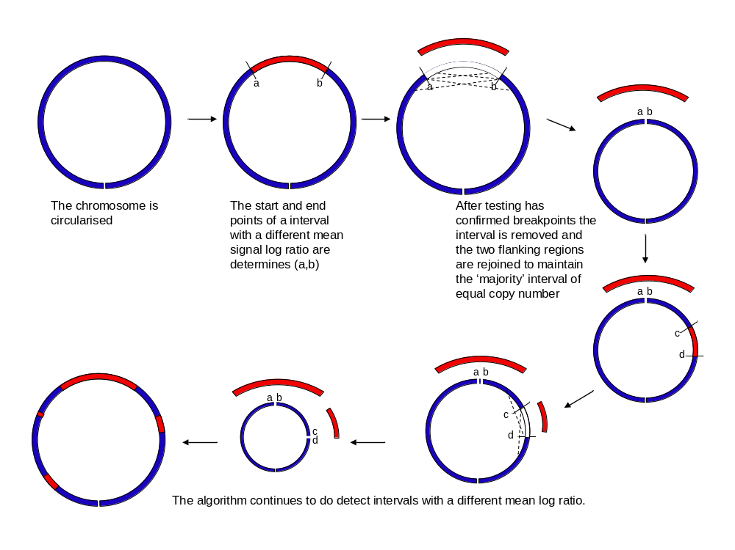A number of checks are performed to ensure the correct end points have been found including edge effect correction, change point pruning and estimation of the log score distribution.
Figure 1 - Circular binary segmentation algorithm

Hidden Markov Model
The hidden Markov model (HMM) can also be applied to determine the aberration state of probes. HMM uses observations (signal log ratios) to determine the state of a hidden or latent value (copy number). The HMM has a chain property which takes into account the state of the previous probe.

Firstly the data is segmented: the Haar wavelet is used to normalise the data before breakpoints are defined using preset parameters (FDR threshold). This step also calculates probabilities and probability distribution parameters used in later steps.

The HMM is then applied. The forward-backward algorithm is used to calculate the posterior probabilities of the states. Baum-Welch learning uses these to ensure that each state has a well defined value.
Finally the Viterbi algorithm is used to assign a state to each probe.

Algorithm Performance
Each algorithm performs differently depending on the signal:noise ratio and the size of the aberration (Willenbrock and Fridlyand, 2005).
Circular binary segmentation (CBS) is rated as one of the most consistent performers albeit one of the most computationally demanding (Lai et al., 2005; Willenbrock and Fridlyand, 2005). Some algorithms performance varies greatly depending on user defined parameters which may be difficult to establish (Lai et al., 2005).

The algorithms described above are global segmentation methods which compare segments to the whole genome. Recently local segmentation methods have been described which looks for CNV using high resolution data sets (Niu and Zhang, 2012). These algorithms have higher power than global algorithms but are less robust so an approach utilising both algorithms may produce the best performance (Roy and Motsinger Reif, 2013).

The rationale for the project – sensitivity and specificity of a clinical tool.
One fear preventing adoption of a patient to patient approach in a clinical setting is the fear of missing a diagnosis due to shared CNV in hybridisation partners (Dunlop and Miller, 2015).

**mention financial pressures**

In a clinical setting it is important to have a high test sensitivity and specificity. Any missed diagnoses due to the patient to patient approach would be a false negative, a type two error, reducing the power of the test.
The chance of two patients having the same aberration (without phenotype mismatching) has been calculated as 1 in 6000 <re-calculate this or get a reference>.

Whilst the chance of this occurring is low, and is mediated with strategies such as mismatched phenotypes, with 4000 arrays performed each year this may occur every 1.5 years (without phenotype mismatching).

Creation of a worksheet at the start of an array run must involve phenotype mismatching performed by a registered clinical scientist. The process occurs twice a week and takes 3 hours for a full run of 96 samples and is at risk of incorrect, limited or vague phenotype information.

Simplifying the creation of a worksheet will save time, possibly reassigned to a lower grade staff member and may also be automated saving further time.

Data storage and manipulation
This tool will require easy access to a vast collection of data. A database is an efficient tool for this role. Relational databases are collections of tables where each row is an instance and each column is an attribute. Tables can be linked to store data in a simple and efficient manner. This can include the use of look up tables to speed up data searches.

Databases are queried using Structured Query Language (SQL). Databases are stored in a server such as MySQL server which can be installed locally or on a server to allow access from remote machines. A graphical ‘front end’ is often used to display the data, commonly seen in Microsoft Access or an internet browser.

SQL queries can be used to extract and manipulate data. Programming languages such as Python have connectors (such as MySQLdb (Dustman, 2014)) which allows a Python script to interact and call SQL commands.

Modules, or packages, can be added to increase the functions available within Python including mathematical packages NumPy and SciPy (van der Walt et al., 2011).

An additional software package which may prove useful is statistical software R (R Foundation for Statistical Computing, 2014). Many of the CNV algorithms described above can be implemented within R such as CBS within DNAcopy (Seshan and Olshen, Accessed 15 January 2015 ).

-----------------------------------------Section 2---------------------------------------------

Shared imbalance/aberration discovery/detection/tool (SIT,SAT,SAD,SID) (working title) structure

Requirements gathering (slight overlap with this in intro)
Functional requirements
- Reads the FE file and identify an region of abnormal copy number independently of the hybridisation partner
- Identify any regions of abnormal copy number present it both hyb partners.

Non functional requirements
- Use an SQL database
- Access the raw FE files
- Run on the trust network (windows)
- Automatable/easily run from multiple computers and by multiple users
- Documentation
- Reproducible
- Db in 3rd normalised form
- Python code style guide

Project management???
- Agile development
- Use smartsheet
- Barista wiki as lab book
- Weekly meetings

Raw array data
- Version of the FE files used
- Array design - # probes etc
- Repeated probes, number of non-control probes etc.
- Stored in a directory used by other software so cannot be moved.

Database structure – how the data will be held
- SQL
  - Mysql server
  - Heidisql client
- Describe the database structure
- Indexes/keys
- Picture/UML of schema
- Compatibility/Conversion/transfer from development server (MYSQL) to production server (MSSQL)???

Importing the FE files – how to get data into db
- Python
  - Anaconda python
  - Mysqldb
  - Pep8
  - Eclipse IDE
  - Benchmarking?
  - Version control
- Steps/schema
- Choices:
  - Duplicated probes – average the SI
  - How to select which probes/regions to import/analyse
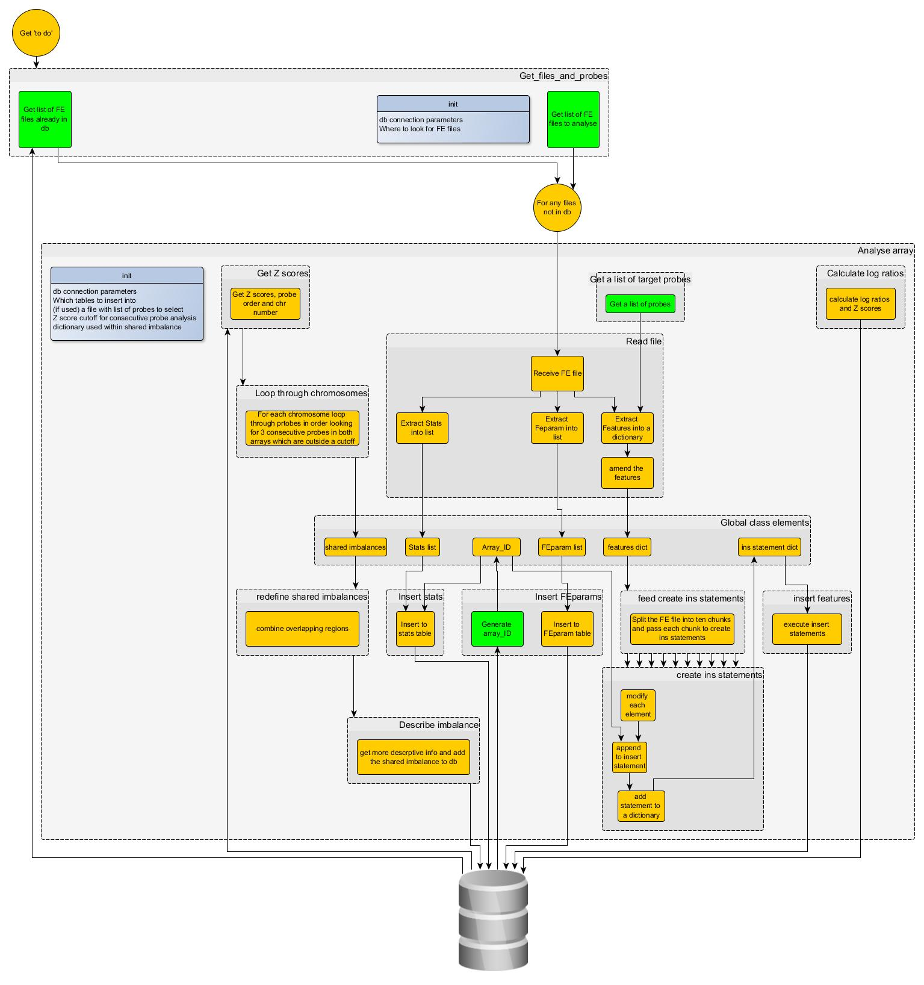

-----------------------------------------Section 3---------------------------------------------
Analysis of probes – finding shared aberrations.
Creating a normal reference range
- Used 100 normal, good quality array cases – but not too carefully selected.
- Calculate mean SI and SD – python script
- This could be recalculated every now and again (also in maintenance section)
- If the array design changes would need to calculate for new probes (also in maintenance section)

Creation of training set (true positives)
A script was written to create some true positives by taking arrays and the reported aberration.
The probes within the reported region were identified and a new FE file was created where the signal intensity for the cy3 was put as the score for both the cy3 and cy5. Another FE file was created with cy5 SI in both cy3 and cy5.

These files mimic an array with a shared imbalance.
98 files were created where the expected imbalance was known.

These were used to investigate/refine the parameters when a probe or region are called as abnormal.

But eg if the abnormality was in cy3. when the cy3 scores were imported into the cy5 probe SI and this analysed they would not have the same Z score as they are compared to a different mean/SD. This is more realistic but may lead to true pos correctly not being called.

Determining if a probe is normal or abnormal
<This chapter focuses on how a single probe is called as normal/abnormal>
- Calculate Z score
- Show signal intensity is normally distributed (Kurtosis scores) or pdf?(Ghasemi and Zahediasl, 2012)
- How determined the Z score cut off
- Z score calculation is performed just after data imported. Currently store all the information needed to recalculate in the features table – this could be replaced by creating a brand new table for the reference values each time it’s recalculated and storing the table name to allow analysis to be repeated in the future.

Determining if a region is normal or abnormal
<This chapter discusses how probes were grouped into segments /regions >
- ROI (Not sure if will go into this in much detail, if at all)
A list of every aberration that has been reported > 2 times was imported to a table. For each ROI if both hyb partners have more than a set % of probes with an abnormal Z score report this region as abnormal.
But this is not as flexible – will cover previously reported regions and this list can be expanded but not catch overlapping regions eg if one patients has a larger deletion and hyb partner has a smaller deletion within the larger del with fewer probes than the cutoff in the larger segment,

This is similar to that described in introduction but not flexible enough.

- Consecutive probes
This is the approach taken. Look for 3 consecutive abnormal probes in both hyb parners:
Eg for a gain
If probe1 in cy3 > cutoff:
If probe2 in cy3 > cutoff:
If probe3 in cy3 > cutoff:
If probe1 in cy5 > cutoff
If probe2 in cy5 > cutoff
If probe3 in cy5 > cutoff
Report shared abberation

Repeat for dels ( < - cutoff)

The script walks along each chromosome doing this and for larger imbalance creates tiles.
These tiles can be combined into larger areas of shared imbalances.

But this can produce false positives, so could increase the min number of probes – limitation/caveat of the tool.

- Briefly toyed with DNAcopy in R but would be an extra thing to validate/dependency of the tool so not pursued.

How to report shared imbalances
- Enter to shared imbalance table – can then be accessed via LIMS system using information in other tables ie filename.

Creation of test cases (EvE)
<These were a new set of cases with shared imbalances used to test the cut off in case the parameters were too specific to training set> these cases will be made up of different patients with the same imbalance reported combined using another tool I have made which performs “insilico hybridisation”

Validation (real cases)
<Normal arrays were run to check how it performed with normal ‘routine’ arrays without shared imbalances ie a trial run on normal arrays >
Hoping not to see any positive calls!

Unit testing
Create a truth set from the training set and an automated test.

Longer term management/support
(Automatically?) Truncate features table (can always be re-imported) to prevent db becoming too large and slow. The reference range table used can be amended to the feparam table (this is required to check which fe files are to be imported)

Periodically recalculate the reference range – the SI can be affected by scanner servicing.

If the array design were to change would need to update probeorder table and recalculate reference range.

Documentation
User manual
Development manual
Validation documentation (if get that far)

-----------------------------------------Section 4---------------------------------------------
Discussion
Summary of tool and benefits (rationale and specification)
How to implement
- How to build link between the LIMS and this.
- How to run the program – automate (but what about different array designs)

Also talk about why I have taken the approach I did.
References
Agilent Technologies (2012) Aglient Workbench - CGH Interactive Analysis User Guide. [online]. Available from: http://www.chem.agilent.com/library/usermanuals/public/g3800-90042_cgh_interactive.pdf (Accessed 20 October 2014).
Agilent Technologies (Accessed 7 January 2015 ) CGH & CGH+SNP Microarrays [online]. Available from: http://www.genomics.agilent.com/en/CGH-CGH-SNP-Microarrays/;jsessionid=Hz91Jt8CfVWDlHljTS2ytPCJG1R3P9xvNZqtS8JrtxP0wrThNLbH!867729385?pgid=AG-PG-9 (Accessed 7 January 2015).
Agilent Technologies (2015) eArray [online]. Available from: https://earray.chem.agilent.com/earray/ (Accessed 14 January 2015).
Ahn, J. W. et al. (2013) Array CGH as a first line diagnostic test in place of karyotyping for postnatal referrals - results from four years’ clinical application for over 8,700 patients. Molecular Cytogenetics. [Online] 616.
Ahn, J. W. et al. (2010) Validation and implementation of array comparative genomic hybridisation as a first line test in place of postnatal karyotyping for genome imbalance. Molecular Cytogenetics. [Online] 39.
Dunlop, J. & Miller, J. (2015) Why haven’t you adopted a patient to patient approach?
Dustman, A. (2014) MySQLdb1 [online]. Available from: https://github.com/farcepest/MySQLdb1 (Accessed 15 January 2015).
Ghasemi, A. & Zahediasl, S. (2012) Normality Tests for Statistical Analysis: A Guide for Non-Statisticians. International Journal of Endocrinology and Metabolism. [Online] 10 (2), 486–489.
Hupe, P. (2004) GLAD-Introduction [online]. Available from: http://bioinfo-out.curie.fr/projects/glad/node2.html (Accessed 7 January 2015).
Jordan, B. (ed.) (2012) Microarrays in diagnostics and biomarker development: current and future applications. Heidelberg ; New York: Springer.
Lai, W. R. et al. (2005) Comparative analysis of algorithms for identifying amplifications and deletions in array CGH data. Bioinformatics (Oxford, England). [Online] 21 (19), 3763.
Niu, Y. S. & Zhang, H. (2012) THE SCREENING AND RANKING ALGORITHM TO DETECT DNA COPY NUMBER VARIATIONS. The annals of applied statistics. [Online] 6 (3), 1306–1326.
R Foundation for Statistical Computing (2014) R: A Language and Environment for Statistical Computing. Vienna, Austria: . [online]. Available from: http://www.R-project.org/.
Roy, S. & Motsinger Reif, A. (2013) Evaluation of calling algorithms for array-CGH. Frontiers in Genetics. [Online] 4. [online]. Available from: http://www.ncbi.nlm.nih.gov/pmc/articles/PMC3829466/ (Accessed 6 January 2015).
Seshan, V. & Olshen, A. (Accessed 15 January 2015 ) DNAcopy : DNA copy number data analysis. R package version 1.40.0. [online]. Available from: http://master.bioconductor.org/packages/release/bioc/html/DNAcopy.html (Accessed 15 January 2015).
van der Walt, S. et al. (2011) The NumPy Array: A Structure for Efficient Numerical Computation. Computing in Science Engineering. [Online] 13 (2), 22–30.
Willenbrock, H. & Fridlyand, J. (2005) A comparison study: applying segmentation to array CGH data for downstream analyses. Bioinformatics. [Online] 21 (22), 4084–4091.
Zhang, F. et al. (2009) Copy Number Variation in Human Health, Disease, and Evolution. Annual Review of Genomics and Human Genetics. [Online] 10 (1), 451–481.

