# Front End Technologies Week 1 Coding Assignment

**Points possible:** 70

|  |  |  |
| --- | --- | --- |
| Category | Criteria | % of Grade |
| Functionality | Does the code work? | 25 |
| Organization | Is the code clean and organized? Proper use of white space, syntax, and consistency are utilized. Names and comments are concise and clear. | 25 |
| Creativity | Student solved the problems presented in the assignment using creativity and out of the box thinking. | 25 |
| Completeness | All requirements of the assignment are complete. | 25 |

**Instructions:** In VS Code, or an IDE of your choice, write the code that accomplishes the objectives listed below. Ensure that the code compiles and runs as directed. Take screenshots of the code and of the running program (make sure to get screenshots of all required functionality) and paste them in this document where instructed below. Create a new repository on GitHub for this week’s assignments and push this document, with your JavaScript project code, to the repository. Add the URL for this week’s repository to this document where instructed and submit this document to your instructor when complete.

**Coding Steps:**

1. Create a website using only HTML. The website can be anything you like (within school guidelines) as long as it meets the following criteria – website must contain:
   1. At least 3 pages
   2. Links to navigate between all pages present on each page
   3. A list
   4. 3 images
   5. 2 different size headers
   6. A table
   7. A form

**Screenshots of Code:**

Page 1

<!DOCTYPE html>

<html lang="en">

<head>

  <meta charset="UTF-8">

  <meta http-equiv="X-UA-Compatible" content="IE=edge">

  <meta name="viewport" content="width=>, initial-scale=1.0">

  <title>Document</title>

</head>

<body>

  <body style="background-color:pink;"

  <a href="Home.html">Home</a>

  <a href="About.html">About</a>

  <a href="Contact.html">Contact</a>

  <h1>Home</h1>

    <p>Hello, thank you for visiting my page today.</p>

    <p>I'd like to introduce you to my family.</p>

    <h2>First we have my daughter Wednesday.</h2>

    <img height=500px src="https://lh3.googleusercontent.com/vMhkxXjBhK4ZSh88DLkKo7l336YNpZnnk2D0E7MnnraTETMlxeCBD1r7Sj5ldkBSnvQWQRB6ZSPIwx8NGsQhwYNdkTNxAdgYxmtkVc4AqHoXNmaSuv6nLFjPuEqm5NmOxC_03kRH68z2HYzfN4Y5QpgebQGNwQwmQcxdtW7_xSCLUqG4a7HzGXOiKb42gm2mJZSZodKjAR6T4eKBp9CpIfD8Ve9c8wgDHrSPSUUJH-YHzr1oW_kLO0n7rEMl5-c-LRktr4zPd1NWBjX2YX-zJofPQr5TWAt2_vJcluG523Xk-cqDqZnDKFMW8KFYtgaMY2mOWS8F-_OfUn-yyYxyzBPILMgzf-_7QTS4Cdw-RK7CgtwYlXhblK_vrdb5rr7vjqC03Ja8CMDAMGUDP9dSbEzx5eAeESvmLO1gu9G-NCVGprlzgw0W-v_rkm0s5eiJWqh31ji3j1cvVup9vmZrzUmQvYNJFT6ilcXzL6ZQOlxrFykVkZPDxEDuwLqdOSSo7L2raNc4577NT_wpDt5f72dZJMfkk9sKY50JE1XQZC4rUsZNloHRNjV2_jpxe-JU17q1NZ8m8-oP_4p9A0RltPN_kbv1HA9bd2QifumIVpgwFP543_CfyQsu2caxEbORWIN8OjZGuY9NOFf_VbGOnaGklxGz0lqmecs983nCs3eyrz_h2kmmFFJGCwlWisVyDILFnC-rWXC0c6eF_xRBIxTd=w730-h973-no?authuser=0" alt="Wednesday At The Zoo">

    <h2>Next, we have my cat Elfie.</h2>

    <img height=400px src="https://lh3.googleusercontent.com/XtzTsq9KA3PvZL-ZVMPJ-OgKyWD0rOmpbi_EvUCFbjFpV44kgHYOwIX7aKo_S-G_JWHNNd7mSLser-DxLIn2nB7dhMjaDBmghWxfvnjy4NKZpRTMNEnoXQl84gRxf3u6lUajpkf7c5LSShwhRywG500FTvjzzEaJzMwbqUd4FZd4_fogmparPtIC9xkBjSIHdlrHjiu9dhyfG3A0K2bOxfyok4e2cCZuTGP6TAgc04eVpmNMPko8ctm-poIKXXRXpq6hY-2XlAFA75eNroqlnWUp9ta2mK_CntnxDON_eJgXDtFyWMz9Kw2VrkCUN8NDm4Te1hBbHdG_c-l7zEifNM0sMJV71412yC5jgYNl-s6fdRDCHZCM7HuNxrZhS4KnFyI6txFSt7fcYgvlQiyMg0BbOMdxUhk00q5kUcrRoRyL3OlgMaawE2yby2TnCFsinhFcq4QELXU3OJo9OtnSCWOY0EtZC-tc4TJiI6xt59GmAqFVUSfHiilndXkRv55eYv5xuU5gbKMhR_dSgjOwQDNqVumL5I607ccKW-IPFGpydLnwfN0BpEKecv_YD2RLtPIXO_I-7hwDL4KU1GhHJ20Qw1uVr1U9IUyvSReY3gKuEwBRV3R6krSW4WiQa29JChsFQerL--ZsqtfBY6v657E2sGyJJnVcTMuuWxwnNCoBWzj8_YUqKQK-F3VRojmw9hLpodg-SzkCE8mB3vqj2Lzl=w960-h720-no?authuser=0" alt="">

    <h2>Then, we have my dog Kai.</h2>

    <img height="400px" src="https://lh3.googleusercontent.com/i9J23XR8IKuZSayPuwz_R6n8ACL4_xPFjRLeC83_jL2lqt2HC97TRGtXuh_BQkvY3Aquw6S7q08zf_Pf8dGZIqqdqAA635Go8IgFf7ybHItK5MO2cNzem-O7LjQ_dMSZ_D_YTCqzeZCW8ouQy-xROILZOk7vJeBUlo8uqoEOc_w7pX7sTA9NK5eUkufI_cFFJEs2DM7Qfvla1O7MHJO_bxIRy5W86JdSJ1nOx6AC1H_z_X8hDxjOod44KWdzC1W7QaByuxaFz0XzPS3XYrcG9VXhx3NNh4kF_tP4T8wf71GRH3EdAzGxjPYk0k4JcuTfk71XK0SuL3MPsaXr2u53X4pzbXCM4XWyXZBx-EBKLdy382B42dYJJrOyFzNDoWQ44h8NXZQ_HYsPDiGMxuiK25moxGvnPDGjQGWCQ-W6tCvZSwcRSm4H4hHZwXhAPZhxu1ALjYHDbmCo2oLbXf7YeY2FtUE0r5b3hPYOKQAkRNBX0SdWMC_IayuYNYCuPpx7Mw2ZbwYPt2Pc_ZMEuySIK2EzDLJm9_a_w9HBGCBr7pa4pszp91jEKGK7lxHr35om2cFlE9yDIZj06wPzqvZcklRmvsjZuWIfaH9ODfQFSuUlFB6YMuSXxJjasBH_TtEmk1AsgKgFrv7FHOQ3YW1H9taI-kWmrjtpdMbiAkom-ASqhuVeGNRZgs85HDFW_W1QeJEhq-7zgUjV0RUT1WPzyDvq=s900-no?authuser=0" alt="Kaiju laying in his bed">

    <h2>Last, we have me. My name is Ashley.</h2>

    <img height="500px" src="https://lh3.googleusercontent.com/-esJBN-0meHSY4IR0vbMBWK0QvloEDuwxfarRKKbTehjiVxA3AsO5UiEY91dLvy3-nP3hkl4fov0t_6gFZiNtYc761iX_s6LZvIRL3qI91g9OnCUKZxiAXwEaU2XBy0gXujzsZw4VNyTpMG6t2iGjuJY-zyb_mZlmMvU-1zoIjYvoz47pUzp8ze84E40JmPK3iEGAX4XBZgxKffoVCWQp08Ml1_nB9VhnaBYItrWSqoHOBKnfTtDA4Tkh2E1eFfiQllCkHjMR_iZaZM4nl00gWYPFvBTxCaOipmL5Sjr376mVVQl8kC3_YLm_hMijJ88WJuGOz8YqYBMJ4N2XnKUnoQZL1BFNDr12JMvSHSNfPoKxYMj9tqUT4WC4QC53Csjukf92RCU3x1vbc37cbwQ2oG07Hcz1h8HoWTwb-yz_sxzAOb_NoUVVx1J68cv2KgdSBFVJTbA3WmmnoJtjVmefCyhAMQYmRS6oG71XREDblsxS48rbE7YHjWCmUADvmE8943qX99L54ryJ9g-yJikTntsWTPPdckda1Ns_oJ9bqk8R6rw8ox1w1d4UDU7cIAac4cxoZajPq4fYBmaJwyZYQatrKbHez5vWDOpPdALp9rtJ2jrwoIJ2z4lc7Eb_q2NFYgOfcI38AF6NGtOUfTJkPCXndo30HOPJvuI9KsZgSetjHQwOfpCvkmqYA6coqdWAc3jbVHijNM7O2I7DaapcSns=w552-h980-no?authuser=0" alt="Ashley">

</body>

</html>

Page 2

<!DOCTYPE html>

<html lang="en">

<head>

  <meta charset="UTF-8">

  <meta http-equiv="X-UA-Compatible" content="IE=edge">

  <meta name="viewport" content="width=device-width, initial-scale=1.0">

  <title>Document</title>

</head>

<body>

  <body style="background-color:pink;"

  <a href="Home.html">Home</a>

  <a href="About.html">About</a>

  <a href="Contact.html">Contact</a>

  <h2>About Us</h2>

  <h3>Wednesday</h3>

  <ol>

    <li>She's 15 years old.</li>

    <li>A sophmore in High School.</li>

    <li>She loves learing new things.</li>

  </ol>

  <h3>Elfie</h3>

  <ul>

    <li>She's a short haired tortie,</li>

    <li>She is 7 human years old, born 02/2014.</li>

    <li>She loves paper, she will lay on it any chance she gets.</li>

  </ul>

  <h3>Kai</h3>

  <ol>

    <li>He's a Staffordshire Terrier mix.</li>

    <li>He's approximately human 7 years old.</li>

    <li>He loves vegetables, especially carrots.</li>

  </ol>

  <h3>Ashley</h3>

  <ul>

    <li>I'm 32 years old.</li>

    <li>I currently work in the Pharmacy Field.</li>

    <li>I love playing Pokemon Go.</li>

  </ul>

  <h4><u>Below is a table on a few more tidbits about my family.</u></h4>

  <table>

    <tr>

      <th>Name</th>

      <th>Age</th>

      <th>Favorite Snack</th>

      <th>Favorite Activity</th>

    </tr>

    <tr>

      <td>Wednesday</td>

      <td>15</td>

      <td>Wafer Cookies</td>

      <td>Watching Anime</td>

    </tr>

    <tr>

      <td>Elfie</td>

      <td>7</td>

      <td>Temptations</td>

      <td>Sleeping</td>

    </tr>

    <tr>

      <td>Kai</td>

      <td>7</td>

      <td>Any Vegetable</td>

      <td>Riding in the car</td>

    </tr>

    <tr>

      <td>Ashley</td>

      <td>32</td>

      <td>Cucumbers</td>

      <td>Finding NBC Merchandise</td>

    </tr>

  </table>

</body>

</html>

Page 3

<!DOCTYPE html>

<html lang="en">

  <head>

    <meta charset="UTF-8">

    <meta http-equiv="X-UA-Compatible" content="IE=edge">

    <meta name="viewport"           content="width=device-width, initial-scale=1.0">

    <title>Document</title>

  </head>

  <body>

    <body style="background-color:pink;"

    <a href="Home.html">Home</a>

    <a href="About.html">About</a>

    <a href="Contact.html">Contact</a>

    <h3>You can get in contact with us by clicking the link below.</h3>

    <a href="leefamily7580@gmail.com">Email Us</a> <br>

    <p>Or you can sign up for our newsletter below.</p>

    <form>

      <input type="text" name="Full Name" placeholder="Full Name"> <br>

      <input type="text" name="Email" placeholder="Email"> <br>

      <input type="submit" value="Submit"> <br>

    </form>

  </body>

</html>

**Screenshots of Running Application:**

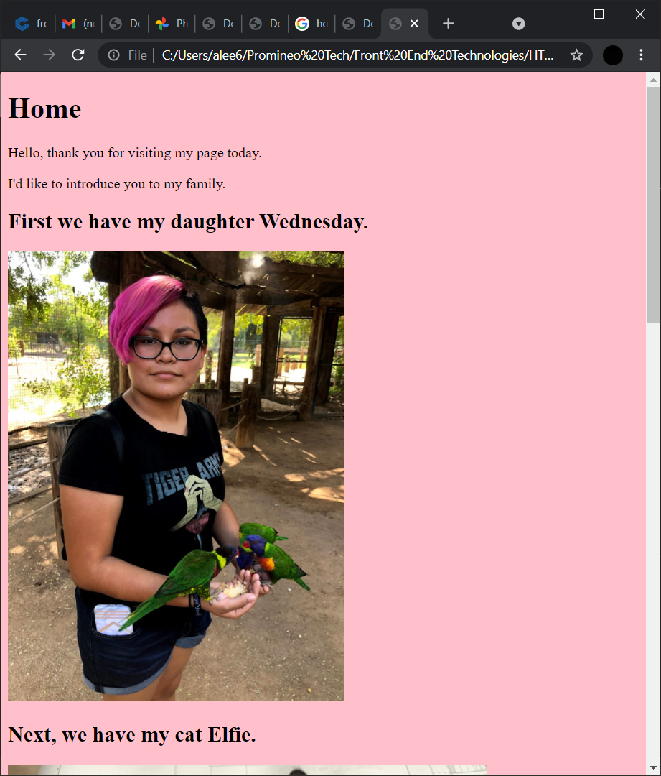

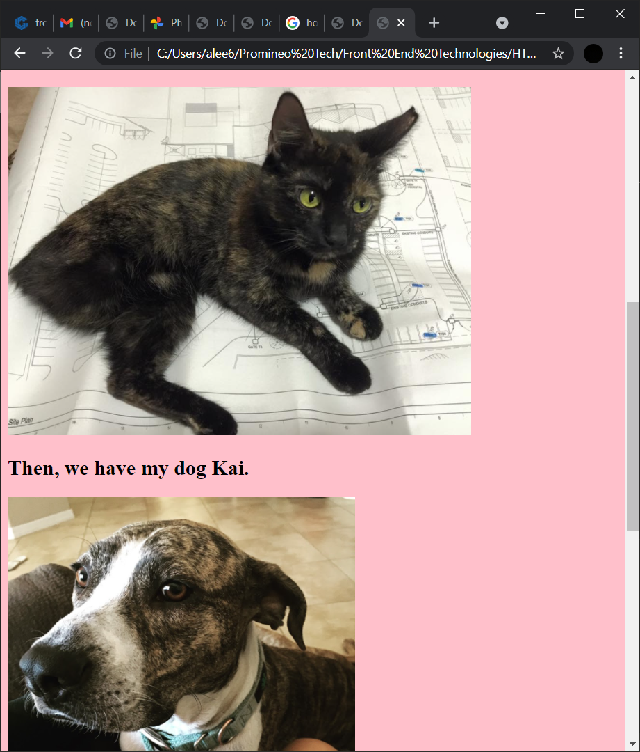

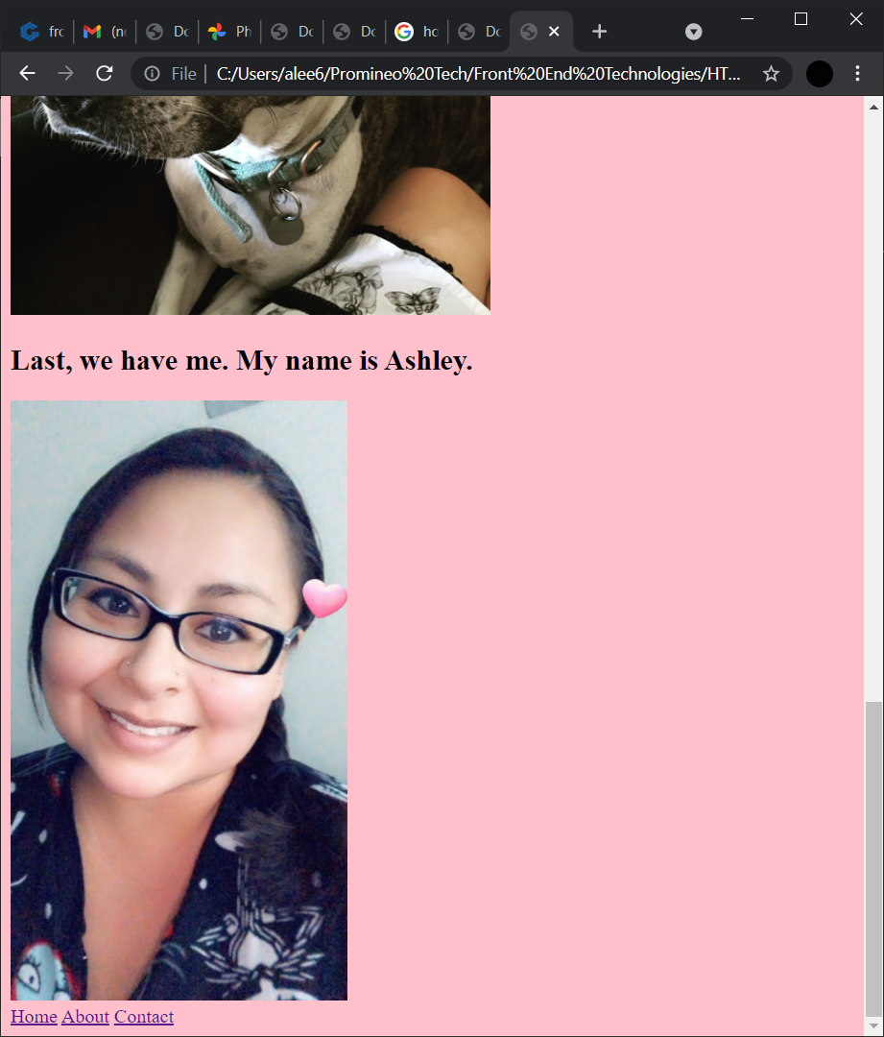

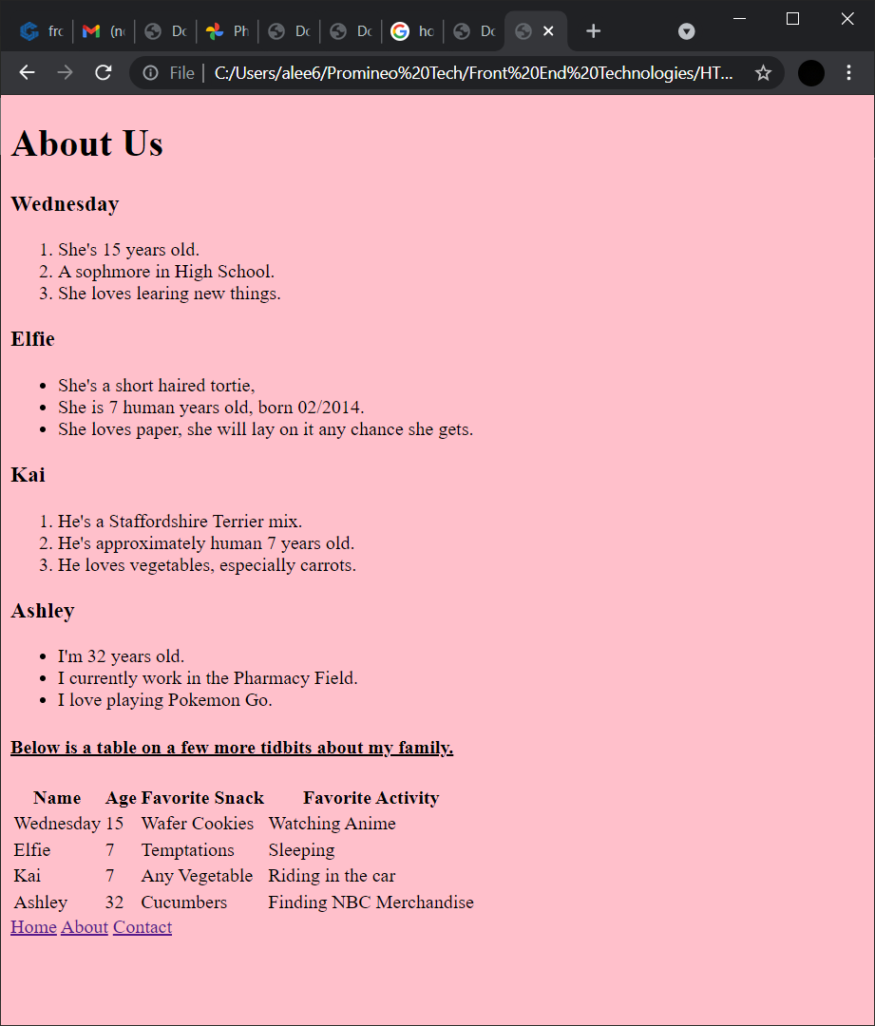

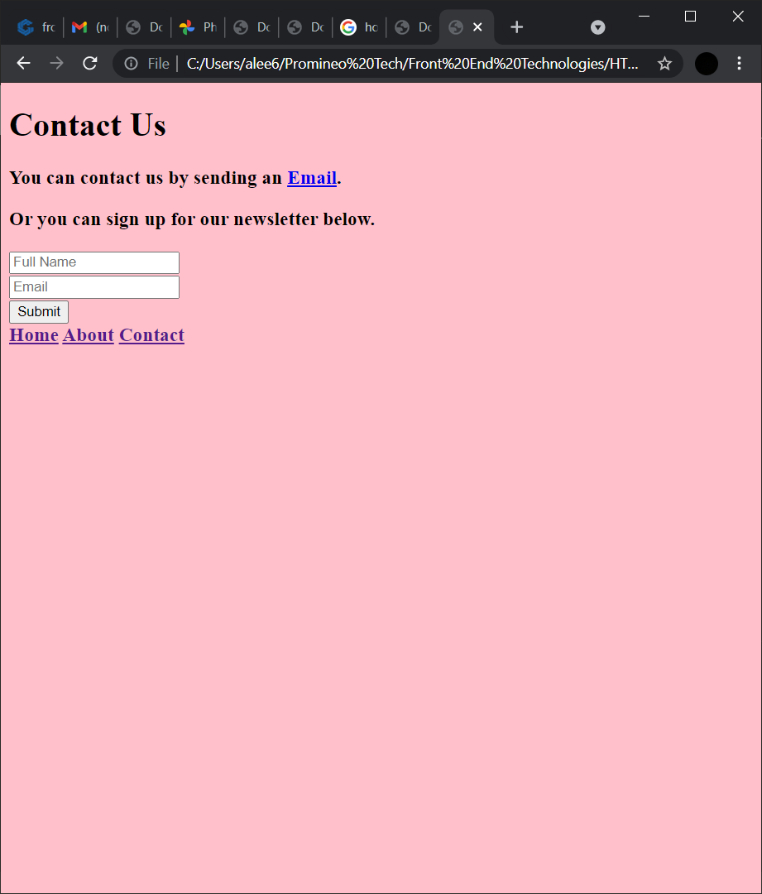

**URL to GitHub Repository:**

https://github.com/alee5699/week1Html