

**A Report on My Fictional Company**

**“SONY Electronics”**

Sadar Road, Barishal

**Submitted to:**

Md. Rashid Al Asif,

Assistant Professor,

Department of CSE, University of Barishal.

**Submitted by:**

MD. Alif Rahman Fahad,

**Batch 19**, EDGE Digital Skills Training Course

Department of Public Administration, University of Barishal.

**Date of Submission:** 14th December , 2024

**Table of Contents**

**Introduction** 2

**Our Product and services** 3

Laptops 3

Desktops 3

Tablets 4

Smartphones 4

**Flow Chart of Business Plan** 5

**Statistics of sold products in the last 3 months** 6

**( January – March 2024)** 6

**Sales Report of SONY Electronic of the Month January – March 2024** 6

**Yearly report of SONY Electronics** 7

# **Introduction**

**SONY, a name synonymous with innovation and entertainment, boasts a rich history that began in the ashes of post-World War II Japan. Founded in 1946 as Tokyo Tsushin Kogyo (Tokyo Telecommunications Engineering Corporation) by Masaru Ibuka and Akio Morita, the company started with a humble capital of ¥190,000 and a handful of employees. Despite these modest beginnings, Ibuka and Morita harbored a bold vision: to utilize technology to empower creativity and enrich lives.**

*Their journey commenced not with the glamorous electronics SONY is known for today, but with an electric rice cooker. Though this initial product wasn't a resounding success, it did not deter their spirit. SONY swiftly pivoted, leveraging their expertise to repair radios for the national broadcaster NHK. This association not only provided them with crucial income but also exposed them to the latest advancements in the field.*

Capitalizing on this knowledge, SONY unveiled its first major triumph in 1950: the Type-G, Japan's first indigenously designed tape recorder. This marked a turning point, showcasing SONY's commitment to domestic innovation. They continued to break new ground throughout the following decades, forever altering the landscape of consumer electronics. From the iconic transistor radio, the TR-55, that revolutionized portable entertainment, to the Walkman, the personal music player that became a cultural phenomenon, SONY established itself as a company at the forefront of technological breakthroughs.

**As we delve deeper into SONY's rich tapestry, we will explore not only their trailblazing inventions but also their strategic ventures into the entertainment industry. From the acquisition of CBS Records to their foray into Hollywood with Columbia Pictures, SONY's ambition transcended electronics, solidifying their position as a multifaceted entertainment powerhouse.**

This introduction merely scratches the surface of SONY's remarkable story. In the following sections, we will embark on a comprehensive exploration of the company's impact, examining their groundbreaking products, their strategic acquisitions, and their lasting influence on the world of technology and entertainment. (SONY, Sony Corporation)

# **Our Product and services**

SONY Electronics offers a diverse range of high-quality electronic products designed to meet the needs of modern consumers. The product lineup includes:

## Laptops:

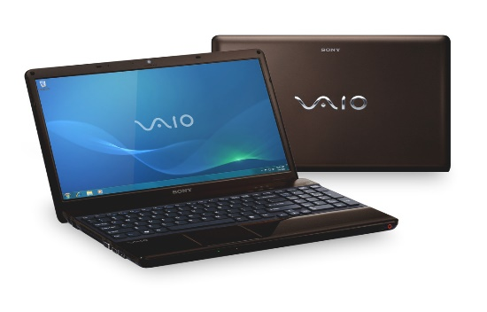

SONY Vaio laptops are highly regarded for their blend of performance, portability, and affordability. Known for their sleek designs and robust build quality, SONY Vaio laptops cater to a wide range of users from students to professionals. The inclusion of the latest processors and high-definition displays has earned them a reputation for reliability and efficiency.

## Desktops:



SONY desktops are synonymous with power and dependability. These desktops are favored by both home users and businesses for their high performance and customizable configurations. With a strong emphasis on quality components and user-friendly designs, SONY desktops are known for their longevity and excellent performance in demanding tasks. (SONY, Sony Bangladesh, 2024)

## Tablets:

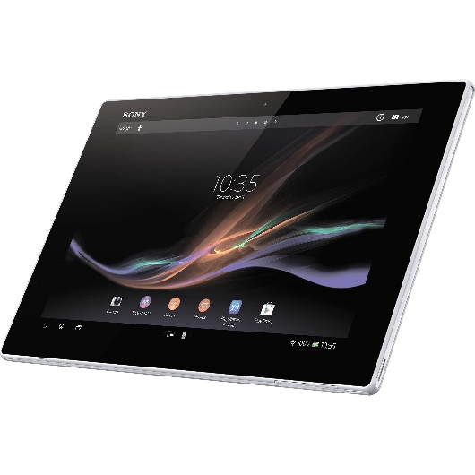

SONY tablets are celebrated for their versatility and innovative features. Popular among digital artists, students, and professionals on the go, these tablets offer high-resolution displays, long battery life, and robust processing power. SONY’s focus on user experience and functionality has made their tablets a preferred choice in the market.

## Smartphones:

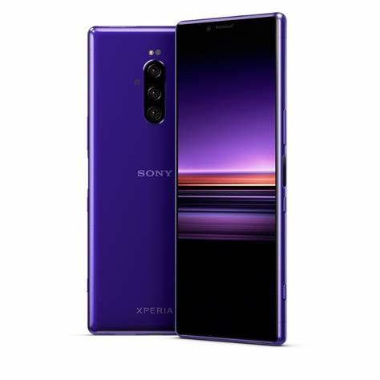

SONY smartphones enjoy a stellar reputation for advanced features, including high-resolution cameras, fast processors, and 5G capabilities. They are appreciated for their affordability without compromising on quality, making them accessible to a broad audience. The brand's continuous innovation and stylish designs have cemented SONY smartphones as a leading choice among consumers. (SONY)

# **Flow Chart of Business Plan**

**SONY Electronics**

**Total sales of the month**

**from June to August 2024**

|  |  |
| --- | --- |
| **The sum of Total Sales (BDT)** | |
| **Months (Date)** | **Total** |
| January | 8750000 |
| February | 9920000 |
| March | 10000000 |
| **Grand Total** | **28670000** |

**Yearly report of SONY Electronics**

|  |
| --- |
| **Yearly report of 2023** |

|  |  |  |  |
| --- | --- | --- | --- |
| **Month** | **Expenses** | **Sales** | **Profit** |
| January | 9288500 | 8750000 | -538500 |
| February | 9744300 | 9920000 | 175700 |
| March | 8904700 | 10000000 | 1095300 |
| April | 7345200 | 7957400 | 612200 |
| May | 8987000 | 9876500 | 889500 |
| June | 5215400 | 5164500 | -50900 |
| July | 9976500 | 11543600 | 1567100 |
| August | 7976700 | 8087900 | 111200 |
| September | 9879000 | 9969800 | 90800 |
| October | 6234800 | 7024000 | 789200 |
| November | 4534800 | 4809300 | 274500 |
| December | 8348700 | 8834800 | 486100 |

**References:**

# Bibliography

(n.d.).

Bangladesh, S. (2024, December 6th). *Sony-Smart 2023*. Retrieved from Sony Bangladesh: https://www.sonysmart.com.bd/

SONY. (2024, Dec 6). *Sony Bangladesh*. Retrieved from https://sonysmart.com.bd/brand/sony

SONY. (n.d.). *Sony Bangladesh*. Retrieved Dec 6, 2024, from www.sonysmart.com.bd: https://www.sonysmart.com.bd/

SONY. (n.d.). *Sony Corporation*. Retrieved from Sony Corporation: https://www.sony.net/