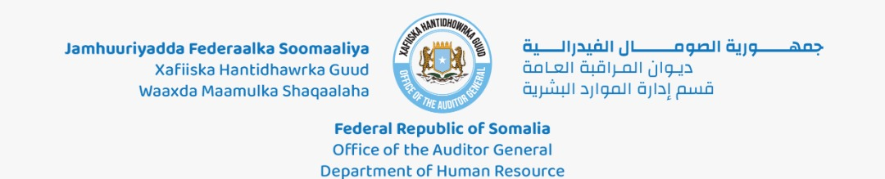

## Tix: ${ref} Taariikh : ${date}

**Ku:** Heeganka Sare ee Madaxtooyada JFS.

**Og:** Agaasimaha Teknoolajiyadda & Amniga ee Madaxtooyada JFS.

# UJEEDO: SOO DEYN MARTI GAAR AH

Waxaan si xushmad & qadarin mudan kaga codsanaynaa Heeganka Sare ee Madaxtooyada JFS inaad noosoo fududeysaan marti shir ku leh Xafiiska Amniga Qaranka JFS, ( **${visitDate} ),** martidas oo u bahan so deyn irdaha laga galo Madaxtooyada J.F.S. (Ceelgaabta, Kashmir, Radio Muqdisho & Gate 1) .

|  |  |  |  |
| --- | --- | --- | --- |
| ID | Visitor Name | Mobile | Vehicle |
| ${id} | ${visitorName} | ${visitorMobile} | ${vehicle} |

${images_table}

Sidaas darteed, waxaan idinka rajeynaynaa inaad tixgelisaan, fududeeysaana codsiga sare kuxusan kana gudataan waajibaadkiina amni.

**Wada-shaqeyn wacan**

**Mr. Daahir Sheikh Shair**

**Madaxa Maamulka Soo Gelidda &**

**Iskaanada Xafiiska Madaxweynaha JFS**

**Somali Presidency, Villa Somalia – Mogadishu, Office Tel: 0615128315 Mobile:+252614010488 Email:**[**dahirsheikh51@gmail.com**](mailto:dahirsheikh51@gmail.com) **Website:** [**www.presidency.gov.so,**](http://www.presidency.gov.so/)[**www.villasomalia.gov.so**](http://www.villasomalia.gov.so/)

${qrcode}