# Predict time having maximum sale of specific Product ID:

1. Import the dataset (Financial_raw_data.csv) in Pandas Data frames.
2. Data Preprocessing

* Remove Null Values that create distortion in data.
* Select Columns that are important for making predictions. In our case, the column of ‘PRODUCT_ID’ and ‘PURCHASE_ORDER_DATE’ and ‘PURCHASE_ORDER_TIME’ are relevant to us.
* Preprocess these columns to fetch them into Machine Learning Model.

1. Dataset plot to get the idea of the data.

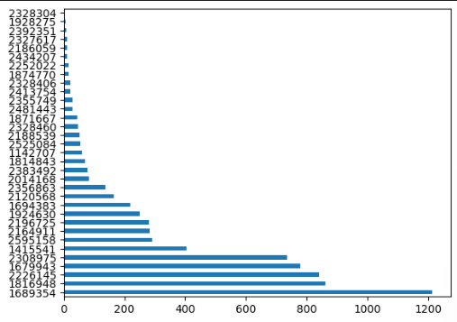

The figure shows the total number of Product Id used in the dataset and their count, to check how many times a product has been sold.

1. We picked only those products that have been sold more than 500 times.

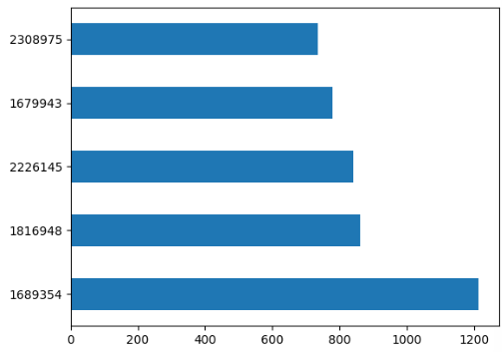

The figure shows the products that are sold more than 500 times.

1. We have X variable that has all the Product_ID and Y variable stored with selling DATE and selling TIME.
2. We have converted these selling date and time into ‘Hours of Day’ and ‘Day of Week’ that gives better prediction at what hour of the day and what day of the week the product sold the most.

* Hours of Day ranges from 1 to 24 and Day of Week ranges from 0 to 6 where 0 is Sunday and so on.

1. Shuffled the complete dataset to produce randomness in the data.
2. Data is split into 90% Training and 10% testing data because we want to predict output from our database.
3. We implement Machine Learning Model, Gradient Boosting Regression, which shows exceptional results for these types of data.
4. In last, we predict the model where model ask the user to:

* Input: Product ID from the database i.e. These 5 products have been used for training till now.
* Output: At this hour of the day and that day of the week, the given product has maximum sale.