Confusion matrix:

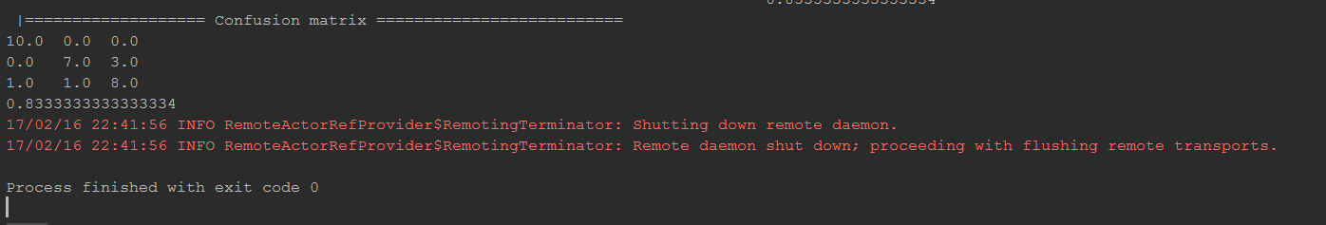

I have 3 classes. The confusion matrix gives 83% accuracy. Even though the training set had few images, we have achieved very good accuracy.

The training and testing images are found in the data folder.

The use case is that we have trained some images of animals and a zoo can use these images to perform some data analysis.