Confusion matrix:

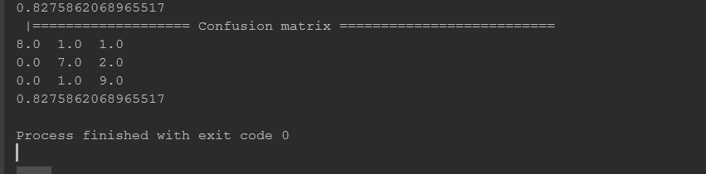

I have 3 classes lion, giraffe, crocodile. The confusion matrix gives almost 83% accuracy. Even though the training set had few images, we have achieved very good accuracy.

The training and testing images are found in the data folder.

The use case is that we have trained some images of animals and a zoo can use these images to perform some data analysis about where the animals are going, and what are the activities they do.