# Question 1

Confusion matrix:

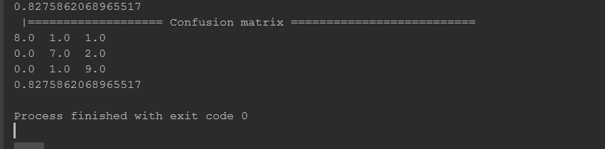

I have 3 classes lion, giraffe, crocodile. The confusion matrix gives almost 83% accuracy. Even though the training set had few images, we have achieved very good accuracy.

I have used a random forest for this.

The training and testing images are found in the data folder.

The use case is that we have trained some images of animals and a zoo can use these images to perform some data analysis about where the animals are going, and what are the activities they do.

# Question 2

For this question, my application classifies animals into their categories. You can run the app by changing directory to the UI folder in command prompt. Then enter superstatic -p 8081 in the command promp. Then from you browser go to <http://localhost:8081/>

The input folder is in the UI\Caltech101\test directory.

The categories in this application are lion, giraffe, and crocodile.

Here are some screenshots of the app:

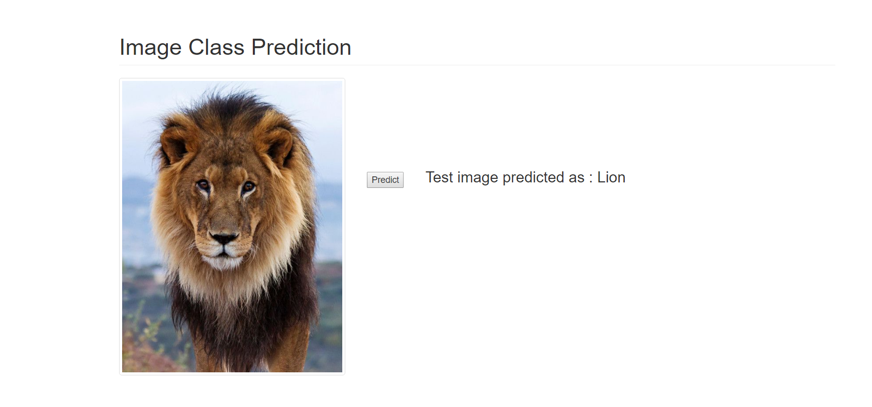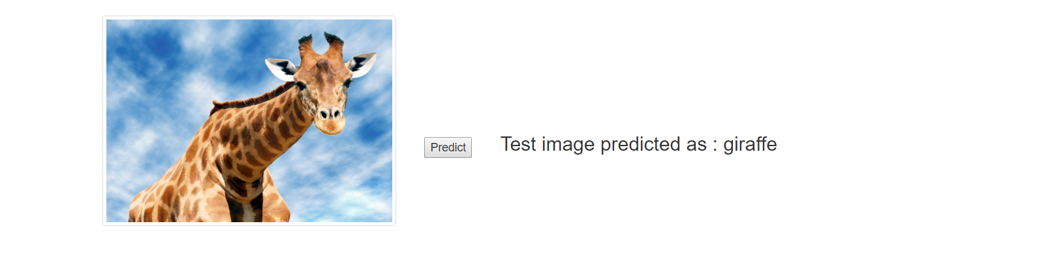

# Question 3

I have attached the conversation api project zip. This application can tell you details about the video. In actuality, we would take the input video file from the user, and then run our image classification algorithm on it to summarize the video.