# Question 1

The inputs is the features of lion, crocodile, and giraffe images, which were extracted using the object and feature detection program.

## Random Forest:

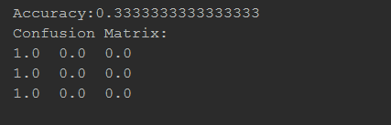

## Decision Tree

