# Question 1

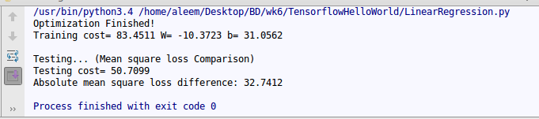

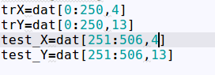

I have selected the 5th column from the data matrix(4th index). The output can be seen in the screenshot.

The main code is in the linearregression.py file.

# Question 2

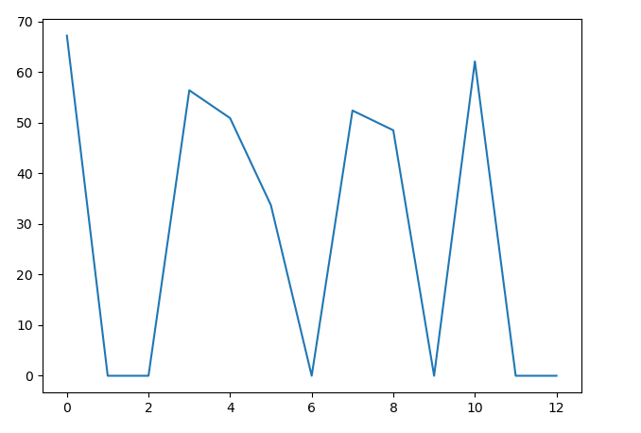

X axis is the feature column

Y axis is the testing score

The testing score is plotted for each feature. Some feature had NaN as the testing score which I have represented as 0.