# Data Set:

I’m using the caltech101 data set. I have chosen 4 classes: Airplanes, Faces, Watches, and Bikes.

First we have to get the data into the mnist data format. The code to do this is provided in the “Convert Mnist” folder. You will need to install PIL (python imaging library for this to run). This converts the data into 4 files which are of the ubyte format supported by mnist data. This also assigns one hot encoding to the labels. Using this method I found it easiest because the code provided in the lab readily takes data in mnist format. The files in the red box are produced by convert-images-to-mnist-format.py program. And they are in the idx3-ubyte.gz file format.

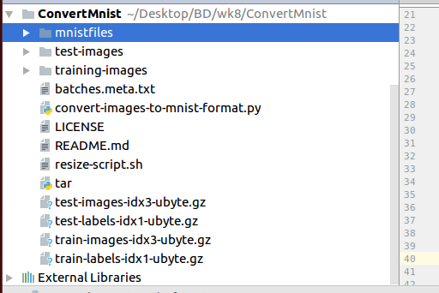

# Parsing

To parse the mnist data I’m using an external library available at: <https://github.com/sorki/python-mnist>

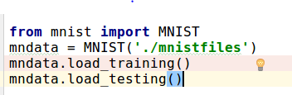

Using this code we can extract the training and testing data, and feed it into tensorflow.

We can load the testing data also by using mndata.load_testing() method.

# Output:

# 

I was able to get 74.71% accuracy with the Caltech data transformed to MNIST format in 4 classes.