# Dataset:

We are using the CIFA-10 dataset. It’s great because it is used by many researchers in the deep learning community. It’s applicable to our project because if our algorithm can work with the CIFAR-10 data set then it can work with our images as well. Also we will be using the MS-COCO data set which is very similar to CIFAR-10 dataset, and has similar categories. The categories are: Airplane, Automobile, Bird, Cat, Deer, Dog, Frog, Horse, Ship, Truck.

## Tensorboard Graph for inference operation:

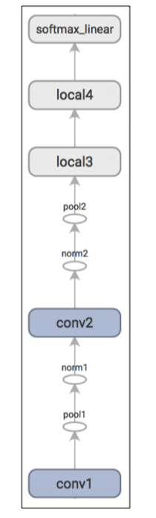

## Loss:

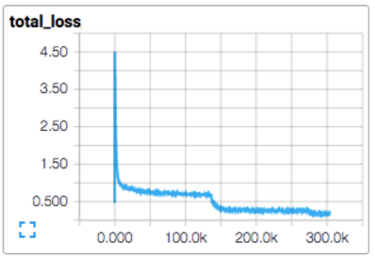

## Learning Rate:

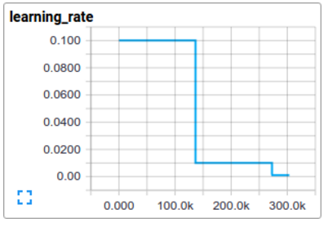

## Accuracy:

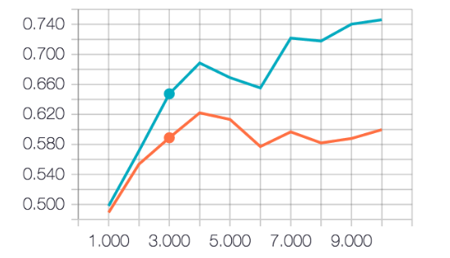

# Question 2:

