Introduction

For this project, I used the Titanic dataset, which contains information about passengers such as age, class, fare, and survival status. The main goal of this analysis is to explore the data, clean it, and discover patterns that might explain differences between passengers.
I focused on understanding how factors like passenger class, age, and fare relate to each other, and how they might influence outcomes.

Cleaning Summary (Phase 1)

The dataset required several cleaning steps before analysis. First, I fixed data types by converting categorical columns like Pclass and Embarked into appropriate formats.
Next, I handled missing values. The Age column had missing values, so I filled them using the median because it is more robust to outliers. The Embarked column was filled using the most frequent value. The Cabin column had too many missing values, so it was removed.
I also checked for duplicate rows, but none were found. To handle extreme values, I capped the Fare column at the 99th percentile to reduce the impact of outliers. Finally, I ensured that all Fare values were non-negative.
Feature Engineering (Phase 2)

In this phase, I created new features to make the dataset more useful. First, I applied one-hot encoding to categorical variables like Sex and Embarked to convert them into numerical format.
Then, I ordinally encoded the Pclass column to preserve its order. I also scaled numerical features such as Age and Fare using StandardScaler to normalize their values.
Additionally, I created new features such as Fare_per_Age to represent the ratio between fare and age, and an interaction feature between class and age. I also applied a log transformation to the Fare column to reduce skewness.
Finally, I removed highly correlated features to avoid redundancy while keeping important variables.
Key Findings (Phase 3)
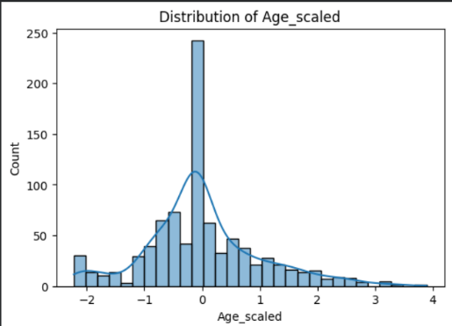
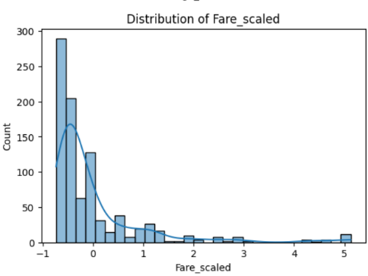
1. Distrizbution Plot

The distribution plots show that the scaled numerical features are approximately symmetric after transformation. This indicates that scaling and log transformation helped reduce skewness and made the data more
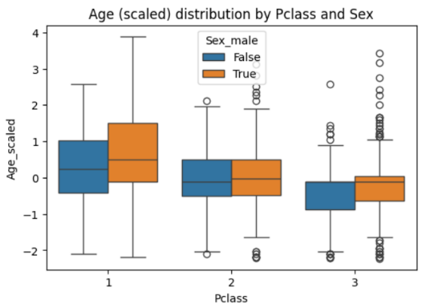
2. Boxplot (Comparison)
The boxplot shows differences in age distribution across passenger classes and gender. Passengers in higher classes tend to have different age distributions compared to lower classes, indicating that class may be related to demographic differences.

3. Correlation Heatmap
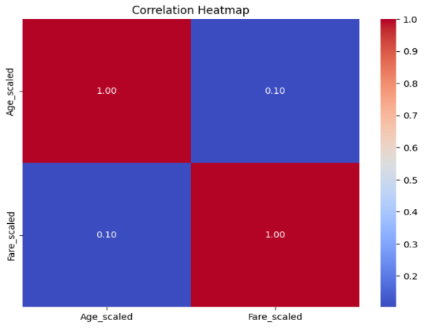

The correlation heatmap highlights relationships between numerical variables. Some features show moderate correlations, which suggests that certain variables are related and can help explain patterns in the dataset.

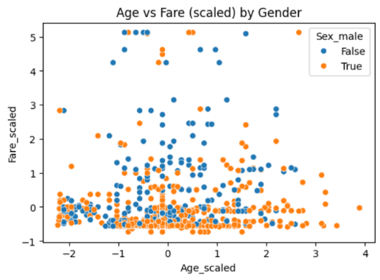
4. Scatter Plot

The scatter plot shows the relationship between age and fare. There is a general trend where passengers who paid higher fares tend to belong to certain groups, although the relationship is not perfectly linear.
5. GroupBy Analysis

Pclass | Average Fare (scaled)
1 | 1.15034
2 | -0.24853
3 | -0.41292

The table shows that passengers in first class have the highest average fare, while second and third classes have lower averages. This confirms that ticket price is strongly related to passenger class.

What I Would Do Next

If I had more time, I would build a predictive model to estimate outcomes such as survival based on the engineered features. I would also explore additional interactions between variables and test whether combining features improves performance.
Additionally, I would analyze more deeply how different factors interact together rather than looking at them individually.

