**COMPONENTS -- THAT ARE INVOKED DURING A CERTAIN INSTRUCTION AND HOW THEY COMMUNICATE WITH EACHOTHER IS SHOWN VIA PINK BARS STEP WISE.**

**STEP 1:**

Address of instruction is fetched from memory

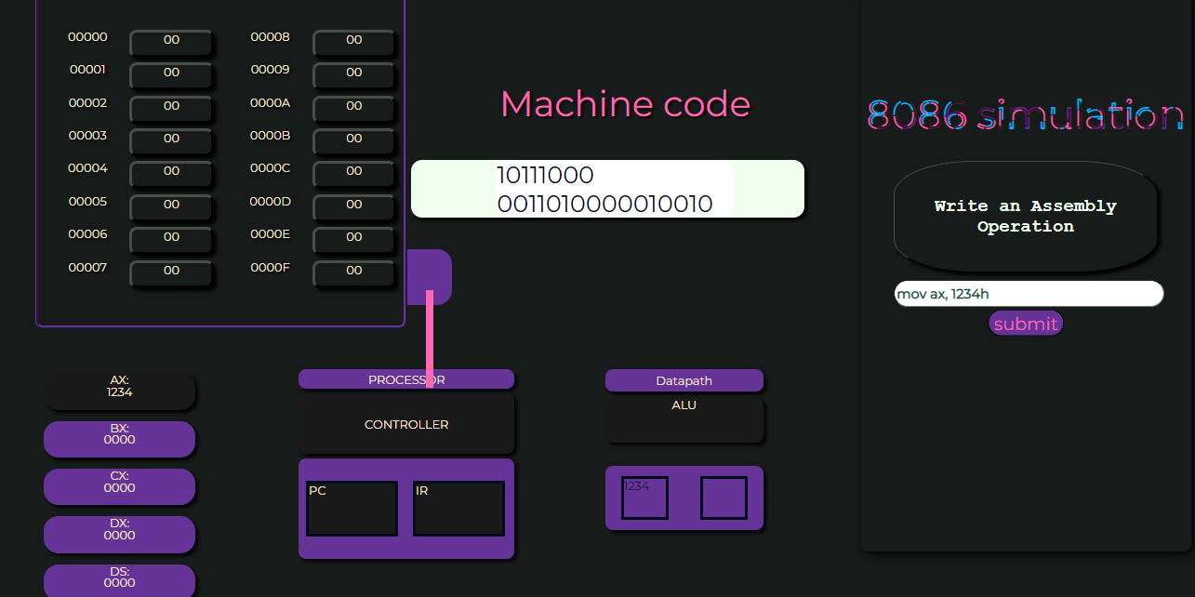

**STEP 2:**

The istruction is decoded and is sent to IR

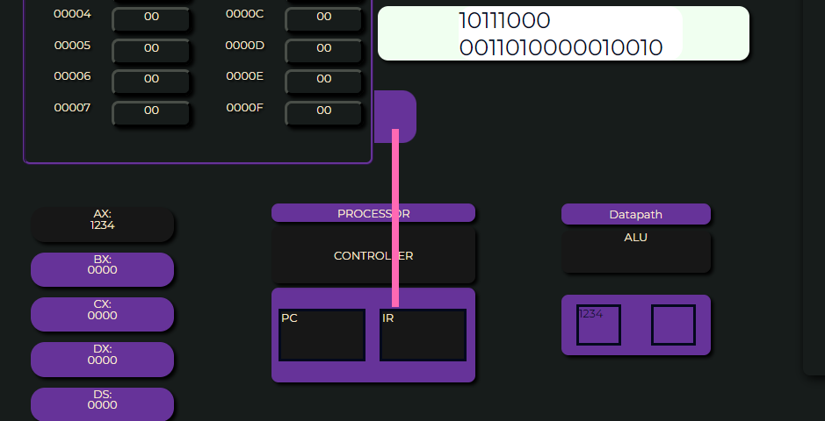

**STEP 3:**

Controller takes instruction from IR

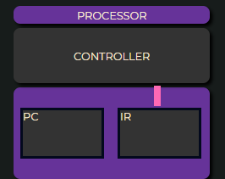

**STEP 4:**

Instruction is sent to ALU for ececution

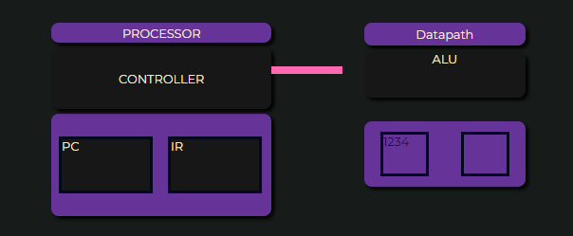

**STEP 5:**

Instruction is finally performed and required data is stored in the respectve register.

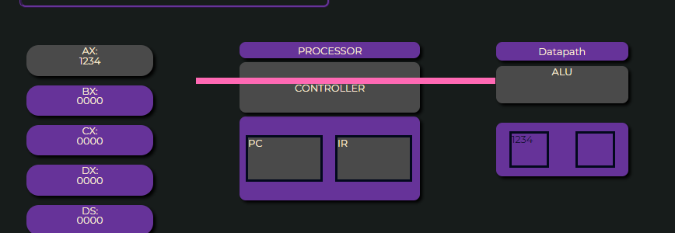

**COMPONENTS WHICH ARE INVOLVED ARE HIGHLIGHTED**

