

Week 2 – pfSense Firewall Configuration & pfBlockerNG Implementation
Prepared By : Aleena Arzoo
Internship Program : SOC (Security Operations Centre)
Organization : ITSimplera Solutions
Submission Date : 07-07-2026

Table of Content
- · Executive Summary
- · Introduction
- · Objectives
- · Learning Outcomes
- · Lab Environment
- · Software & Hardware Requirements
- · Network Topology
- · Task 1 – pfSense Firewall Deployment
- · Task 2 – pfBlockerNG Installation
- · Task 3 – GeoIP Country Blocking
- · Task 4 – DNSBL Website Filtering
- · Task 5 – Administrator Access Control
- · Task 6 – Firewall Logs & Reports Validation
- · Challenges Faced
- · Results
- · Skills Gained
- · Conclusion
- · References

- Introduction
AFirewalls play a vital role in protecting modern computer networks by monitoring and controlling incoming and outgoing traffic based on predefined security rules. pfSense is a powerful open-source firewall platform that is widely used in enterprise environments due to its reliability, flexibility, and extensive security features.The purpose of this assignment was to gain practical experience in deploying and configuring pfSense together with pfBlockerNG, an advanced security package that provides GeoIP filtering, DNSBL website blocking, IP reputation filtering, and threat intelligence integration.
Throughout this assignment, the following security tasks were successfully completed:
- Installation and configuration of pfBlockerNG.
- Implementation of GeoIP-based country blocking using the MaxMind GeoLite2 Database.
- Configuration of DNSBL website filtering to block Facebook and Chat.com.
- Implementation of administrator access control for securing the pfSense WebGUI.
- Validation of firewall rules and monitoring of firewall logs and reports.
This assignment provided valuable practical exposure to firewall administration, network security, and security monitoring while improving my understanding of real-world Security Operations Center (SOC) practices

Executive Summary
This report presents the successful completion of Week 2 of the SOC Internship at ITSimplera Solutions. The primary objective of this assignment was to deploy and configure a pfSense Firewall and enhance its security capabilities using pfBlockerNG.During this assignment, several security features were successfully implemented, including GeoIP-based country blocking, DNSBL website filtering, administrator access control, and firewall log monitoring. Each configuration was carefully tested and validated to ensure that the implemented security policies were functioning correctly.This practical exercise provided valuable hands-on experience in enterprise firewall management and improved my understanding of network security, access control, threat prevention, and security monitoring techniques commonly used in a Security Operations Center (SOC).

Objectives
TThe main objectives of this assignment were:
- Successfully deploy the pfSense Firewall.
- Install and configure the pfBlockerNG security package.
- Configure the MaxMind GeoLite2 database for GeoIP filtering.
- Block incoming traffic from selected geographical regions.
- Configure DNSBL to restrict access to selected websites.
- Implement administrator access control for the pfSense WebGUI.
- Validate all security configurations using firewall logs and reports.
- Gain practical experience in enterprise firewall administration.

Learning Outcomes
After successfully completing this assignment, I gained practical knowledge and hands-on experience in the following areas:
- Deploying and configuring pfSense Firewall.
- Installing and managing pfBlockerNG.
- Configuring GeoIP filtering using MaxMind.
- Implementing DNSBL website filtering.
- Creating and managing firewall rules.
- Securing administrative access to network devices.
- Monitoring firewall logs and security reports.
- Validating firewall configurations through practical testing.
- Understanding enterprise firewall management and SOC operations

Lab Environment
The following lab environment was used during the implementation of this assignment.
Component | Details
Host Operating System | Windows 10
Virtualization Software | Oracle VirtualBox
Firewall Platform | pfSense CE
Security Package | pfBlockerNG-devel
DNS Resolver | Unbound DNS
GeoIP Provider | MaxMind GeoLite2
Client Machine | Windows Host
Web Browser | Google Chrome

Software & Hardware Requirements

Software
- Oracle VirtualBox
- pfSense CE
- pfBlockerNG-devel
- MaxMind Account
- Windows 10
- Google Chrome

Hardware
- Intel Processor
- 8GB RAM
- 100GB Storage
- Stable Internet Connection

Network Topology
The lab environment consisted of a Windows host machine connected to a pfSense firewall running inside Oracle VirtualBox using a Host-Only Network Adapter. The pfSense firewall acted as the central security gateway, where all firewall rules, GeoIP filtering, DNSBL configurations, and administrator access policies were implemented.The Windows host system was used to access the pfSense WebGUI, perform configuration tasks, and validate the implemented security controls throughout the assignment
.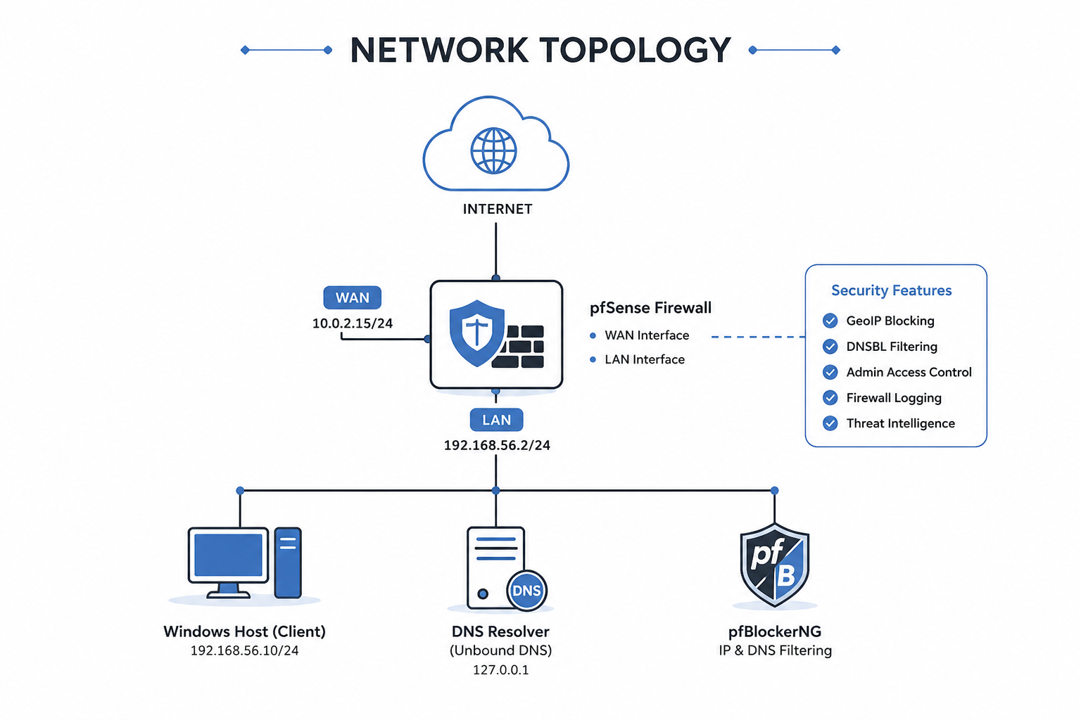

Task 1 – pfSense Firewall Deployment

Objective

The objective of this task was to deploy the pfSense Community Edition firewall in a virtual environment using Oracle VirtualBox and configure its basic network interfaces. The firewall was prepared to serve as the primary security gateway for all subsequent security configurations performed during the internship
Introduction
A firewall is one of the most important security components in any network because it monitors, filters, and controls incoming and outgoing traffic based on predefined security rules. In this lab environment, pfSense was selected because it is a powerful open-source firewall platform widely used by organizations for network security, routing, VPN services, intrusion prevention, and traffic monitoring.
The deployment of pfSense served as the foundation for implementing advanced security features such as GeoIP filtering, DNSBL website blocking, administrator access control, and firewall monitoring using pfBlockerNG.

Procedure
The deployment process began by importing the pfSense virtual appliance into Oracle VirtualBox. During the initial boot process, the WAN and LAN interfaces were assigned according to the lab requirements.
After interface assignment, the LAN interface was configured with the IP address 192.168.56.2/24, which served as the management interface for accessing the firewall.
The DHCP server was enabled on the LAN interface so that connected devices could automatically obtain IP addresses. Once the configuration was completed, the Windows host machine successfully communicated with the firewall using ICMP (Ping), confirming proper network connectivity.
Finally, the pfSense WebGUI was accessed through the browser using the configured LAN IP address, where the administrator successfully logged in and verified that the firewall was operational.

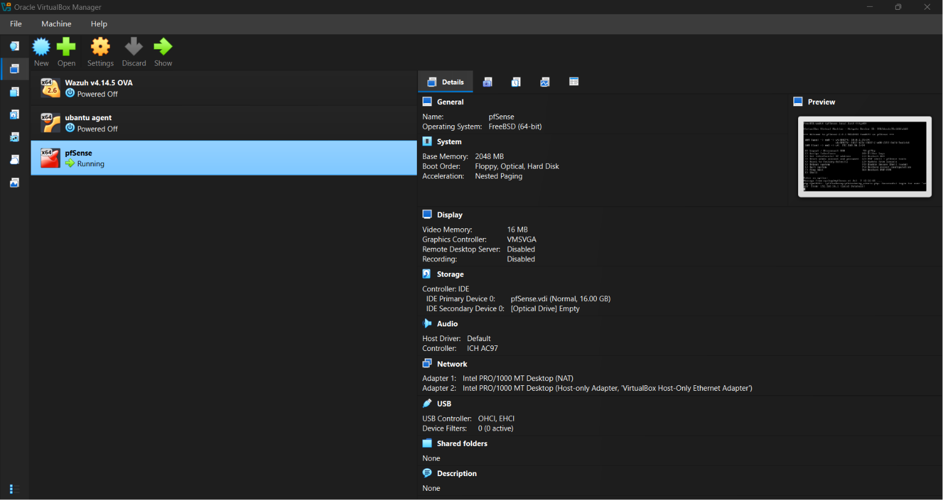
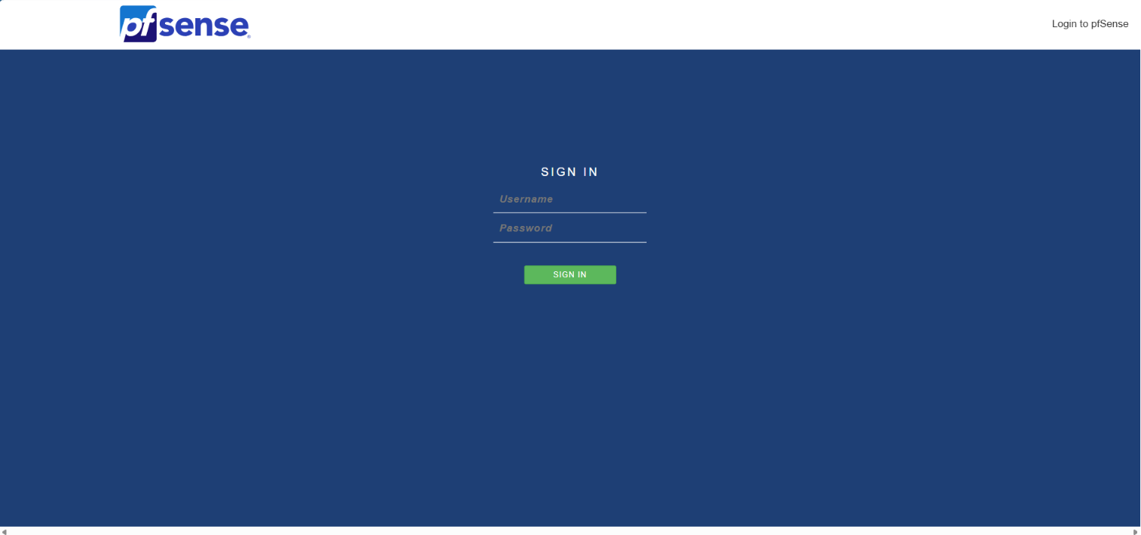
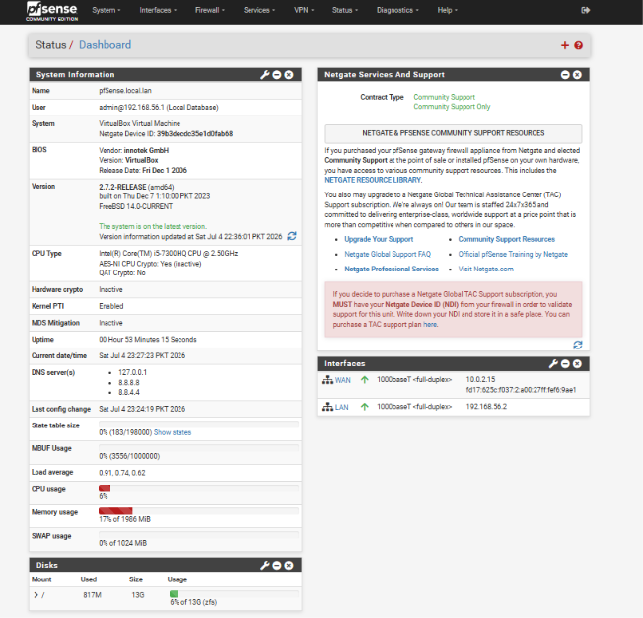
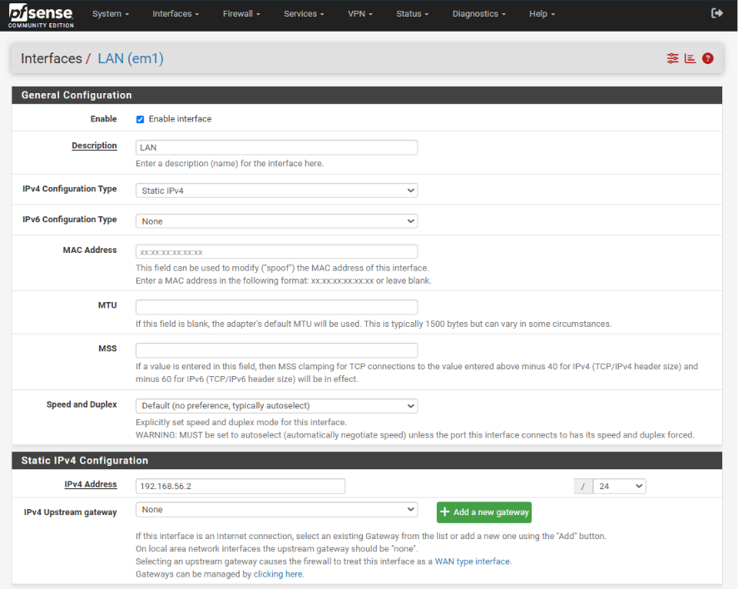
Validation
The deployment was verified by successfully accessing the pfSense WebGUI through the Windows host system. Network connectivity was confirmed using the Ping command, and the dashboard displayed both WAN and LAN interfaces in an active state. The successful login confirmed that the firewall was correctly configured and ready for additional security configurations.

Result

The pfSense firewall was successfully deployed and configured within Oracle VirtualBox. The WebGUI became accessible through the configured LAN interface, providing a stable platform for implementing advanced firewall security features during the remaining internship tasks.
Security Benefit
Deploying pfSense provides centralized network security by monitoring, filtering, and controlling all network traffic. It establishes a secure gateway between internal devices and external networks while serving as the primary platform for implementing enterprise-level security policies

Task 2 – pfBlockerNG Installation
Objective

The objective of this task was to install and configure pfBlockerNG-devel, an advanced security package available for pfSense Firewall. This package extends the firewall's capabilities by providing IP reputation filtering, GeoIP country blocking, DNSBL (DNS Blackhole List), and threat intelligence integration. Installing pfBlockerNG was an essential step because the remaining security tasks of this assignment depended on its successful deployment
Procedure
The installation process began by accessing the Package Manager from the pfSense WebGUI. The Package Manager contains a list of official packages that can be installed to extend pfSense functionality.Using the search feature, the pfBlockerNG-devel package was located and selected for installation. After confirming the installation, pfSense automatically downloaded the required files and completed the installation process. Once the installation finished successfully, a new pfBlockerNG option appeared under the Firewall menu, confirming that the package had been integrated into the firewall. The package was then ready for further configuration, including GeoIP filtering and DNSBL implementation in the subsequent tasks.
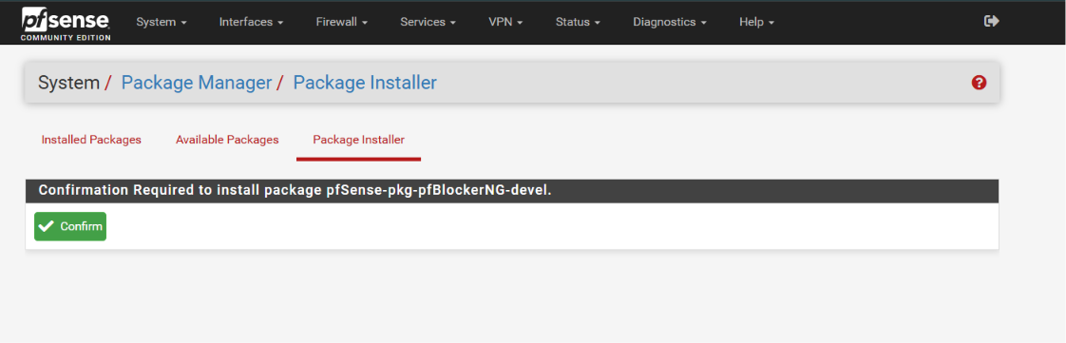

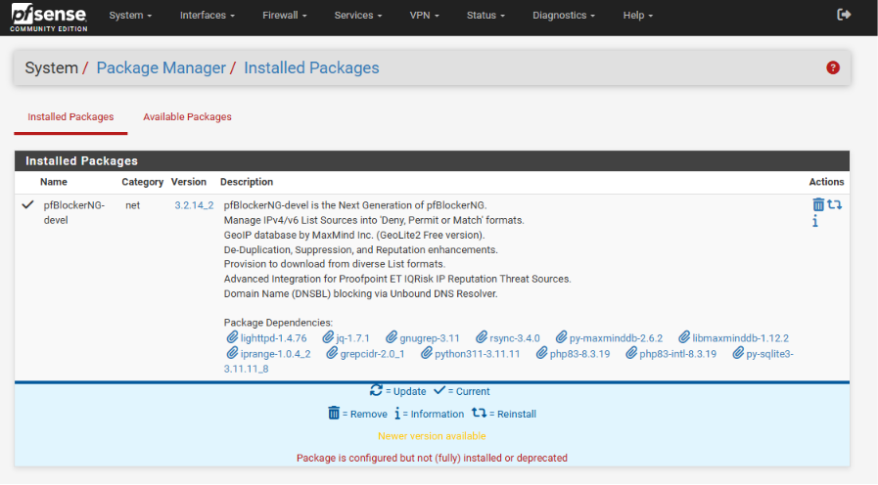
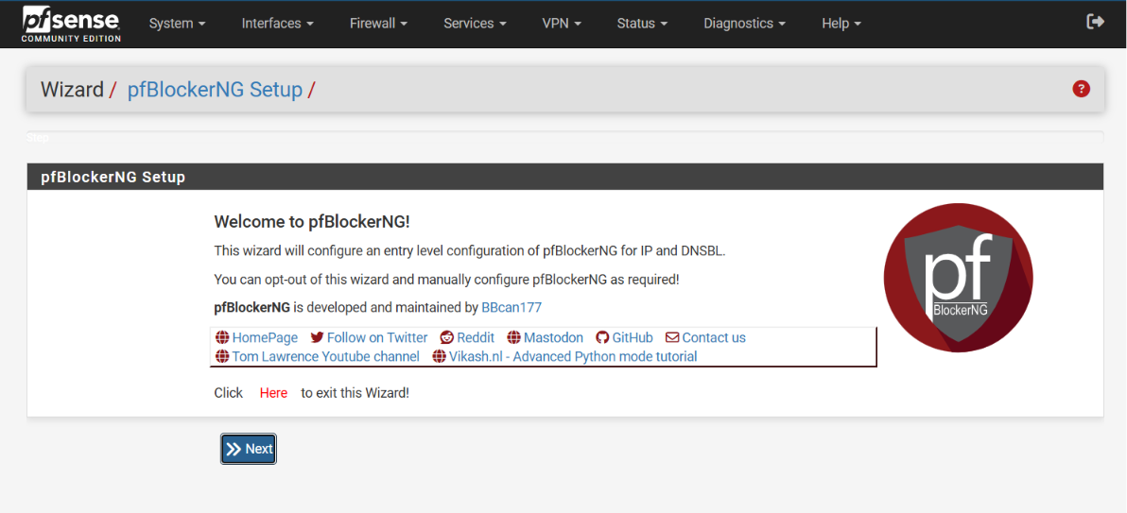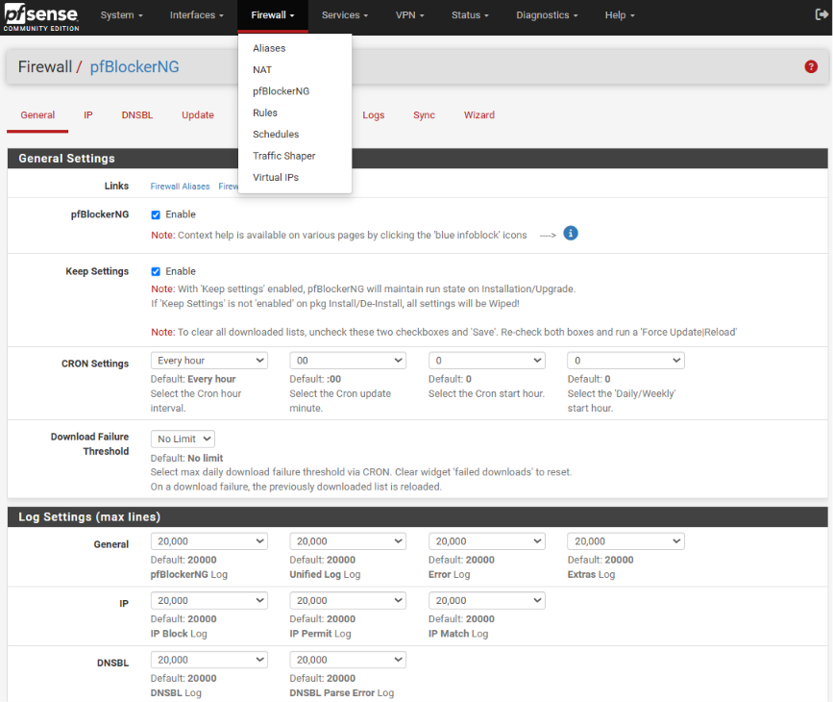
Validation
The installation was verified by checking the Installed Packages section in the Package Manager. Additionally, the appearance of the pfBlockerNG option under the Firewall menu confirmed that the installation was completed successfully and that the package was ready for configuration.

Result
The pfBlockerNG-devel package was installed successfully without any errors. The package became fully operational and was successfully integrated into the pfSense firewall, enabling advanced security features required for the remaining tasks of the internship assignment.

Security Benefit
Installing pfBlockerNG significantly enhances the security capabilities of pfSense by enabling IP reputation filtering, GeoIP-based traffic blocking, DNS-based website filtering, and threat intelligence integration. These features help organizations prevent malicious traffic, reduce exposure to cyber threats, and improve overall network security through centralized firewall management.

Task 3 – GeoIP Country Blocking Using MaxMind

Objective
The objective of this task was to configure GeoIP-based country blocking using MaxMind GeoLite2 Database within pfBlockerNG. This feature was implemented to restrict inbound traffic originating from selected geographical locations, specifically Netherlands (NL) and Europe, thereby reducing the risk of unauthorized access and cyber threats.

Introduction
GeoIP filtering is an advanced security feature that allows a firewall to make access control decisions based on the geographical location of an IP address. Instead of allowing traffic from every country, administrators can selectively block or allow connections from specific regions according to organizational security requirements.pfBlockerNG integrates with the MaxMind GeoLite2 database, which maintains an up-to-date mapping between IP addresses and their geographical locations. During this task, the MaxMind database was connected with pfSense, enabling the firewall to automatically identify IP addresses belonging to the selected countries.To demonstrate this functionality, the Netherlands (NL) and the Europe region were configured with the Deny Inbound action. This ensured that any incoming connection attempts originating from those regions would be blocked before reaching the internal network.

Procedure
The configuration process started by creating a free account on the MaxMind website and generating a valid License Key. This key was required so that pfBlockerNG could download the latest GeoLite2 database. Inside the pfSense WebGUI, the Firewall → pfBlockerNG → IP section was opened. The MaxMind Account ID and License Key were entered into the GeoIP configuration page and the settings were saved successfully. Next, the GeoIP tab was opened, where the Netherlands (NL) and the required Europe region were selected. The List Action was configured as Deny Inbound, instructing pfSense to reject all incoming traffic originating from the selected locations. After completing the configuration, the Force Update / Reload option was executed. pfBlockerNG downloaded the latest GeoIP database from MaxMind, processed the selected regions, and generated the required firewall aliases. Finally, the generated alias pfB_Europe_v4 was verified under the Firewall Aliases section, confirming that the selected IP ranges had been successfully loaded into the firewall.
- 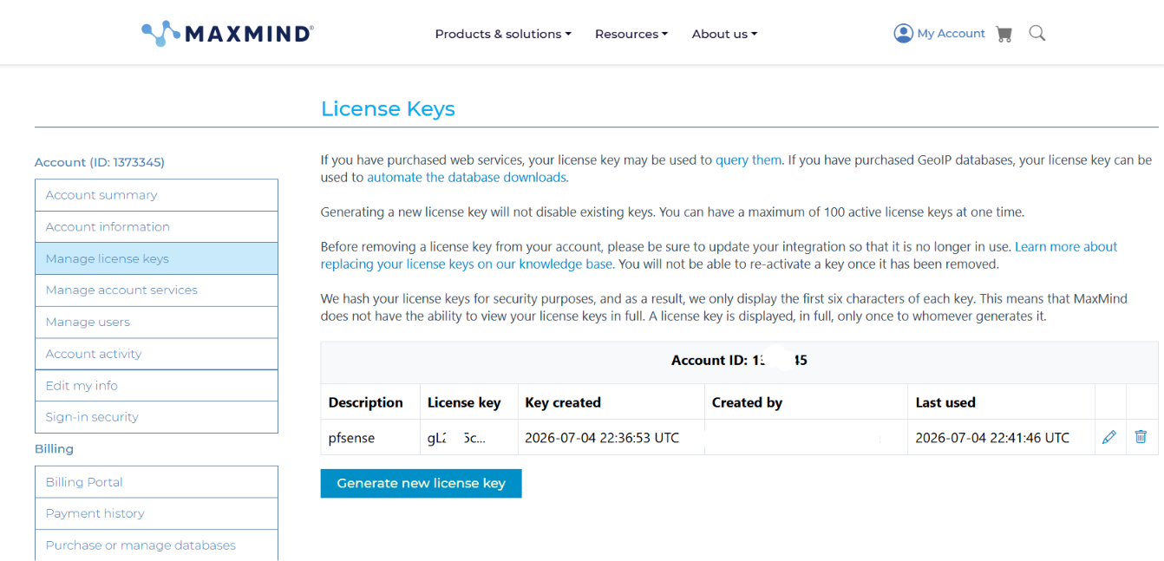
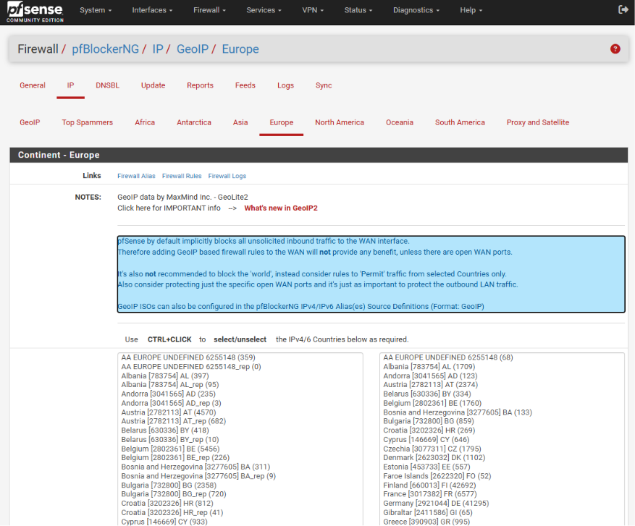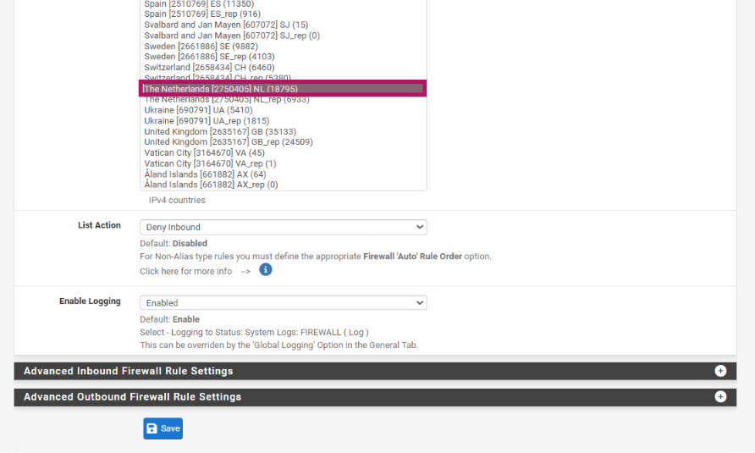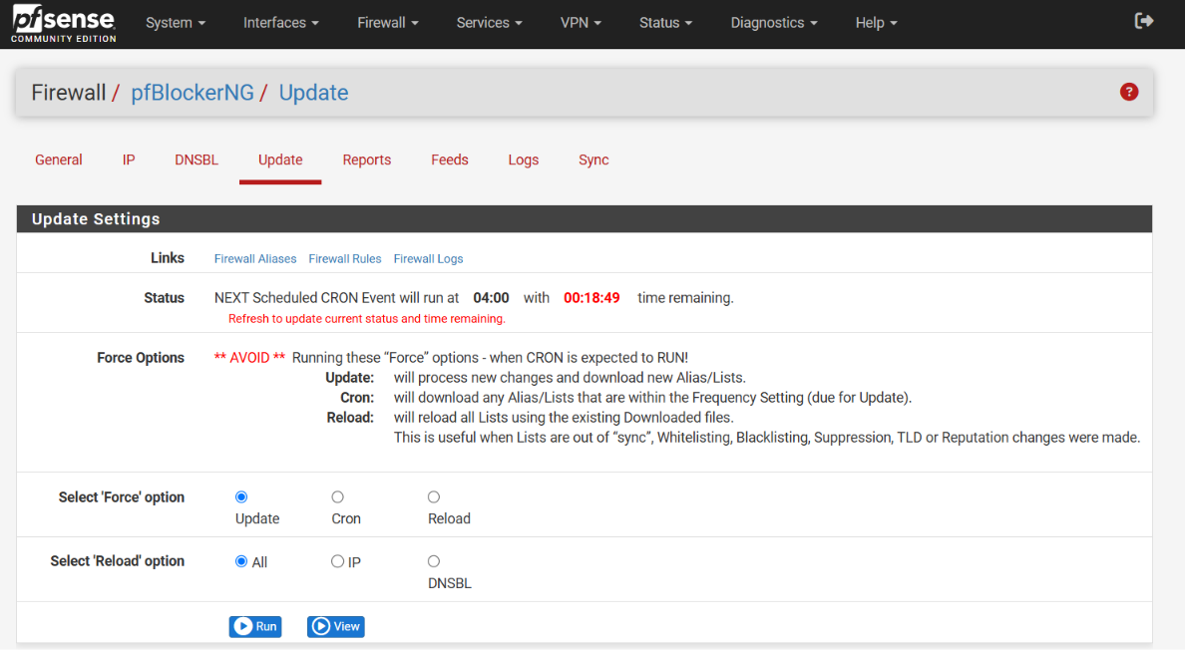

Validation
The GeoIP configuration was validated after executing the Force Update / Reload process. The update completed successfully without errors, and the alias pfB_Europe_v4 appeared in the Firewall Aliases section containing thousands of IP addresses associated with the selected geographical region.The successful creation of the alias confirmed that pfSense had correctly downloaded the MaxMind GeoLite2 database and applied the GeoIP filtering policy.

Result
The GeoIP filtering policy was successfully implemented using the MaxMind GeoLite2 database. The firewall generated the pfB_Europe_v4 alias containing the IP ranges associated with the selected European region. As a result, inbound traffic originating from the configured locations was automatically denied, strengthening the overall security of the firewall.

Security Benefit
GeoIP filtering provides an additional layer of defense by allowing administrators to restrict traffic based on geographical regions. This reduces unnecessary exposure to internet-based threats, blocks unwanted connection attempts from selected countries, and helps minimize the organization's attack surface. It also supports organizational security policies by allowing access only from trusted locations while preventing communication from regions considered high risk.

Task 4 – DNSBL Website Filtering

Objective
The objective of this task was to configure DNSBL (DNS Blackhole List) using pfBlockerNG to block access to selected websites at the DNS level. In this assignment, Facebook and Chat.com were added to the custom DNSBL list to demonstrate website filtering and domain blocking within the pfSense firewall environment.

Introduction
DNSBL (DNS Blackhole List) is one of the most powerful features of pfBlockerNG. It works by blocking domain name resolution before a connection to the website is established. Instead of allowing the client device to resolve the real IP address of a blocked website, DNSBL redirects the request to a local sinkhole IP address, preventing access to the website.Unlike traditional firewall rules that block traffic after a connection attempt is made, DNSBL stops the communication at the DNS resolution stage. This approach improves network performance while providing an efficient method for blocking malicious, phishing, advertising, or non-work-related websites.During this task, Facebook and Chat.com were selected as sample domains to verify that DNSBL was functioning correctly.

Procedure
The DNSBL configuration began by creating a Virtual IP Address, which acts as the DNSBL sinkhole. This Virtual IP is used to redirect requests for blocked domains instead of allowing them to resolve to their actual public IP addresses.After creating the Virtual IP, the DNSBL feature was enabled from the Firewall → pfBlockerNG → DNSBL menu.A new DNSBL Group named SocialBlock was then created to organize the blocked domains. Inside the DNSBL Custom List, the following domains were added:
- facebook.com
- www.facebook.com
- chat.com
- www.chat.com
Once the domains were added, the configuration was saved and the Force Update / Reload option was executed. pfBlockerNG processed the DNSBL configuration, updated the DNS database, and applied the new filtering rules.Finally, website blocking was verified by attempting to access the blocked domains from the client machine. The browser was unable to establish a connection to the configured websites, confirming that the DNSBL policy was working successfully.

Blocked Domains
The following domains were configured in the DNSBL Custom List:
- facebook.com
- www.facebook.com
- chat.com
- www.chat.com
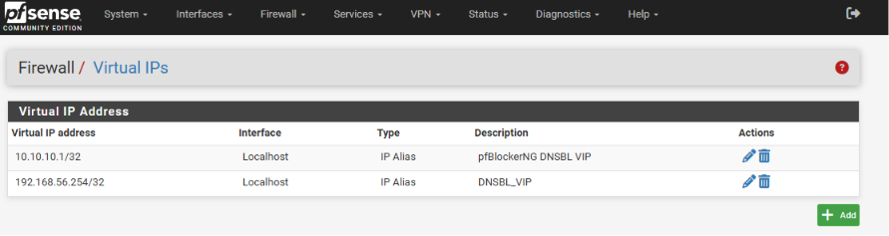
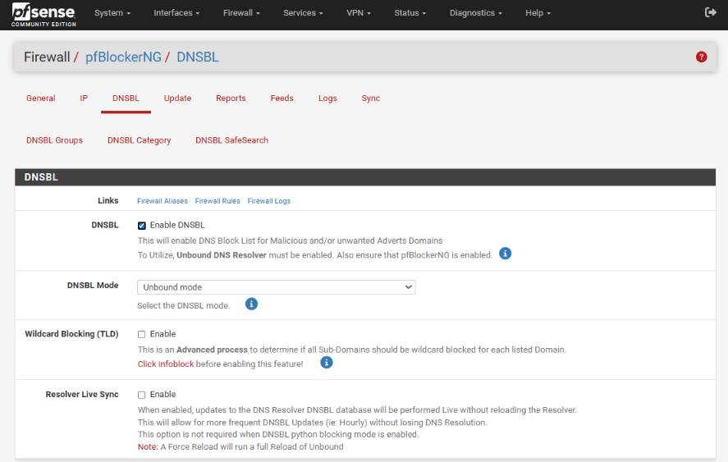
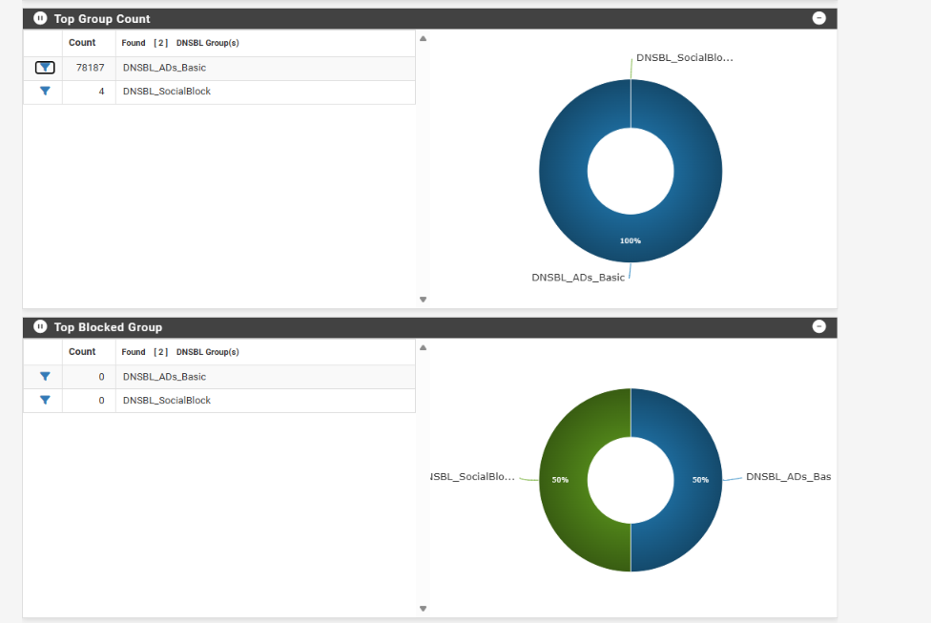


Validation
The DNSBL configuration was validated by performing practical testing from the Windows host system.After the DNSBL update completed successfully, an attempt was made to open Facebook using a web browser. The website failed to load, confirming that the configured DNSBL policy was successfully preventing access to the blocked domain.Additionally, the DNSBL reports within pfBlockerNG were reviewed to verify that the blocked domain requests were being recorded. The successful appearance of these entries confirmed that the DNS filtering policy was functioning correctly.

Result
The DNSBL configuration was successfully implemented using pfBlockerNG. Both Facebook and Chat.com were added to the custom block list and became inaccessible from the client system. The successful browser test and DNSBL report entries confirmed that the website filtering policy had been applied correctly.

Security Benefit
DNSBL significantly enhances organizational security by preventing users from accessing unauthorized, malicious, or distracting websites before any network connection is established. This reduces the risk of phishing attacks, malware infections, and unnecessary internet usage while helping organizations enforce acceptable use policies. By blocking domains at the DNS level, DNSBL provides an efficient and lightweight method of web filtering without requiring additional software on client machines.

Task 5 – Administrator Access Control

Objective
The objective of this task was to secure the pfSense WebGUI by restricting administrative access to only an authorized host. This was achieved by creating a dedicated firewall rule that allowed HTTPS access exclusively from the Windows administrator machine while preventing unauthorized systems on the network from accessing the firewall management interface.

Introduction
The pfSense WebGUI is the primary interface used by network administrators to configure and manage the firewall. Since it provides complete control over firewall settings, protecting access to this interface is a critical security requirement.Allowing unrestricted access to the WebGUI increases the risk of unauthorized configuration changes and potential security breaches. To minimize this risk, only trusted administrator devices should be granted permission to access the firewall management portal.In this task, an Alias was created for the administrator's Windows machine, and a firewall rule was implemented to allow HTTPS (Port 443) access only from that specific host.

Procedure
The configuration process began by navigating to Firewall → Aliases in the pfSense WebGUI. A new Host Alias named Admin_Host was created, and the IP address of the Windows administrator system (192.168.56.1) was assigned to it. This alias provides a simple and organized way to reference the administrator's device in firewall rules.After creating the alias, the Firewall → Rules → LAN section was opened. A new firewall rule was added at the top of the rule list to ensure it would be evaluated before other rules.
The rule was configured with the following settings:
- Action: Pass
- Protocol: TCP
- Source: Admin_Host (192.168.56.1)
- Destination: This Firewall (Self)
- Destination Port: HTTPS (443)
- Logging: Enabled
- Description: Allow Admin Access – Only Windows Host
After reviewing the configuration, the rule was saved and Apply Changes was selected. The firewall immediately began enforcing the new access control policy.

Firewall Rule Configuration
Setting | Value
Action | Pass
Protocol | TCP
Source | Admin_Host
Destination | This Firewall (Self)
Port | HTTPS (443)
Logging | Enabled
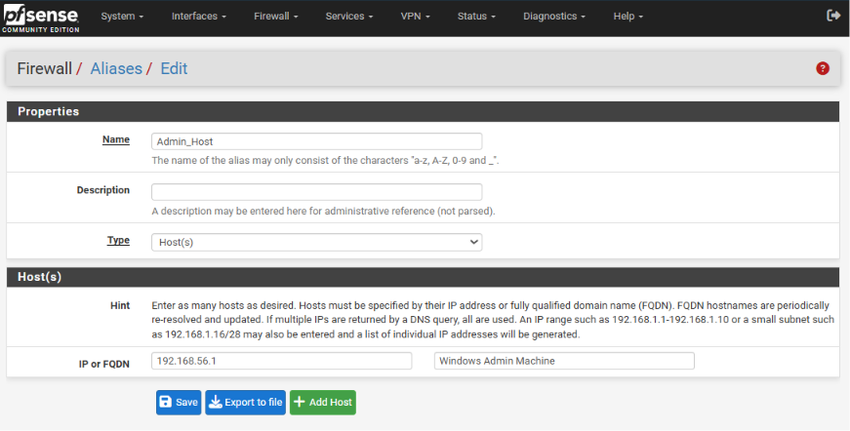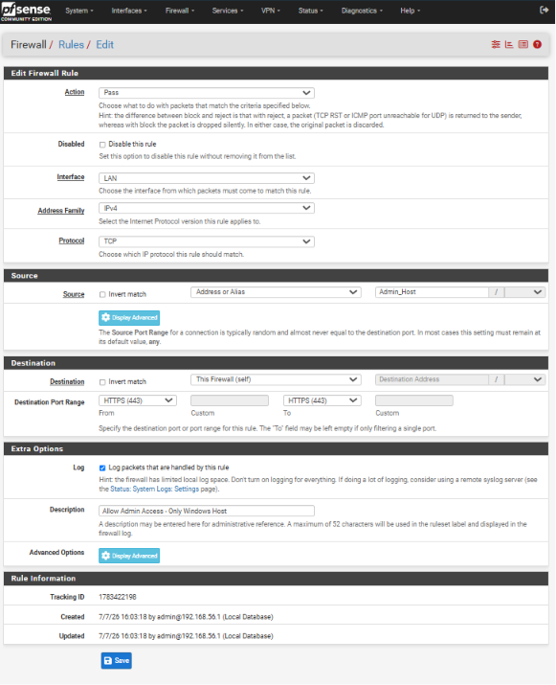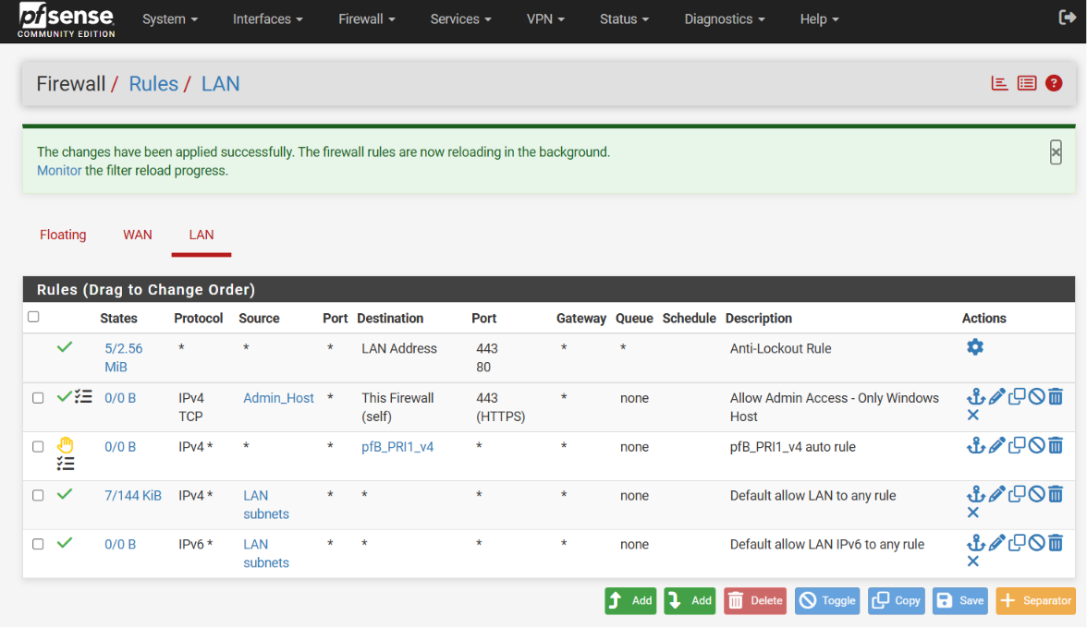

RValidation
The administrator access policy was verified by accessing the pfSense WebGUI from the authorized Windows host machine. The login page loaded successfully, confirming that the firewall rule was functioning as intended.The firewall rule was also reviewed under the LAN Rules section, where the configured source, destination, and HTTPS port settings matched the intended security policy. This confirmed that only the designated administrator system had permission to access the firewall management interface.

Result
The administrator access control policy was successfully implemented. Access to the pfSense WebGUI was limited to the authorized Windows host through the configured firewall rule. This ensured that firewall management could only be performed from a trusted device within the network.

Security Benefit
Restricting administrative access is a fundamental security practice in enterprise networks. By allowing only authorized systems to access the pfSense WebGUI, the risk of unauthorized configuration changes, credential misuse, and management interface attacks is significantly reduced. This implementation strengthens the overall security posture of the firewall and ensures that administrative privileges remain protected.
.

Task 6 – Firewall Logs & Reports Validation

Objective
The objective of this task was to validate and monitor all previously configured security policies by reviewing the pfSense and pfBlockerNG firewall logs and reports. This step ensured that the implemented configurations, including GeoIP blocking, DNSBL website filtering, and administrator access control, were functioning correctly and generating the expected security events.

Introduction
Monitoring and log analysis are fundamental responsibilities of a Security Operations Center (SOC) analyst. Configuring security controls alone is not sufficient; administrators must continuously verify that these controls are operating correctly and are effectively protecting the network.pfSense provides detailed firewall logs and reporting features that allow administrators to monitor blocked connections, DNSBL events, GeoIP filtering activities, and firewall rule enforcement. These logs help identify suspicious activities, troubleshoot configuration issues, and verify that security policies are working as intended.In this task, the configured security features were validated by reviewing pfBlockerNG reports, checking firewall aliases, and performing practical tests from the Windows host system.

Procedure
After completing all previous configurations, the Firewall → pfBlockerNG → Reports section was opened to review the generated security logs and statistics.The IP Block Statistics report was examined to verify that the configured GeoIP rules were active and that the firewall had successfully loaded the blocked IP ranges from the MaxMind GeoLite2 database.Next, the DNSBL Reports were reviewed to confirm that the blocked domains, including Facebook and Chat.com, were being processed correctly by the DNSBL engine.To validate website filtering, an attempt was made to access Facebook through a web browser. The website failed to load, confirming that the DNSBL policy was successfully blocking access.The Firewall Aliases section was also reviewed to verify that the pfB_Europe_v4 alias had been created successfully and contained the imported IP addresses associated with the selected geographical regions.Finally, the overall firewall dashboard and reports were reviewed to ensure that all implemented configurations were functioning correctly without any errors.

Validation Activities
The following validation checks were performed during this task:
- Verified that the pfB_Europe_v4 alias was successfully created.
- Reviewed IP Block Statistics within pfBlockerNG.
- Checked DNSBL Reports for blocked domain entries.
- Confirmed that Facebook and Chat.com were inaccessible through the web browser.
- Reviewed firewall logs to ensure that security events were being recorded successfully.
- Confirmed that all implemented security configurations were operating without errors.



Result
The validation process confirmed that all firewall security policies were successfully implemented and operating as expected. GeoIP filtering effectively loaded and enforced the configured country-blocking rules, while DNSBL successfully prevented access to the specified websites. The firewall logs and reports accurately recorded security events, providing clear visibility into network activity and confirming the successful deployment of all required security controls.

Security Benefit
Firewall logs and reports provide continuous visibility into network activity and are essential for detecting, investigating, and responding to security incidents. Regular log monitoring enables administrators to identify suspicious behavior, verify the effectiveness of implemented security policies, and maintain compliance with organizational security standards. By validating the configured firewall rules and DNSBL policies, the overall reliability and effectiveness of the network security infrastructure were successfully confirmed.

Project Summary
After completing all six tasks, the pfSense firewall was successfully configured with pfBlockerNG, enabling enterprise-grade security features such as GeoIP-based country blocking, DNSBL website filtering, administrator access control, and continuous firewall monitoring. The implementation demonstrated practical knowledge of firewall administration, threat prevention, and SOC operations while providing hands-on experience with tools commonly used in real-world cybersecurity environments

Challenges Faced

Introduction
During the implementation of this assignment, several technical and configuration-related challenges were encountered. These issues are common while deploying a firewall in a virtual lab environment. Each challenge was analyzed carefully and resolved through troubleshooting, documentation review, and repeated testing.

Challenge 1 – Virtual Machine Network Connectivity
Initially, the Windows host system was unable to communicate with the pfSense firewall because the network adapter was not configured correctly. After verifying the Host-Only Adapter settings in Oracle VirtualBox and reconfiguring the LAN interface, connectivity was successfully established.

Challenge 2 – pfBlockerNG Installation
During the installation process, downloading the package required a stable internet connection. After verifying internet connectivity and refreshing the Package Manager, the installation completed successfully.

Challenge 3 – GeoIP Database Configuration
The MaxMind GeoLite2 database required a valid Account ID and License Key before downloading the GeoIP database. Once the credentials were configured correctly, the database was updated successfully.

Challenge 4 – DNSBL Configuration
The DNSBL configuration required proper Virtual IP settings and a Force Update before website filtering became active. After updating the DNSBL database, the blocked websites became inaccessible as expected.

Challenge 5 – Firewall Rule Verification
Careful attention was required while creating firewall rules to ensure that the administrator access policy was correctly applied. After reviewing the firewall rule order and configuration, the desired access restrictions were successfully implemented.

Results
The implementation of all assigned tasks was completed successfully. Each security feature was configured, tested, and verified using pfSense reports, browser testing, and firewall logs.
Task | Status
pfSense Deployment | ✅ Successfully Completed
pfBlockerNG Installation | ✅ Successfully Completed
GeoIP Blocking | ✅ Successfully Completed
DNSBL Website Filtering | ✅ Successfully Completed
Administrator Access Control | ✅ Successfully Completed
Firewall Logs & Reports Validation | ✅ Successfully Completed

Overall Outcome
The firewall successfully blocked the configured geographical locations using GeoIP filtering, prevented access to Facebook and Chat.com through DNSBL, restricted administrator access to the authorized system, and generated firewall logs confirming that all security policies were functioning correctly.

Skills Gained
This internship assignment provided valuable hands-on experience with enterprise firewall administration and security monitoring. The following technical skills were developed during the completion of this task:
- pfSense Firewall Deployment and Configuration
- VirtualBox Network Configuration
- pfBlockerNG Installation and Management
- GeoIP Filtering using MaxMind
- DNSBL Website Filtering
- Firewall Rule Configuration
- Access Control Implementation
- Security Log Monitoring
- Network Troubleshooting
- Technical Documentation Writing
- SOC Workflow Understanding
- Cybersecurity Best Practices

Conclusion
The successful completion of this assignment provided practical exposure to enterprise firewall technologies and real-world Security Operations Center (SOC) activities. Throughout the implementation process, pfSense and pfBlockerNG were configured to strengthen network security by applying multiple layers of protection, including GeoIP country blocking, DNSBL website filtering, administrator access control, and continuous firewall monitoring.
Each configuration was tested and validated through firewall logs, browser verification, and security reports, confirming that all implemented security controls were functioning correctly. This assignment significantly enhanced my understanding of firewall management, network defense strategies, and security monitoring techniques while improving my practical cybersecurity skills and technical documentation abilities.

References
ITSimplera Solutions – SOC Internship Training Materials:
- Netgate. pfSense Documentation. https://docs.netgate.com/pfsense/en/latest/
- pfBlockerNG Documentation. https://www.pfblockerng.com/
- MaxMind GeoLite2 Documentation. https://www.maxmind.com/
- Oracle VirtualBox User Manual. https://www.virtualbox.org/wiki/Documentation

